In following test Hello, World! is sent from the FPGA to the minicom terminal.
sudo ~/catboard_yosys/config_cat ~/07118catzip/rtl/uart/noflowcntl/helloworld.bin
[sudo] password for devel:

OK: GPIO 25 exported
OK: GPIO 17 exported
OK: GPIO 22 exported

OK: SPI driver loaded

Setting GPIO directions
out
out
in
Setting output to low
0
Reseting FPGA
0
1
Checking DONE pin
0
Continuing with configuration procedure
263+1 records in
263+1 records out
135100 bytes (135 kB, 132 KiB) copied, 0.0168507 s, 8.0 MB/s
Setting output to high
1
Checking DONE pin
1

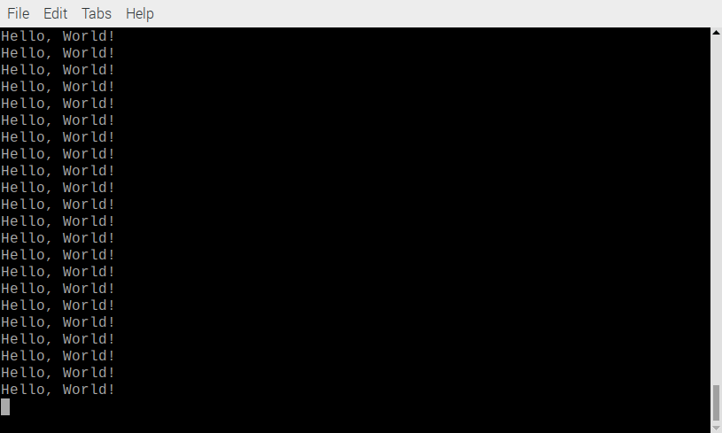
Working Baudrate
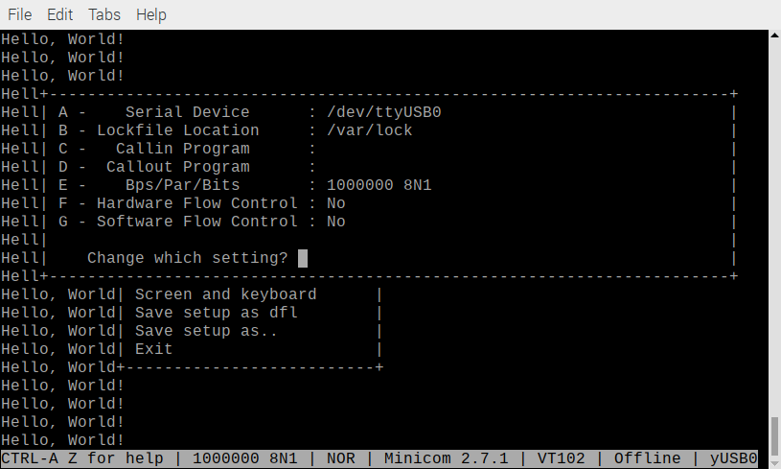
In following test data received from the minicom terminal is sent back to the minicom terminal.

sudo ~/catboard_yosys/config_cat ~/07118catzip/rtl/uart/noflowcntl/echotest.bin

OK: GPIO 25 exported
OK: GPIO 17 exported
OK: GPIO 22 exported

OK: SPI driver loaded

Setting GPIO directions
out
out
in
Setting output to low
0
Reseting FPGA
0
1
Checking DONE pin
0
Continuing with configuration procedure
263+1 records in
263+1 records out
135100 bytes (135 kB, 132 KiB) copied, 0.0193156 s, 7.0 MB/s
Setting output to high
1
Checking DONE pin
1

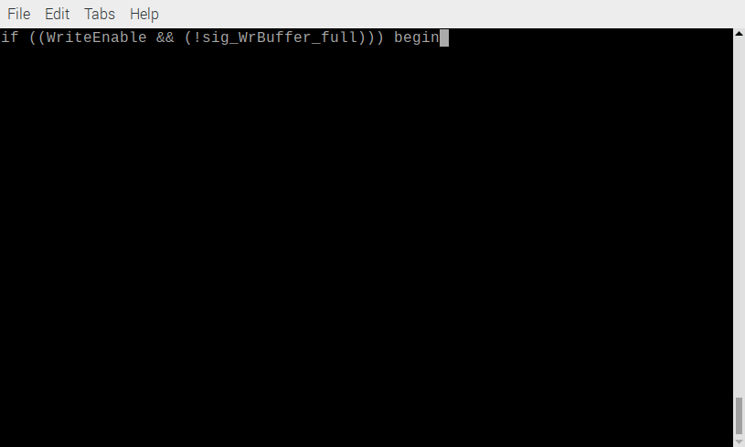

sudo ~/catboard_yosys/config_cat ~/07118catzip/rtl/uart/noflowcntl/speechfifo.bin
[sudo] password for devel:

OK: GPIO 25 exported
OK: GPIO 17 exported
OK: GPIO 22 exported

OK: SPI driver loaded

Setting GPIO directions
out
out
in
Setting output to low
0
Reseting FPGA
0
1
Checking DONE pin
0
Continuing with configuration procedure
263+1 records in
263+1 records out
135100 bytes (135 kB, 132 KiB) copied, 0.016955 s, 8.0 MB/s
Setting output to high
1
Checking DONE pin
1

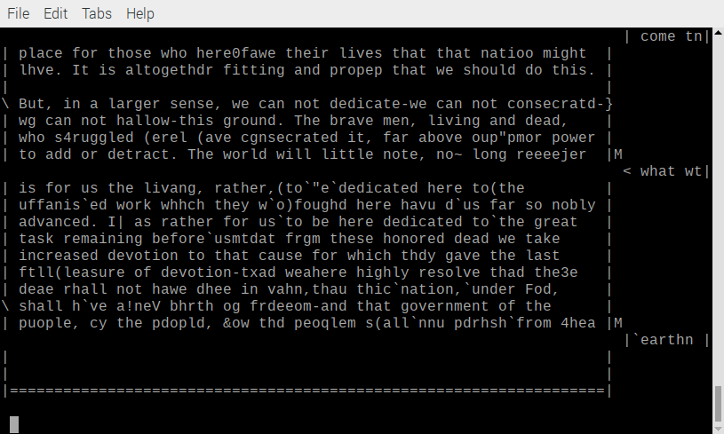
Gobal signals and constants

Clk_f=100e6 #100 Mhz
BAUDRATE=230400
clk = Signal(bool(0))
iRst = Signal(bool(0))
iRX = Signal(bool(0))
oTX = Signal(bool(0))
iData=Signal(intbv(0)[8:])
WriteEnable=Signal(bool(0))
oWrBuffer_full=Signal(bool(0))
oData=Signal(intbv(0)[8:])
read_addr=Signal(intbv(0,min=0,max=8))
RX_BUFF_LEN=8
rx_addr=Signal(intbv(0,min=0,max=RX_BUFF_LEN))

Simulation using rs232loopback_1 = rs232loopback(oTX, iRX)
in place of the

""""
@always_comb
def rs232loopback():
iRX.next=oTX
"""
python RS232_Norbo.py

Running Test Array: [85, 170, 255, 0, 1, 128, 239, 254]
##################################################
RXData: 55 TXData: 85 Buffer Address: 0
RXData: aa TXData: 170 Buffer Address: 1
RXData: ff TXData: 255 Buffer Address: 2
RXData: 00 TXData: 0 Buffer Address: 3
RXData: 01 TXData: 1 Buffer Address: 4
RXData: 80 TXData: 128 Buffer Address: 5
RXData: ef TXData: 239 Buffer Address: 6
RXData: fe TXData: 254 Buffer Address: 7

Running Test Array: [8, 4, 5, 2, 1, 0]
##################################################
RXData: 08 TXData: 8 Buffer Address: 0
RXData: 04 TXData: 4 Buffer Address: 1
RXData: 05 TXData: 5 Buffer Address: 2
RXData: 02 TXData: 2 Buffer Address: 3
RXData: 01 TXData: 1 Buffer Address: 4
RXData: 00 TXData: 0 Buffer Address: 5

Running Test Array: [255, 254, 253, 251]
##################################################
RXData: ff TXData: 255 Buffer Address: 6
RXData: fe TXData: 254 Buffer Address: 7
RXData: fd TXData: 253 Buffer Address: 0
RXData: fb TXData: 251 Buffer Address: 1

Running Test Array: [85, 170, 255, 0, 1, 128, 239, 254, 8, 89, 55]
##################################################
Value: 8 Not written, RS232 Transmittbuffer has indiciated to be allready full. (by oWrBuffer_full)
Value: 89 Not written, RS232 Transmittbuffer has indiciated to be allready full. (by oWrBuffer_full)
Value: 55 Not written, RS232 Transmittbuffer has indiciated to be allready full. (by oWrBuffer_full)
RXData: 55 TXData: 85 Buffer Address: 0
RXData: aa TXData: 170 Buffer Address: 1
RXData: ff TXData: 255 Buffer Address: 2
RXData: 00 TXData: 0 Buffer Address: 3
RXData: 01 TXData: 1 Buffer Address: 4
RXData: 80 TXData: 128 Buffer Address: 5
RXData: ef TXData: 239 Buffer Address: 6
RXData: fe TXData: 254 Buffer Address: 7
Warning: Not all values of the Array have been received (Check if Transmittbuffer was full)
Missing Data is: [8, 89, 55]

End of Simulation, simulation succesfull!

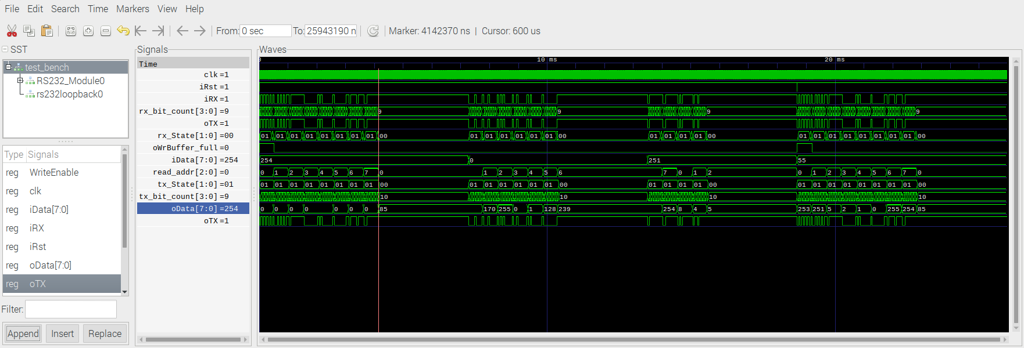

Simulation not using rs232loopback_1 = rs232loopback(oTX, iRX)
in place of the

""""
@always_comb
def rs232loopback():
iRX.next=oTX
"""
#return clk_gen,rs232loopback_1,stimulus,rs232_instance#,Monitor_oTX
return clk_gen,stimulus,rs232_instance#,Monitor_oTX

python RS232_Norbo.py

Running Test Array: [85, 170, 255, 0, 1, 128, 239, 254]
##################################################
Warning: Not all values of the Array have been received (Check if Transmittbuffer was full)
Missing Data is: [85, 170, 255, 0, 1, 128, 239, 254]

Running Test Array: [8, 4, 5, 2, 1, 0]
##################################################
Value: 0 Not written, RS232 Transmittbuffer has indiciated to be allready full. (by oWrBuffer_full)
Warning: Not all values of the Array have been received (Check if Transmittbuffer was full)
Missing Data is: [8, 4, 5, 2, 1, 0]

Running Test Array: [255, 254, 253, 251]
##################################################
Warning: Not all values of the Array have been received (Check if Transmittbuffer was full)
Missing Data is: [255, 254, 253, 251]

Running Test Array: [85, 170, 255, 0, 1, 128, 239, 254, 8, 89, 55]
##################################################
Value: 8 Not written, RS232 Transmittbuffer has indiciated to be allready full. (by oWrBuffer_full)
Value: 89 Not written, RS232 Transmittbuffer has indiciated to be allready full. (by oWrBuffer_full)
Value: 55 Not written, RS232 Transmittbuffer has indiciated to be allready full. (by oWrBuffer_full)
Warning: Not all values of the Array have been received (Check if Transmittbuffer was full)
Missing Data is: [85, 170, 255, 0, 1, 128, 239, 254, 8, 89, 55]

End of Simulation, simulation succesfull!

