This eample is of 512 x 512 red.pgm



1 level DWT

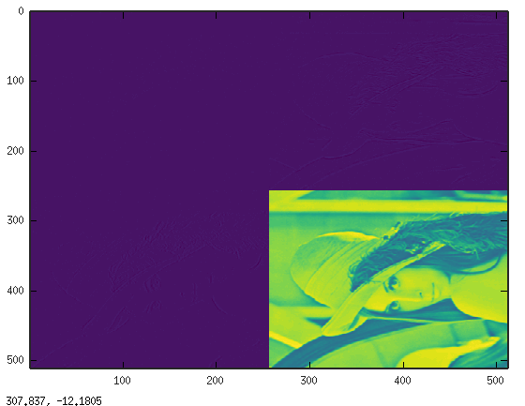
This eample is of 32 x 32 red-32.pgm

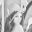

1 level DWT

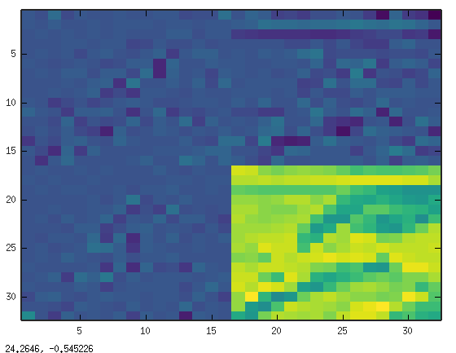

The first line of 32 x 32 image is read.

This is the first four dump of lifting.c which match the values obtained in VCD file below.

ip = 0xe196c8 tp = 0xe1a6c8 32
in singlelift row start loop
ip = 0xe196c8 op = 0xe1a6c8 opb = 0xe1aec8
start ap = 226 b = 224 cp = 230 d = 220
start HP filter *** l = 224 s = 230 r = 220 ss = 8
start HP filter ** ap = 2 b = 224 d = 220 cp = 8
start ****LP filter l = 2 s = 224 r = 8 ss = 227
start LP filter * opb = 227
HP filter *** l = 220 s = 167 r = 178 ss = -32
HP filter ** cp = -32 b = 220 d = 178 ap = 8 ip = 0xe196d8 op = 0xe1a748 opb = 0xe1af48 row = 0 col = 1
LP filter **** l = 8 s = 220 r = -32 ss = 214
LP filter * opb = 214

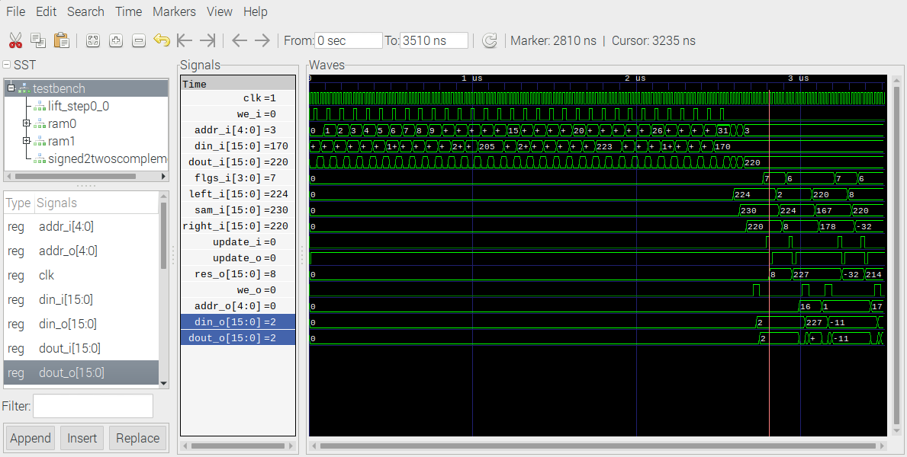
first-hi

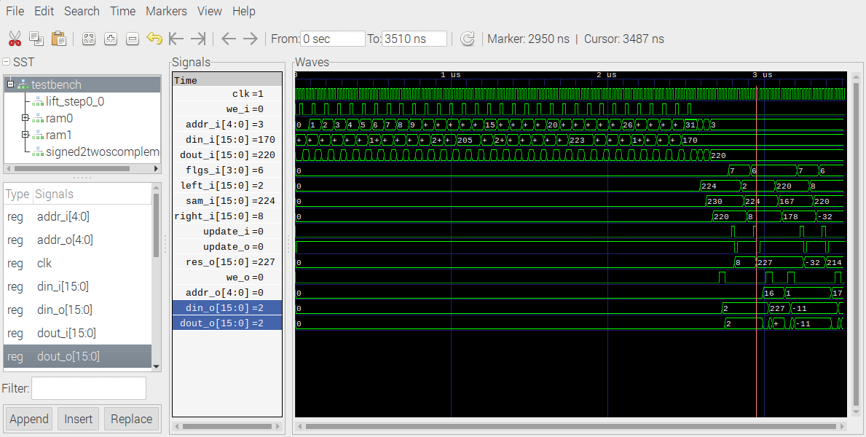
first-lo

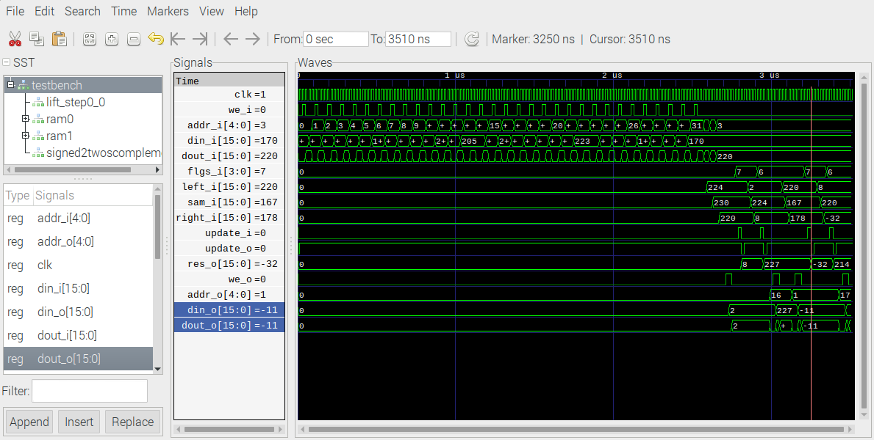
2nd-hi

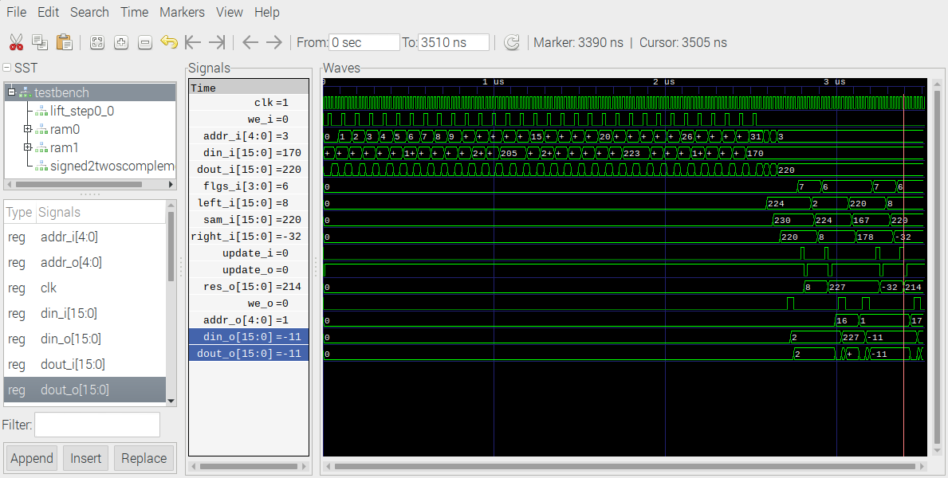
The following verilog module performs the high pass flgs_i = 7 and lo pass flgs_i = 6 dwt filters when the update_i is high and the samples left_i, sam_i, and right_i. The output is res_o. The are 16 bit signed values.

// File: lift_step.v
// Generated by MyHDL 0.11
// Date: Tue Dec 15 17:16:32 2020

`timescale 1ns/10ps

module lift_step (
left_i,
sam_i,
right_i,
flgs_i,
update_i,
clk,
res_o,
update_o
);

input signed [15:0] left_i;
input signed [15:0] sam_i;
input signed [15:0] right_i;
input [3:0] flgs_i;
input update_i;
input clk;
output signed [15:0] res_o;
reg signed [15:0] res_o;
output update_o;
reg update_o;

always @(posedge clk) begin: LIFT_STEP_RTL
if ((update_i == 1)) begin
update_o <= 0;
case (flgs_i)
'h7: begin
res_o <= (sam_i - ($signed(left_i >>> 1) + $signed(right_i >>> 1)));
end
'h5: begin
res_o <= (sam_i + ($signed(left_i >>> 1) + $signed(right_i >>> 1)));
end
'h6: begin
res_o <= (sam_i + $signed(((left_i + right_i) + 2) >>> 2));
end
'h4: begin
res_o <= (sam_i - $signed(((left_i + right_i) + 2) >>> 2));
end
endcase
end
else begin
update_o <= 1;
end
end

endmodule

The first line of 32 x 32 image is read into the ram module.

// File: ram.v
// Generated by MyHDL 0.11
// Date: Tue Dec 15 13:23:26 2020

`timescale 1ns/10ps

module ram (
dout,
din,
addr,
we,
clk
);
// Ram model

output signed [15:0] dout;
wire signed [15:0] dout;
input signed [15:0] din;
input [4:0] addr;
input we;
input clk;

reg signed [15:0] mem [0:32-1];

always @(posedge clk) begin: RAM_WRITE
if (we) begin
mem[addr] <= din;
end
end

assign dout = mem[addr];

endmodule

