cd myhdl-relook/lift/model/6464
./compile.sh

#/bin/bash
gcc -c lifting.c
gcc -c error.c
gcc -c pnmio.c
gcc t-rd.c pnmio.o error.o lifting.o -o t-rd



The above image 64x64 in the file red.pgm is read by the t-rd

./t-rd
octave
dwt
The image below is the fwd lifting step.

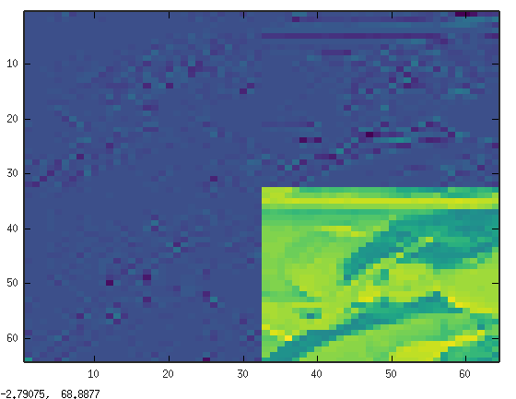

The values in the dark blue area are very
small compare to the values in the lower right corner.
1 Lvl DWT returns 32x32 at the same resolution.

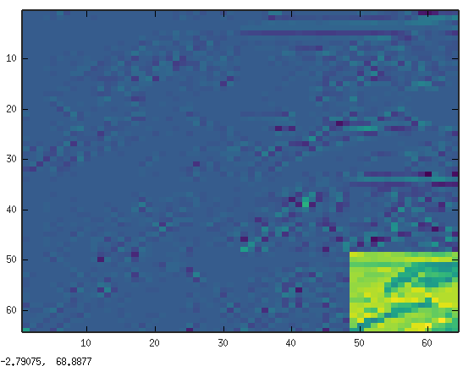

The values in the dark blue area are very
small compare to the values in the lower right corner.
2 Lvl DWT returns 16x16 at the same resolution.
im4(1:32)
ans =

Columns 1 through 16:

1 -2 -1 1 -1 -1 -1 1 -1 -1 2 1 2 -2 -2 0

Columns 17 through 32:

-1 0 1 1 13 -4 -2 1 1 8 -5 20 -4 0 0 -24

205 212 199 197 183 166 179 176 159 159 174 200
207 206 210 211 221 228 229 219 231 224 220 184
160 157 167 163 181 133 118 96 86 80 74 89
226 227 197 219 112 125 114 134 110 90 90 122
185 196 213 123 122 98 197 146 154 139 133 100
209 214 117 87 86 173 107 90 105 110 76 172
220 145 90 145 219 140 151 97 99 161 182 216
228 110 161 206 211 242 237 184 205 215 227 221
218 163 230 182 220 219 215 245 217 220 221 225
212 227 249 246 231 247 218 124 253 222 221 223
225 205 162 145 146 123 84 100 169 247 247 229
242 207 110 107 110 151 186 189 176 185 169 196
171 72 104 165 203 213 205 193 174 182 137 187
106 210 222 216 201 187 193 177 213 261 209 146
231 208 209 200 194 244 247 266 180 169 140 149
209 205 208 179 232 234 243 193 143 147 110 134

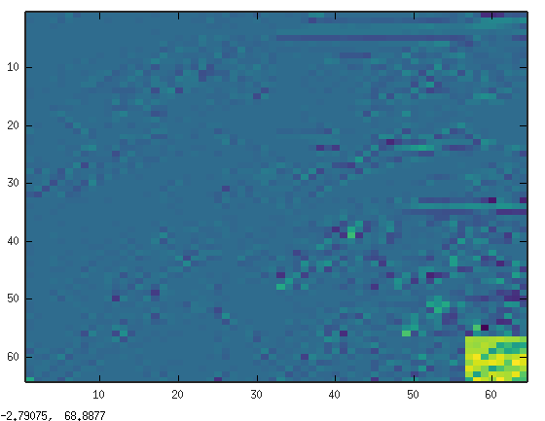

The values in the dark blue area are very
small compare to the values in the lower right corner.
3 Lvls DWT returns 8x8 at the same resolution.

17 8 4 8 201 191 194 200 208 191 192 173
-28 11 -1 -5 195 190 208 192 98 126 80 93
-1 8 -1 -46 199 197 199 73 146 91 108 159
22 21 -18 13 217 243 123 202 230 198 214 228
1 9 56 2 185 225 225 234 225 149 249 229
-5 1 -22 -26 227 205 174 88 142 173 174 201
-4 1 -12 -6 201 86 174 219 206 197 238 151
21 26 -29 -31 96 235 210 188 250 202 127 131

