*********************Draft*********************
JPEG provides better compression than SVG.
07/11/20
*********************Draft*********************

Forked https://github.com/memononen/nanosvg

Scalable Vector Graphics is an Extensible Markup Language-based vector image format for
two-dimensional graphics with support for interactivity and animation. The SVG
specification is an open standard developed by the World Wide Web Consortium

git clone https://github.com/develone/nanosvg.git

Used Gimp to convert to a bmp file

-rw-r--r-- 1 devel devel 96719 Jul 11 06:15 23.svg

-rw-r--r-- 1 devel devel 31451 Jul 11 07:20 test.j2k

gimp nanosvg/example/23.svg

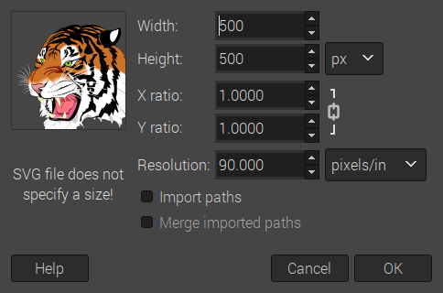

tiger.bmp

11-7-20 13:18:36 786486 tiger_512.bmp copied to

11-7-20 13:18:36 786486 MyBitmap.bmp

6-3-20 12:28:26 24 512com
00000000 19 00 00 00 01 00 00 00 00 00 00 00 00 00 00 00 ................
00000010 00 02 00 00 00 02 00 00

~/Ultibo_Projects/jpeg2000/src $
./compile_ultibo.sh

-rw-r--r-- 1 devel devel 387632 Jul 11 07:00 libopenjp2.a

less libopenjp2_obj.txt
bio.o
cio.o
dwt.o
event.o
function_list.o
image.o
invert.o
j2k.o
jp2.o
mct.o
mqc.o
openjpeg.o
opj_clock.o
opj_malloc.o
pi.o
raw.o
rd-wr-ops.o
t1.o
t2.o
tcd.o
tgt.o
thread.o

~/Ultibo_Projects/jpeg2000/RPi2 $
./libbuild.sh
-rw-r--r-- 1 devel devel 409590 Jul 11 07:00 libdwtlift.a

less libdwtlift_obj.txt

bio.o
cio.o
dwt.o
event.o
function_list.o
image.o
invert.o
j2k.o
jp2.o
mct.o
mqc.o
openjpeg.o
opj_clock.o
opj_malloc.o
pi.o
raw.o
rd-wr-ops.o
t1.o
t2.o
tcd.o
tgt.o
thread.o
dwtlift.o

Lazarus IDE (Ultibo Edition)
Was used to create the kernel7.img
ls -la kernel7.img

DWT_LIFT_Rpi2.lpr

{$linklib dwtlift}
{$linklib libm}
procedure decom_test(x0,y0,x1,y1:LongWord;fn:string); cdecl; external 'libdwtlift' name 'decom_test';
procedure rd_inps(); cdecl; external 'libdwtlift' name 'rd_inps';

-rwxr-xr-x 1 devel devel 3197924 Jul 11 07:00 kernel7.img

~/Ultibo_Projects/jpeg2000/RPi2 $ tftp 192.168.1.245 < cmdstftp
tftp> tftp> Sent 3197924 bytes in 12.7 seconds

telnet xx.xx.xx.xx
C:\>del testfile
C:\copy 512com testfile
1 file(s) copied

C:\>del MyBitmap.bmp
C:\copy tiger_512.bmp MyBitmap.bmp
C:\>restart

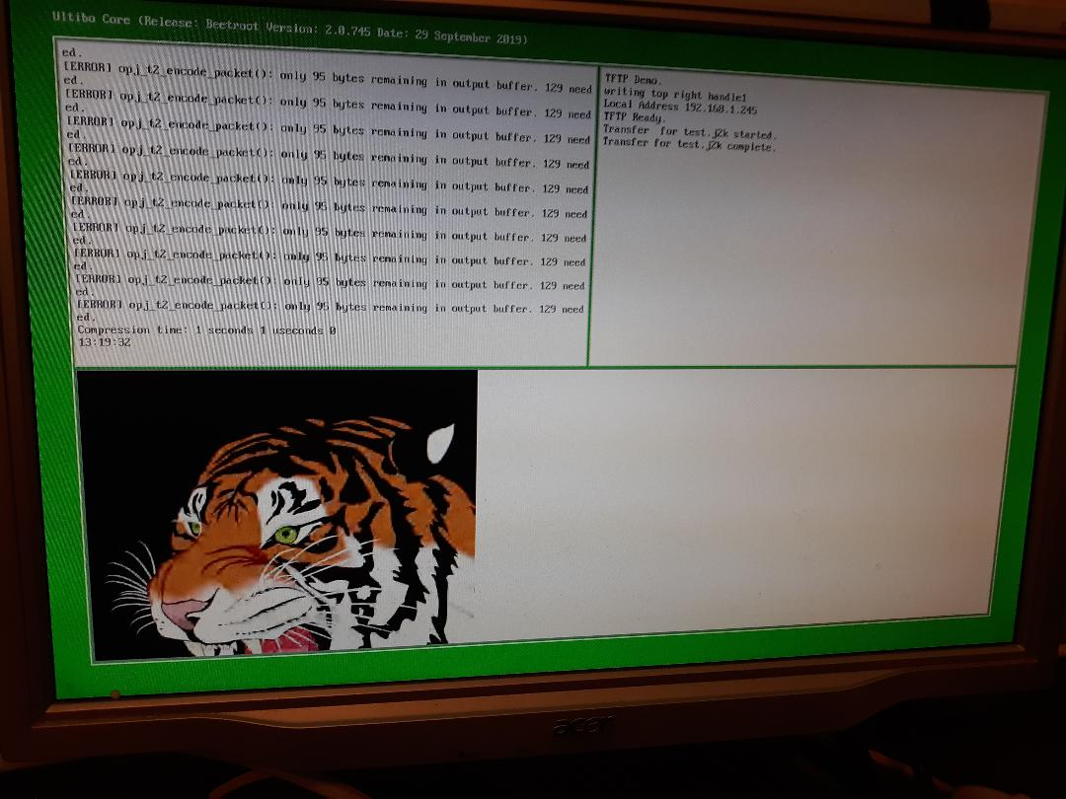

-rw-r--r-- 1 devel devel 31451 Jul 11 07:20 test.j2k

git clone https://github.com/develone/openjpeg.git t_ultibo

cd t_ultibo/

git checkout ultibo

cd build/

cmake ../

~/t_ultibo/build/src

bin lib

cd lib/

make

cd ../bin

make

libopenjp2.a opj_compress opj_decompress opj_dump

~/t_ultibo/build/bin/ultibo $ ../opj_decompress -i test.j2k -o ultibo.bmp

[INFO] Start to read j2k main header (0).
[INFO] Main header has been correctly decoded.
[INFO] No decoded area parameters, set the decoded area to the whole image
[INFO] Header of tile 1 / 1 has been read.
[INFO] Generated Outfile ultibo.bmp
decode time: 106 ms

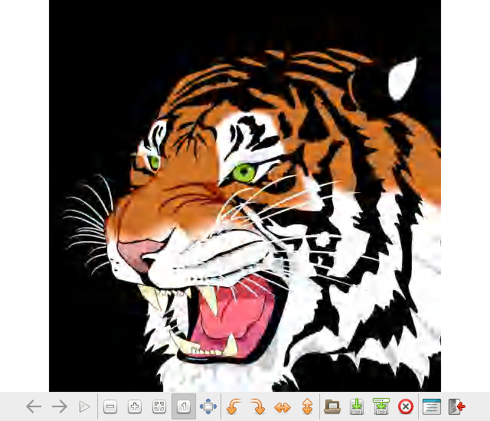

C:\>del testfile
C:\512decom2decom testfile
1 file(s) copied
C:\>restart

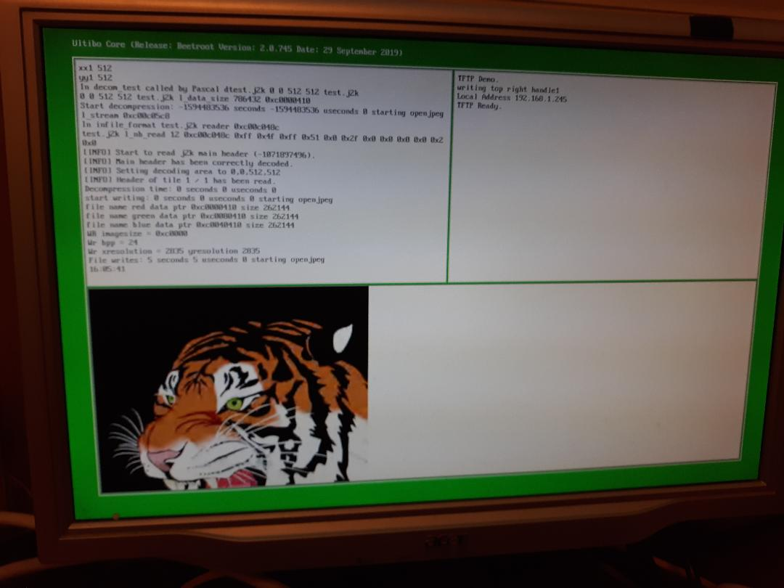

11-7-20 13:03:18 196730 test_wr.bmp

