*********************Draft*********************
Nuklear Library Testing Rpi4 4gb
08/12/20
*********************Draft*********************

Appendix A Notes demo-test

devel@mypi3-20:~/nuklear/demo/x11_opengl2 $ bin/demo
[X11] Failed to create OpenGL 3.0 context
[X11] ... using old-style GLX context!
Major chg in demo when the Makefile is modified.
-CFLAGS += -std=c99 -pedantic -O2
+CFLAGS += -std=c99 -pedantic -O2 -DINCLUDE_ALL

In main.c

/* This are some code examples to provide a small overview of what can be
* done with this library. To try out an example uncomment the defines */

#ifdef INCLUDE_ALL
#define INCLUDE_STYLE
#define INCLUDE_CALCULATOR
#define INCLUDE_OVERVIEW
#define INCLUDE_NODE_EDITOR
#endif

#ifdef INCLUDE_STYLE
#include "../style.c"
#endif
#ifdef INCLUDE_CALCULATOR
#include "../calculator.c"
#endif
#ifdef INCLUDE_OVERVIEW
#include "../overview.c"
#endif
#ifdef INCLUDE_NODE_EDITOR
#include "../node_editor.c"
#endif

Running the program “bin/demo”

demo1

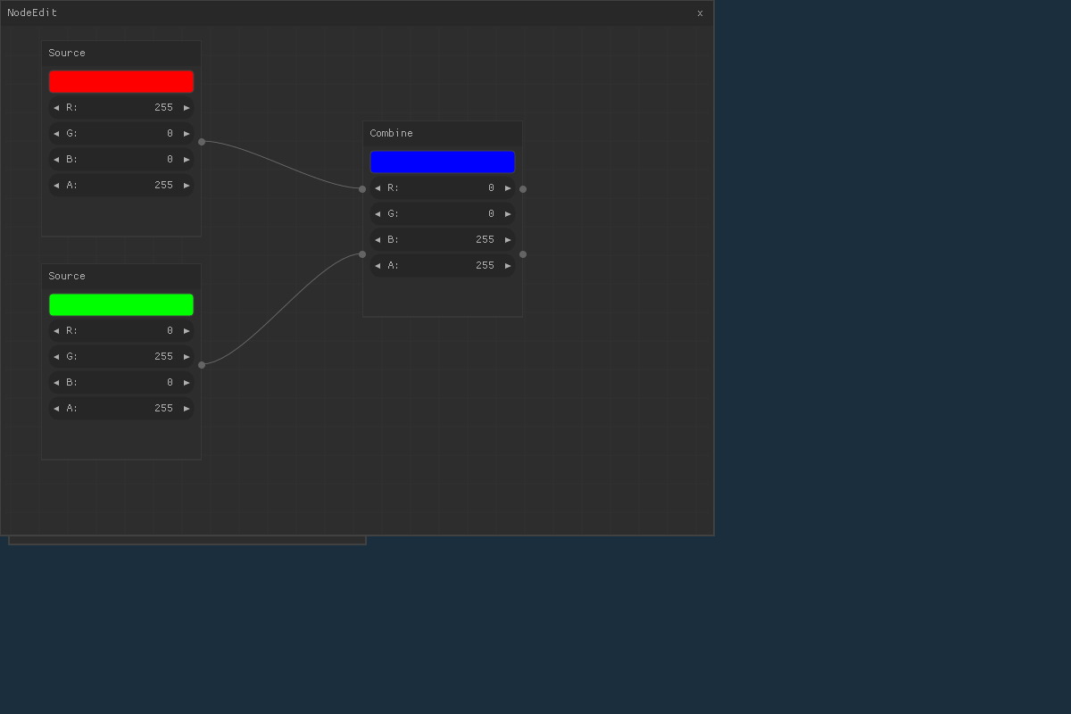
Closing the first window in Demo. Depress the x on NodeEdit window. This brings up a new window. Clicking the Chart arrow brings up several graphs.

demo2

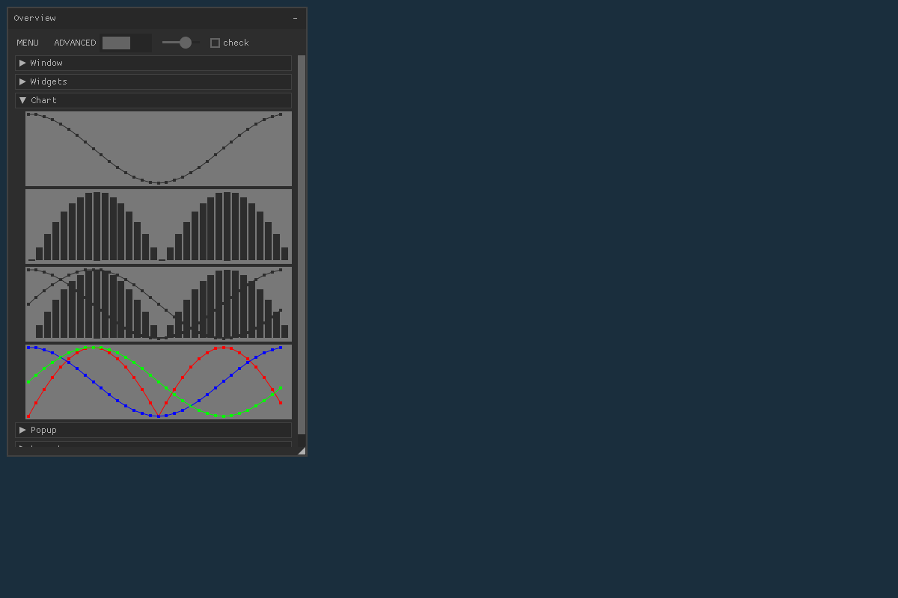
Clicking the Widigets arrow brings up arrows for different type widigets.

demo3

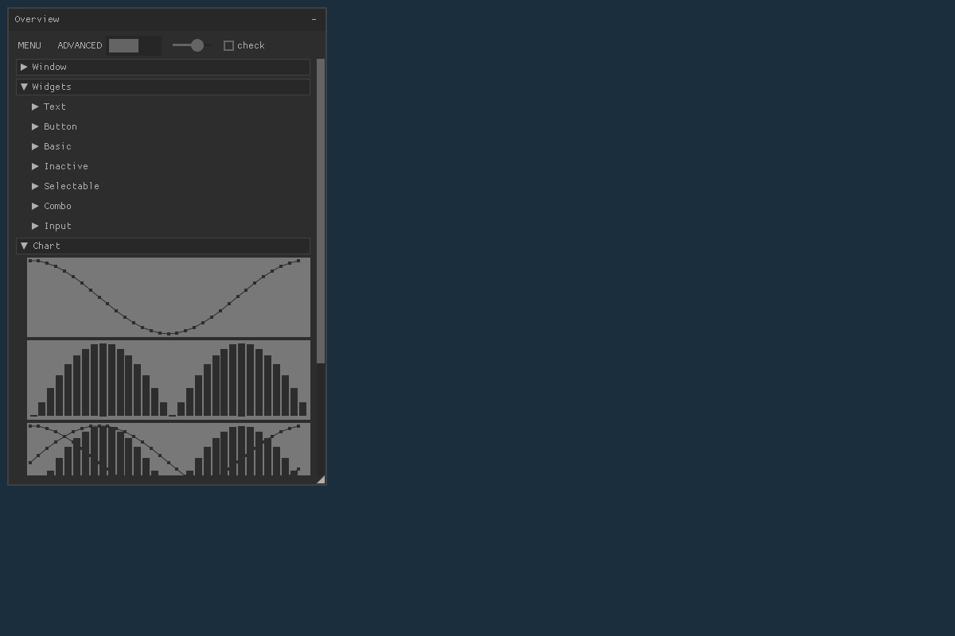
Clicking the Inactive arrow brings up a check box and a button widigets.

demo4

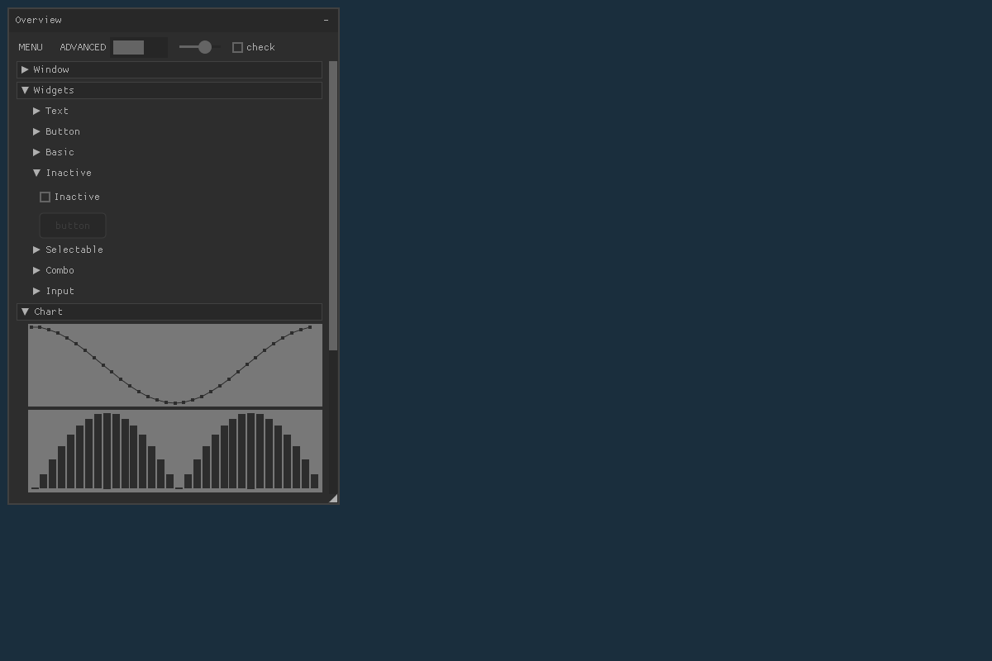
Setting check box and the button is active widigets. Pressing the button displays
button pressed in the start shell.

demo5

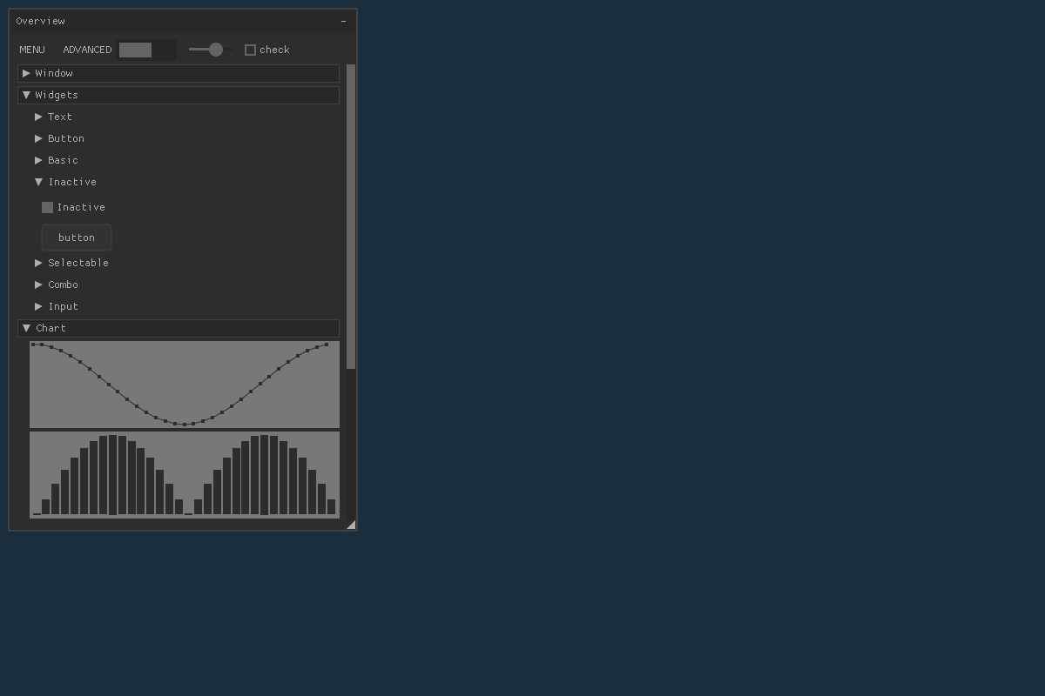
Appendix A Notes demo-tests

Testing nuklear 08/10/20 RPi4 4gB
demo x11 creates bin/zahnrad works okay

demo x11_opengl2 creates bin/demo works okay

demo x11_opengl3
bin/demo
[X11] Failed to create OpenGL 3.0 context
[X11] ... using old-style GLX context!
[GL]: Graphics card does not fullfill minimum OpenGL 2.0 support
demo: ../../nuklear.h:13949: nk_input_begin: Assertion `ctx' failed.
Aborted

glfw_opengl2
Makefile modification
- LIBS = -lglfw -lGL -lm -lGLU
+ LIBS = -lglfw3 -lGL -lm -lGLU
make
rm -f bin/demo
cc main.c -std=c99 -pedantic -O2 -o bin/demo -lglfw3 -lGL -lm -lGLU
/usr/bin/ld: //usr/local/lib/libglfw3.a(vulkan.c.o): undefined reference to symbol 'dlopen@@GLIBC_2.4'
/usr/bin/ld: //lib/arm-linux-gnueabihf/libdl.so.2: error adding symbols: DSO missing from command line
collect2: error: ld returned 1 exit status
make: *** [Makefile:25: demo] Error 1

devel@mypi3-20:~/nuklear/example $ make
cc -std=c99 -pedantic -O2 -o bin/file_browser file_browser.c -L/usr/local/lib -lglfw3 -lGL -lm -lGLU -lGLEW
file_browser.c:15:10: fatal error: GL/glew.h: No such file or directory
#include <GL/glew.h>
^~~~~~~~~~~
compilation terminated.
make: *** [Makefile:32: file_browser] Error 1

sudo apt install libglew-dev

devel@mypi3-20:~/nuklear/example $ make
cc -std=c99 -pedantic -O2 -o bin/file_browser file_browser.c -L/usr/local/lib -lglfw3 -lGL -lm -lGLU -lGLEW
/usr/bin/ld: /usr/local/lib/libglfw3.a(vulkan.c.o): undefined reference to symbol 'dlopen@@GLIBC_2.4'
/usr/bin/ld: //lib/arm-linux-gnueabihf/libdl.so.2: error adding symbols: DSO missing from command line
collect2: error: ld returned 1 exit status
make: *** [Makefile:32: file_browser] Error 1

- LIBS := $(GLFW3) -lGL -lm -lGLU -lGLEW
+ LIBS := $(GLFW3) -lX11 -lGL -lm -lGLU -lGLEW -ldl -lpthread
devel@mypi3-20:~/nuklear/example $ make
cc -std=c99 -pedantic -O2 -o bin/file_browser file_browser.c -L/usr/local/lib -lglfw3 -lX11 -lGL -lm -lGLU -lGLEW -ldl -lpthread
cc -std=c99 -pedantic -O2 -o bin/extended extended.c -L/usr/local/lib -lglfw3 -lX11 -lGL -lm -lGLU -lGLEW -ldl -lpthread
cc -std=c99 -pedantic -O2 -o bin/canvas canvas.c -L/usr/local/lib -lglfw3 -lX11 -lGL -lm -lGLU -lGLEW -ldl -lpthread
cc -std=c99 -pedantic -O2 -o bin/skinning skinning.c -L/usr/local/lib -lglfw3 Yes, it's graphics card limitation, mesa supports minimum 3.1 for all included drivers: https://mesamatrix.net/
Proprietary drivers should support max hardware capabilities too
ls bin/
canvas extended file_browser skinning

devel@mypi3-20:~/nuklear/example $ bin/canvas
Error 65543: GLX: Failed to create context: GLXBadFBConfig
canvas: /home/devel/glfw/src/window.c:958: glfwSetWindowUserPointer: Assertion `window != NULL' failed.
Aborted
devel@mypi3-20:~/nuklear/example $ bin/extended
Error 65543: GLX: Failed to create context: GLXBadFBConfig
extended: /home/devel/glfw/src/window.c:958: glfwSetWindowUserPointer: Assertion `window != NULL' failed.
Aborted
devel@mypi3-20:~/nuklear/example $ bin/file_browser
Error 65543: GLX: Failed to create context: GLXBadFBConfigq
file_browser: /home/devel/glfw/src/window.c:958: glfwSetWindowUserPointer: Assertion `window != NULL' failed.
Aborted
devel@mypi3-20:~/nuklear/example $ bin/skinning
Error 65543: GLX: Failed to create context: GLXBadFBConfig
skinning: /home/devel/glfw/src/window.c:958: glfwSetWindowUserPointer: Assertion `window != NULL' failed.
Aborted

https://github.com/vurtun/nuklear/issues/364

glxinfo | grep 'version'
server glx version string: 1.4
client glx version string: 1.4
GLX version: 1.4
Max core profile version: 0.0
Max compat profile version: 2.1
Max GLES1 profile version: 1.1
Max GLES[23] profile version: 3.1
OpenGL version string: 2.1 Mesa 19.3.2
OpenGL shading language version string: 1.20
OpenGL ES profile version string: OpenGL ES 3.1 Mesa 19.3.2
OpenGL ES profile shading language version string: OpenGL ES GLSL ES 3.10
GL_EXT_separate_shader_objects, GL_EXT_shader_implicit_conversions,

comments
Hmmm... how odd, glxinfo shows 2.1 for me too. Is that a graphics card limitation? My system is up to date, so I don't think it's a software issue

Yes, it's graphics card limitation, mesa supports minimum 3.1 for all included drivers: https://mesamatrix.net/
Proprietary drivers should support max hardware capabilities too

glfw_opengl2
Makefile modification
- LIBS = -lglfw -lGL -lm -lGLU
+ LIBS = -lglfw3 -lGL -lm -lGLU
make
rm -f bin/demo
cc main.c -std=c99 -pedantic -O2 -o bin/demo -lglfw3 -lGL -lm -lGLU
/usr/bin/ld: //usr/local/lib/libglfw3.a(vulkan.c.o): undefined reference to symbol 'dlopen@@GLIBC_2.4'
/usr/bin/ld: //lib/arm-linux-gnueabihf/libdl.so.2: error adding symbols: DSO missing from command line
collect2: error: ld returned 1 exit status
make: *** [Makefile:25: demo] Error 1
2nd chg
- LIBS = -lglfw3 -lGL -lm -lGLU
+ LIBS = -lglfw3 -lGL -lm -lGLU -lX11 -lGL -lm -lGLU -lGLEW -ldl -lpthread

devel@mypi3-20:~/nuklear/demo/glfw_opengl3 $ make
rm -f bin/demo
cc main.c -std=c99 -pedantic -O2 -o bin/demo -L/usr/local/lib -lglfw3 -lGL -lm -lGLU -lGLEW
/usr/bin/ld: /usr/local/lib/libglfw3.a(vulkan.c.o): undefined reference to symbol 'dlopen@@GLIBC_2.4'
/usr/bin/ld: //lib/arm-linux-gnueabihf/libdl.so.2: error adding symbols: DSO missing from command line
collect2: error: ld returned 1 exit status
make: *** [Makefile:26: demo] Error 1
devel@mypi3-20:~/nuklear/demo/glfw_opengl3 $ git diff Makefile
diff --git a/demo/glfw_opengl3/Makefile b/demo/glfw_opengl3/Makefile
index da95261..159383d 100644
--- a/demo/glfw_opengl3/Makefile
+++ b/demo/glfw_opengl3/Makefile
@@ -16,7 +16,7 @@ else
ifeq ($(UNAME_S),Darwin)
LIBS := $(GLFW3) -framework OpenGL -framework Cocoa -framework IOKit -framework CoreVideo -lm -lGLEW -L/usr/local/lib
else
- LIBS = $(GLFW3) -lGL -lm -lGLU -lGLEW
+ LIBS = $(GLFW3) -lGL -lm -lGLU -lGLEW -lX11 -lGL -lm -lGLU -lGLEW -ldl -lpthread
endif
endif

devel@mypi3-20:~/nuklear/demo/glfw_opengl3 $ make
rm -f bin/demo
cc main.c -std=c99 -pedantic -O2 -o bin/demo -L/usr/local/lib -lglfw3 -lGL -lm -lGLU -lGLEW -lX11 -lGL -lm -lGLU -lGLEW -ldl -lpthread
devel@mypi3-20:~/nuklear/demo/glfw_opengl3 $ bin/demo
Error 65543: GLX: Failed to create context: GLXBadFBConfig
demo: /home/devel/glfw/src/window.c:547: glfwGetWindowSize: Assertion `window != NULL' failed.
Aborted

sudo apt-get install libsdl2-dev
devel@mypi3-20:~/nuklear/demo/sdl_opengl2 $ make
creates bin/demo works okay

devel@mypi3-20:~/nuklear/demo/x11_opengl2 $ bin/demo
[X11] Failed to create OpenGL 3.0 context
[X11] ... using old-style GLX context!
Major chg in demo when the Makefile is modified.
-CFLAGS += -std=c99 -pedantic -O2
+CFLAGS += -std=c99 -pedantic -O2 -DINCLUDE_ALL

Adding the -DINCLUDE_ALL to Makefile in glfw_opengl2

-CFLAGS += -std=c99 -pedantic -O2
+CFLAGS += -std=c99 -pedantic -O2 -DINCLUDE_ALL

Adding the -DINCLUDE_ALL to Makefile in x11

-CFLAGS += -std=c89 -pedantic -O2
+CFLAGS += -std=c99 -pedantic -O2 -DINCLUDE_ALL

