********************Draft********************
Encryption Decryption using openssl
Edward Vidal Jr.
06/10/23
********************Draft********************

On most all Unix system “openssl” is available. The follow description was found at the following:
https://www.openssl.org/
“Welcome to OpenSSL!
The OpenSSL Project develops and maintains the OpenSSL software - a robust, commercial-grade, full-featured toolkit for general-purpose cryptography and secure communication. The project’s technical decision making is managed by the OpenSSL Technical Committee (OTC) and the project governance is managed by the OpenSSL Management Committee (OMC). The project operates under formal Bylaws.
For more information about the team and community around the project, or to start making your own contributions, start with the community page. To get the latest news, download the source, and so on, please see the sidebar or the buttons at the top of every page.
OpenSSL is licensed under an Apache-style license, which basically means that you are free to get and use it for commercial and non-commercial purposes subject to some simple license conditions.
For a list of vulnerabilities, and the releases in which they were found and fixes, see our Vulnerabilities page.”
In this example “aes-256-cbc” will be used to encrypt. The key that will is “4e6f772077652061726520656e676167656420696e2061206772656174206369”
that will is iv “23ae14f4a7b2dc7f1dd89cf6f07e4048”. These 2 items would need to know by parties sender receiver, since they would not be sent with the file secretwork.enc

The “cmd1” below will encrypt the file work.txt into the file secretwork.enc.
cmd1
openssl enc -v -P -p -nosalt -aes-256-cbc -K 4e6f772077652061726520656e676167656420696e2061206772656174206369 -iv 23ae14f4a7b2dc7f1dd89cf6f07e4048 -in work.txt -out secretwork.enc
bufsize=8192

The “cmd2” below will decrypt the file secretwork.enc into the file text.plain1dec.
cmd2
openssl enc -d -v -P -p -nosalt -aes-256-cbc -K 4e6f772077652061726520656e676167656420696e2061206772656174206369 -iv 23ae14f4a7b2dc7f1dd89cf6f07e4048 -in secretwork.enc -out text.plain1dec
bufsize=8192

part1
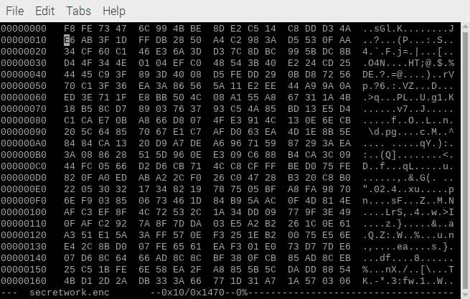
part2
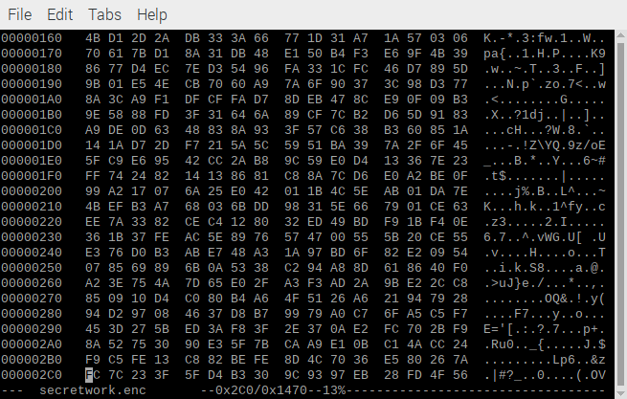
part3

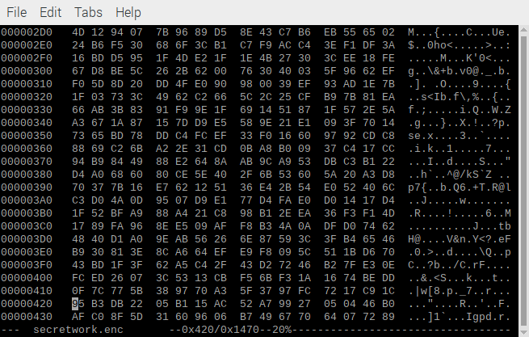
cmd2
openssl enc -d -v -P -p -nosalt -aes-256-cbc -K 4e6f772077652061726520656e676167656420696e2061206772656174206369 -iv 23ae14f4a7b2dc7f1dd89cf6f07e4048 -in secretwork.enc -out text.plain1dec
bufsize=8192

