*********DRAFT*********
Adapting the OLED designed for the ICOBOARD
to the CATBOARD
05/27/18
*********DRAFT*********

The youtube video https://www.youtube.com/watch?v=UMDcnwZA2YE describes the interface between an OLED display and the ICOBOARD.

Goal of this effor: Is to perform the same functions using the CATBOARD instead of the ICOBOARD.

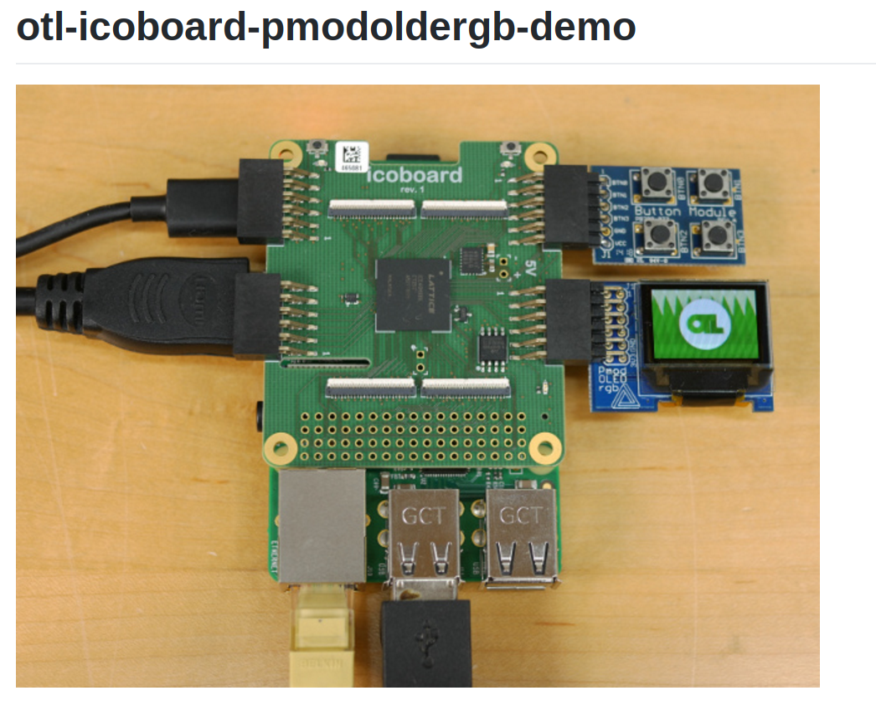

Design Block Diagram

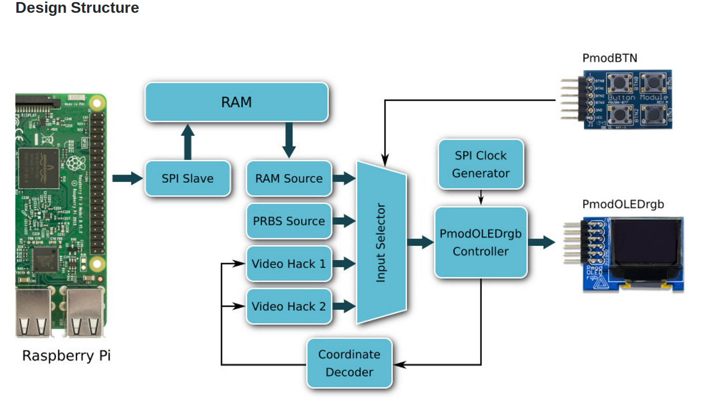

First forked the repository ttps://github.hcom/jhol/otl-icoboard-pmodoledrgb-demo

git clone https://github.com/develone/otl-icoboard-pmodoledrgb-demo.git

“cd otl-icoboard-pmodoledrgb-demo/”

Need to create a new branch to track the changes required for the CATBOARD.
“git branch catboard”
Even though the FPGAs ice40 HX8K are same for the CATBOARD and the ICOBOARD.

1.) The first issue is the interface between the Raspberry Pi and FPGA hat.

ICOBOARD RPi
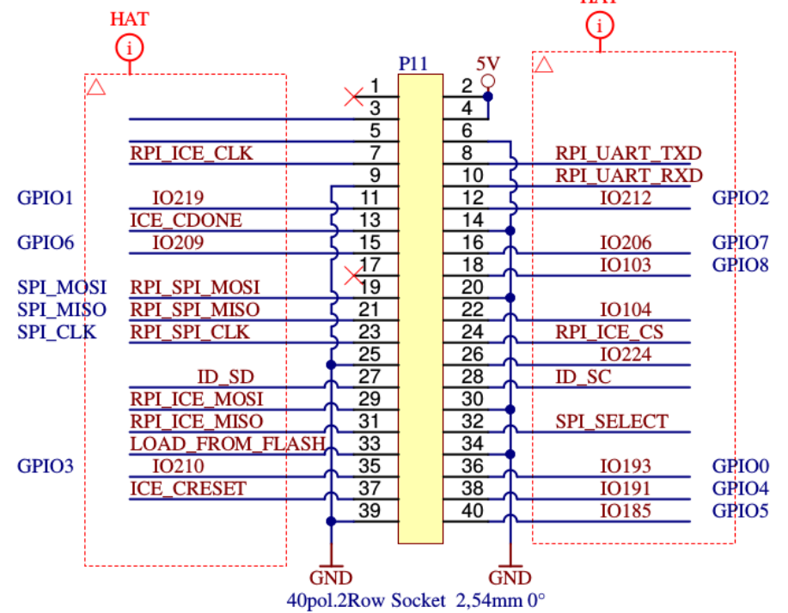

CATBOARD RPi

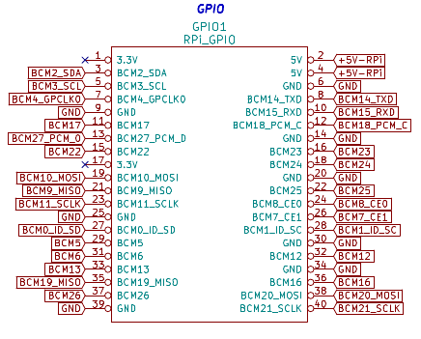

2.) The 2nd issue is the PMOD connections to FPGA are different.
3.) Third, I do not have a Diglient PMOD 4 push button switch module.
4.) The 4th issue is the PHASE LOCK LOOP difference.

set_io clk_100mhz C8 #R9

set_io pmod1_1 A11 #D8
set_io pmod1_2 B12 #B9
set_io pmod1_3 B14 #B10
set_io pmod1_4 B15 #B11
# 654321 catboard # 654321 icoboard
# xxxxxx PMOD3 A # xxxxxx PMOD1 A
# xxxxxx PMOD3 B # xxxxxx PMOD1 B
# 654321 # 654321
#
set_io pmod1_7 B10 #B8
set_io pmod1_8 B11 #A9
set_io pmod1_9 B13 #A10
set_io pmod1_10 A15 #A11

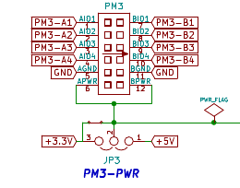

CATBOARD connection to FPGA pins PMOD 2 & PMOD 3 push button switches, dip switch, and leds.

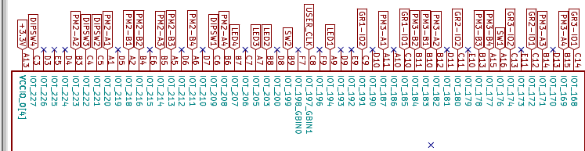

In top.v

module top(clk_100mhz, pmod1_1, pmod1_2, pmod1_3, pmod1_4, pmod1_7, pmod1_8,
pmod1_9, pmod1_10, pmod2_7, pmod2_8, pmod2_9, pmod2_10, rpi_sck, rpi_cs,
rpi_mosi);

input rpi_sck, rpi_cs, rpi_mosi;
rpi_sck
rpi_cs
rpi_mosi

spi_ram_slave spi_ram_slave(clk, rpi_sck, rpi_cs, rpi_mosi,
ram_addr, ram_data, ram_wr);
module spi_ram_slave(clk, sck, cs, mosi, ram_addr, ram_data, ram_wr);
PMOD pin out on icoboard
