******************Draft******************
Part 5 pico
freeRTOS
Semaphore
03/10/22

******************Draft******************

https://learnembeddedsystems.co.uk/freertos-on-the-rp2040-part-5-semaphores

https://www.youtube.com/watch?v=0mqlPds5rkU

Intro

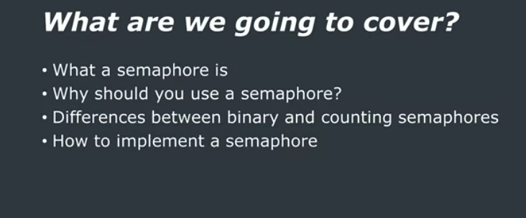

What is a Binary Semaphore?

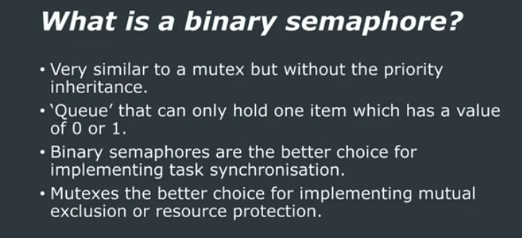

What is a Binary Semaphore?

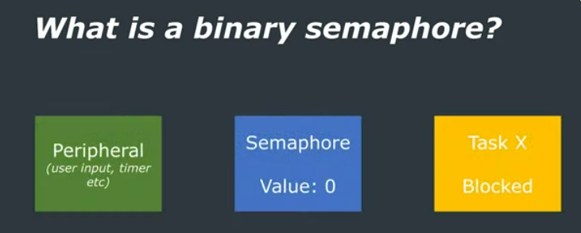

What is a Binary Semaphore?

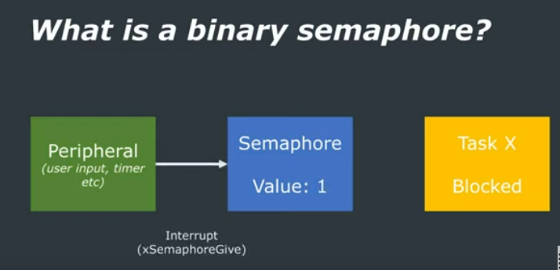
What is a Binary Semaphore?

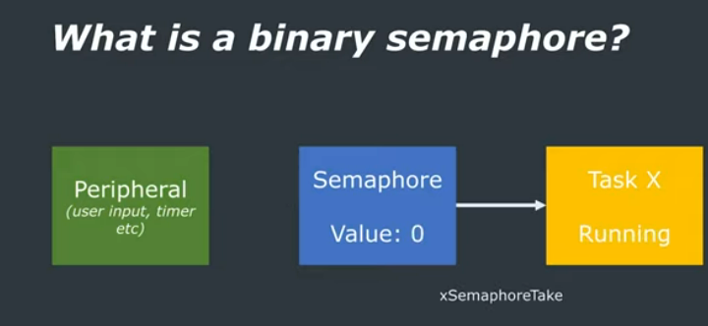

What is a Binary Semaphore?

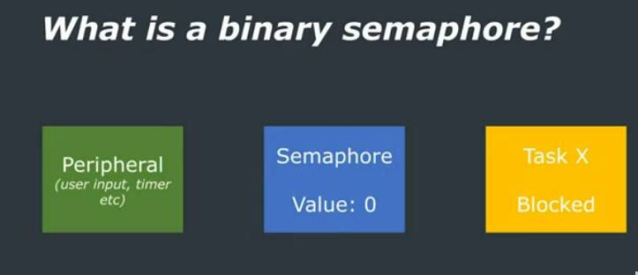
What is a Counting Semaphore?

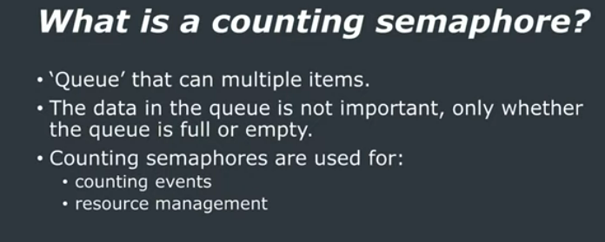

What is a Counting Semaphore?

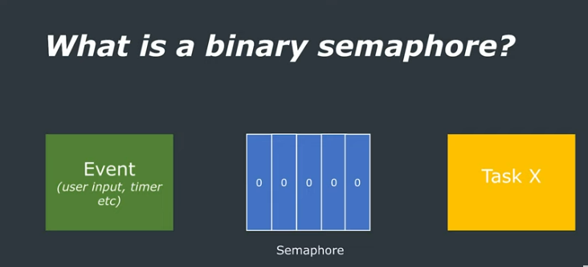

What is a Counting Semaphore?

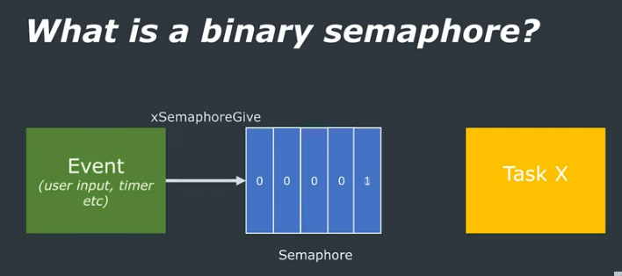
What is a Counting Semaphore?

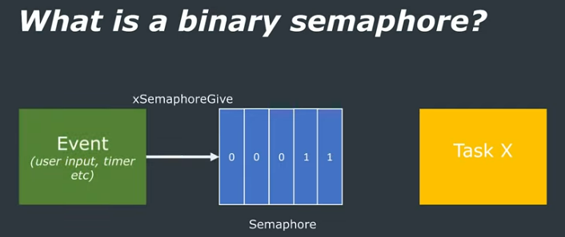

What is a Counting Semaphore?

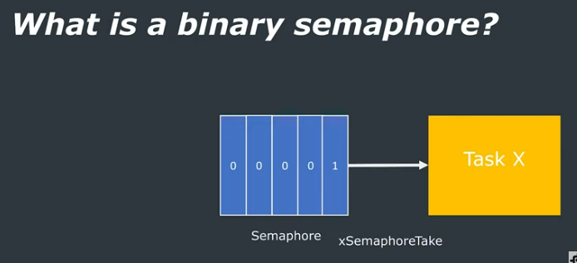

What is a Counting Semaphore?

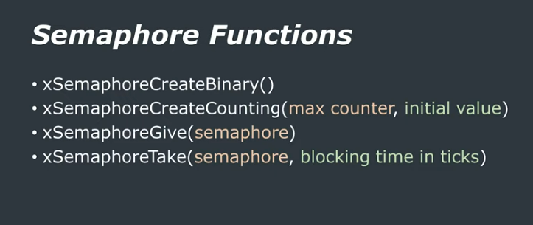
FreeRTOS API Calls

Example

Conclusion

