********************Draft********************
pico & pico2
spi-master-slave
08/07/26
********************Draft********************

Two Raspberry Pi 5 8Gb systems were used in developing the code.

Testing the original spi_master_slave code.

devel@pi5-80:~ $ mkdir spi

devel@pi5-80:~ $ cd spi/

devel@pi5-80:~ $ git clone -b test-dev https://github.com/develone/pico-examples.git

devel@pi5-80:~/spi $ cd pico-examples/

devel@pi5-80:~/spi/pico-examples $ git checkout 314d

devel@pi5-80:~/spi/pico-examples $ git log
commit 314d551230e637ba111ab14c7e4fcb73ff9ac114 (HEAD)
Merge: 026f37b 4c3a3dc
Author: develone <develone@sbcglobal.net>
Date: Thu Aug 7 06:24:36 2025 -0600

Merge branch 'raspberrypi:master' into test-dev
This was the Raspberry Pi 5 8Gb pi5-80 build which is the original code for the spi_master_slave with spi/spi_master_slave/spi_slave/CmakeLists.txt modified.
devel@pi5-80:~/spi/pico-examples $ git diff spi/spi_master_slave/spi_slave/CMakeLists.txt
diff --git a/spi/spi_master_slave/spi_slave/CMakeLists.txt b/spi/spi_master_slave/spi_slave/CMakeLists.txt
index 8e05645..6f83582 100644
--- a/spi/spi_master_slave/spi_slave/CMakeLists.txt
+++ b/spi/spi_master_slave/spi_slave/CMakeLists.txt
@@ -1,12 +1,20 @@
-add_executable(spi_slave
- spi_slave.c
+if (TARGET tinyusb_device)
+ add_executable(spi_slave
+ spi_slave.c
)

-# Pull in basic dependencies
-target_link_libraries(spi_slave pico_stdlib hardware_spi)
+ # Pull in basic dependencies
+ target_link_libraries(spi_slave pico_stdlib hardware_spi)

-# create map/bin/hex file etc.
-pico_add_extra_outputs(spi_slave)
+ # create map/bin/hex file etc.

-# add url via pico_set_program_url
-example_auto_set_url(spi_slave)
+
+ pico_add_extra_outputs(spi_slave)
+ pico_enable_stdio_usb(spi_slave 1)
+ pico_enable_stdio_uart(spi_slave 0)
+
+ # add url via pico_set_program_url
+ example_auto_set_url(spi_slave)
+elseif(PICO_ON_DEVICE)
+ message("Skipping hello_usb because TinyUSB submodule is not initialized in the SDK")
+endif()

This is what is seen on the minicom myusb0 when the pico2 spi_master is power-up.
SPI master example
SPI master says: The following buffer will be written to MOSI endlessly:
00 01 02 03 04 05 06 07 08 09 0a 0b 0c 0d 0e 0f
10 11 12 13 14 15 16 17 18 19 1a 1b 1c 1d 1e 1f
20 21 22 23 24 25 26 27 28 29 2a 2b 2c 2d 2e 2f
30 31 32 33 34 35 36 37 38 39 3a 3b 3c 3d 3e 3f
40 41 42 43 44 45 46 47 48 49 4a 4b 4c 4d 4e 4f
50 51 52 53 54 55 56 57 58 59 5a 5b 5c 5d 5e 5f
60 61 62 63 64 65 66 67 68 69 6a 6b 6c 6d 6e 6f
70 71 72 73 74 75 76 77 78 79 7a 7b 7c 7d 7e 7f
80 81 82 83 84 85 86 87 88 89 8a 8b 8c 8d 8e 8f
90 91 92 93 94 95 96 97 98 99 9a 9b 9c 9d 9e 9f
a0 a1 a2 a3 a4 a5 a6 a7 a8 a9 aa ab ac ad ae af
b0 b1 b2 b3 b4 b5 b6 b7 b8 b9 ba bb bc bd be bf
c0 c1 c2 c3 c4 c5 c6 c7 c8 c9 ca cb cc cd ce cf
d0 d1 d2 d3 d4 d5 d6 d7 d8 d9 da db dc dd de df
e0 e1 e2 e3 e4 e5 e6 e7 e8 e9 ea eb ec ed ee ef
f0 f1 f2 f3 f4 f5 f6 f7 f8 f9 fa fb fc fd fe ff
SPI master says: read page 0 from the MISO line:
fb fa f9 f8 f7 f6 f5 f4 f3 f2 f1 f0 ef ee ed ec
eb ea e9 e8 e7 e6 e5 e4 e3 e2 e1 e0 df de dd dc
db da d9 d8 d7 d6 d5 d4 d3 d2 d1 d0 cf ce cd cc
cb ca c9 c8 c7 c6 c5 c4 c3 c2 c1 c0 bf be bd bc
bb ba b9 b8 b7 b6 b5 b4 b3 b2 b1 b0 af ae ad ac
ab aa a9 a8 a7 a6 a5 a4 a3 a2 a1 a0 9f 9e 9d 9c
9b 9a 99 98 97 96 95 94 93 92 91 90 8f 8e 8d 8c
8b 8a 89 88 87 86 85 84 83 82 81 80 7f 7e 7d 7c
7b 7a 79 78 77 76 75 74 73 72 71 70 6f 6e 6d 6c
6b 6a 69 68 67 66 65 64 63 62 61 60 5f 5e 5d 5c
5b 5a 59 58 57 56 55 54 53 52 51 50 4f 4e 4d 4c
4b 4a 49 48 47 46 45 44 43 42 41 40 3f 3e 3d 3c
3b 3a 39 38 37 36 35 34 33 32 31 30 2f 2e 2d 2c
2b 2a 29 28 27 26 25 24 23 22 21 20 1f 1e 1d 1c
1b 1a 19 18 17 16 15 14 13 12 11 10 0f 0e 0d 0c
0b 0a 09 08 07 06 05 04 03 02 01 00 00 00 00 00

This is what is seen on the minicom myACM0 when the pico2 spi_slave is power-up.
SPI slave example
SPI slave says: When reading from MOSI, the following buffer will be written to MISO:
ff fe fd fc fb fa f9 f8 f7 f6 f5 f4 f3 f2 f1 f0
ef ee ed ec eb ea e9 e8 e7 e6 e5 e4 e3 e2 e1 e0
df de dd dc db da d9 d8 d7 d6 d5 d4 d3 d2 d1 d0
cf ce cd cc cb ca c9 c8 c7 c6 c5 c4 c3 c2 c1 c0
bf be bd bc bb ba b9 b8 b7 b6 b5 b4 b3 b2 b1 b0
af ae ad ac ab aa a9 a8 a7 a6 a5 a4 a3 a2 a1 a0
9f 9e 9d 9c 9b 9a 99 98 97 96 95 94 93 92 91 90
8f 8e 8d 8c 8b 8a 89 88 87 86 85 84 83 82 81 80
7f 7e 7d 7c 7b 7a 79 78 77 76 75 74 73 72 71 70
6f 6e 6d 6c 6b 6a 69 68 67 66 65 64 63 62 61 60
5f 5e 5d 5c 5b 5a 59 58 57 56 55 54 53 52 51 50
4f 4e 4d 4c 4b 4a 49 48 47 46 45 44 43 42 41 40
3f 3e 3d 3c 3b 3a 39 38 37 36 35 34 33 32 31 30
2f 2e 2d 2c 2b 2a 29 28 27 26 25 24 23 22 21 20
1f 1e 1d 1c 1b 1a 19 18 17 16 15 14 13 12 11 10
0f 0e 0d 0c 0b 0a 09 08 07 06 05 04 03 02 01 00
SPI slave says: read page 0 from the MOSI line:
00 01 02 03 04 05 06 07 08 09 0a 0b 0c 0d 0e 0f
10 11 12 13 14 15 16 17 18 19 1a 1b 1c 1d 1e 1f
20 21 22 23 24 25 26 27 28 29 2a 2b 2c 2d 2e 2f
30 31 32 33 34 35 36 37 38 39 3a 3b 3c 3d 3e 3f
40 41 42 43 44 45 46 47 48 49 4a 4b 4c 4d 4e 4f
50 51 52 53 54 55 56 57 58 59 5a 5b 5c 5d 5e 5f
60 61 62 63 64 65 66 67 68 69 6a 6b 6c 6d 6e 6f
70 71 72 73 74 75 76 77 78 79 7a 7b 7c 7d 7e 7f
80 81 82 83 84 85 86 87 88 89 8a 8b 8c 8d 8e 8f
90 91 92 93 94 95 96 97 98 99 9a 9b 9c 9d 9e 9f
a0 a1 a2 a3 a4 a5 a6 a7 a8 a9 aa ab ac ad ae af
b0 b1 b2 b3 b4 b5 b6 b7 b8 b9 ba bb bc bd be bf
c0 c1 c2 c3 c4 c5 c6 c7 c8 c9 ca cb cc cd ce cf
d0 d1 d2 d3 d4 d5 d6 d7 d8 d9 da db dc dd de df
e0 e1 e2 e3 e4 e5 e6 e7 e8 e9 ea eb ec ed ee ef
f0 f1 f2 f3 f4 f5 f6 f7 f8 f9 fa fb fc fd fe ff
xx
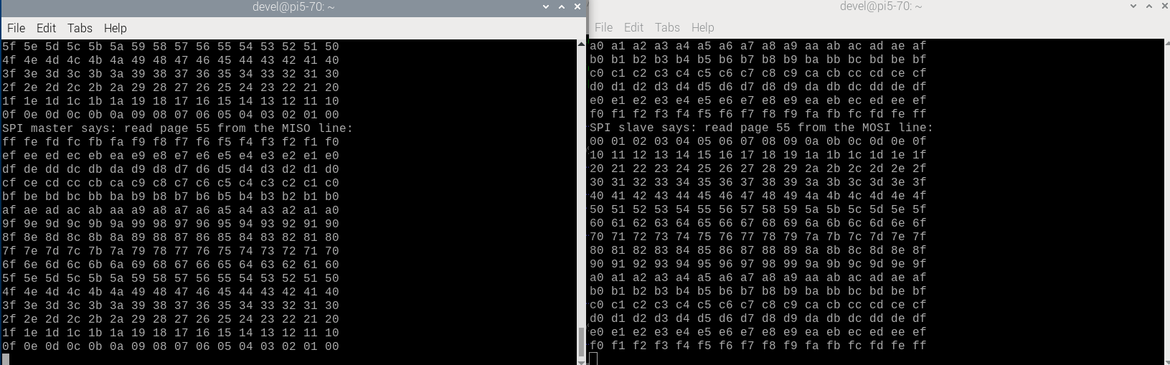
xx

Currently the pico2 is the only master slave working. The pico needs rewiring and testing.

These are variables found .bashrc on pi5-90

#export WIFI_SSID=
#export WIFI_PASSWORD=
export WIFI_SSID="TMOBILE-CE06"
export WIFI_PASSWORD="k64ndv2czh8"
#export PATH="/home/devel/oss-cad-suite/bin:$PATH"
#export PIPELINEC_REPO="$HOME/PipelineC_pmod-ethernet-jpeg/PipelineC"
export PIPELINEC_REPO="$HOME/PipelineC"
export PICO_EXTRAS_PATH=/home/devel/pico-extras
#export PICO_SDK_PATH=/home/devel/pico/pico-sdk
export PICO_SDK_PATH=/home/devel/pico2/pico-sdk
#export PICO_2350=1
#export FREERTOS_KERNEL_PATH=/home/devel/rp2350-freeRTOS/test-read-crc16/FreeRTOS-Kernel
export FREERTOS_KERNEL_PATH=/home/devel/pico2/freertos-lib/FreeRTOS-Kernel
export PICO_FREERTOS=/home/devel/pico2/freertos-lib/FreeRTOS-Kernel
export PICTOOL_FETCH_FROM_GITHUB=/home/devel/pico2/BUILT_PICOTOOL
#export PATH="$HOME/.pyenv/bin:$HOME/local/openocd/bin:$HOME/qemu-6.2.0-rpios/bin:$PATH"
#export PIPELINEC_REPO=$HOME/PipelineC
export OSS_CAD_SUITE=$HOME/oss-cad-suite/
export PATH="$HOME/.pyenv/bin:$HOME/local/openocd/bin:$PATH"
eval "$(pyenv init --path)"
eval "$(pyenv virtualenv-init -)"
devel@pi5-90:~ $ mkdir spi

devel@pi5-90:~ $ cd spi

devel@pi5-90:~/spi $ git clone -b test-dev https://github.com/develone/pico-examples.git

Need to modify the files compile-rp2040.sh & compile-rp2040.sh

devel@pi5-90:~/spi/pico-examples $ git diff compile-rp2040.sh
diff --git a/compile-rp2040.sh b/compile-rp2040.sh
index 8905c4d..ae7fb2e 100755
--- a/compile-rp2040.sh
+++ b/compile-rp2040.sh
@@ -3,5 +3,5 @@ rm -rf build-rp2040
mkdir build-rp2040
cd build-rp2040
cmake .. -DPICO_BOARD=pico_w -DPICO_PLATFORM=rp2040 -DWIFI_SSID="WIFI_SSID" -DWIFI_PASSWORD="WIFI_PASSWORD"
-make
+#make

devel@pi5-90:~/spi/pico-examples $ git diff compile-rp2350.sh
diff --git a/compile-rp2350.sh b/compile-rp2350.sh
index 596732e..af2b30d 100755
--- a/compile-rp2350.sh
+++ b/compile-rp2350.sh
@@ -3,5 +3,5 @@ rm -rf build-rp2350
mkdir build-rp2350
cd build-rp2350
cmake .. -DPICO_BOARD=pico2_w -DPICO_PLATFORM=rp2350 -DWIFI_SSID="WIFI_SSID" -DWIFI_PASSWORD="WIFI_PASSWORD"
-make
+#make

devel@pi5-90:~/spi/pico-examples $ cd build-rp2350/spi/spi_master_slave/spi_master/

devel@pi5-90:~/spi/pico-examples/build-rp2350/spi/spi_master_slave/spi_master $ make

devel@pi5-90:~/spi/pico-examples/build-rp2350/spi/spi_master_slave/spi_master $ scp spi_master.uf2 pi5-70:/media/devel/RP2350

devel@pi5-90:~/spi/pico-examples/build-rp2350/spi/spi_master_slave/spi_slave $ make

devel@pi5-90:~/spi/pico-examples/build-rp2350/spi/spi_master_slave/spi_slave $ scp spi_slave.uf2 pi5-70:/media/devel/RP2350

The master is on the left and slave is on the right.
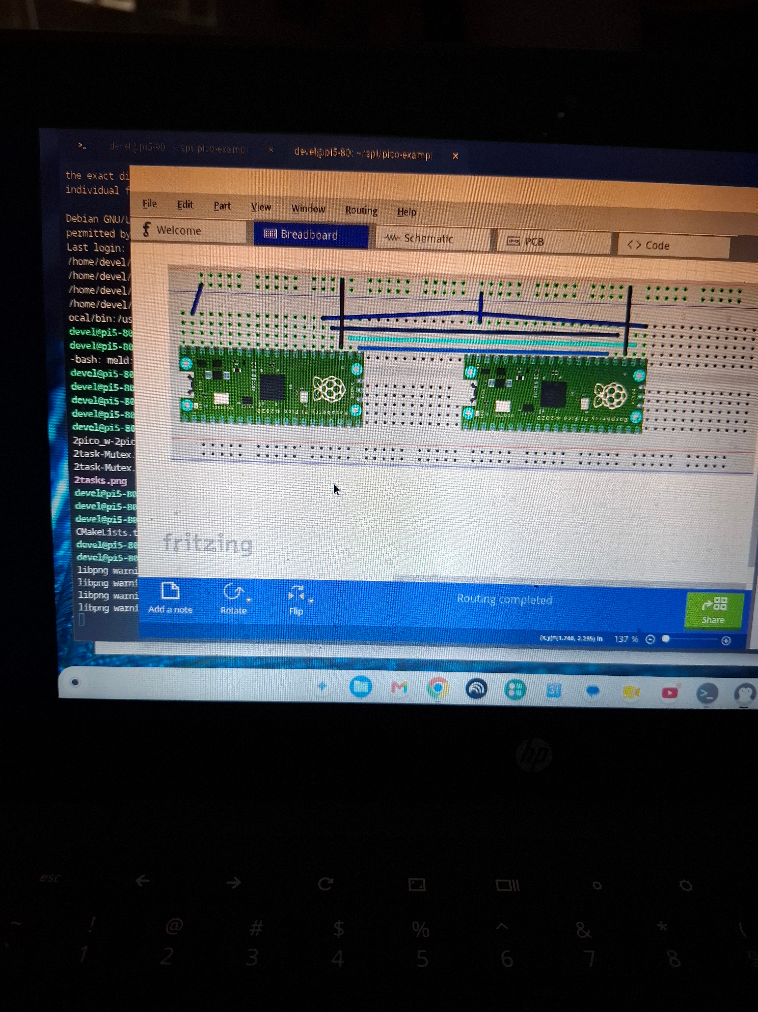

The pico2 master slave in the middle of the breadboard. The pico master slave on the top.

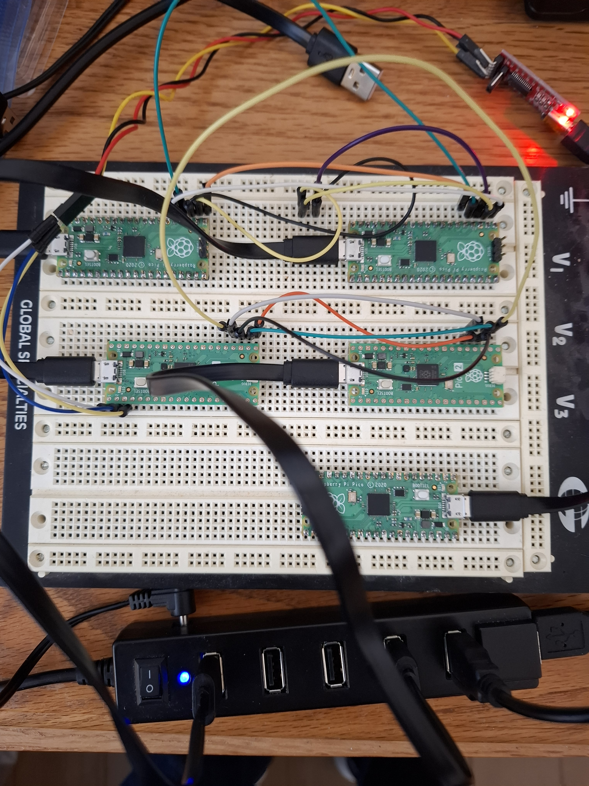

The shell on left is the spi_master.
// commonly used crc test data and also space for the crc value
static uint8_t src[TOTAL_LEN] = { 0x31, 0x32, 0x33, 0x34, 0x35, 0x36, 0x37, 0x38, 0x39, 0x00, 0x00, 0x00, 0x00 };
crc32 0xd9 0xc6 0xb 0x34

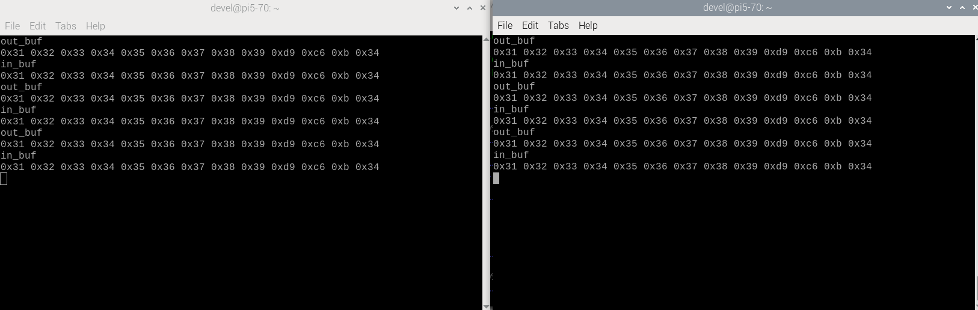
The shell on right is the spi_slave.

Next steps adding the preamble.

