2tasks and Mutex
12/21/24

scp freertos/2tasks/2tasks.uf2 pi5-80:/media/devel/RP2350/
scp ../build-rp2040/freertos/2tasks/2tasks.uf2 pi5-80:/media/devel/RPI-RP2/

The top is the pico2 rp2350 in the image below. The lower is the pico rp2040 in the image below.

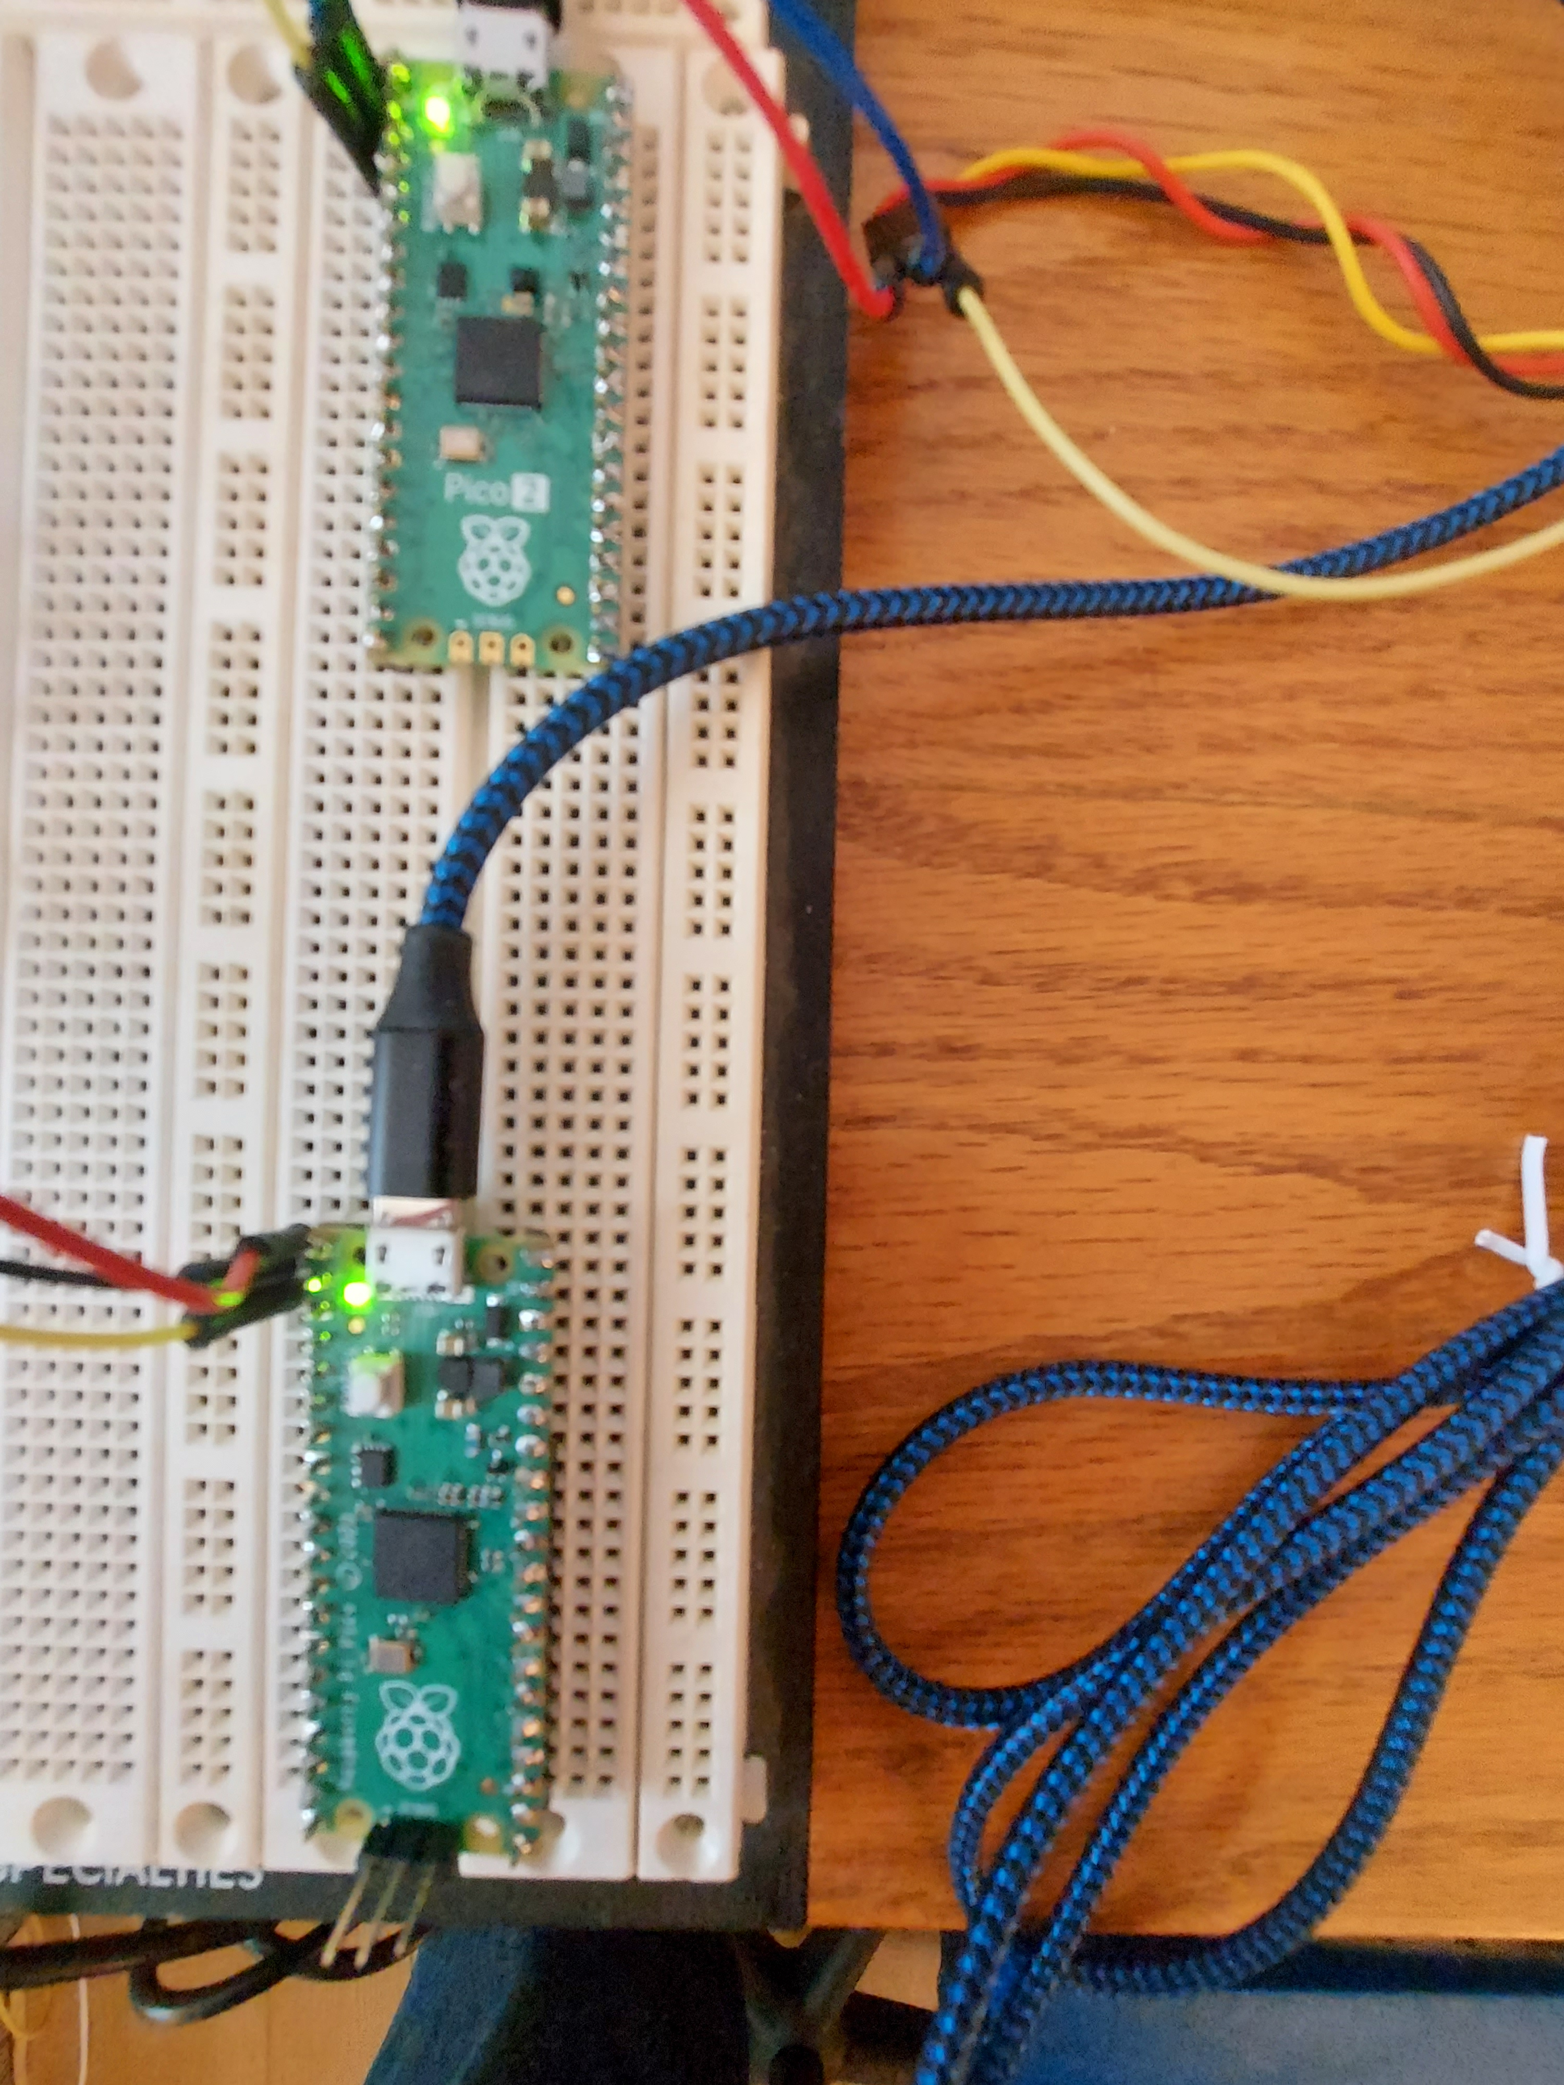

2tasks in the image below.

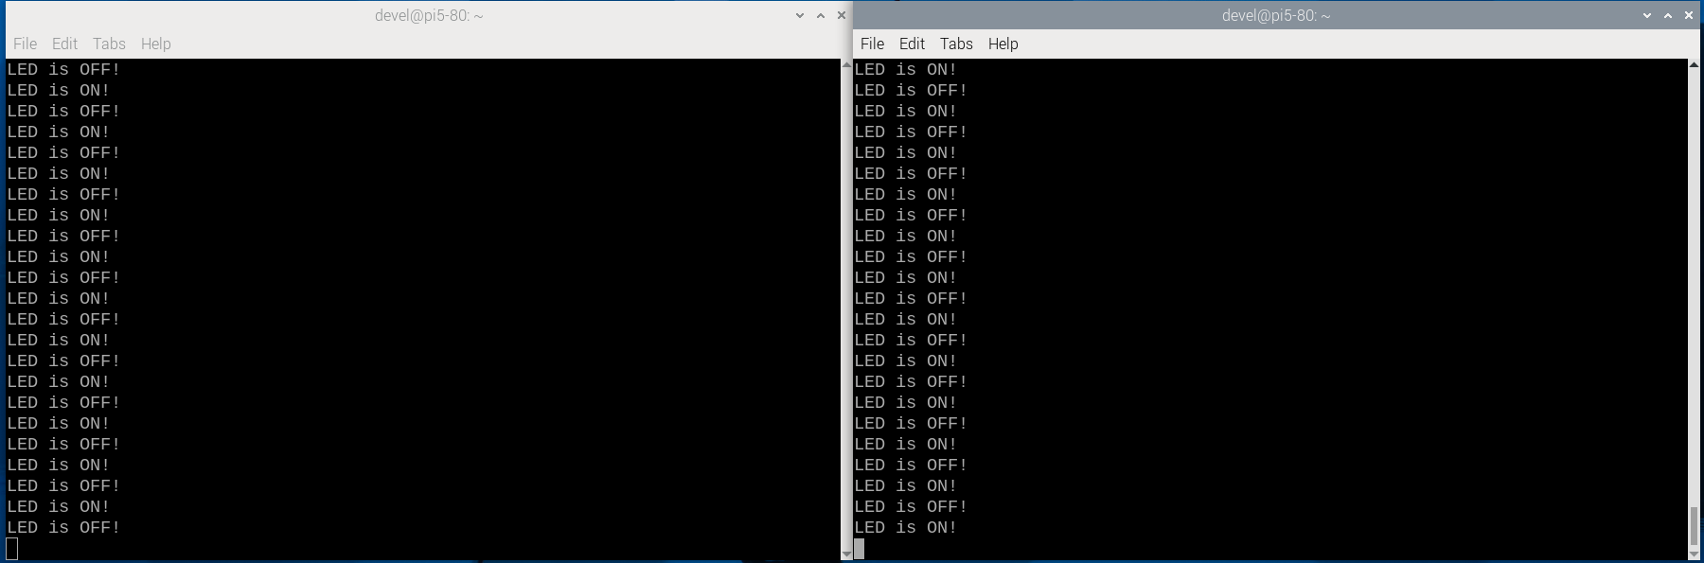
The left shell above is rp2350 2taks.uf2 The right shell above is rp2040 2taks.uf2

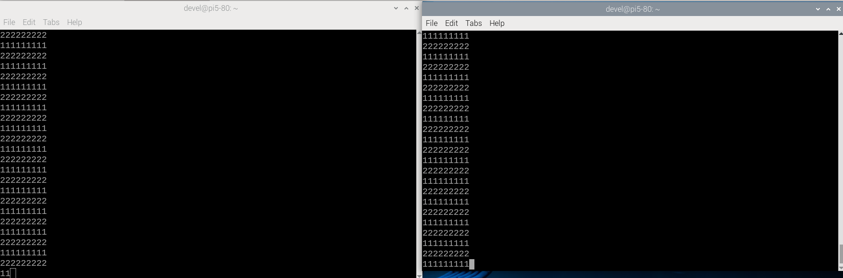

The left shell above is rp2350 Mutex.uf2 The right shell above is rp2040 Mutex.uf2

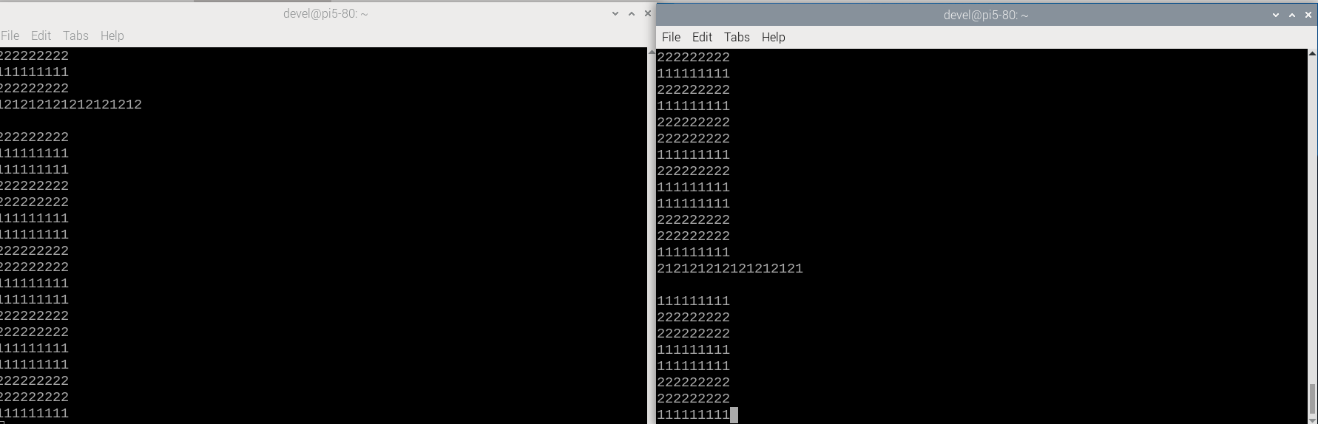

The left shell above is rp2350 Mutex-with-out.uf2 The right shell above is rp2040 Mutex-with-out.uf2

