****************************DRAFT****************************
433 MHz transmitter receiver
pico or pico2
08/18/26
****************************DRAFT****************************

Currently using the https://github.com/develone/pico-examples/blob/test-dev/pio/uart_tx/uart_tx.c and https://github.com/develone/pico-examples/blob/test-dev/pio/uart_rx/uart_rx.c

Tx is a pico and Rx is a pico2 at a range of 15 feet.

The Tx is sending uint8_t preamble[RH_ASK_PREAMBLE_LEN] = {0x2a, 0x2a, 0x2a, 0x2a, 0x2a, 0x2a, 0x38, 0x2c}. commonly used crc test data 1 2 3 4 5 6 7 8 9 and also space for the crc value 0x340bc6d9.
The Rx is checking when the 0x2c is received and then displays the 13 bytes

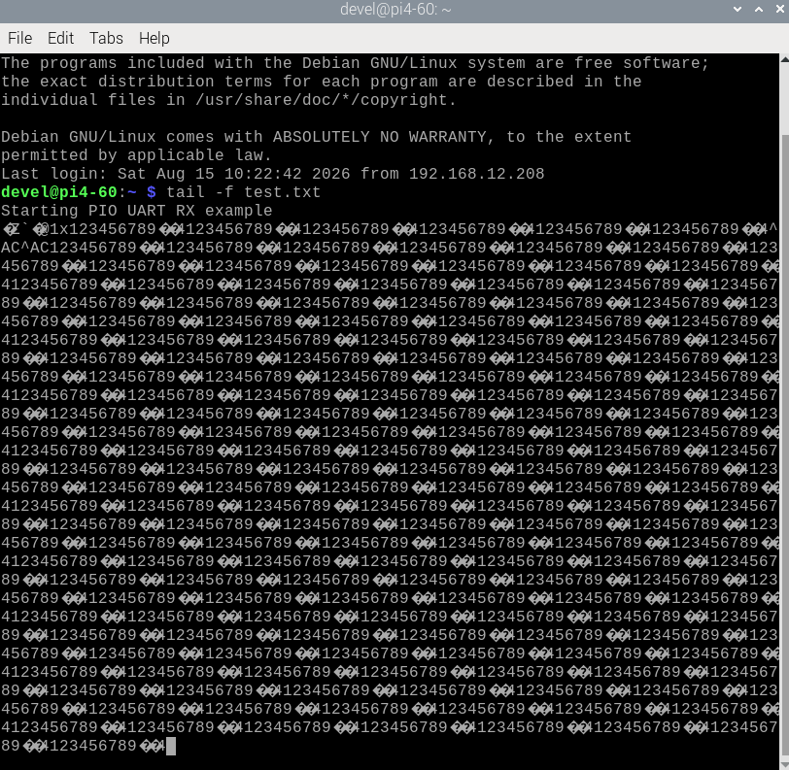
433 MHz transmitter pico
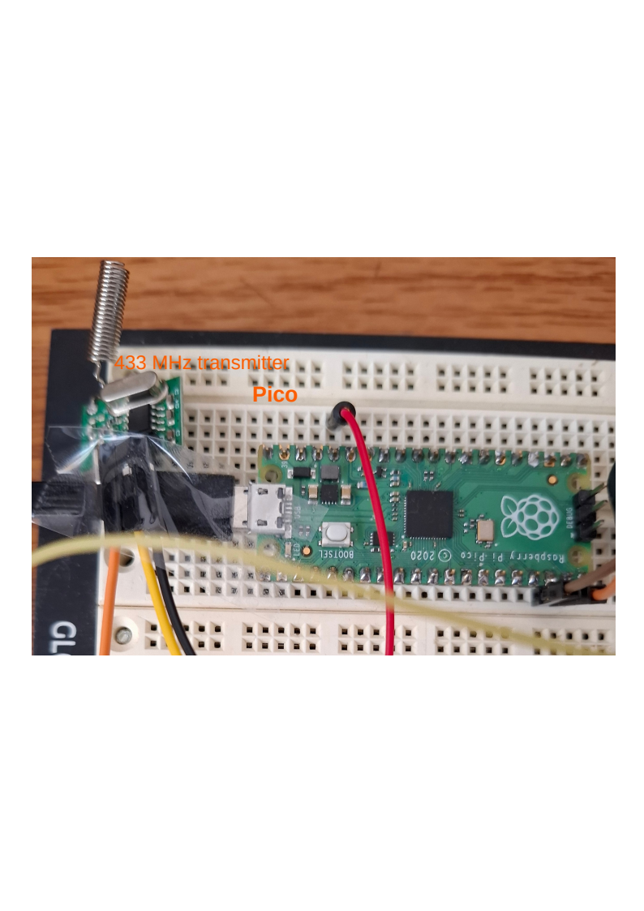

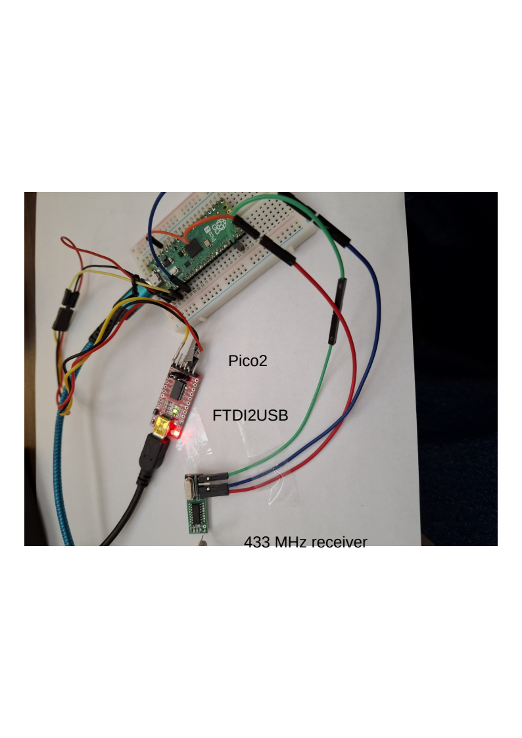

pico2 FTDI2USB 433 MHz receiver

pico transmitter
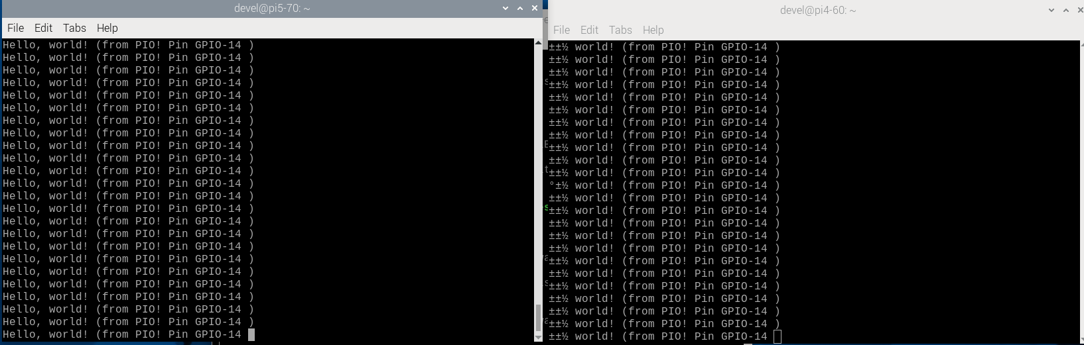
pico2 reciever

