Notes Receiver changes 082126

#define CRC32_INIT ((uint32_t)-1l)
#define DATA_TO_CHECK_LEN 9
#define CRC32_LEN 4
#define TOTAL_LEN (DATA_TO_CHECK_LEN + CRC32_LEN)
static uint8_t src[TOTAL_LEN] = { 0x31, 0x32, 0x33, 0x34, 0x35, 0x36, 0x37, 0x38, 0x39, 0x00, 0x00, 0x00, 0x00 };

static uint8_t src1[TOTAL_LEN] = { 0x39, 0x38, 0x37, 0x36, 0x35, 0x34, 0x33, 0x32, 0x31, 0x00, 0x00, 0x00, 0x00 };
static uint8_t srcR[TOTAL_LEN];
// This uses a standard polynomial with the alternate 'reversed' shift direction.
// It is possible to use a non-reversed algorithm here but the DMA sniff set-up
// below would need to be modified to remain consistent and allow the check to pass.

static uint32_t soft_crc32_block(uint32_t crc, uint8_t *bytp, uint32_t length) {
while(length--) {
uint32_t byte32 = (uint32_t)*bytp++;

for (uint8_t bit = 8; bit; bit--, byte32 >>= 1) {
crc = (crc >> 1) ^ (((crc ^ byte32) & 1ul) ? 0xEDB88320ul : 0ul);
}
}
return crc;
}

while (true) {
if ( invert == false)
{
// Invert the input logic hardware-wide (if using as an input)
gpio_set_inover(PIO_RX_PIN, GPIO_OVERRIDE_INVERT);

invert = true;
}

while (c = uart_rx_program_getc(pio, sm) != 0x2c)
{
}

for(i=0;i < TOTAL_LEN;i++)
{
c = uart_rx_program_getc(pio, sm);

putchar(c);

srcR[i] = c;
}

crc_res = soft_crc32_block(CRC32_INIT, srcR, DATA_TO_CHECK_LEN);
printf("0x%x\n",crc_res);

//9-1 0xfea0fdfe 1-9 0x340bc6d9
// fefda0fe d9c60b34

}

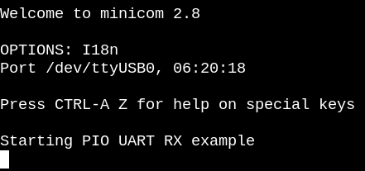
crc32 was generated correctly on incoming data 123456789

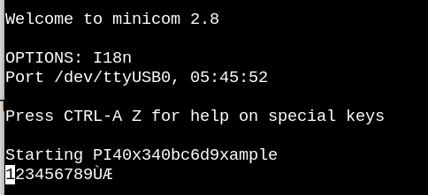

crc32 was generated correctly on incoming data 123456789

