**********************Default**********************
pico-ice-micropython
creating firmware for pico2-ice
creating firmware for picoo-ice
04/24/25
**********************Default**********************

04/24/25 updated main & test-dev branches
Common steps:
Step 1 devel@pi5-90:~ $ git clone https://github.com/develone/pico-ice-micropython.git -b test-dev

Step 2 devel@pi5-90:~ $ cd pico-ice-micropython/

Step 3 devel@pi5-90:~ $ git clone https://github.com/develone/pico-ice-micropython.git -b test-dev

Step 4 devel@pi5-90:~ $ cd pico-ice-micropython/

Step 5 devel@pi5-90:~/pico-ice-micropython $ git submodule update --init lib/micropython
Found at Appendix A mpy-cross

pico2 firmware
devel@pi5-90:~/pico-ice-micropython/boards/PICO_ICE $ mkdir pico2-ice
devel@pi5-90:~/pico-ice-micropython/boards/PICO_ICE $ cd pico2-ice
devel@pi5-90:~/pico-ice-micropython/boards/PICO_ICE/pico2-ice $ mkdir build && cd build
Installing pico2 firmware
While connecting pico2-ice depress switch next to USB
Depress OK
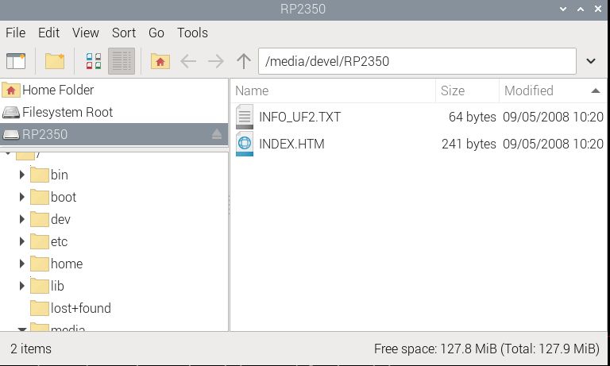
devel@pi5-90:~/master-repos/pico-ice-micropython $ cp ~/master-repos/pico-ice-micropython/pico2-ice-uf2/firmware.uf2 /media/devel/RP2350/
pico2-ice starts blinking Green.
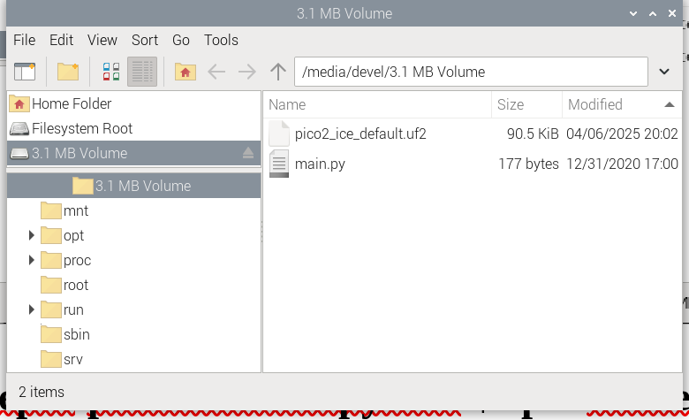

pico firmware
devel@pi5-90:~/pico-ice-micropython/boards/PICO_ICE $ mkdir pico-ice
devel@pi5-90:~/pico-ice-micropython/boards/PICO_ICE $ cd pico-ice
devel@pi5-90:~/pico-ice-micropython/boards/PICO_ICE/pico-ice $ mkdir build && cd build

