**************************Default**************************
MicroPython Pico
11/07/24

**************************Default**************************

Copied “RPI_PICO-20241025-v1.24.0.uf2” to Raspberry Pico.

Created first MicroPython program hello.py

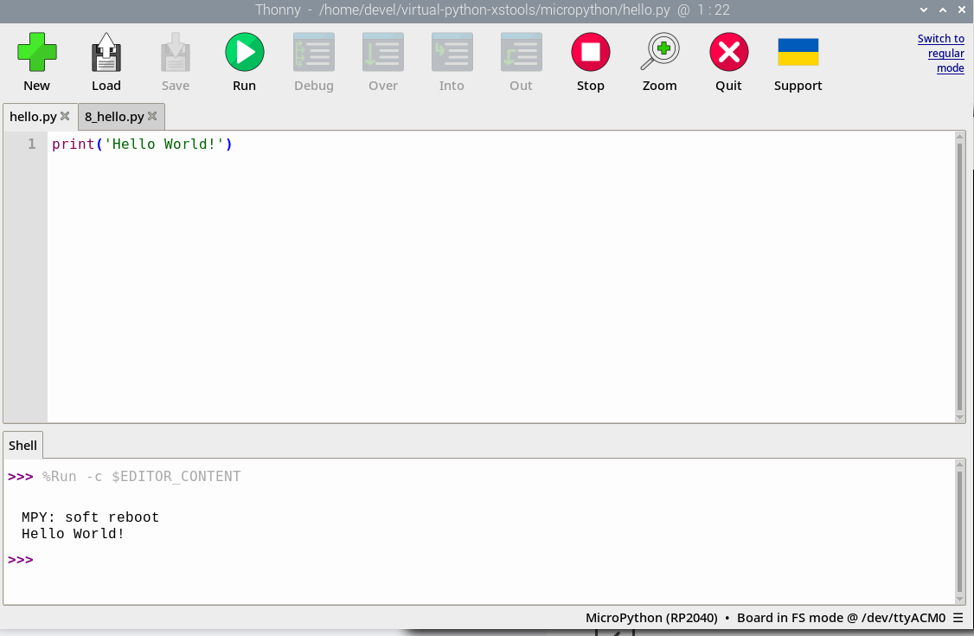
Running MicroPython program hello.py

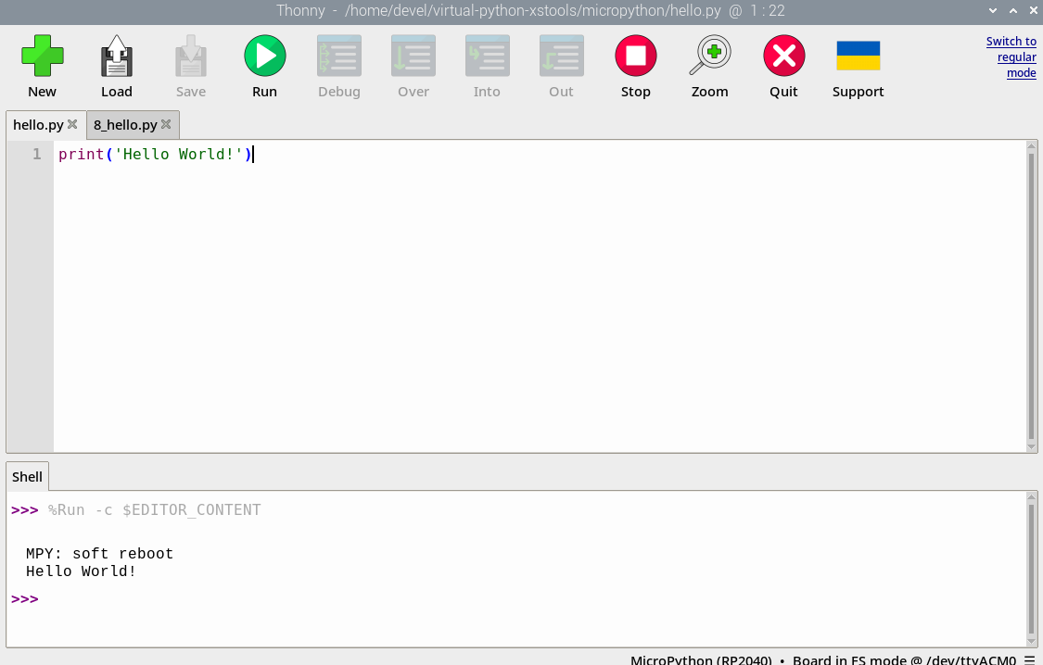
Modified MicroPython program hello.py 8_hello.py.

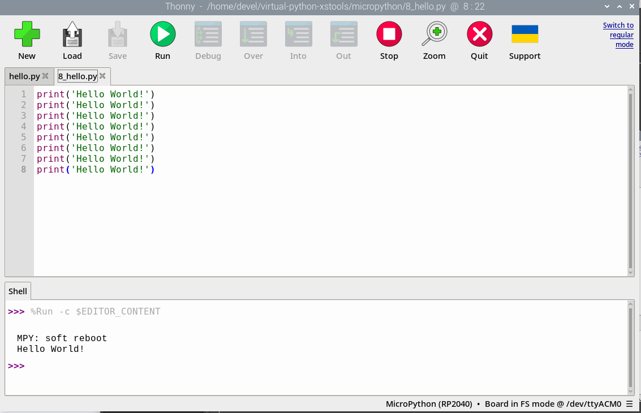
Running MicroPython 8_hello.py

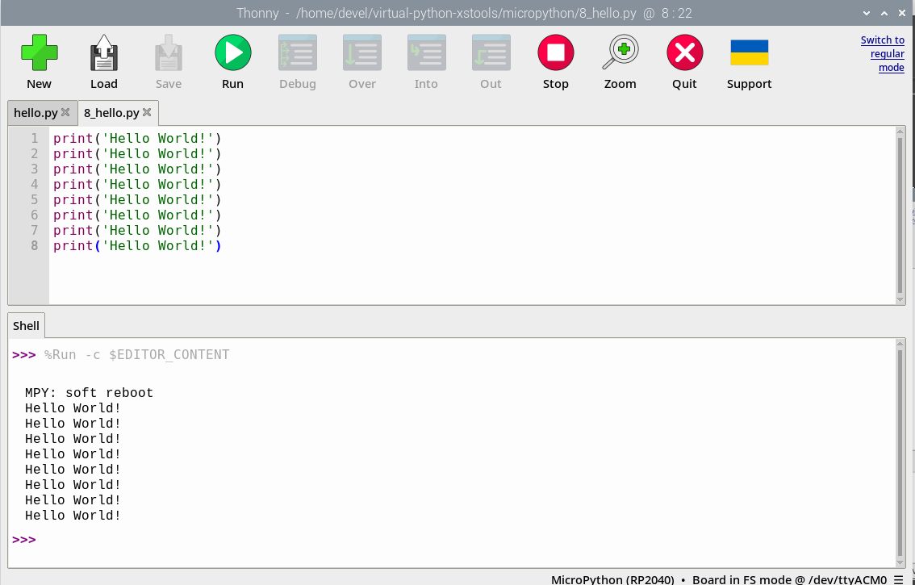
Up to now no imports required.

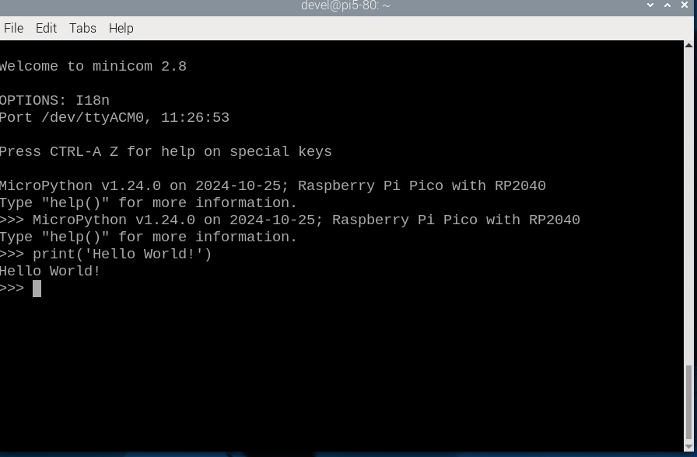

Testing using minicom

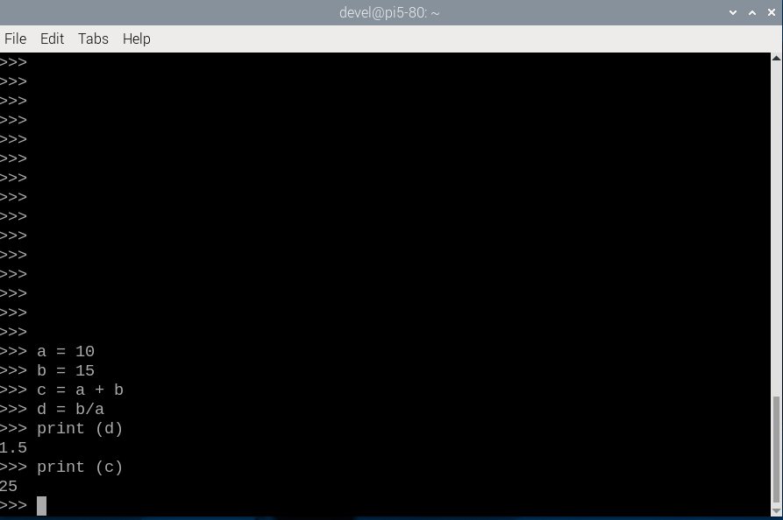

MicroPython variables and simple math.

