****************Defualt****************
Three pmod-ethernet FPGAs
2 pico-ice with pmod-ethernet
1 Catboard with pmod-ethernet
10/29/25
****************Defualt****************

devel@pi5-90:~ $ ssh -Y ubuntu@vps-a35f6ef3

ubuntu@vps-a35f6ef3:~$ . myenv.sh
/home/ubuntu/oss-cad-suite/
/home/ubuntu/PipelineC

Appendix A fixing the compiler Linux vps-a35f6ef3 6.8.0-86-generic #87-Ubuntu SMP PREEMPT_DYNAMIC Mon Sep 22 18:03:36 UTC 2025 x86_64 x86_64 x86_64 GNU/Linux
Programming the Catboard

devel@pi3-28:~/ubuntu-vps-a35f6ef3/PipelineC/backup-A8 $ sudo ~/pmod-a0.b1.c2.d3.e4.f5/config_cat ~/pmod-a0.b1.c2.d3.e4.f5/gateware.bin

Programming the 1st pico-ice
devel@pi3-28:~/ubuntu-vps-a35f6ef3/PipelineC/backup-A8 $ cp ../backup-A9/gateware.uf2 /media/devel/pico-ice/

Programming the 2nd pico-ice
devel@pi3-28:~/ubuntu-vps-a35f6ef3/PipelineC/backup-A8 $ cp gateware.uf2 /media/devel/pico-ice1/

devel@pi3-28:~/ubuntu-vps-a35f6ef3/PipelineC/backup-A8 $ sudo ~/pmod-a0.b1.c2.d3.e4.f5/work_test
CPU threads: 1
n 'work()'s: 1
Total tx bytes: 8
Total rx bytes: 4
CPU took 0.001606 seconds to execute
CPU iteration time: 0.001606 seconds
CPU bytes per sec: 7472.038005 B/s
FPGA took 0.001149 seconds to execute
FPGA iteration time: 0.001149 seconds
FPGA bytes per sec: 10444.417514 B/s
Speedup: 1.397800
devel@pi3-28:~/ubuntu-vps-a35f6ef3/PipelineC/backup-A8 $ sudo ./work_test
CPU threads: 1
n 'work()'s: 1
Total tx bytes: 8
Total rx bytes: 4
CPU took 0.001513 seconds to execute
CPU iteration time: 0.001513 seconds
CPU bytes per sec: 7931.239836 B/s
FPGA took 0.001015 seconds to execute
FPGA iteration time: 0.001015 seconds
FPGA bytes per sec: 11823.267089 B/s
Speedup: 1.490721
devel@pi3-28:~/ubuntu-vps-a35f6ef3/PipelineC/backup-A8 $ sudo ../backup-A9/work_test
CPU threads: 1
n 'work()'s: 1
Total tx bytes: 8
Total rx bytes: 4
CPU took 0.001547 seconds to execute
CPU iteration time: 0.001547 seconds
CPU bytes per sec: 7756.456773 B/s
FPGA took 0.000908 seconds to execute
FPGA iteration time: 0.000908 seconds
FPGA bytes per sec: 13217.344538 B/s
Speedup: 1.704044

Catboard MAC a0:b1:c2:d3:e4:f5

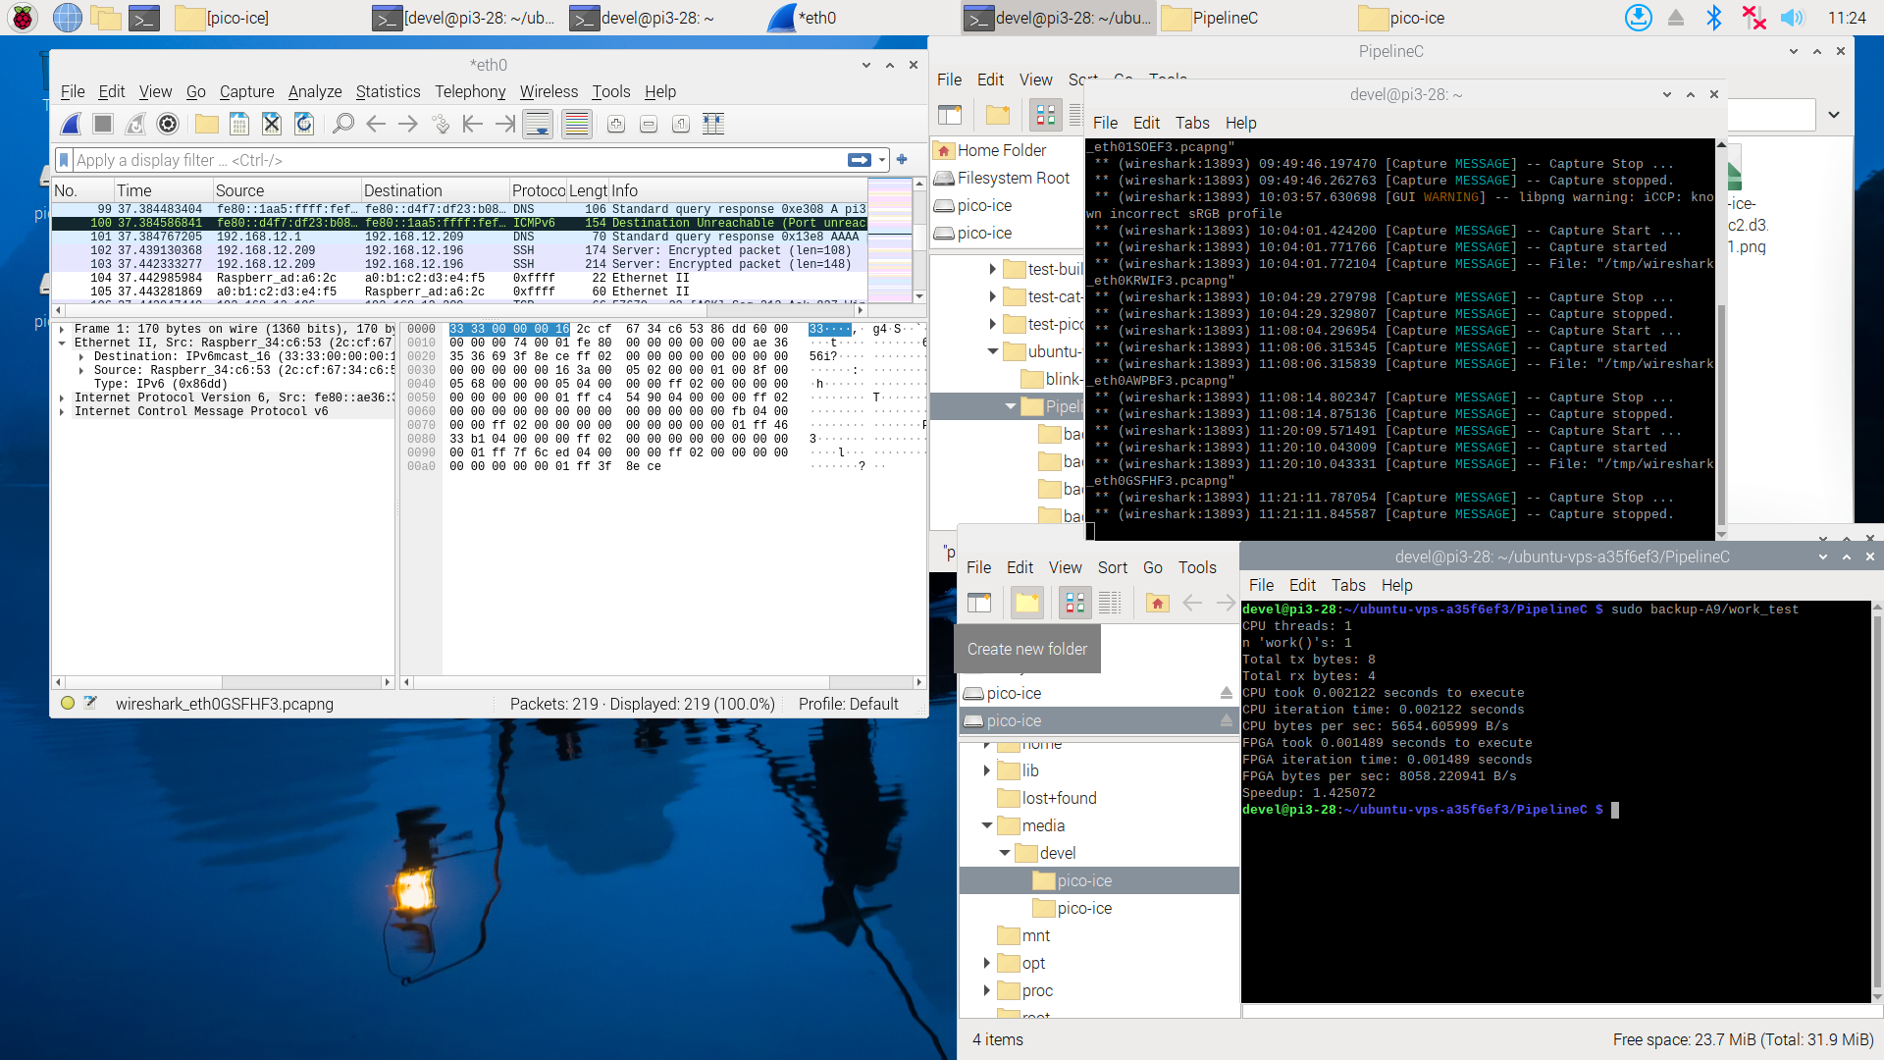
pico-ice MAC a9:b1:c2:d3:e4:f5

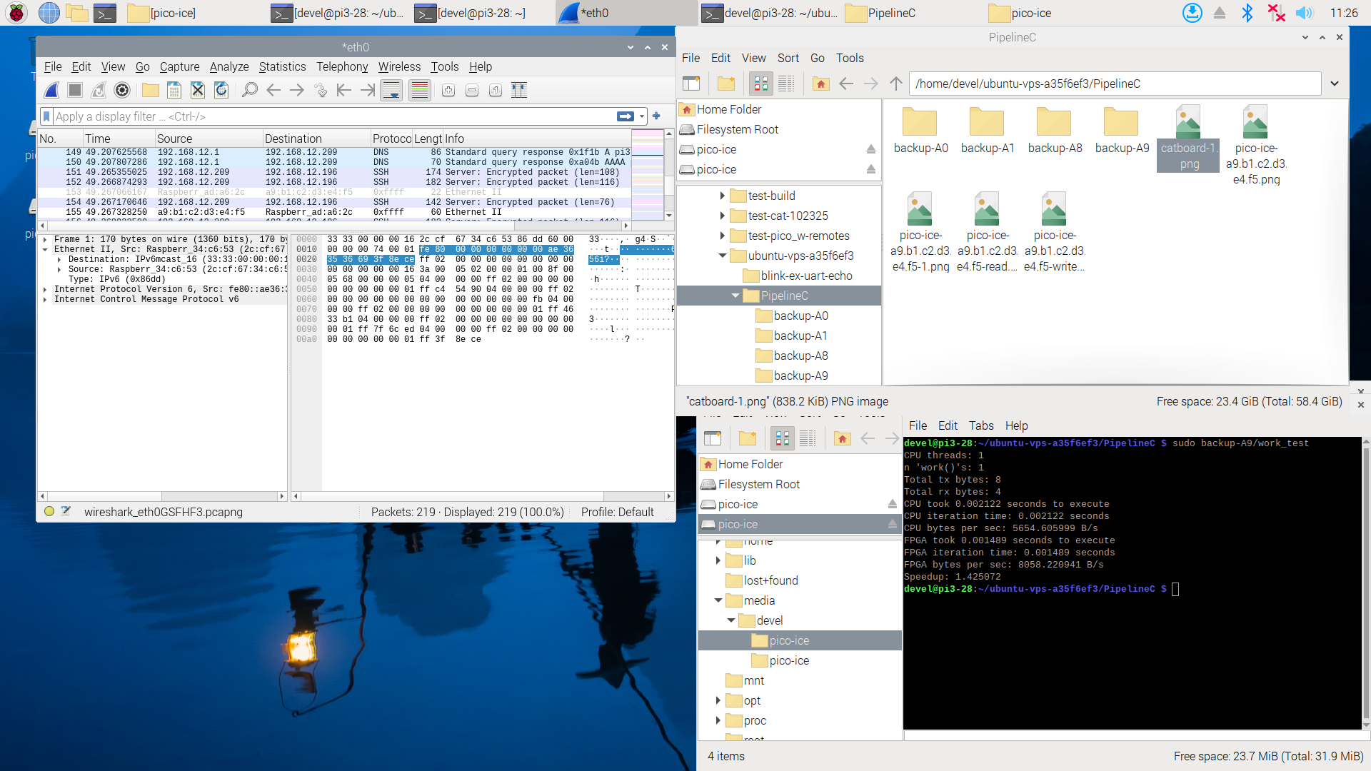
pico-ice MAC a8:b1:c2:d3:e4:f5
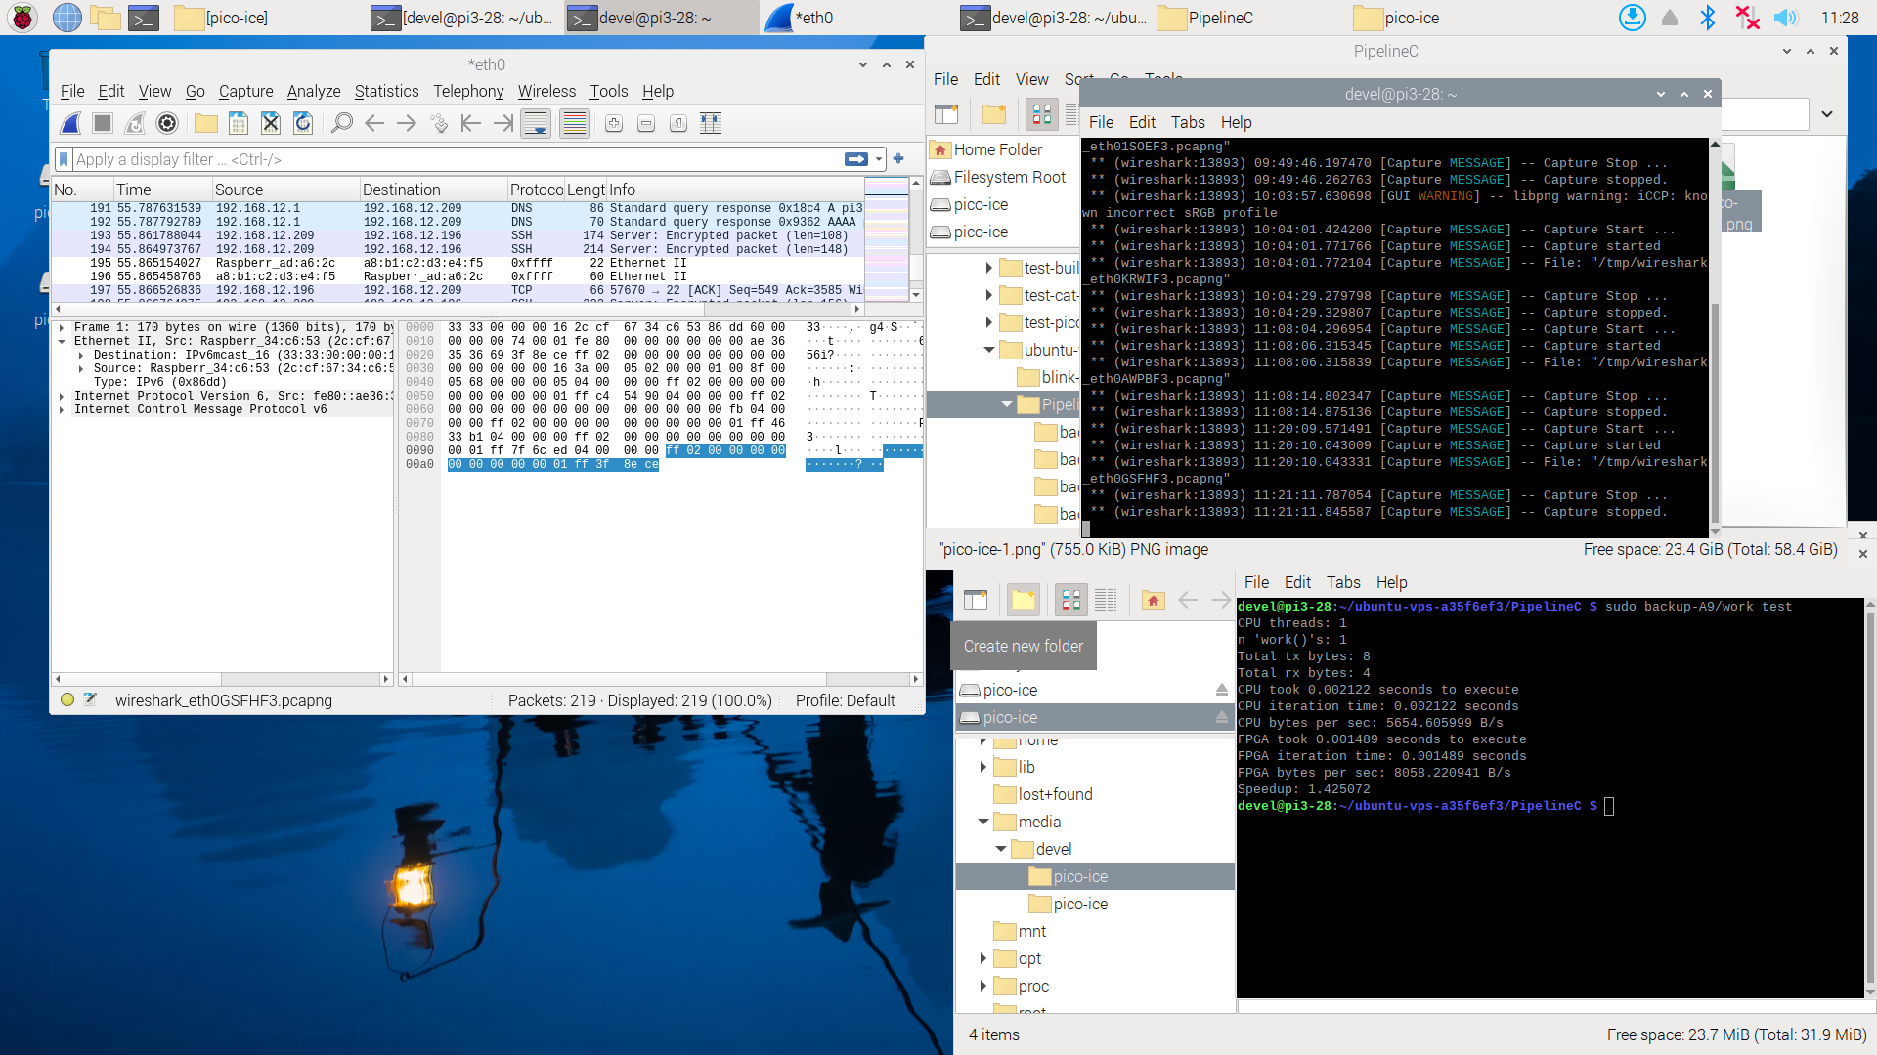
Appendix A fixing the compiler Linux vps-a35f6ef3 6.8.0-86-generic #87-Ubuntu SMP PREEMPT_DYNAMIC Mon Sep 22 18:03:36 UTC 2025 x86_64 x86_64 x86_64 GNU/Linux

10/29/25
how to compile on ubuntu 24.04 for raspberry pi arm64

ubuntu@vps-a35f6ef3:~/PipelineC/examples/net$ sudo apt update

sudo apt install gcc-aarch64-linux-gnu g++-aarch64-linux-gnu

ubuntu@vps-a35f6ef3:~/PipelineC/examples/net$ aarch64-linux-gnu-gcc --version
aarch64-linux-gnu-gcc (Ubuntu 13.3.0-6ubuntu2~24.04) 13.3.0
Copyright (C) 2023 Free Software Foundation, Inc.
This is free software; see the source for copying conditions. There is NO
warranty; not even for MERCHANTABILITY or FITNESS FOR A PARTICULAR PURPOSE.

#!/bin/bash
aarch64-linux-gnu-gcc -I ../../include -I ../pico-ice/ice_makefile_pipelinec/pipelinec_output -Wall -pthread work_test.c -o work_test

ubuntu@vps-a35f6ef3:~/pico-ice/PipelineC/pmod-ethernet/examples/net$ ./compile-work_test.sh

devel@pi3-28:~/ubuntu-vps-a35f6ef3/PipelineC $ scp ubuntu@vps-a35f6ef3:/home/ubuntu/pico-ice/PipelineC/pmod-ethernet/examples/net/work_test .

devel@pi3-28:~/ubuntu-vps-a35f6ef3/PipelineC $ sudo ./work_test
CPU threads: 1
n 'work()'s: 1
Total tx bytes: 8
Total rx bytes: 4
CPU took 0.002190 seconds to execute
CPU iteration time: 0.002190 seconds
CPU bytes per sec: 5479.765705 B/s
FPGA took 0.001072 seconds to execute
FPGA iteration time: 0.001072 seconds
FPGA bytes per sec: 11194.761566 B/s
Speedup: 2.042927

efile_pipelinec$ git diff ../../net/compile-work_test.sh
diff --git a/PipelineC/pmod-ethernet/examples/net/compile-work_test.sh b/PipelineC/pmod-ethernet/examples/net/compile-work_test.sh
index 7ad3ed4..dc3dbf0 100755
--- a/PipelineC/pmod-ethernet/examples/net/compile-work_test.sh
+++ b/PipelineC/pmod-ethernet/examples/net/compile-work_test.sh
@@ -1,3 +1,3 @@
#!/bin/bash
-gcc -I ../../include -I ../pico-ice/ice_makefile_pipelinec/pipelinec_output -Wall -pthread work_test.c -o work_test
+aarch64-linux-gnu-gcc -I ../../include -I ../pico-ice/ice_makefile_pipelinec/pipelinec_output -Wall -pthread work_test.c -o work_test

