****************Default****************
MicroPython Pico-Ice nanoV
11/10/24
****************Default****************
Running in a virtual environment on Raspberry Pi 5.
“cd virtual-python-xstools”
“. virtp.sh”
“cd micropython/nanoV”
Connect to rp2040 of the pico-ice which has the firmware.uf2 running MicroPython.

MicroPython remote control: mpremote

The mpremote command line tool provides an integrated set of utilities to remotely interact with, manage the filesystem on, and automate a MicroPython device over a serial connection.

“mpremote connect /dev/ttyACM0 + mount .”

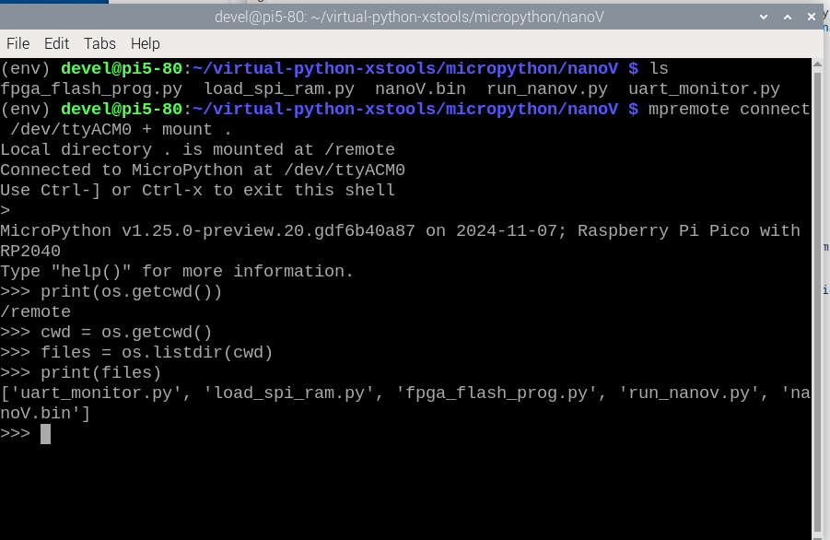
At the prompt execute “import fpga_flash_prog” which will read the file “nanoV.bin” and program the iCE40UP5K of the pico-ice.

