*************************Default*************************
pico-ice documentation
tinyvision.ai
08/03/24
*************************Default*************************
The following links were provided by josuah when I created an issue at pico-ice.

Missing files at repo or did get moved? #49

HTML documentation is generated from here:
https://pico-ice.tinyvision.ai/modules.html

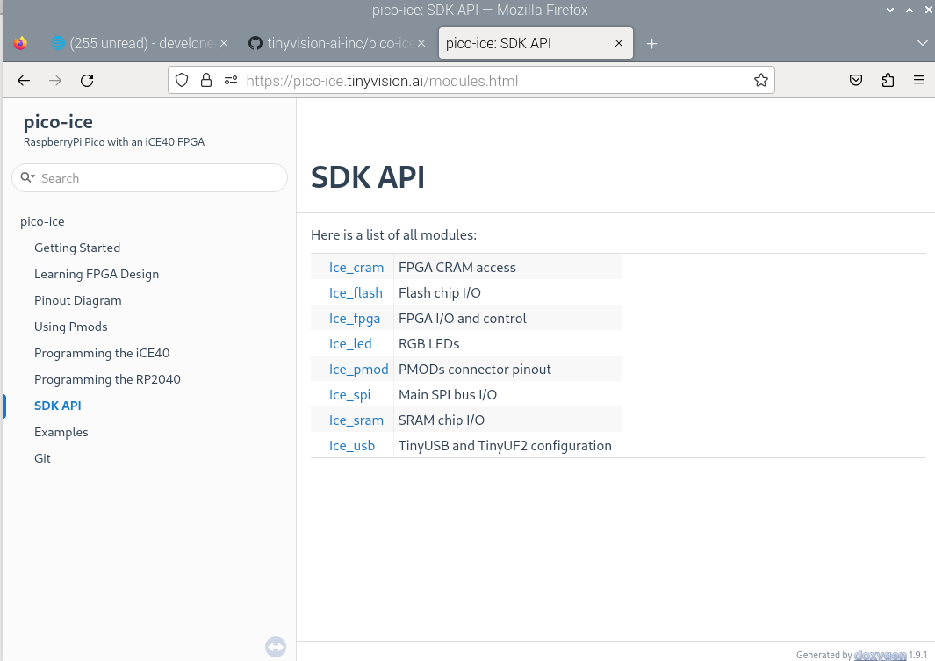
ice_[...].md files
https://github.com/tinyvision-ai-inc/pico-ice-sdk/tree/main/include

This issue pico-ice-sdk

Which ice40.pcf is correct pico-ice-sdk/examples/ice_makefile_iverilog/ice40.pcf or pico-ice-sdk/examples/ice_makefile_verilator/ice40.pcf?

It is possible that the firmware you receive on the pico-ice is not the latest one.
There are occasionally bugfixes published and a good precaution would be to download the latest release as soon as receiving the board, or indicate anyone using them to do so, in order to avoid confusing bugs that are already fixed:
https://github.com/tinyvision-ai-inc/pico-ice/releases/latest

