***********************Draft***********************
Creating a New PMOD Ethernet
for pico-ice & catboard
Starting with lifting step of Images
Using 8X8 Blocks

03/14/25
***********************Draft***********************

One question that needs to be answered is what is the optimal block size?
The first step is divide the image in

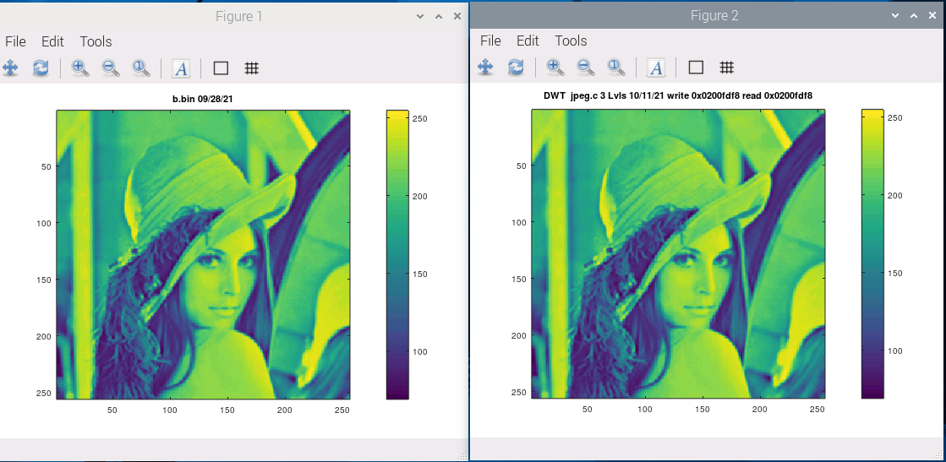
The default should be 3 lvls of decomposition
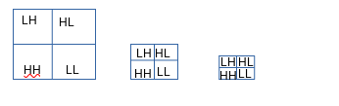
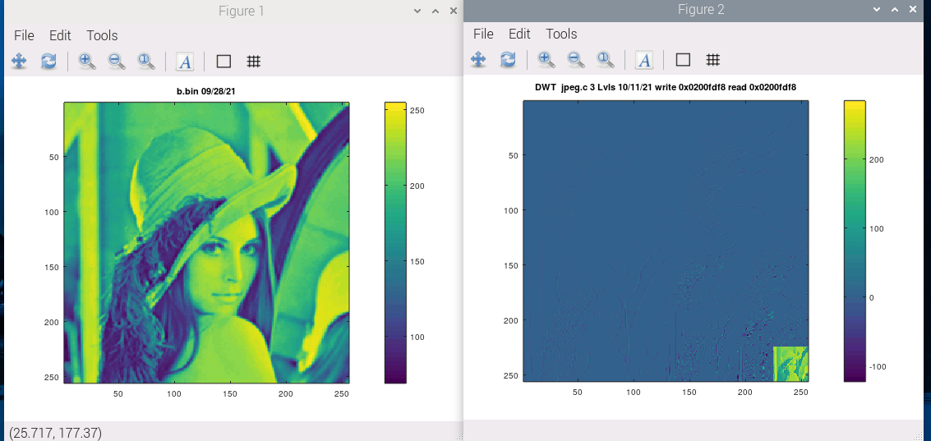

The pico-ice could have a 2nd pmod-ethernet this would require 2 different MAC address.

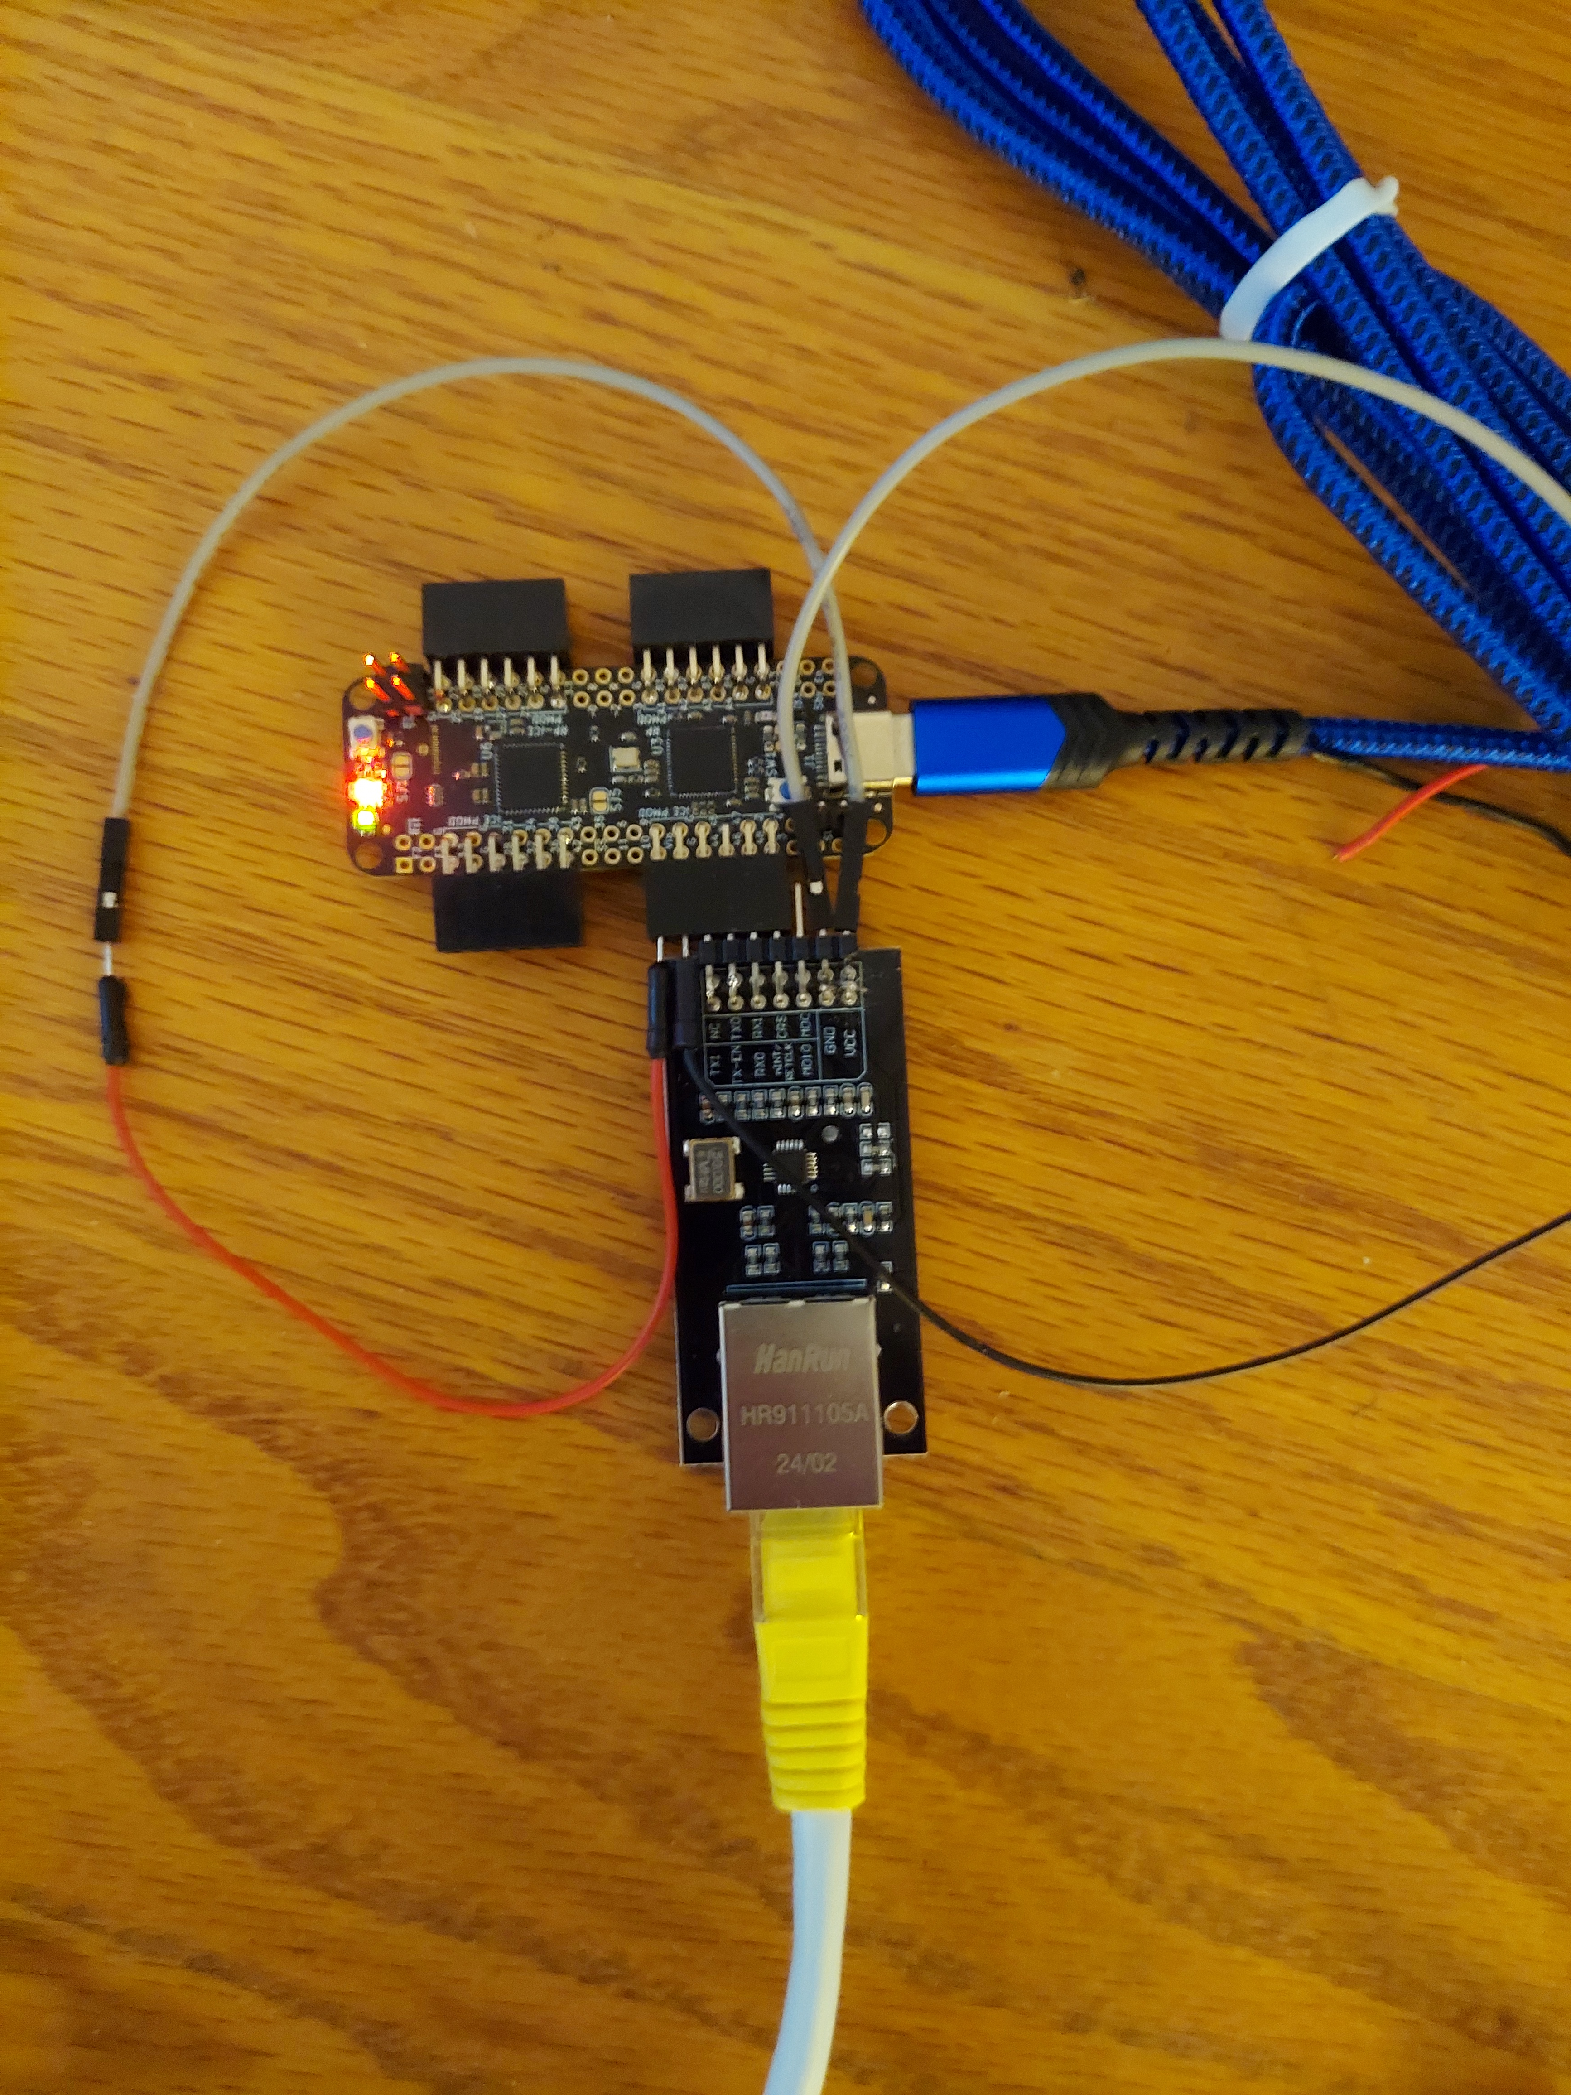
Current pi_jpeg.c Works on an entire image 256x256 RGB

devel@pi5-90:~/102121icozip/sw/board $ ./buildpi_lift.sh
#/bin/bash
rm -f ../host/pi_jpeg lifting.o pi_jpeg.o
gcc -g -c lifting.c -o lifting.o
gcc -g -c pi_jpeg.c -o pi_jpeg.o
gcc -g pi_jpeg.o lifting.o -o ../host/pi_jpeg

line 183 const int LVLS = 1; controls the level of decomposition.
devel@pi5-90:~/102121icozip/sw/host $ ./pi_jpeg 0 1 Red
devel@pi5-90:~/102121icozip/sw/host $ ./pi_jpeg 1 1 Green
devel@pi5-90:~/102121icozip/sw/host $ ./pi_jpeg 2 1 Blue

https://github.com/develone/102121icozip/tree/catzip/sw/board
rgb.m creates the figures below.

The C pi_jpeg.c found Appendix A. Appendix B. lifting.c

Red
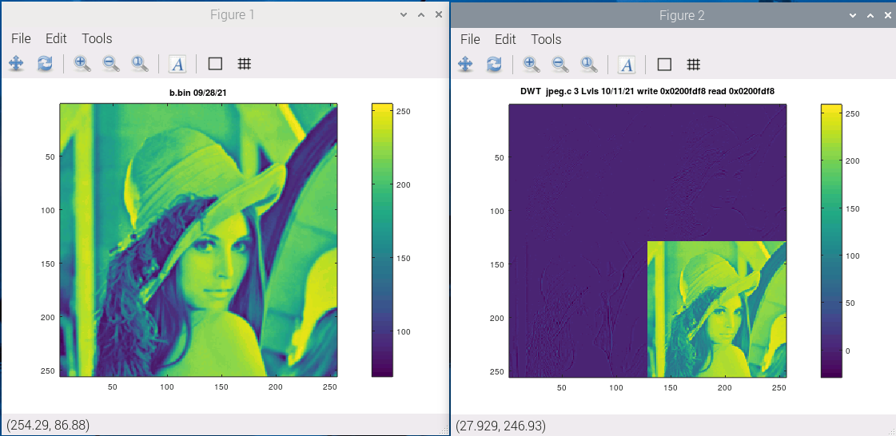
Green

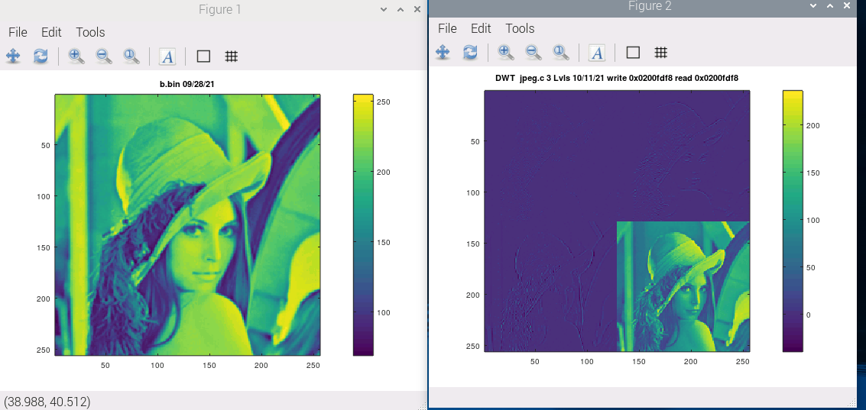
Blu
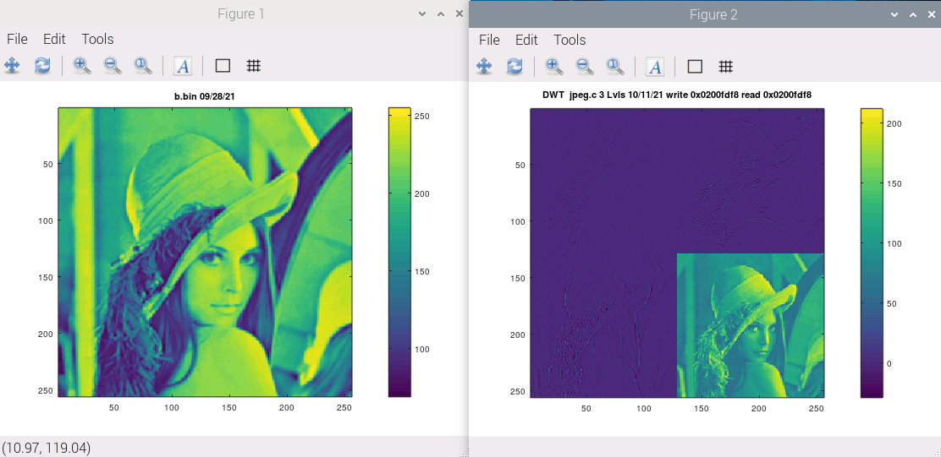
At a glance it didn't seem like a lot of VHDL inside jpeg.vhd?
Is that all of the code from myHDL or is there more?

Very likely can rewrite that in pipelinec in a few minutes

```vhdl
if bool(lo_hi_s) then
if bool(fwd_inv_s) then
res_s <= (sam_s - (shift_right(left_s, 1) + shift_right(right_s, 1)));
else
res_s <= (sam_s + (shift_right(left_s, 1) + shift_right(right_s, 1)));
end if;
else
if bool(fwd_inv_s) then
res_s <= (sam_s + shift_right(((left_s + right_s) + 2), 2));
else
res_s <= (sam_s - shift_right(((left_s + right_s) + 2), 2));
end if;
end if;
```

What you would want to do is define an input struct that rounds things to byte sized types for sharing data with software (notice lo_hi flag is u8, etc)
work_inputs_t
int16_t left,
int16_t right,
int16_t sam,
uint8_t lo_hi,
uint8_t fwd_inv

work_outputs_t
int16_t res;

work_outputs_t work(work_inputs_t) and fill in work() like JPEG_HDL from above

Appendix A pi_jpeg.c

#include <stdio.h>
#include <stdlib.h>
#include <string.h>
#include "lifting.h"
/* First parameter is used to tell the program which sub band to use
* 0 Red
* 1 Green
* 2 Blue
* 2nd parameter is used to tell the program to compute the fwd lifting step only or fwd lifting then inv lifting step
* 0 fwd lifting then inv lifting step
* 1 fwd lifting step only
* ./pi_jpeg 0 1 or ./pi_jpeg 0 0
* ./pi_jpeg 1 1 or ./pi_jpeg 1 0
* ./pi_jpeg 2 1 or ./pi_jpeg 2 0
*/
struct PTRs {
int inpbuf[65536];

int flag;
int w;
int h;

int *red;

int *grn;
int *blu;
int *alt;
//int *fwd_inv;
} ptrs;

int main(int argc, char **argv) {

FILE *inptr,*outptr;
char *ch;
int tmp,loop;

int *red_s_ptr, *gr_s_ptr, *bl_s_ptr;
int *wptr,*wptr1,*wptr2;
int *alt,*alt1,*alt2;

int *buf_red, *buf_gr, *buf_bl;
int ur,ug,ub,x,y,z;
int *fwd_inv;

int i,j;

ptrs.w = 256;
ptrs.h = 256;

buf_red = ( int *)malloc(sizeof( int)* ptrs.w*ptrs.h*2);
red_s_ptr = buf_red;

fwd_inv = (int *)malloc(1);

if(buf_red == NULL) return 2;

if(fwd_inv == NULL) return 5;
red_s_ptr = buf_red;
printf("buf_red = 0x%x\n",buf_red);

printf("fwd_inv = 0x%x\n",fwd_inv);
/*The file rgb_pack.bin contains the rgb images
* packed in bits red 29-20
* packed in bits grn 19-10
* packed in bits blu 9-0
*/

loop = 65536;
for(i=0;i<loop;i++) buf_red[i]=ptrs.inpbuf[i];
ch = argv[1];
tmp = atoi(ch);
if (tmp == 0) {
printf("spliting red sub band\n");
ptrs.flag = tmp;
inptr = fopen("r.bin","rb");
if (!inptr)
{
printf("Unle to open file!");
return 1;
}
else fread(ptrs.inpbuf,sizeof(int),65536,inptr);

fclose(inptr);

}
else if (tmp == 1) {
printf("spliting green sub band\n");
ptrs.flag = tmp;
inptr = fopen("g.bin","rb");
if (!inptr)
{
printf("Unle to open file!");
return 1;
}
else fread(ptrs.inpbuf,sizeof(int),65536,inptr);

fclose(inptr);

}
else if (tmp == 2) {
printf("spliting blue sub band\n");
ptrs.flag = tmp;
inptr = fopen("b.bin","rb");
if (!inptr)
{
printf("Unle to open file!");
return 1;
}
else fread(ptrs.inpbuf,sizeof(int),65536,inptr);

fclose(inptr);

}
else {
printf("First parameter can only be 0 1 2 \n");
free(buf_red);
free(fwd_inv);
exit (1);
}
for(i=0;i<loop;i++) buf_red[i]=ptrs.inpbuf[i];
ch = argv[2];
tmp = atoi(ch);

if (tmp == 0) {
printf("fwd lifting then inv lifting step\n");
*fwd_inv = tmp;
}
else if (tmp == 1) {
printf("fwd lifting step only\n");
*fwd_inv = tmp;
} else
{
printf("2nd parameter can only be 0 1 \n");
free(buf_red);
free(fwd_inv);
exit (2);
}

buf_red = red_s_ptr;
wptr = buf_red;
alt = &buf_red[ptrs.w*ptrs.h];
printf("w = 0x%x buf_red wptr = 0x%x alt = 0x%x fwd_inverse = 0x%x fwd_inverse = 0x%x \n",ptrs.w, wptr,alt,fwd_inv,*fwd_inv);
printf("starting red dwt\n");

lifting(ptrs.w,wptr,alt,fwd_inv);
printf("finished ted dwt\n");
//pack(ptrs.flag, i,buf_red, ptrs.inpbuf);

outptr = fopen("dwt.bin","wb");
if (!outptr)
{
printf("Unle to open file!");
return 1;
}
fwrite(buf_red,sizeof( int),65536,outptr);
//fwrite(alt,sizeof( int),65536,outptr);
fclose(outptr);

free(buf_red);
free(fwd_inv);

return 0;

}

Appendix B. lifting.c

////////////////////////////////////////////////////////////////////////////////
//
// Filename: lifting.c
//
// Project: XuLA2-LX25 SoC based upon the ZipCPU
//
// Purpose: This goal of this file is to perform, on either the ZipCPU or
// a more traditional architecture, the lifting/WVT step of the
// JPEG-2000 compression (and decompression) scheme.
//
// Currently, the lifting scheme performs both forward and inverse
// transforms, and so (if done properly) it constitutes an identity
// transformation.
//
// Creator: Dan Gisselquist, Ph.D.
// Gisselquist Technology, LLC
//
////////////////////////////////////////////////////////////////////////////////
//
// Copyright (C) 2015-2016, Gisselquist Technology, LLC
//
// This program is free software (firmware): you can redistribute it and/or
// modify it under the terms of the GNU General Public License as published
// by the Free Software Foundation, either version 3 of the License, or (at
// your option) any later version.
//
// This program is distributed in the hope that it will be useful, but WITHOUT
// ANY WARRANTY; without even the implied warranty of MERCHANTIBILITY or
// FITNESS FOR A PARTICULAR PURPOSE. See the GNU General Public License
// for more details.
//
// You should have received a copy of the GNU General Public License along
// with this program. (It's in the $(ROOT)/doc directory, run make with no
// target there if the PDF file isn't present.) If not, see
// <http://www.gnu.org/licenses/> for a copy.
//
// License: GPL, v3, as defined and found on www.gnu.org,
// http://www.gnu.org/licenses/gpl.html
//
//
////////////////////////////////////////////////////////////////////////////////
//
//
#include "lifting.h"
#include <stdio.h>
void singlelift(int rb, int w, int * const ibuf, int * const obuf) {
int col, row;
//printf("in singlelift \n");
for(row=0; row<w; row++) {
register int *ip, *op, *opb;
register int ap,b,cp,d;

//
// Ibuf walks down rows (here), but reads across columns (below)
// We might manage to get rid of the multiply by doing something
// like:
// ip = ip + (rb-w);
// but we'll keep it this way for now.
//
//setting to beginning of each row
ip = ibuf+row*rb;

//
// Obuf walks across columns (here), writing down rows (below)
//
// Here again, we might be able to get rid of the multiply,
// but let's get some confidence as written first.
//
op = obuf+row;
opb = op + w*rb/2;
printf("ip = 0x%x op = 0x%x opb = 0x%x\n",ip,op,opb);
//
// Pre-charge our pipeline
//

// a,b,c,d,e ...
// Evens get updated first, via the highpass filter
ap = ip[0];
b = ip[1];
cp = ip[2];
d = ip[3]; ip += 4;
printf("ap = %d b = %d cp = %d d = %d\n",ap,b,cp,d);
//
ap = ap-b; // img[0]-(img[1]+img[-1])>>1)
cp = cp- ((b+d)>>1);

op[0] = ap;
opb[0] = b+((ap+cp+2)>>2);

for(col=1; col<w/2-1; col++) {
op +=rb; // = obuf+row+rb*col = obuf[col][row]
opb+=rb;// = obuf+row+rb*(col+w/2) = obuf[col+w/2][row]
ap = cp;
b = d;
cp = ip[0]; // = ip[row][2*col+1]
d = ip[1]; // = ip[row][2*col+2]

//HP filter in fwd dwt
cp = (cp-((b+d)>>1)); //op[0] is obuf[col][row]
*op = ap; //op[0] is obuf[col][row]

//LP filter in fwd dwt
*opb = b+((ap+cp+2)>>2);
ip+=2; // = ibuf + (row*rb)+2*col
}

op += rb; opb += rb;
*op = cp;
*opb = d+((cp+1)>>3);
}
}

void ilift(int rb, int w, int * const ibuf, int * const obuf) {
int col, row;

for(row=0; row<w; row++) {
register int *ip, *ipb, *op;
register int b,c,d,e;

//
// Ibuf walks down rows (here), but reads across columns (below)
// We might manage to get rid of the multiply by doing something
// like:
// ip = ip + (rb-w);
// but we'll keep it this way for now.
//
//setting to beginning of each row
op = obuf+row*rb;

//
// Obuf walks across columns (here), writing down rows (below)
//
// Here again, we might be able to get rid of the multiply,
// but let's get some confidence as written first.
//
ip = ibuf+row;
ipb = ip + w*rb/2;
printf("ip = 0x%x op = 0x%x ipb = 0x%x\n",ip,op,ipb);
//
// Pre-charge our pipeline
//
*****************************************
// a,b,c,d,e ...
// Evens get updated first, via the highpass filter
c = ip[0]; // would've been called 'a'
ip += rb;
e = ip[0]; // Would've been called 'c'
d = ipb[0] -((c+e+2)>>2);

op[0] = c+d; // Here's the mirror, left-side
op[1] = d;
printf("c = %d e = %d d = %d c+d = %d\n",c,e,c,c+d);
for(col=1; col<w/2-1; col++) {
op += 2;
ip += rb; ipb += rb;

c = e; b = d;
e = ip[0];
d = ipb[0] - ((c+e+2)>>2);
c = c + ((b+d)>>1);

op[0] = c;
op[1] = d;
}

ipb += rb;
d = ipb[0] - ((e+1)>>3);

c = e + ((b+d)>>1);
op[2] = c;
op[3] = d; // Mirror
}
}

void lifting(int w, int *ibuf, int *tmpbuf, int *fwd) {
const int rb = w;
int lvl;

int *ip = ibuf, *tp = tmpbuf, *test_fwd = fwd;
printf("ip = 0x%x tp = 0x%x \n",ip,tp);
int ov[3];

const int LVLS = 1;

/*
for(lvl=0; lvl<w*w; lvl++)
ibuf[lvl] = 0;
for(lvl=0; lvl<w*w; lvl++)
tmpbuf[lvl] = 5000;

for(lvl=0; lvl<w; lvl++)
ibuf[lvl*(rb+1)] = 20;

singlelift(rb,w,ip,tp);
for(lvl=0; lvl<w*w; lvl++)
ibuf[lvl] = tmpbuf[lvl];

return;
*/

for(lvl=0; lvl<LVLS; lvl++) {
// Process columns -- leave result in tmpbuf
//printf("in lifting \n");
singlelift(rb, w, ip, tp);
// Process columns, what used to be the rows from the last
// round, pulling the data from tmpbuf and moving it back
// to ibuf.
printf("w = 0x%x ip = 0x%x tp = 0x%x \n",w,ip,tp);
singlelift(rb, w, tp, ip);
//printf("back from singlelift\n");
// lower_upper
//
// For this, we just adjust our pointer(s) so that the "image"
// we are processing, as referenced by our two pointers, now
// references the bottom right part of the image.
//
// Of course, we haven't really changed the dimensions of the
// image. It started out rb * rb in size, or the initial w*w,
// we're just changing where our pointer into the image is.
// Rows remain rb long. We pretend (above) that this new image
// is w*w, or should I say (w/2)*(w/2), but really we're just
// picking a new starting coordinate and it remains rb*rb.
//
// Still, this makes a subimage, within our image, containing
// the low order results of our processing.
int offset = w*rb/2+w/2;
ip = &ip[offset];
tp = &tp[offset];
ov[lvl] = offset + ((lvl)?(ov[lvl-1]):0);

// Move to the corner, and repeat
w>>=1;
}
//printf("testing test_fwd \n");
if (test_fwd[0]==0) {
for(lvl=(LVLS-1); lvl>=0; lvl--) {
int offset;

w <<= 1;

if (lvl)
offset = ov[lvl-1];
else
offset = 0;
ip = &ibuf[offset];
tp = &tmpbuf[offset];
printf("ip = 0x%x tp = 0x%x \n",ip,tp);

ilift(rb, w, ip, tp);
//printf("back from ilift\n");
ilift(rb, w, tp, ip);
//printf("back from ilift\n");
}
}
}

