****************Default****************
MicroPython Pico-Ice tinyQV or nanoV
sharing files between the Raspberry Pi 5 and rp2040 of the pico-ice
2 method of programimport fpga_
execfi(“fpga_flash_prog.py)
flash_progming the iCE40UP5K

Using mpremote
11/10/24
****************Default****************

tinyQV TT06 or nanoV TT04

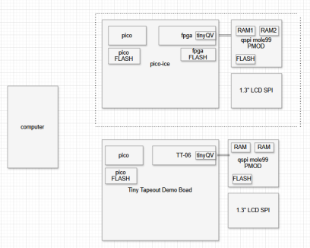
The computer in the figure above is a Raspberry Pi 5.
The pico in the figure above is rp2040 on the pico-ice module.

Running in a virtual environment on Raspberry Pi 5.
“cd virtual-python-xstools”
“. virtp.sh”
“cd micropython/nanoV”
Connect to rp2040 of the pico-ice which has the firmware.uf2 running MicroPython.

MicroPython remote control: mpremote
tree
.
├── flash_prog.py
├── fpga_flash_prog.py
├── prog_fpga.py
├── run_tinyqv.py
├── test_psram.py
├── test_qspi_pmod.py
├── test_qspi_read.py
└── tinyqv.bin

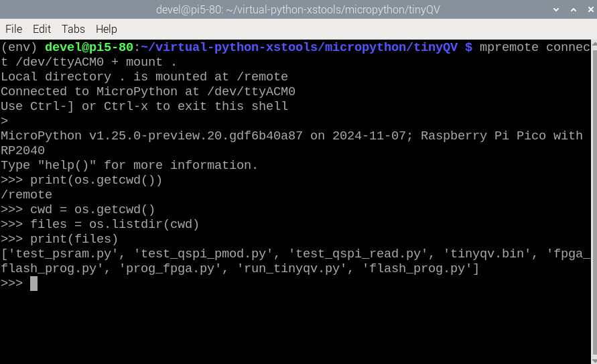
xxxxx

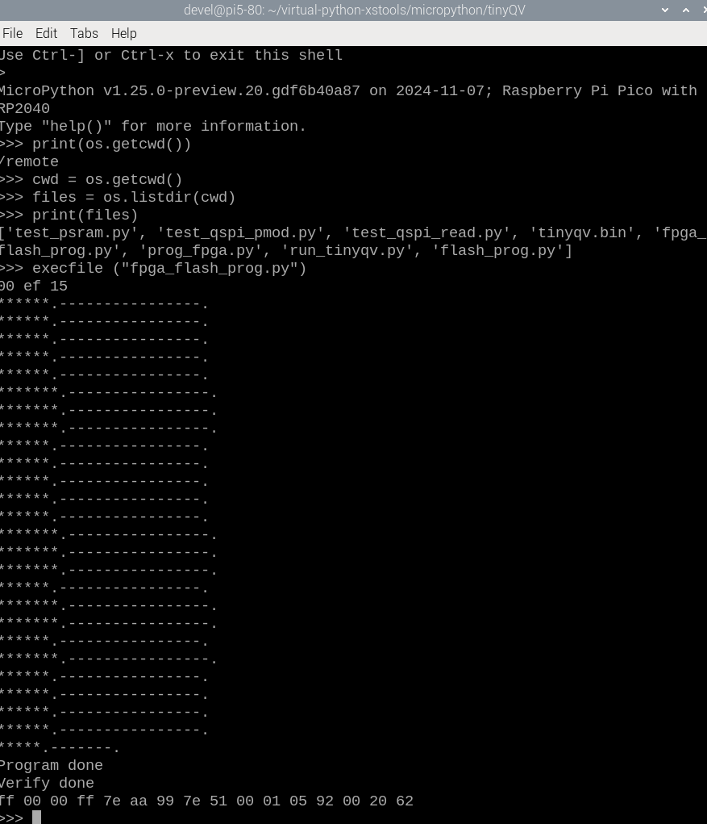
The mpremote command line tool provides an integrated set of utilities to remotely interact with, manage the filesystem on, and automate a MicroPython device over a serial connection.

“mpremote connect /dev/ttyACM0 + mount .”

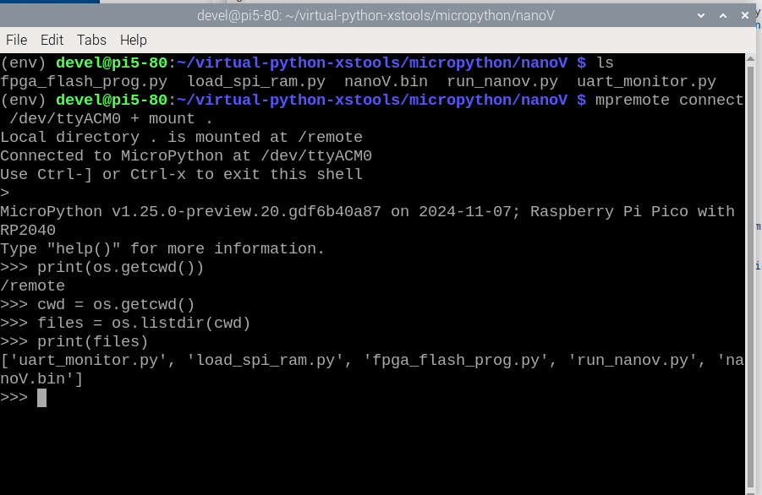
The computer in the figure below is the Raspberry Pi5 which
(env) devel@pi5-80:~/virtual-python-xstools/micropython/nanoV $ tree
.
├── fpga_flash_prog.py
├── load_spi_ram.py
├── nanoV.bin
├── run_nanov.py
└── uart_monitor.py

1 directory, 5 files

tinyQV or nanoV

I use standard Pico Micropython on the RP2040, and then `fpga_flash_prog.py` to program the ICE40 (supplying the `.bin` built by yosys and nextpnr).

At the prompt execute “import fpga_flash_prog” which will read the file “nanoV.bin” and program the iCE40UP5K fpga flash of the pico-ice in the figue above.

