*************************Default*************************
pico-ice with Digilent PmodVGA program using PipelineC
oss-cad-suite
ghdl
ghdl-yosys-plugin
Raspberry Pi5 8Gb
blue blinky led
uart-echo
12/06/24
*************************Default*************************

git clone https://github.com/develone/PipelineC.git -b test-dev.

Note: The oss-cad-suite for arm does not include ghdl & ghdl-yosys-plugin.

Download from https://github.com/YosysHQ/oss-cad-suite-build/releases/
oss-cad-suite-linux-arm64-20241128.tgz
export PATH="/home/devel/oss-cad-suite/bin:$PATH"

git clone https://github.com/ghdl/ghdl
cd ghdl
./configure --with-llvm-config
make
sudo make install
git clone https://github.com/ghdl/ghdl-yosys-plugin.git
cd ghdl-yosys-plugin
make
sudo make install

export PIPELINEC_REPO="$HOME/PipelineC"
devel@pi5-80:~/pico-ice/PipelineC/vga-pll/ice_makefile_pipelinec $
make pipelinec
make gateware.bin
bin2uf2 -o gateware.uf2 gateware.bin
co gateware.uf2 /media/devel/pico-ice
picocom-0.sh
#!/bin/bash
~/picocom/picocom --baud 115200 --imap crcrlf,lfcrlf /dev/ttyACM1

Depress Execute in Terminal
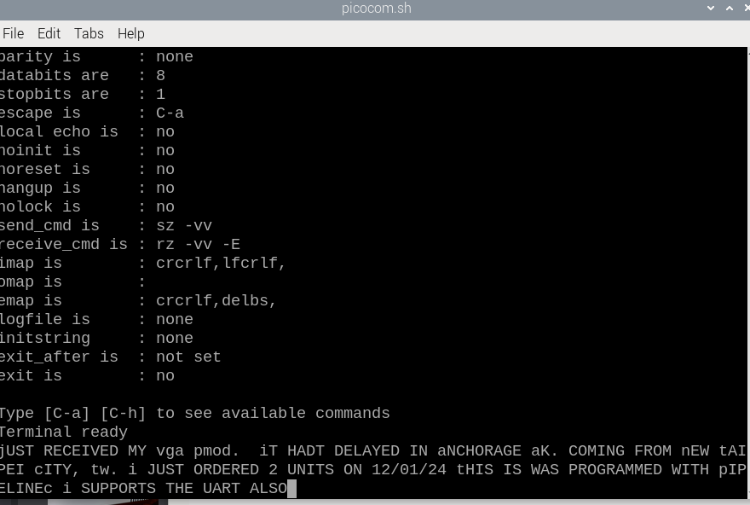

Uart echo

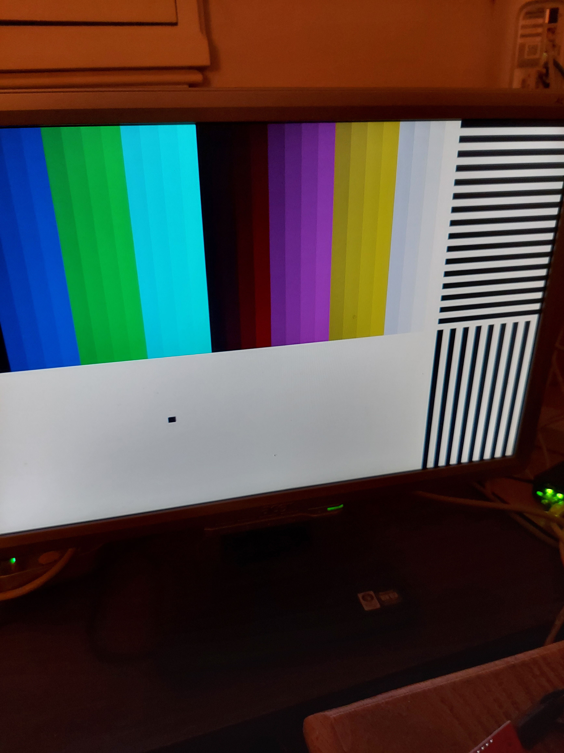
pico-ice with PMODVGA


