********************Default********************
Smaller Data Sets
11/04/25
********************Default********************

devel@pi5-90:~/zipcpu-dwt-lifting/src $ ./buildpi_lift128.sh

devel@pi5-90:~/zipcpu-dwt-lifting/host $ ./pi_jpeg128 3 1

octave:3> rgb128

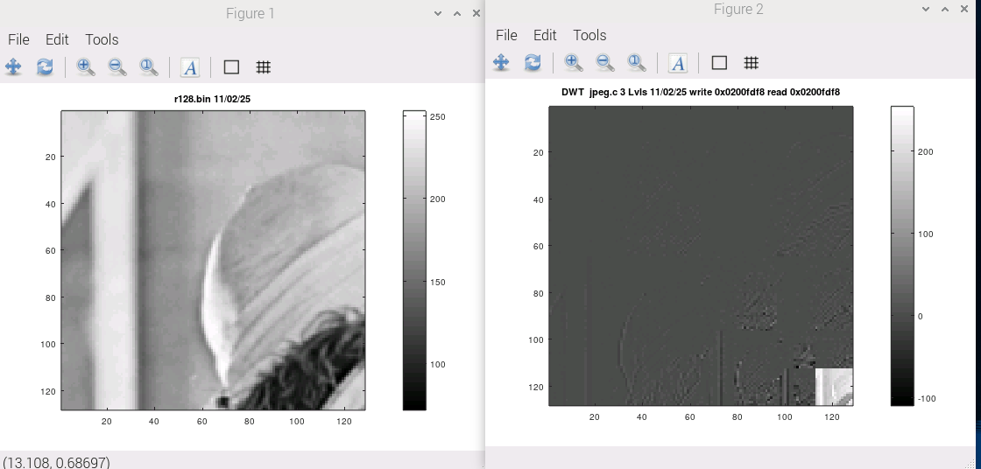

devel@pi5-90:~/zipcpu-dwt-lifting/src $ ./buildpi_lift64.sh

devel@pi5-90:~/zipcpu-dwt-lifting/host $ ./pi_jpeg64 4 1

devel@pi5-90:~/zipcpu-dwt-lifting/host $ octave

octave:1> rgb64

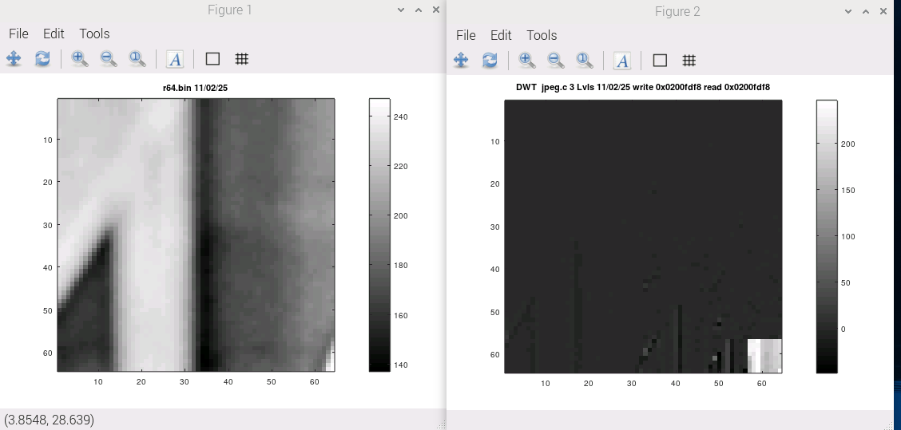

xxdevel@pi5-90:~/zipcpu-dwt-lifting/src $ ./buildpi_lift32.sh

devel@pi5-90:~/zipcpu-dwt-lifting/host $ ./pi_jpeg32 5 1

devel@pi5-90:~/zipcpu-dwt-lifting/host $ octave

octave:1> rgb32

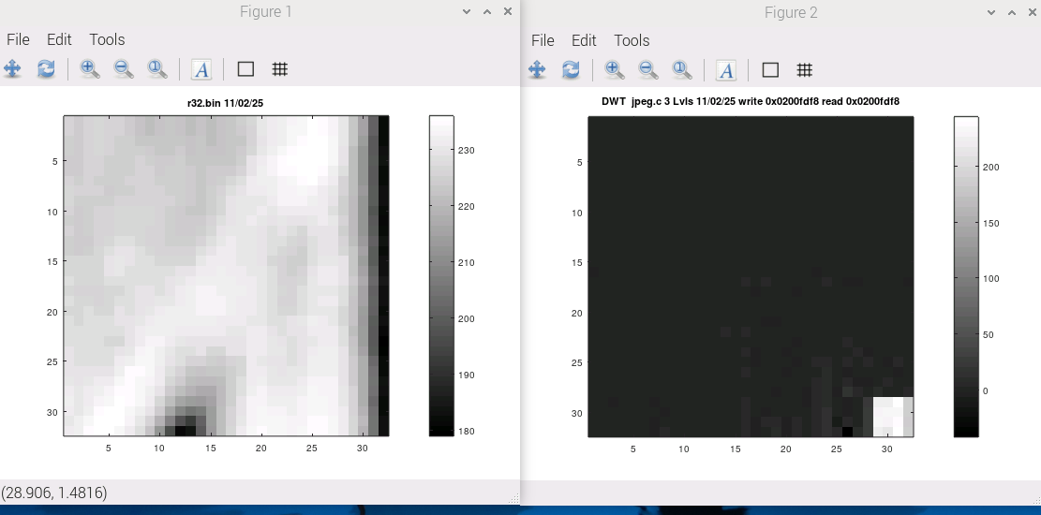
xx

