********************Default********************
Steps to add a UART to iCE40UP5K
08/10/24
********************Default********************

pico_ice_default_firmware_v1.6.1.uf2 RP2040

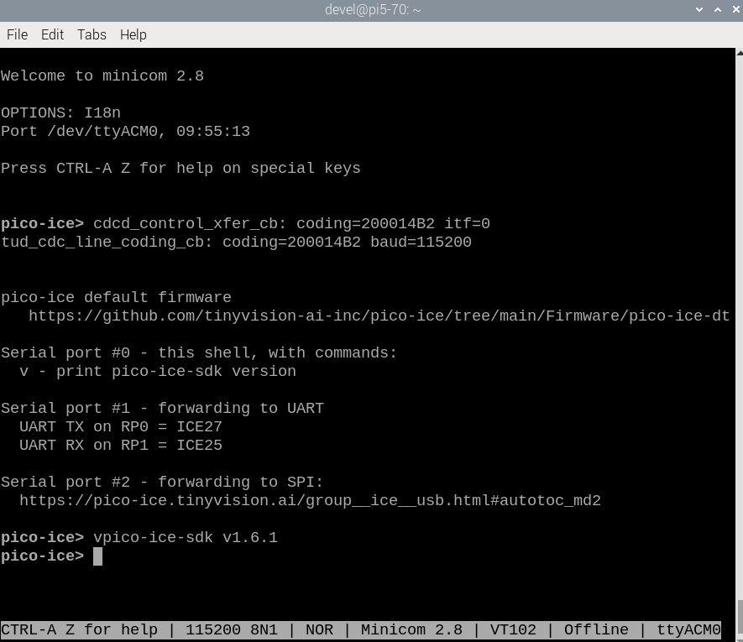

minicom myusb0 sudo minicom -s
blu tx ice25
red rx ice27
/dev/ttyUSB0 /dev/ttyACM1

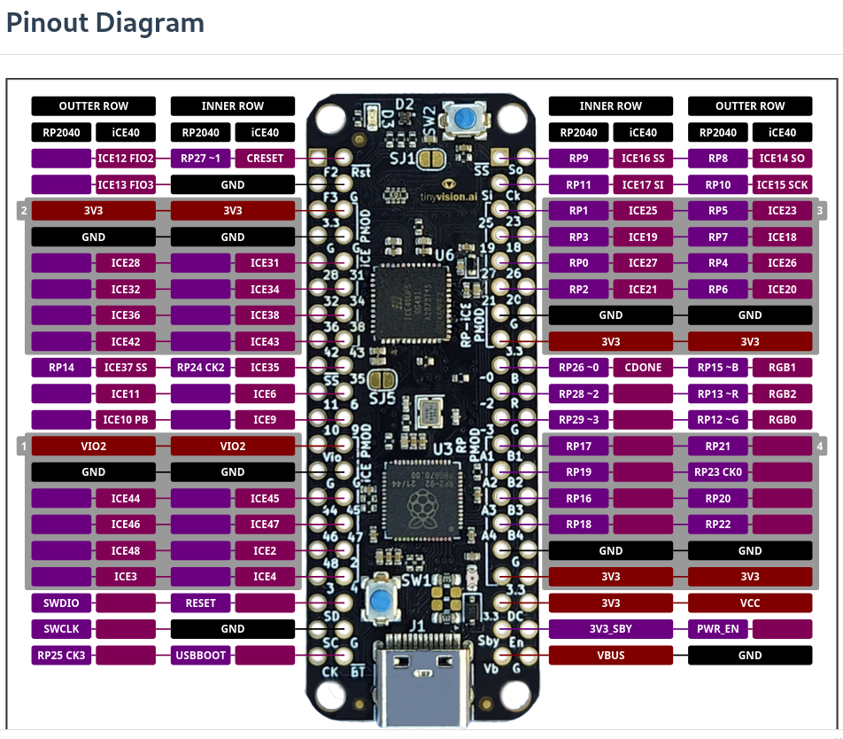
left right
minicom myusb0 sudo minicom -s
/dev/ttyUSB0 /dev/ttyACM1

Change default /dev/ttyACM0 to dev/ttyACM1

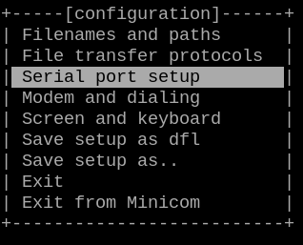

Depress enter

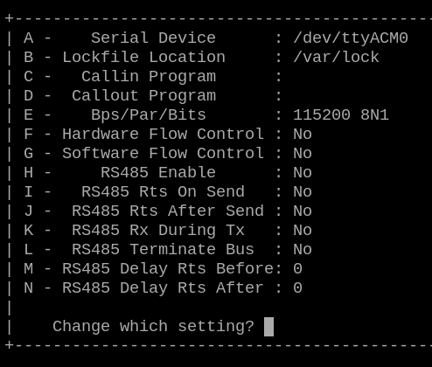

Type A enter

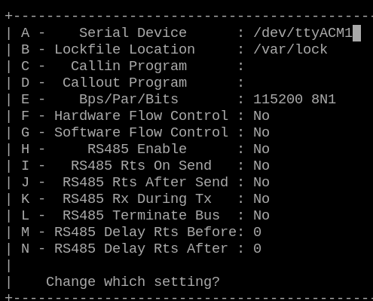

Change 0 to 1

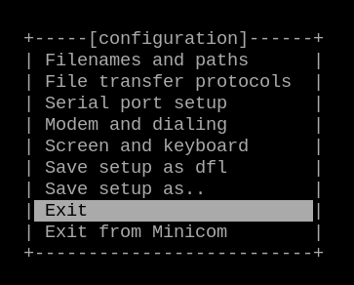

scroll to Exit enter

Typing in left terminal is displayed in right terminal.

The tx from left is connect pico-ice PMOD ICE_25 and rx is MOD ICE_27 see the pico-ice Pinout Diagram above.

With minor changes to the top.sv to detect the toggle of ICE_25 the blinking green led of the pico-ice show a spec of red.

diff --git a/pico-ice/my-new-pico-ice-firmware/ice_makefile_blinky/top.sv b/pico-ice-sdk/examples/ice_makefile_blinky/top.sv
index 8c90cb5..88f0a17 100644
--- a/pico-ice/my-new-pico-ice-firmware/ice_makefile_blinky/top.sv
+++ b/pico-ice-sdk/examples/ice_makefile_blinky/top.sv
@@ -4,28 +4,17 @@ module top (
output LED_R,
output LED_G,
output LED_B,
- input ICE_25,
);

localparam N = 22;

reg [N:0] counter;
- reg in1;
- always @(posedge CLK) begin
- counter <= counter + 1;
- end

-
always @(posedge CLK) begin
- if (ICE_25 == 0)
- begin
- in1 <= 1'b0;
- end
- else
- in1 <= 1'b1;
+ counter <= counter + 1;
end

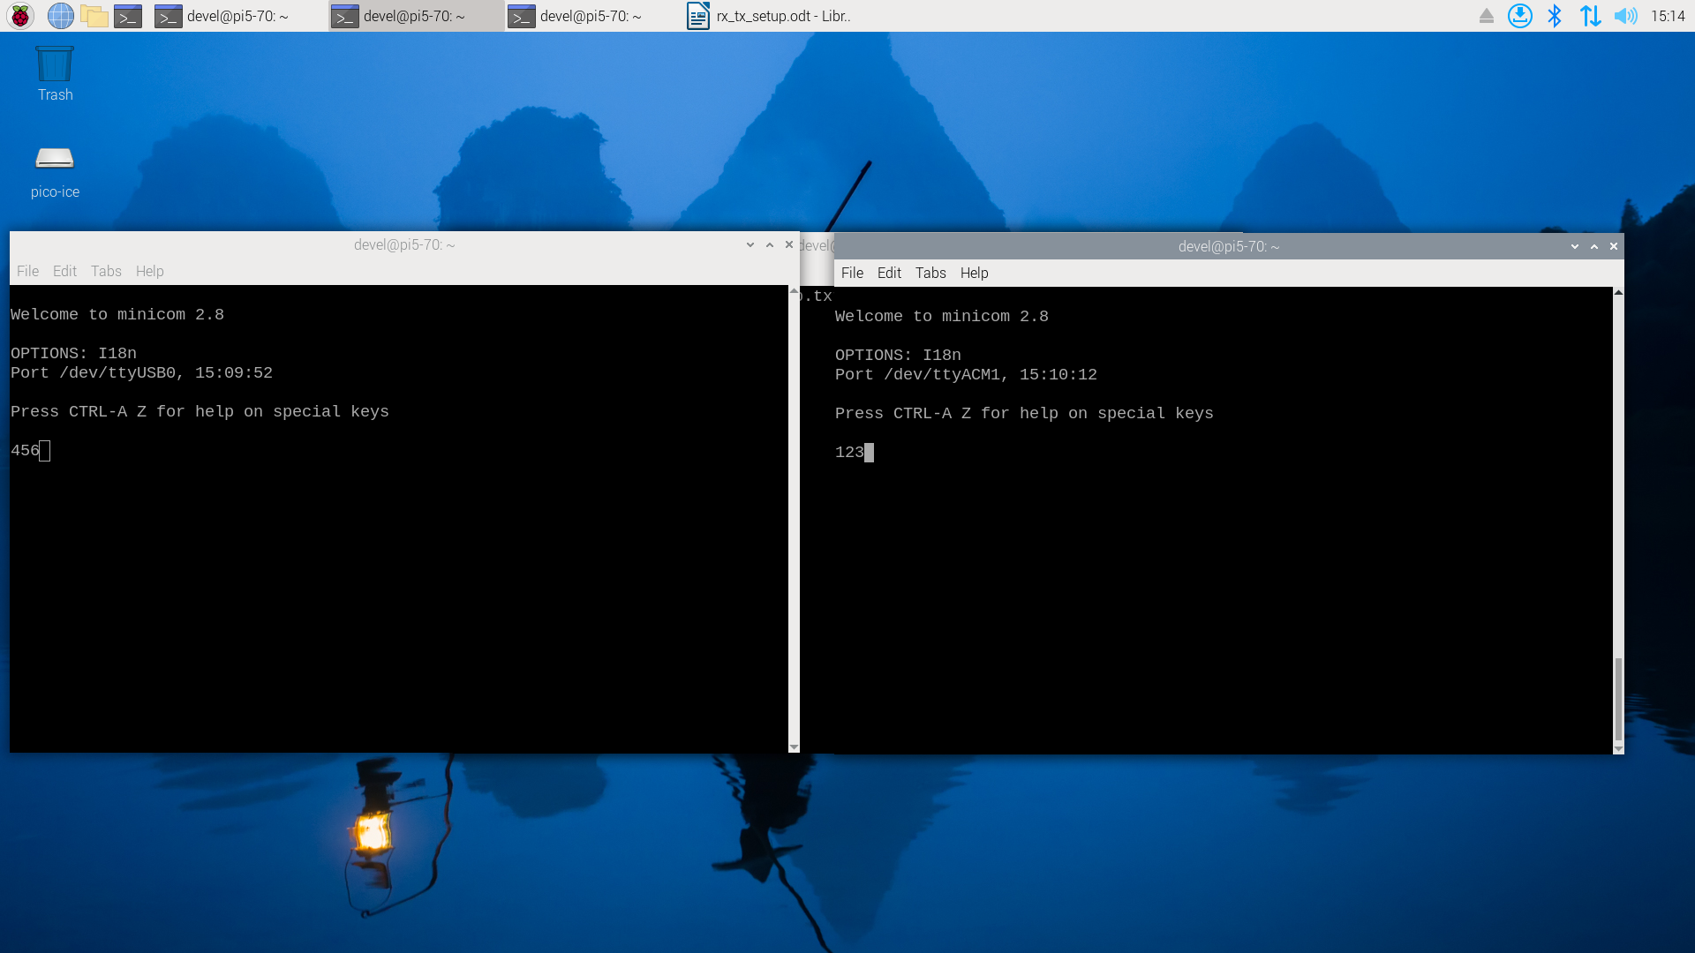
xx
steps to program the pico-ice ice40UP5K

devel@pi5-70:~/pico-ice/my-new-pico-ice-firmware/ice_makefile_blinky $ . ~/OSS_CAD_SUITE.sh
/usr/local/
devel@pi5-70:~/pico-ice/my-new-pico-ice-firmware/ice_makefile_blinky $ make clean
rm -f *.json *.asc *.bin *.uf2
devel@pi5-70:~/pico-ice/my-new-pico-ice-firmware/ice_makefile_blinky $ make
/usr/local//bin/yosys -q -p "read_verilog -sv top.sv; synth_ice40 -top top -json gateware.json"
/usr/local//bin/nextpnr-ice40 -q --randomize-seed --up5k --package sg48 --pcf ice40.pcf --json gateware.json --asc gateware.asc
/usr/local//bin/icepack gateware.asc gateware.bin

devel@pi5-70:~/pico-ice/my-new-pico-ice-firmware/ice_makefile_blinky $ bin2uf2 -o grn-red.uf2 gateware.bin

Drag-Drop the grn-red.uf2 file on the pico-ice.

