**************************Default**************************
Testing Google Cloud Free
Generating test-top.uf2 for the pico-ice
RP2040 & iCE40UP5K FPGA
leddigits
PipelineC blink-ex
PipelineC blink-ex-uart-echo
10/22/25
**************************Default**************************

First the Google Cloud VPS is created. This takes several steps found in ~/samba_info25/oct_eom/google-cloud.doc. Once the VPS is created
https://console.cloud.google.com/compute/instances?project=liquid-engine-468502-s6

The OSS_CAD_SUITE oss-cad-suite-linux-x64-20251020.tgz provides Yosys Yosys Open SYnthesis Suite and iCE40-Nextpnr -- a portable FPGA place and route tool

vidal_develone@mygoogle-cloud1:~$ uname -a
Linux mygoogle-cloud1 6.1.0-40-cloud-amd64 #1 SMP PREEMPT_DYNAMIC Debian 6.1.153-1 (2025-09-20) x86_64 GNU/Linux
vidal_develone@mygoogle-cloud1:~$ df
Filesystem 1K-blocks Used Available Use% Mounted on
udev 1997928 0 1997928 0% /dev
tmpfs 401892 2000 399892 1% /run
/dev/sda1 82317152 19790164 59057028 26% /
tmpfs 2009444 0 2009444 0% /dev/shm
tmpfs 5120 0 5120 0% /run/lock
/dev/sda15 126678 11840 114838 10% /boot/efi
tmpfs 401888 0 401888 0% /run/user/1000

processor : 0
vendor_id : GenuineIntel
cpu family : 6
model : 79
model name : Intel(R) Xeon(R) CPU @ 2.20GHz
stepping : 0
microcode : 0xffffffff
cpu MHz : 2199.998
cache size : 56320 KB
physical id : 0
siblings : 2
core id : 0
cpu cores : 1
apicid : 0
initial apicid : 0
fpu : yes
fpu_exception : yes
cpuid level : 13
wp : yes
flags : fpu vme de pse tsc msr pae mce cx8 apic sep mtrr pge mca cmov pat pse36 clflush mmx fxsr sse sse2 ss ht syscall nx pdpe1gb rdtscp lm constant_tsc rep_good nopl xtopology nonstop_tsc cpuid tsc_known_freq pni pclmulqdq ssse3 fma cx16 pcid sse4_1 sse4_2 x2apic movbe popcnt aes xsave avx f16c rdrand hypervisor lahf_lm abm 3dnowprefetch invpcid_single pti ssbd ibrs ibpb stibp fsgsbase tsc_adjust bmi1 hle avx2 smep bmi2 erms invpcid rtm rdseed adx smap xsaveopt arat md_clear arch_capabilities
bugs : cpu_meltdown spectre_v1 spectre_v2 spec_store_bypass l1tf mds swapgs taa mmio_stale_data retbleed bhi its
bogomips : 4399.99
clflush size : 64
cache_alignment : 64
address sizes : 46 bits physical, 48 bits virtual
power management:

processor : 1
vendor_id : GenuineIntel
cpu family : 6

model name : Intel(R) Xeon(R) CPU @ 2.20GHz
stepping : 0
microcode : 0xffffffff
cpu MHz : 2199.998
cache size : 56320 KB
physical id : 0
siblings : 2
core id : 0
cpu cores : 1
apicid : 1
initial apicid : 1
fpu : yes
fpu_exception : yes
cpuid level : 13
wp : yes
flags : fpu vme de pse tsc msr pae mce cx8 apic sep mtrr pge mca cmov pat pse36 clflush mmx fxsr sse sse2 ss ht syscall nx pdpe1gb rdtscp lm constant_tsc rep_good nopl xtopology nonstop_tsc cpuid tsc_known_freq pni pclmulqdq ssse3 fma cx16 pcid sse4_1 sse4_2 x2apic movbe popcnt aes xsave avx f16c rdrand hypervisor lahf_lm abm 3dnowprefetch invpcid_single pti ssbd ibrs ibpb stibp fsgsbase tsc_adjust bmi1 hle avx2 smep bmi2 erms invpcid rtm rdseed adx smap xsaveopt arat md_clear arch_capabilities
bugs : cpu_meltdown spectre_v1 spectre_v2 spec_store_bypass l1tf mds swapgs taa mmio_stale_data retbleed bhi its
bogomips : 4399.99
clflush size : 64
cache_alignment : 64
address sizes : 46 bits physical, 48 bits virtual
power management:

Additional package are added with the script extra64.sh

#!/bin/bash
sudo apt-get update
sudo apt-get install octave vlc kicad hexchat \
gawk gimp gtkwave iverilog clang \
samba samba-common-bin smbclient cifs-utils \
libftdi-dev libmpc-dev libmpfr-dev squashfs-tools bc mercurial \
libbison-dev libgmp-dev libelf-dev ncurses-dev \
default-jdk libreadline-dev xdot graphviz minicom xpdf lrzsz \
libusb-1.0.0 exuberant-ctags gparted ffmpeg \
mesa-utils libboost-all-dev freeglut3-dev \
python3-dev libgtk2.0-dev libcairo2-dev libpango1.0-dev \
libgdk-pixbuf2.0-dev libatk1.0-dev libghc-x11-dev binutils-arm-none-eabi \
gcc-arm-none-eabi diffuse gitk tcl-dev telnet tftp hexedit cmake flex bison \
gtkmm-3.0 gperf build-essential nfs-kernel-server \
libeigen3-dev libffi-dev libssl-dev python3-pip libtiff-dev ppp \
gdb-multiarch firefox-esr ninja-build ecryptfs-utils \
liboctave-dev autoconf automake libreoffice indent iperf \
wireshark nmap dnsmasq mosquitto mosquitto-clients fritzing doxygen espeak \
libssl-dev zlib1g-dev libbz2-dev libreadline-dev libsqlite3-dev llvm \
libncurses5-dev libncursesw5-dev xz-utils tk-dev libgdbm-dev lzma \
lzma-dev tcl-dev libxml2-dev libxmlsec1-dev libffi-dev liblzma-dev \
wget curl make build-essential openssl libhdf5-dev libc-ares-dev \
libeigen3-dev gcc gfortran libgfortran5 libatlas3-base libatlas-base-dev \
libopenblas-dev libblas-dev liblapack-dev cython3 \
libatlas-base-dev openmpi-bin libopenmpi-dev python3-dev \
libssl-dev zlib1g-dev libbz2-dev libreadline-dev libsqlite3-dev \
llvm libncurses5-dev libncursesw5-dev xz-utils tk-dev libgdbm-dev \
lzma lzma-dev tcl-dev libxml2-dev libxmlsec1-dev libffi-dev \
liblzma-dev wget curl make build-essential openssl \
libssl-dev zlib1g-dev libbz2-dev libreadline-dev libsqlite3-dev \
llvm libncurses5-dev libncursesw5-dev xz-utils tk-dev libgdbm-dev \
lzma lzma-dev tcl-dev libxml2-dev libxmlsec1-dev libffi-dev \
liblzma-dev wget curl make build-essential openssl \
libusb-dev libreadline-dev libglib2.0-dev libudev-dev libdbus-1-dev \
libical-dev libmosquitto-dev hostapd traceroute help2man gforth \
lld pkg-config python3 libboost-system-dev libboost-python-dev \
libboost-filesystem-dev clang-format mosh

vidal_develone@mygoogle-cloud1:~/PipelineC$ less .git/config

[core]
repositoryformatversion = 0
filemode = true
bare = false
logallrefupdates = true
[remote "origin"]
url = https://github.com/develone/PipelineC.git
fetch = +refs/heads/*:refs/remotes/origin/*
[branch "test-dev-050125"]
remote = origin
merge = refs/heads/test-dev-050125
[branch "test-dev"]
remote = origin
merge = refs/heads/test-dev

vidal_develone@mygoogle-cloud1:~/PipelineC$ git branch -a
* test-dev
test-dev-050125
remotes/origin/HEAD -> origin/master
remotes/origin/master
remotes/origin/test-dev
remotes/origin/test-dev-050125
remotes/origin/test-dev-060125
remotes/origin/test-dev-091125

vidal_develone@mygoogle-cloud1:~/PipelineC$ cd ~/pico-ice/

vidal_develone@mygoogle-cloud1:~/pico-ice$ less .git/config

[core]
repositoryformatversion = 0
filemode = true
bare = false
logallrefupdates = true
[remote "origin"]
url = https://github.com/develone/pico-ice.git
fetch = +refs/heads/*:refs/remotes/origin/*
[branch "test-dev-100424"]
remote = origin
merge = refs/heads/test-dev-100424

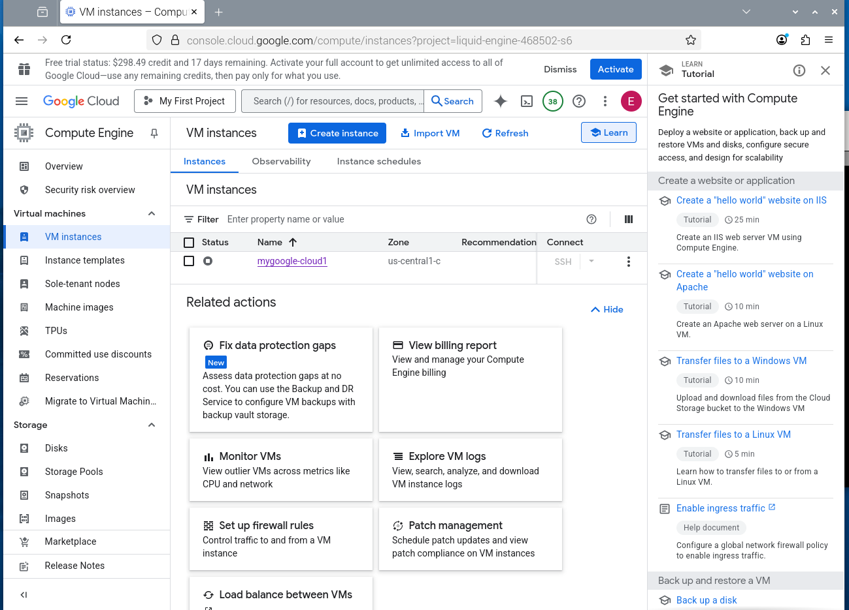
img1

xx
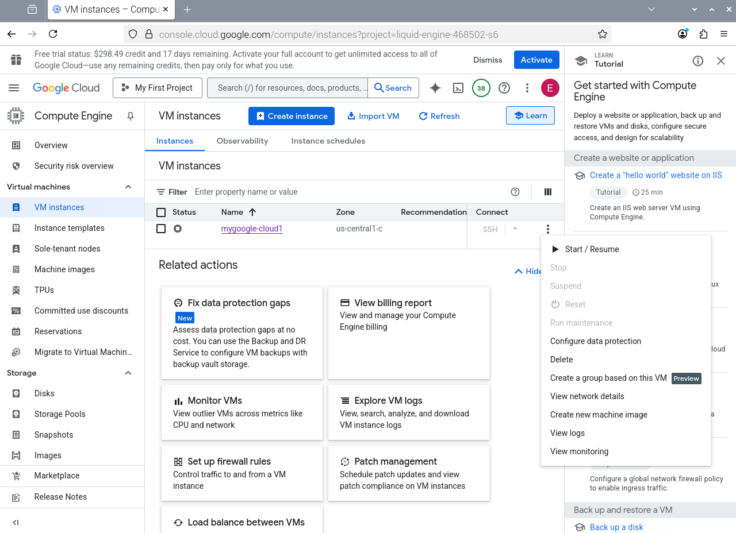
img2

After depressing Start/Resume The ssh is enable

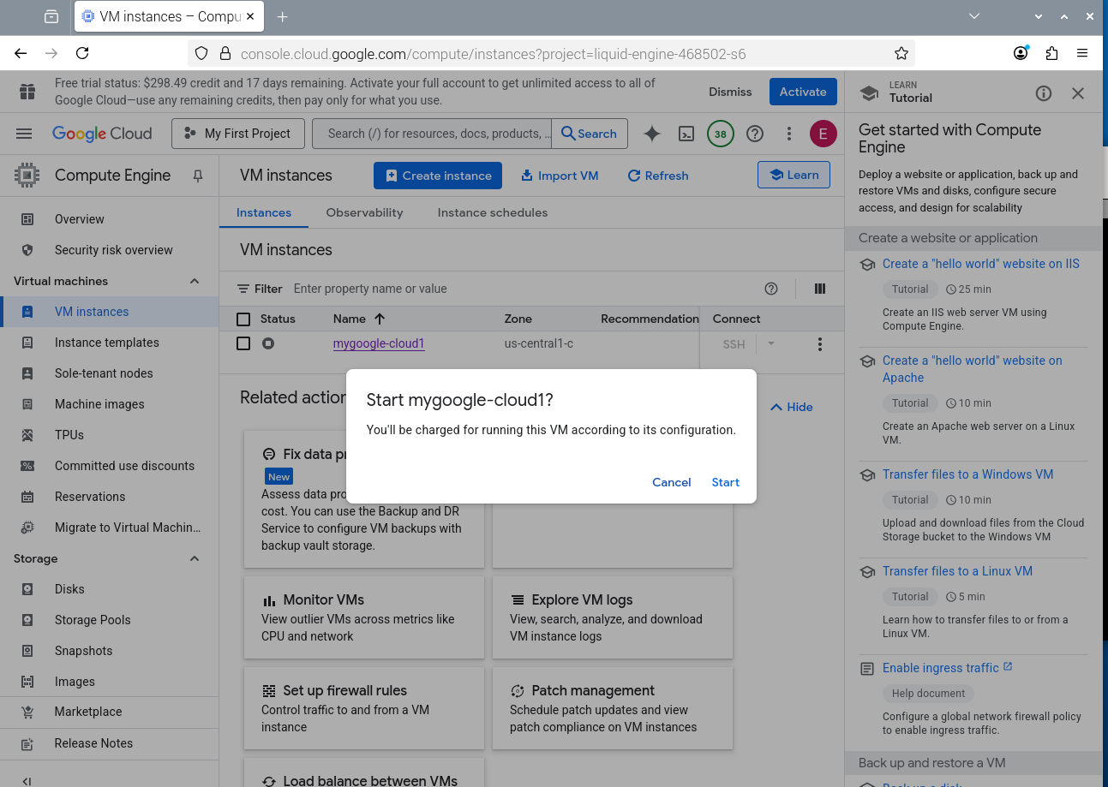

Depress Start

img3

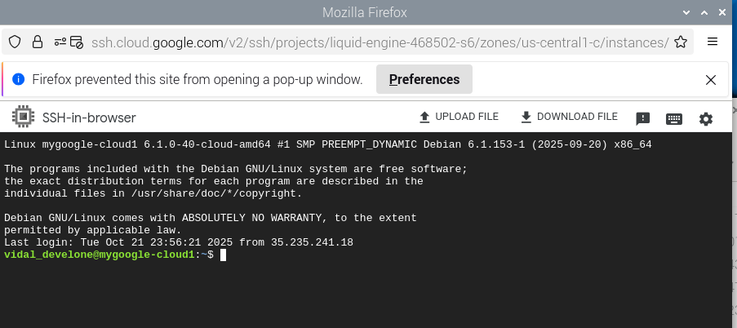

img4

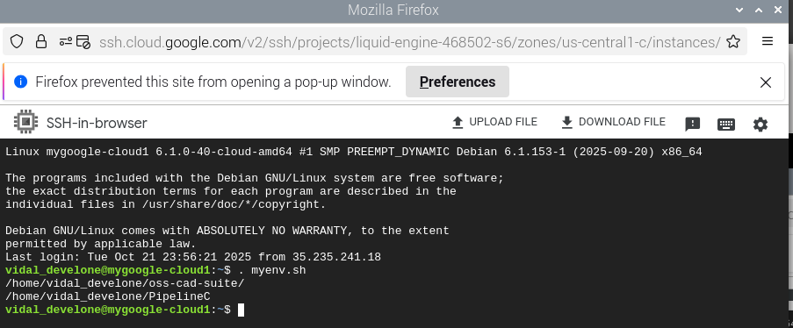

10/21/25 testing google cloud mygoogle-cloud1

PRETTY_NAME="Debian GNU/Linux 12 (bookworm)"
NAME="Debian GNU/Linux"
VERSION_ID="12"
VERSION="12 (bookworm)"
VERSION_CODENAME=bookworm
ID=debian
HOME_URL="https://www.debian.org/"
SUPPORT_URL="https://www.debian.org/support"
BUG_REPORT_URL="https://bugs.debian.org/"

vidal_develone@mygoogle-cloud1:~/pico-ice/PipelineC/blink-ex-uart-echo/ice_makefile_pipelinec$ git branch -a
* test-dev-100424

vidal_develone@mygoogle-cloud1:~/PipelineC$ git branch -a
* test-dev

. myenv.sh
cat ~/myenv.sh
#!/bin/bash
export OSS_CAD_SUITE=$HOME/oss-cad-suite/
export PIPELINEC_REPO="$HOME/PipelineC"
echo $OSS_CAD_SUITE
echo $PIPELINEC_REPO

cd pico-ice/PipelineC/blink-ex-uart-echo/ice_makefile_pipelinec/
./build.sh

scp gateware.uf2 devel@100.89.157.49:~/mygoogle-cloud1/

cd ../

cd blink-ex-uart-echo/ice_makefile_pipelinec/

./build.sh

scp gateware.uf2 devel@100.89.157.49:~/mygoogle-cloud1/blink-ex-uart-echo/

devel@pi5-90:~ $ minicom ACM1

ABCDEFGHIJKLMNOPQRSTUVWXYZabcdefghijklmnopqrstuvwxyz0123456789

img5

video

