This is the repo that provides the lifting step.

git clone https://github.com/develone/zipcpu-dwt-lifting.git

cd zipcpu-dwt-lifting/src/

These are the 32 bit images used to test the software

devel@pi5-90:~/zipcpu-dwt-lifting/host $ ls -la *.bin
-rw-r--r-- 1 devel devel 262144 Nov 2 06:32 b.bin
-rw-r--r-- 1 devel devel 262144 Nov 2 06:58 dwt.bin
-rw-r--r-- 1 devel devel 262144 Nov 2 06:32 g.bin
-rw-r--r-- 1 devel devel 262144 Nov 2 06:32 r.bin

lift-red-110225.png

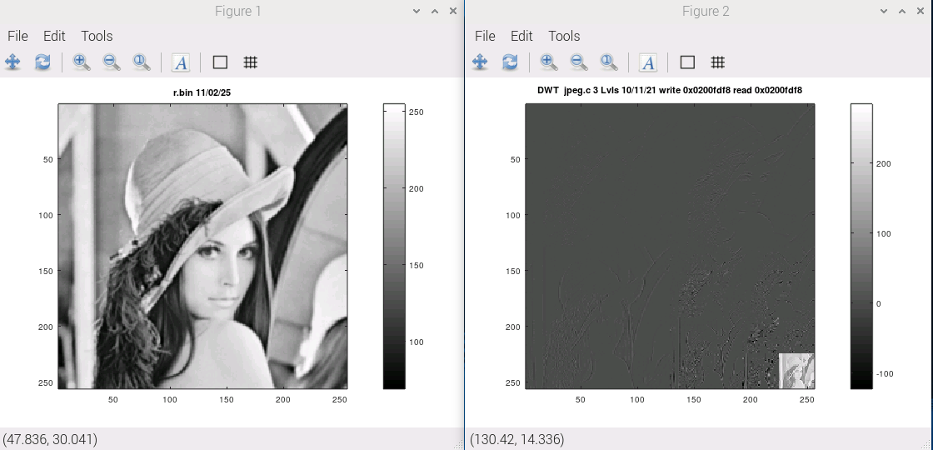
lift-grn-110225.png

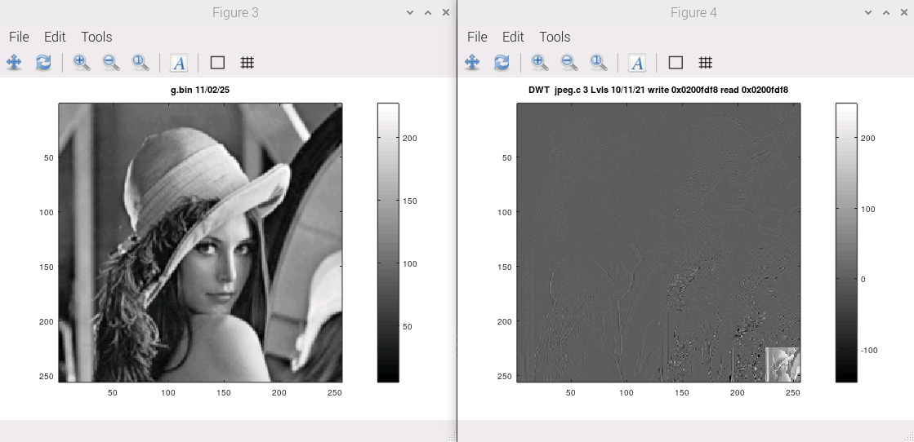

lift-blue-11025

