********************Default********************
pico-ice compiled pi5-70 executed pi3-28
10/26/25
********************Default********************

devel@pi5-70:~/PipelineC $ git log
commit 422abd8ec3496d109e1153989ac848503e1292fe (HEAD -> test-dev, origin/test-dev)
Merge: ba22d9f 0213aad
Author: develone <develone@sbcglobal.net>
Date: Thu Apr 24 15:12:02 2025 -0600

Merge branch 'JulianKemmerer:master' into test-dev

devel@pi5-70:~/pico-ice/PipelineC/pmod-ethernet/examples/net $ git log
commit 854eef3655f9cf3b912ab83cd14d646fdfdadd43 (HEAD -> test-dev-100424, origin/test-dev-100424)
Author: Edward Vidal Jr <develone@sbcglobal.net>
Date: Wed Oct 22 09:49:13 2025 -0600

Testing Google Cloud Free
Generating test-top.uf2 for the pico-ice
RP2040 & iCE40UP5K FPGA
leddigits
PipelineC blink-ex
PipelineC blink-ex-uart-echo
10/22/25

devel@pi5-70:~/pico-ice/PipelineC/pmod-ethernet/examples/net $ ./compile-work_test.sh

devel@pi5-70:~/pico-ice/PipelineC/pmod-ethernet/examples/net $ cp work_test ~/pico-ice-a0.b1.c2.d3.e4.f5/

devel@pi5-70:~/pico-ice/PipelineC/pmod-ethernet/examples/pico-ice/ice_makefile_pipelinec $ cp gateware.uf2 ~/pico-ice-a0.b1.c2.d3.e4.f5/

devel@pi5-70:~/pico-ice/PipelineC/pmod-ethernet/examples/pico-ice/ice_makefile_pipelinec $ rsync -avl --delete /home/devel/pico-ice-a0.b1.c2.d3.e4.f5 pi3-28:~/
sending incremental file list
pico-ice-a0.b1.c2.d3.e4.f5/
pico-ice-a0.b1.c2.d3.e4.f5/gateware.uf2
pico-ice-a0.b1.c2.d3.e4.f5/work_test

devel@pi3-28:~/pico-ice-a0.b1.c2.d3.e4.f5 $ sudo ./work_test
CPU threads: 1
n 'work()'s: 1
Total tx bytes: 8
Total rx bytes: 4
CPU took 0.001652 seconds to execute
CPU iteration time: 0.001652 seconds
CPU bytes per sec: 7263.912253 B/s
FPGA took 0.001050 seconds to execute
FPGA iteration time: 0.001050 seconds
FPGA bytes per sec: 11428.621253 B/s
Speedup: 1.573342

pmod-eth-rx

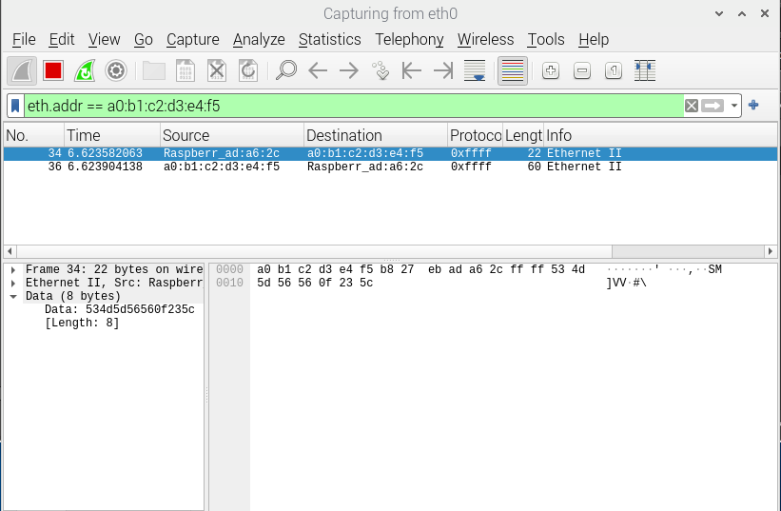

pmod-eth-tx
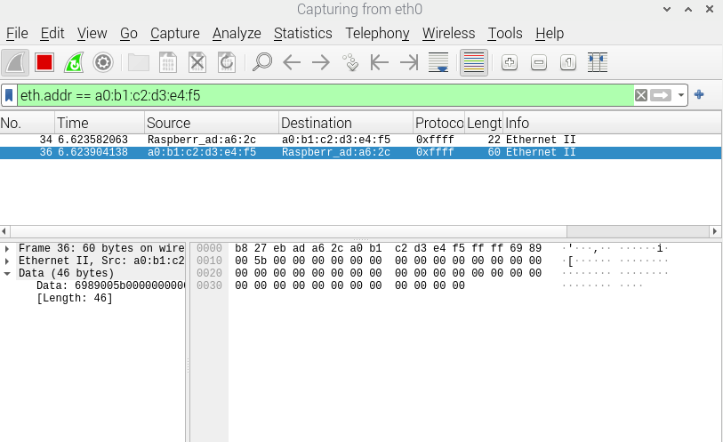

xx

