**************************Defualt**************************
4 pmod-ethernets
pico2-ice PipelineC pmod-ethernet MAC a7:b1:c2:d3:e4:f5
pico-ice PipelineC pmod-ethernet MAC a8:b1:c2:d3:e4:f5
pico-ice PipelineC pmod-ethernet MAC a9:b1:c2:d3:e4:f5
Catboard PipelineC pmod-ethernet MAC a0:b1:c2:d3:e4:f5
gateware.bin and gateware.uf2 created with oss-cad-suite
OVHcloud VPS Ubuntu 24.04
10/31/25
**************************Defualt**************************

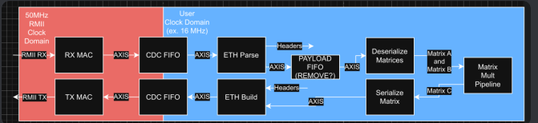
xx
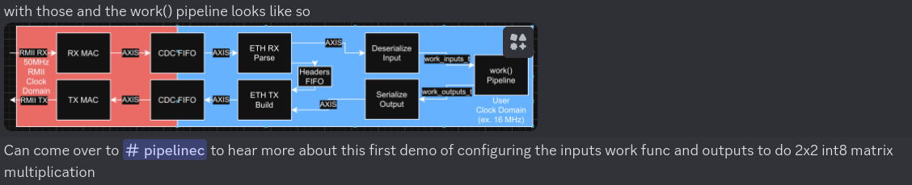
RPi3 with Catboard 2 pico-ice and pico2-ice

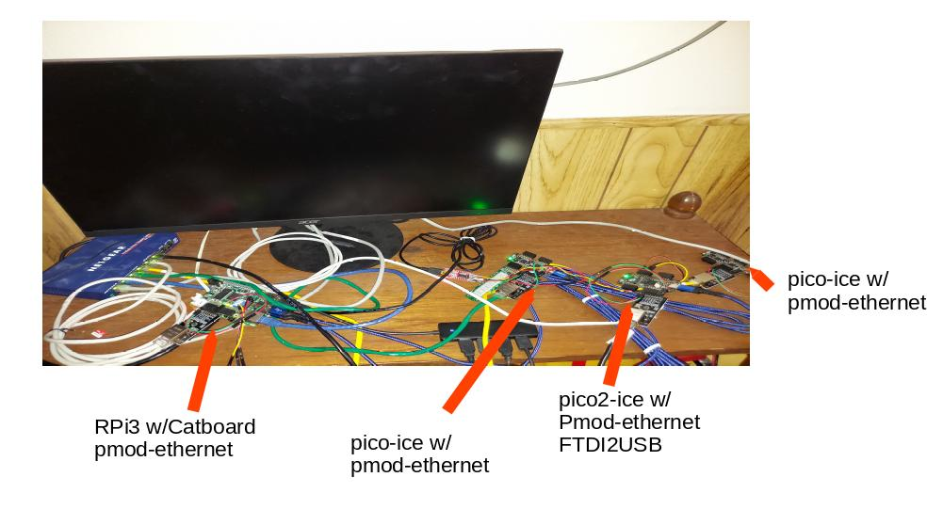

a0:b1:c2:d3:e4:f5
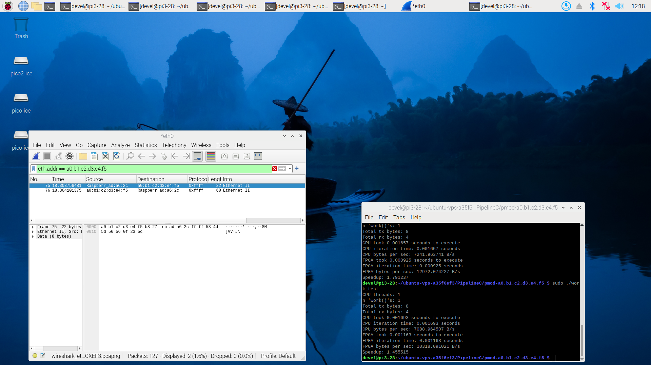
a7:b1:c2:d3:e4:f5
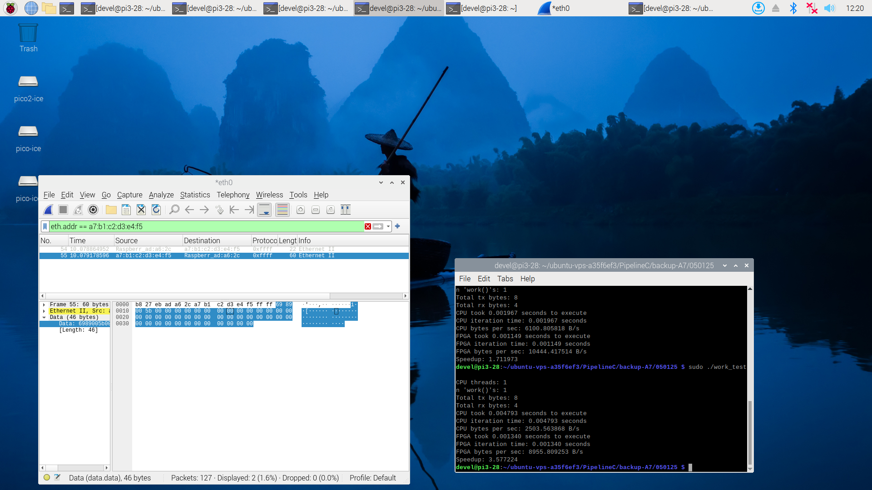
a8:b1:c2:d3:e4:f5
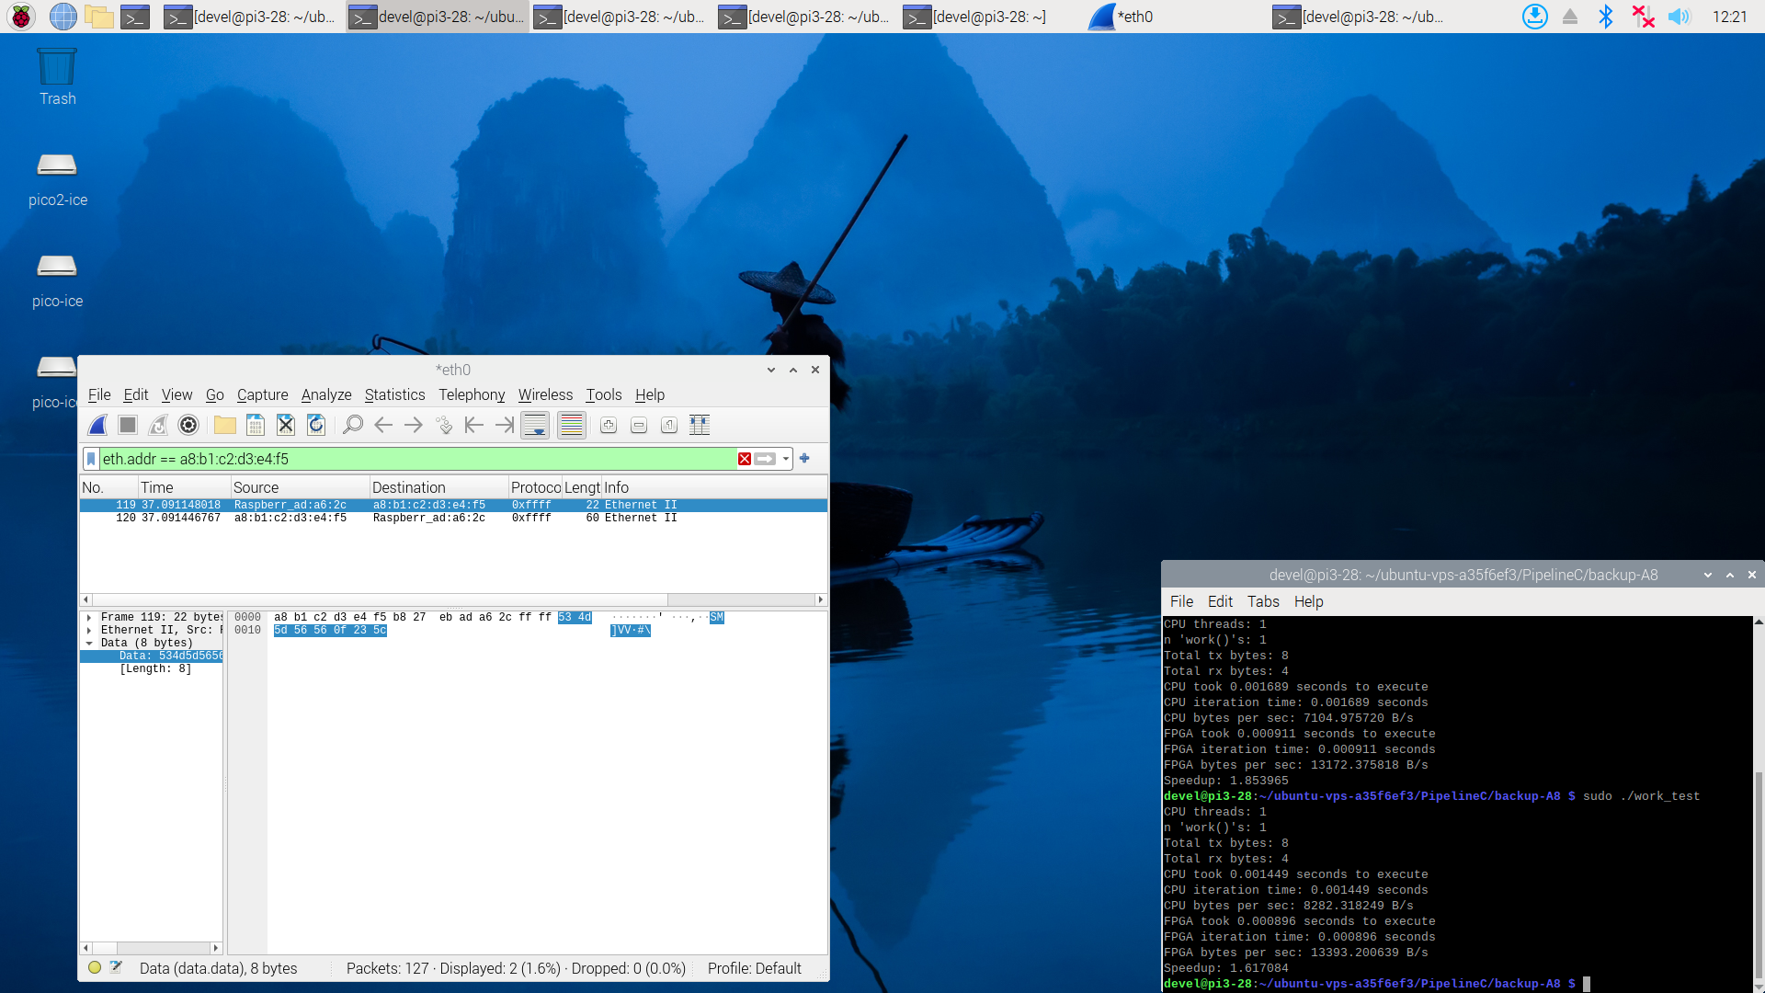
a9:b1:c2:d3:e4:f5
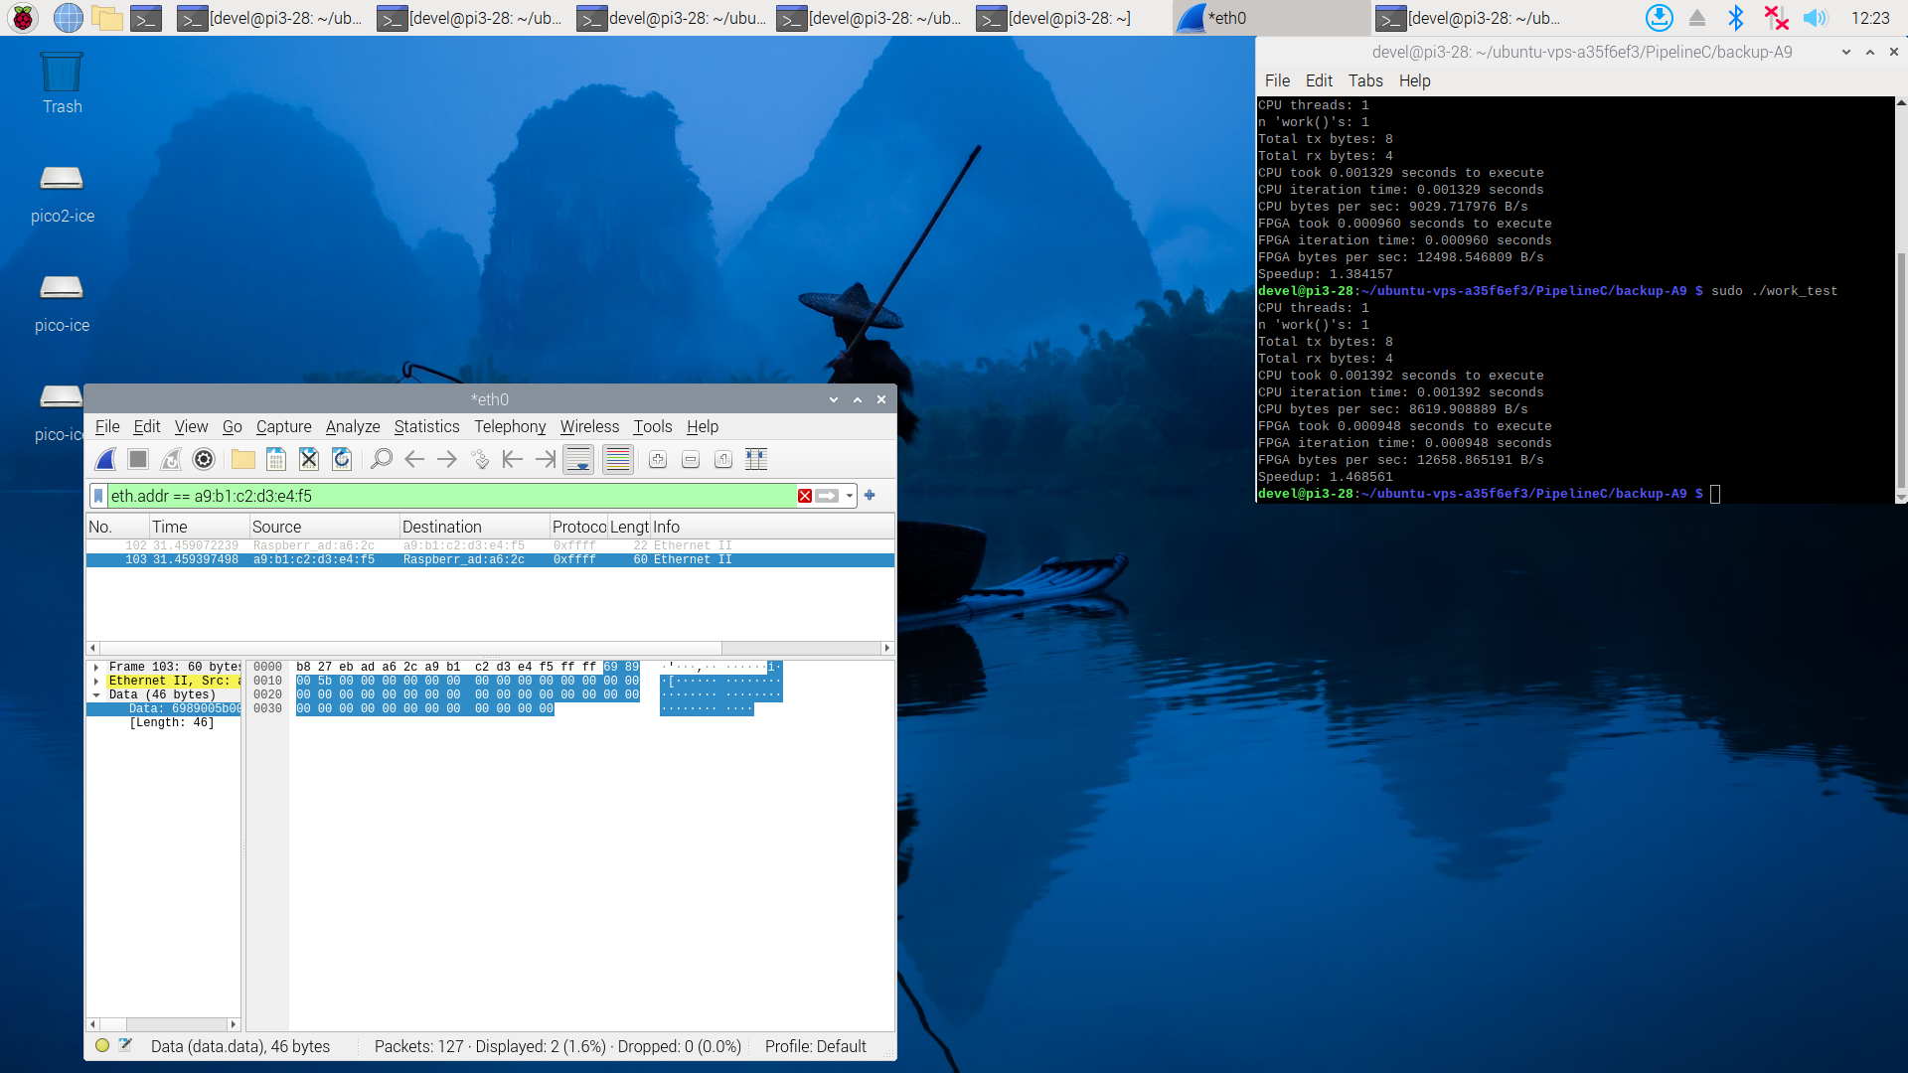
xx

