***********************Default***********************
PipelineC Ethernet PMOD
02/15/25

***********************Default***********************

02/13/25

------| |------
----| | | |----
grd-- | | | |
vcc | | | | |
o o o o o o
o o o o o o
vcc | | | | |
grd-- | | | |
----| | | |----
------| |------

02/15/25
*******************pi5-80*******************
export PIPELINEC_REPO="$HOME/PipelineC"
export OSS_CAD_SUITE=$HOME/oss-cad-suite/
export PATH="$HOME/.pyenv/bin:$HOME/local/openocd/bin:$PATH"

devel@pi5-70:~/PipelineC $
devel@pi5-80:~/PipelineC $ git log
commit ff24c29192f5a479eed5e34c54ba3eabc5d1ec67 (HEAD -> test-dev, origin/test-dev)
Merge: cb8e24b 707142c
Author: develone <develone@sbcglobal.net>
Date: Fri Feb 14 20:25:24 2025 -0700

Merge branch 'JulianKemmerer:master' into test-dev

devel@pi5-80:~/pico-ice/PipelineC/pmod-ethernet/ice_makefile_pipelinec $ make clean
rm -f lextab.py
rm -f yacctab.py
rm -f pll_clk_mhz.h
rm -f -r pipelinec_output
rm -f pipelinec.log
rm -f pll.v
rm -f *.json *.asc *.bin *.uf2
rm -f yosys_stderr.log
rm -f dfu_util.log
devel@pi5-80:~/pico-ice/PipelineC/pmod-ethernet/ice_makefile_pipelinec $ ls
eth_clocks.py ethernet_top.sv Makefile README.md top.h top.sv
ethernet_top.c ice40.pcf pong_top.c top.c top_pins.svh
devel@pi5-80:~/pico-ice/PipelineC/pmod-ethernet/ice_makefile_pipelinec $ make pipelinec
echo "#define PLL_CLK_MHZ 25.0\n" > pll_clk_mhz.h
/home/devel/PipelineC/src/pipelinec top.c --top pipelinec_top --out_dir pipelinec_output --comb --no_synth > pipelinec.log
devel@pi5-80:~/pico-ice/PipelineC/pmod-ethernet/ice_makefile_pipelinec $ make gateware.bin
/home/devel/oss-cad-suite//bin/icepll -q -i 12 -o 25.0 -p -m -f pll.v
/home/devel/oss-cad-suite//bin/yosys -q -m ghdl -p "ghdl --std=08 -frelaxed `cat pipelinec_output/vhdl_files.txt` -e pipelinec_top; read_verilog -sv top.sv pll.v; synth_ice40 -top top -json gateware.json" 2> yosys_stderr.log
/home/devel/oss-cad-suite//bin/nextpnr-ice40 -q --randomize-seed --up5k --package sg48 --pcf ice40.pcf --json gateware.json --asc gateware.asc --freq 25.0
/home/devel/oss-cad-suite//bin/icepack gateware.asc gateware.bin
devel@pi5-80:~/pico-ice/PipelineC/pmod-ethernet/ice_makefile_pipelinec $ bin2uf2 -o gateware.uf2 gateware.bin
*******************pi5-70*******************
devel@pi5-70:~/PipelineC $
commit ff24c29192f5a479eed5e34c54ba3eabc5d1ec67 (HEAD -> test-dev, origin/test-dev)
Merge: cb8e24b 707142c
Author: develone <develone@sbcglobal.net>
Date: Fri Feb 14 20:25:24 2025 -0700

Merge branch 'JulianKemmerer:master' into test-dev

devel@pi5-70:~/pico-ice/PipelineC/pmod-ethernet/ice_makefile_pipelinec $ ls
eth_clocks.py gateware.uf2 pll_clk_mhz.h top_pins.svh
ethernet_top.c ice40.pcf pll.v top.sv
ethernet_top.sv lextab.py pong_top.c yacctab.py
gateware.asc Makefile README.md yosys_stderr.log
gateware.bin pipelinec.log top.c
gateware.json pipelinec_output top.h

devel@pi5-70:~/pico-ice/PipelineC/pmod-ethernet/ice_makefile_pipelinec $ make clean
rm -f lextab.py
rm -f yacctab.py
rm -f pll_clk_mhz.h
rm -f -r pipelinec_output
rm -f pipelinec.log
rm -f pll.v
rm -f *.json *.asc *.bin *.uf2
rm -f yosys_stderr.log
rm -f dfu_util.log
devel@pi5-70:~/pico-ice/PipelineC/pmod-ethernet/ice_makefile_pipelinec $ make pipelinec
echo "#define PLL_CLK_MHZ 25.0\n" > pll_clk_mhz.h
/home/devel/PipelineC/src/pipelinec top.c --top pipelinec_top --out_dir pipelinec_output --comb --no_synth > pipelinec.log
devel@pi5-70:~/pico-ice/PipelineC/pmod-ethernet/ice_makefile_pipelinec $ make gateware.bin
/home/devel/oss-cad-suite//bin/icepll -q -i 12 -o 25.0 -p -m -f pll.v
/home/devel/oss-cad-suite//bin/yosys -q -m ghdl -p "ghdl --std=08 -frelaxed `cat pipelinec_output/vhdl_files.txt` -e pipelinec_top; read_verilog -sv top.sv pll.v; synth_ice40 -top top -json gateware.json" 2> yosys_stderr.log
/home/devel/oss-cad-suite//bin/nextpnr-ice40 -q --randomize-seed --up5k --package sg48 --pcf ice40.pcf --json gateware.json --asc gateware.asc --freq 25.0
/home/devel/oss-cad-suite//bin/icepack gateware.asc gateware.bin
devel@pi5-70:~/pico-ice/PipelineC/pmod-ethernet/ice_makefile_pipelinec $ bin2uf2 -o gateware.uf2 gateware.bin

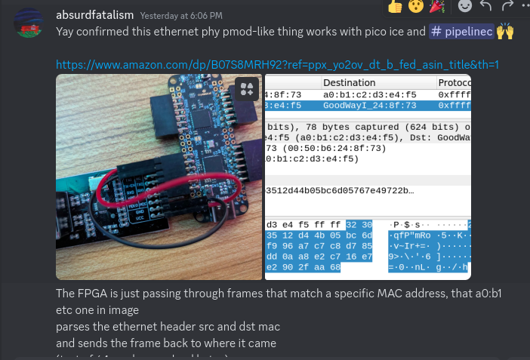
xx
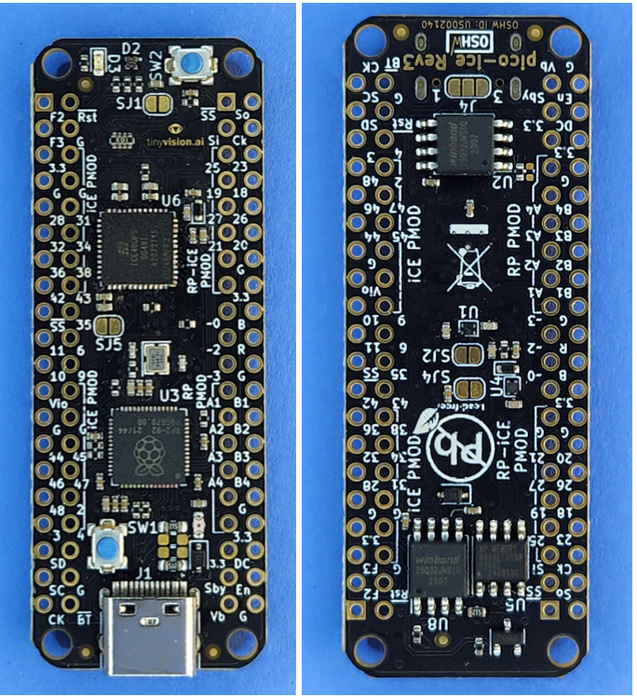
xx

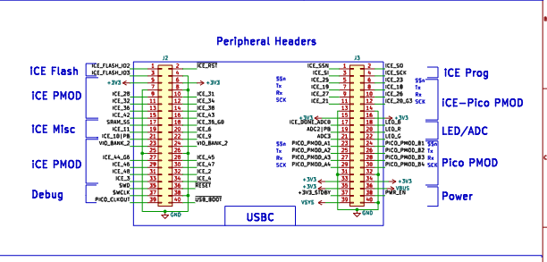

xx

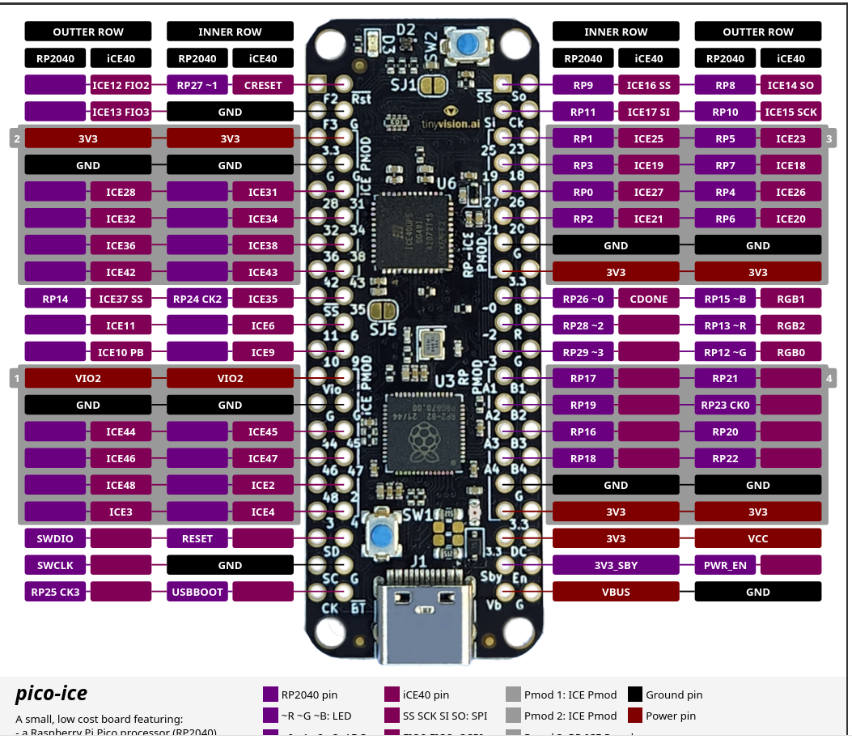

xx

