Next instead of reading the files and writing the results in dwt.bin The goal is use as serial tx & rx to send the data to the program. Then transmit the result over the serial tx.

The folder testfiles/2048/ has the files to perform a 2048 lifting step.
The folder testfiles/256/ has the files to perform a 256 lifting step.

The following command compiles the code ./buildpi_lift.sh

There is a define in pi_jpeg.c that turns off the debug

rm -f dwt.bin ; ./pi_jpeg 0 1
0x0 0x22048 0x1022048
ptrs.fwd_inv = 0x2022060
reading r.bin
fwd lifting step only
w = 0x800 ptrs.inp_buf wptr = 0x22048 alt = 0x1022048 ptrs.fwd_inverse = 0x2022060 ptrs.fwd_inverse = 0x1
starting red dwt
finished ted dwt
octave
GNU Octave, version 4.4.1
Copyright (C) 2018 John W. Eaton and others.
This is free software; see the source code for copying conditions.
There is ABSOLUTELY NO WARRANTY; not even for MERCHANTABILITY or
FITNESS FOR A PARTICULAR PURPOSE. For details, type 'warranty'.

Octave was configured for "arm-unknown-linux-gnueabihf".

Additional information about Octave is available at https://www.octave.org.

Please contribute if you find this software useful.
For more information, visit https://www.octave.org/get-involved.html

Read https://www.octave.org/bugs.html to learn how to submit bug reports.
For information about changes from previous versions, type 'news'.

octave:1> rgb

The input was a pgm file 2048 x 2048
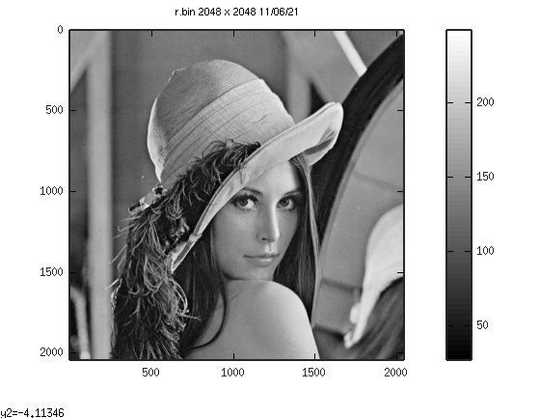
4 lvs 2048 x 2048 lifting step.

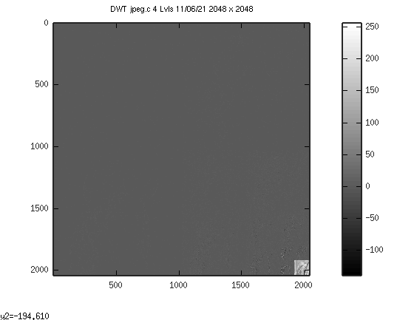

cp testfiles/256/* .
./buildpi_lift.sh
devel@mypi3-20:~/pico-lifting $ rm -f dwt.bin ; ./pi_jpeg 0 1
0x0 0x22048 0x62048
ptrs.fwd_inv = 0xa2060
reading r.bin
fwd lifting step only
w = 0x100 ptrs.inp_buf wptr = 0x22048 alt = 0x62048 ptrs.fwd_inverse = 0xa2060 ptrs.fwd_inverse = 0x1
starting red dwt
finished ted dwt

octave
GNU Octave, version 4.4.1
Copyright (C) 2018 John W. Eaton and others.
This is free software; see the source code for copying conditions.
There is ABSOLUTELY NO WARRANTY; not even for MERCHANTABILITY or
FITNESS FOR A PARTICULAR PURPOSE. For details, type 'warranty'.

Octave was configured for "arm-unknown-linux-gnueabihf".

Additional information about Octave is available at https://www.octave.org.

Please contribute if you find this software useful.
For more information, visit https://www.octave.org/get-involved.html

Read https://www.octave.org/bugs.html to learn how to submit bug reports.
For information about changes from previous versions, type 'news'.

octave:1> rgb

The input was a pgm file 256 x 256
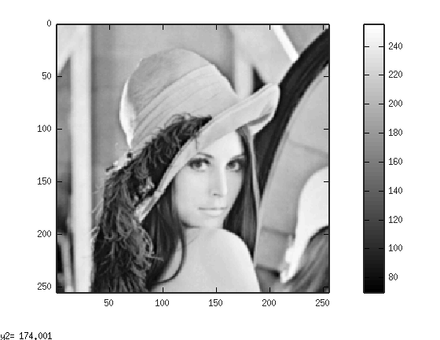
3 lvs 256 x 256 lifting step.

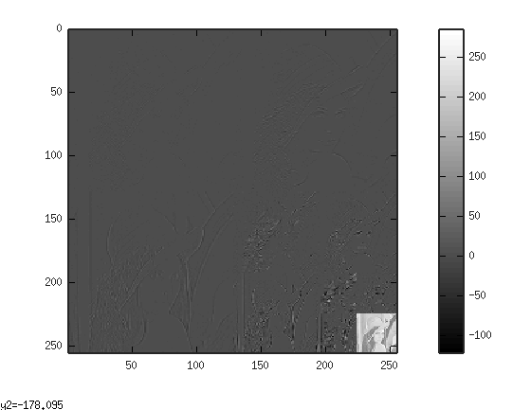

Rpi Pico
SWDIO----18 red--------black-------black------ blue----swclk
grd----------20 yellow-----red---------blue------- green---grd
SWCLK---22 orange-----orange------green------ black---swdio

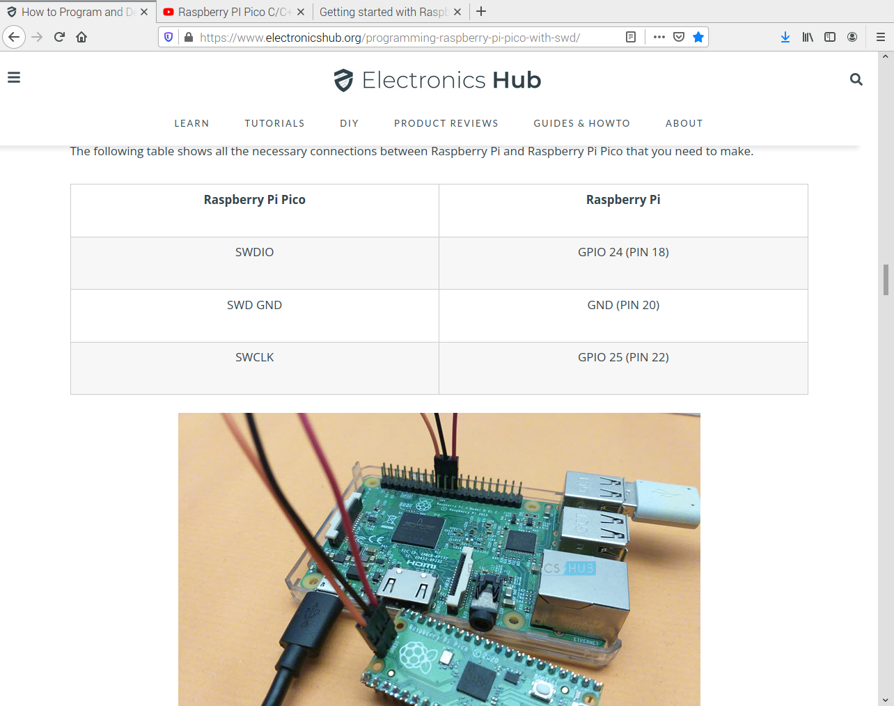
Pico The labels swclk grd swdio are only on the bottom side.

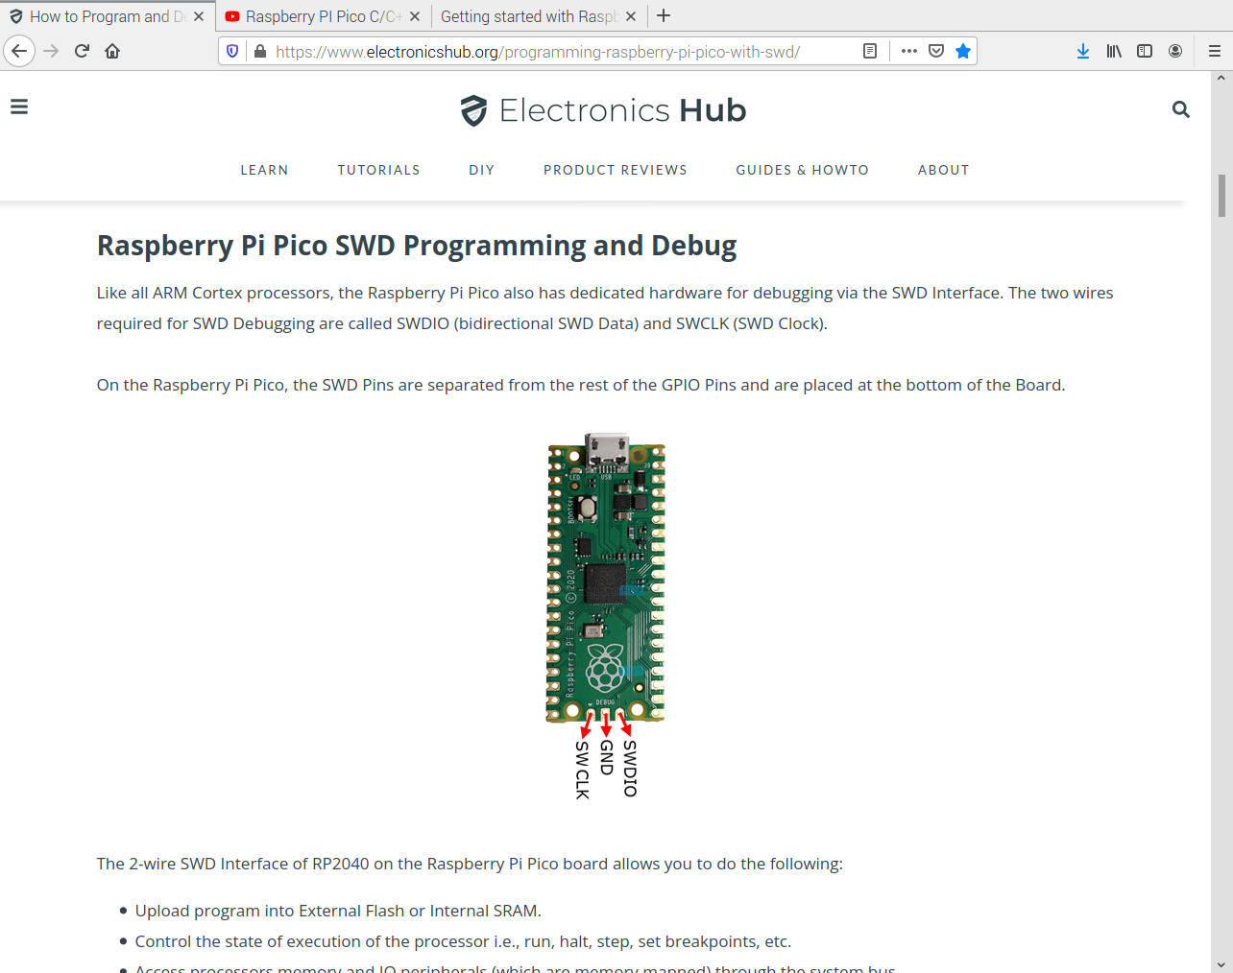
pico-pi-sdk-build.txt has the instruction from the video below.

Revist the video below
https://www.youtube.com/watch?v=UZwq3eb5My0

Downloaded the getting-started

https://datasheets.raspberrypi.com/pico/getting-started-with-pico.pdf

