******************Draft******************
Pico Lifting Step
Data Serial Transfers

11/07/21
******************Draft******************

“sudo minicon -s”

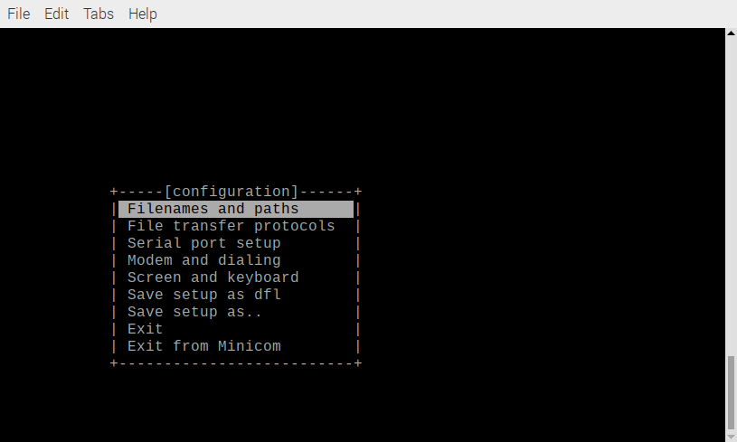
Scroll down to “Serial port setup”

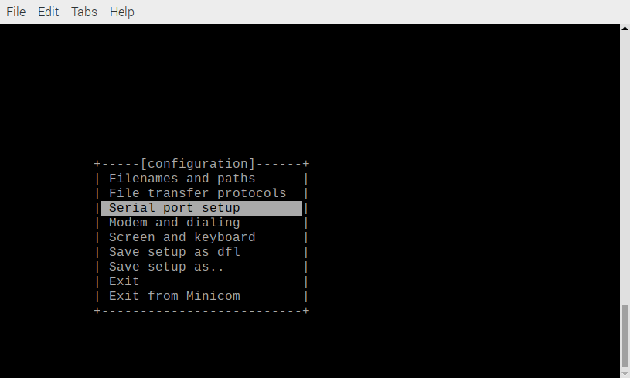
Depress Enter

Configure ttyUSB0

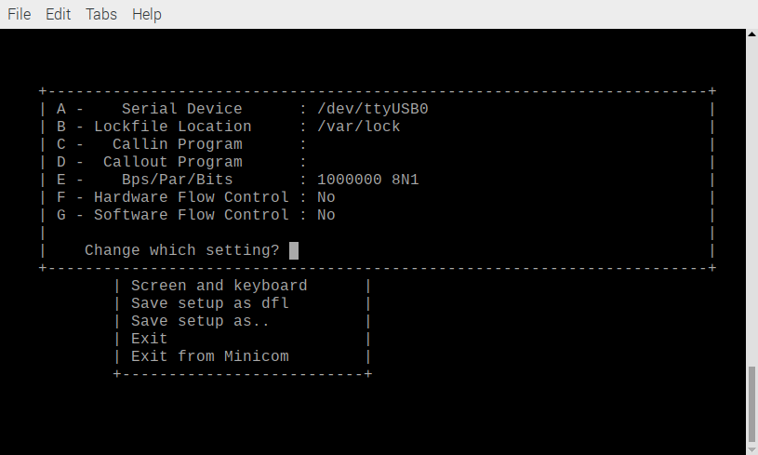
Depress Enter

Scroll down to “Exit”

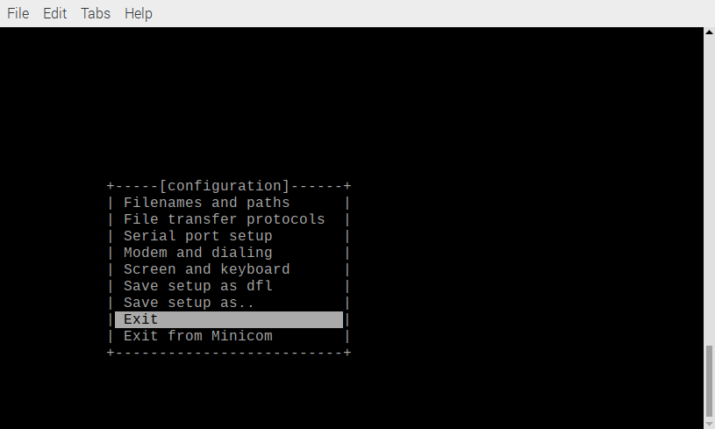
Depress Enter

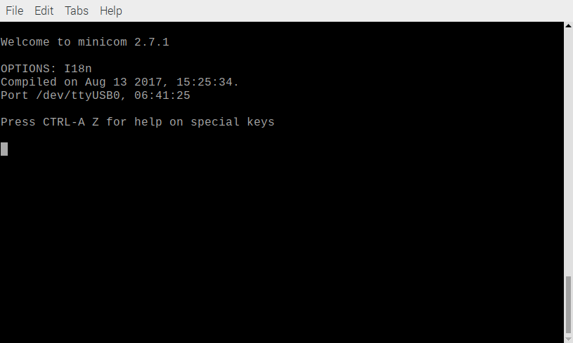
The file “r.bin” will be sent. The file needs to be in /root folder.

Depress “ctrl A S”

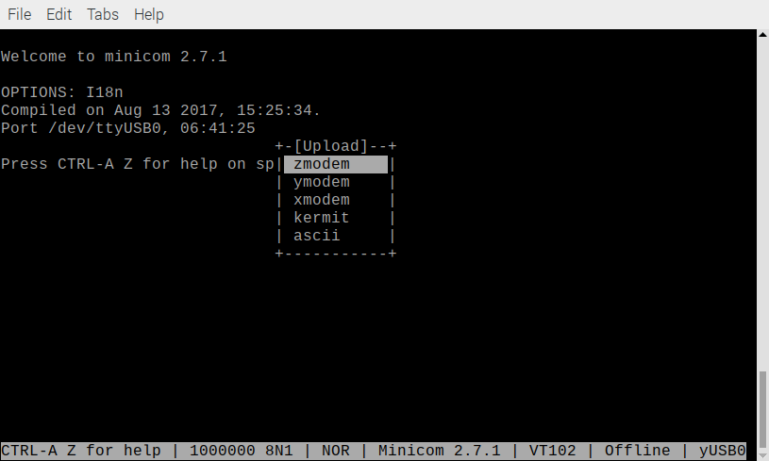

Scroll down to ascii.

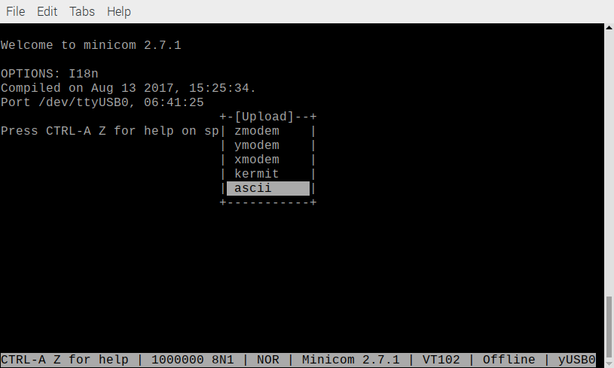
Depress Enter

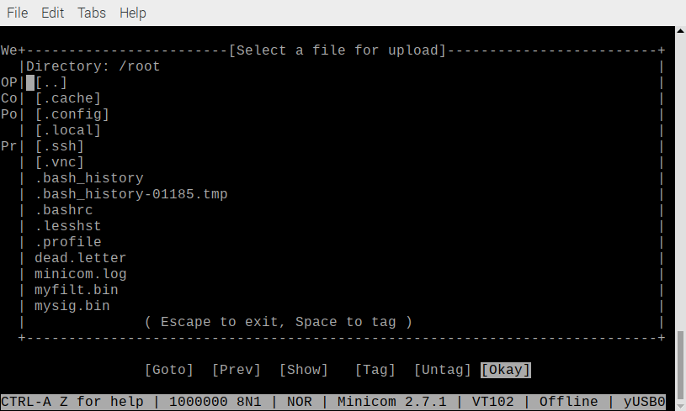
scroll down to “r.bin”

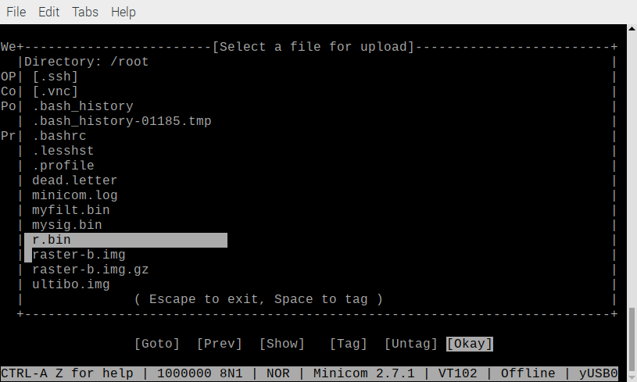

Depress Enter. The transfer will begin.

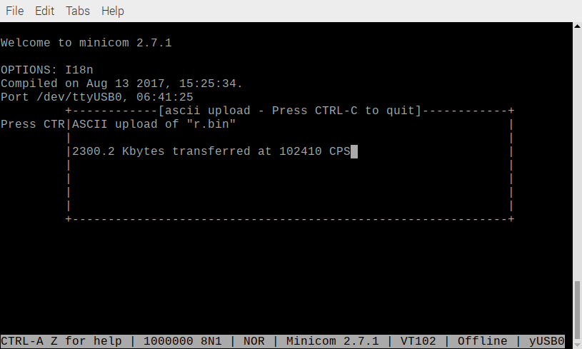
When the file is sent.

