******************************Draft******************************
uart_advanced pi400-1
11/15/21
******************************Draft******************************

The Raspberry Pi Pico was programmed with “uart_advanced.uf2”.

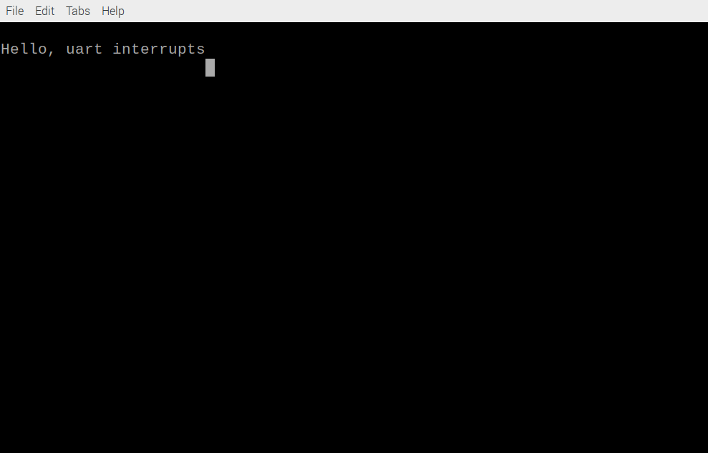

This is running on the pi400-1 The character 1234567890 were typed. The received characters started at 23456789:1.

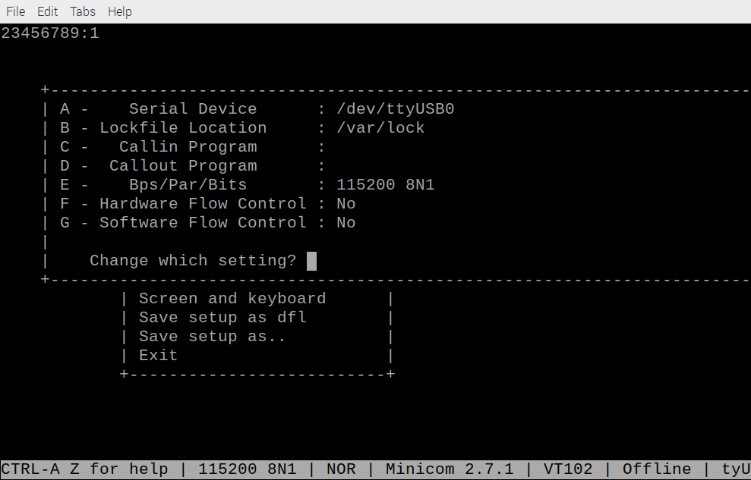

From the getting started

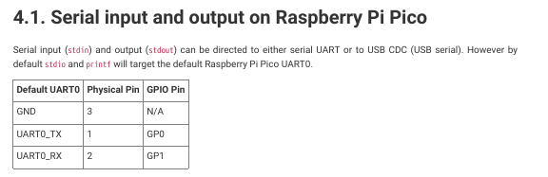

Uart Advanced
pico pin 1 red GP0
pico pin 2 yellow GP1
pico pin 3 blue GRD

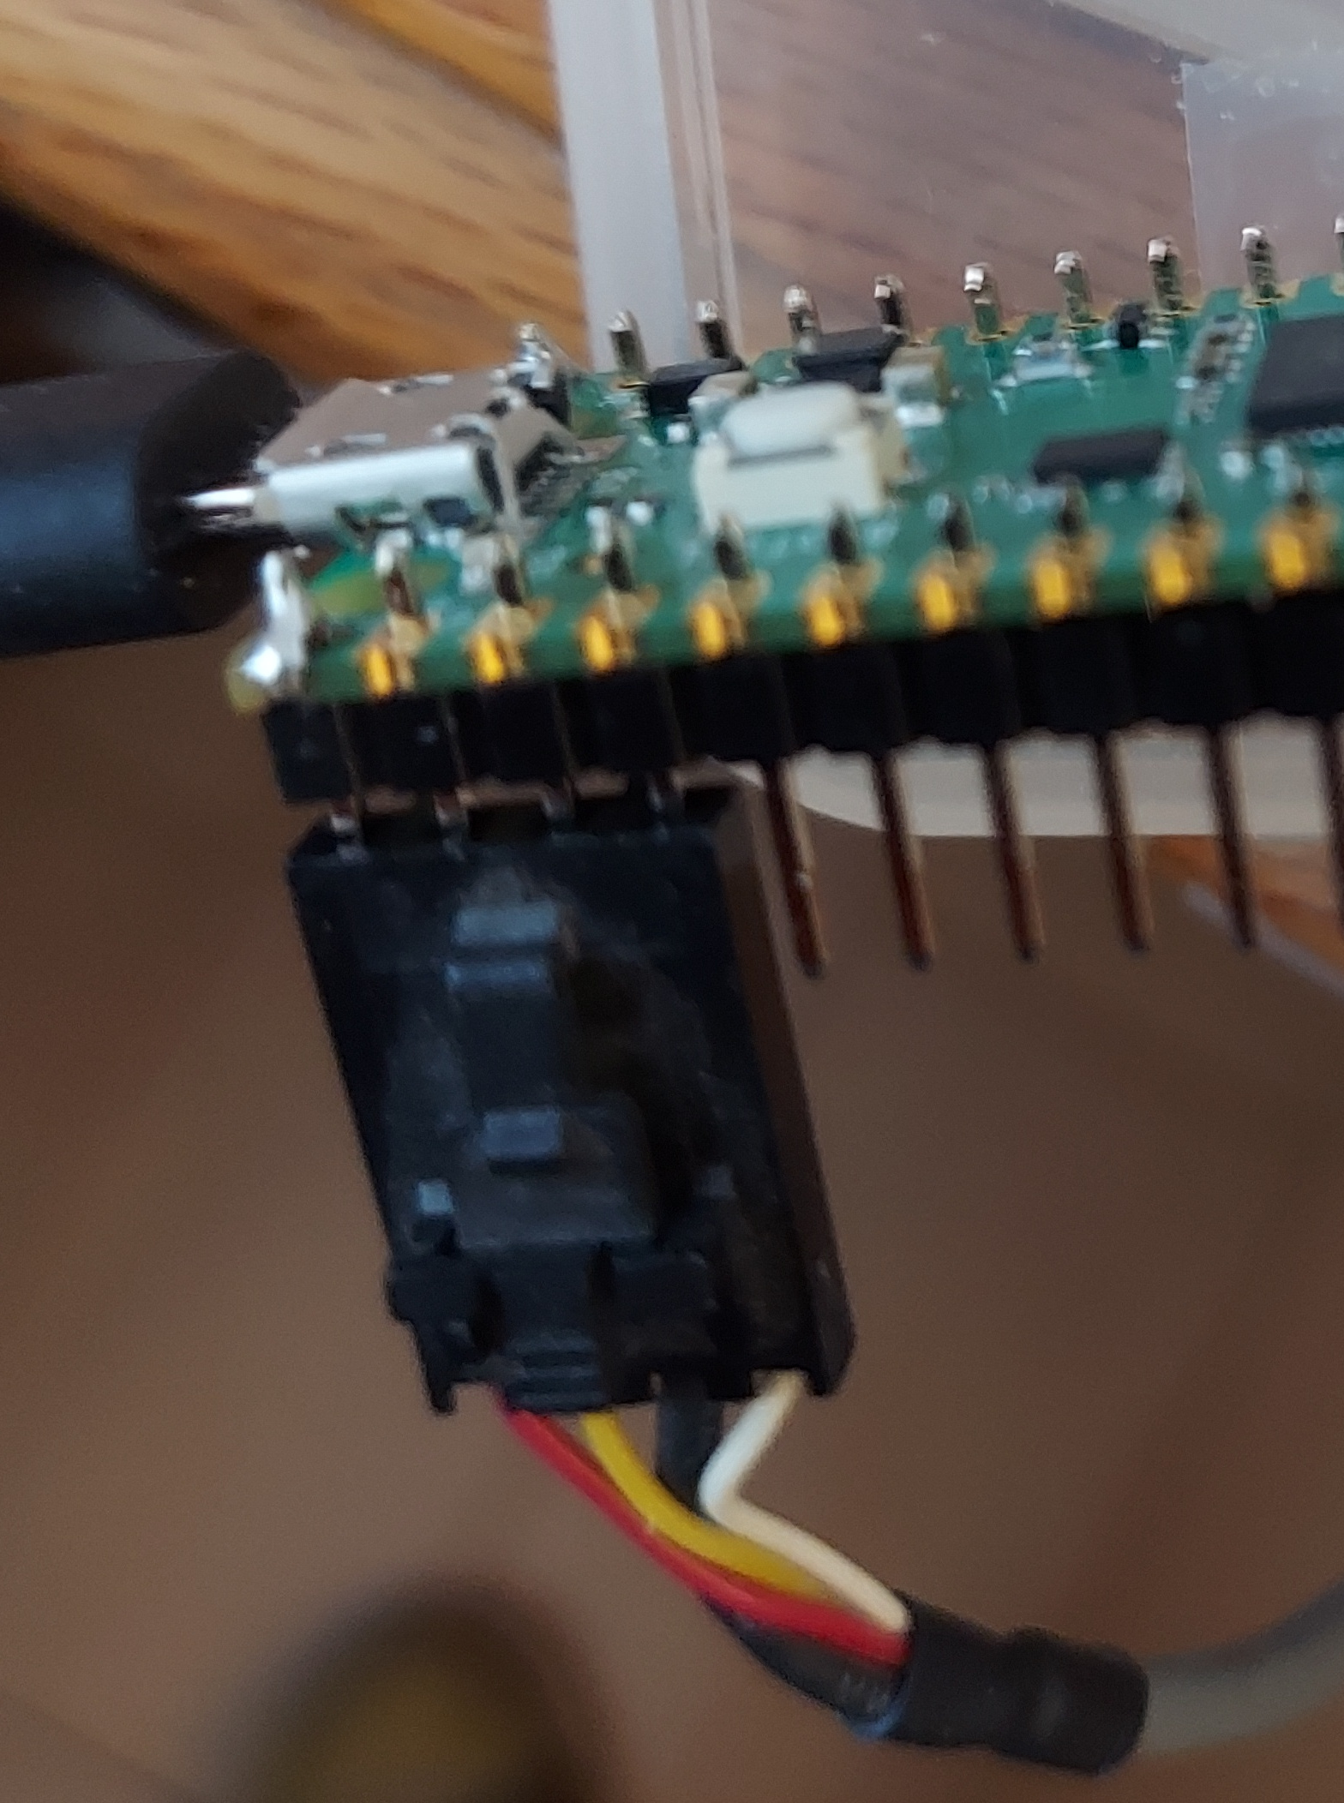
Pin 1 red is continued as black.
Pin 2 yellow is continued as red.
Pin 3 blue is continued as green.
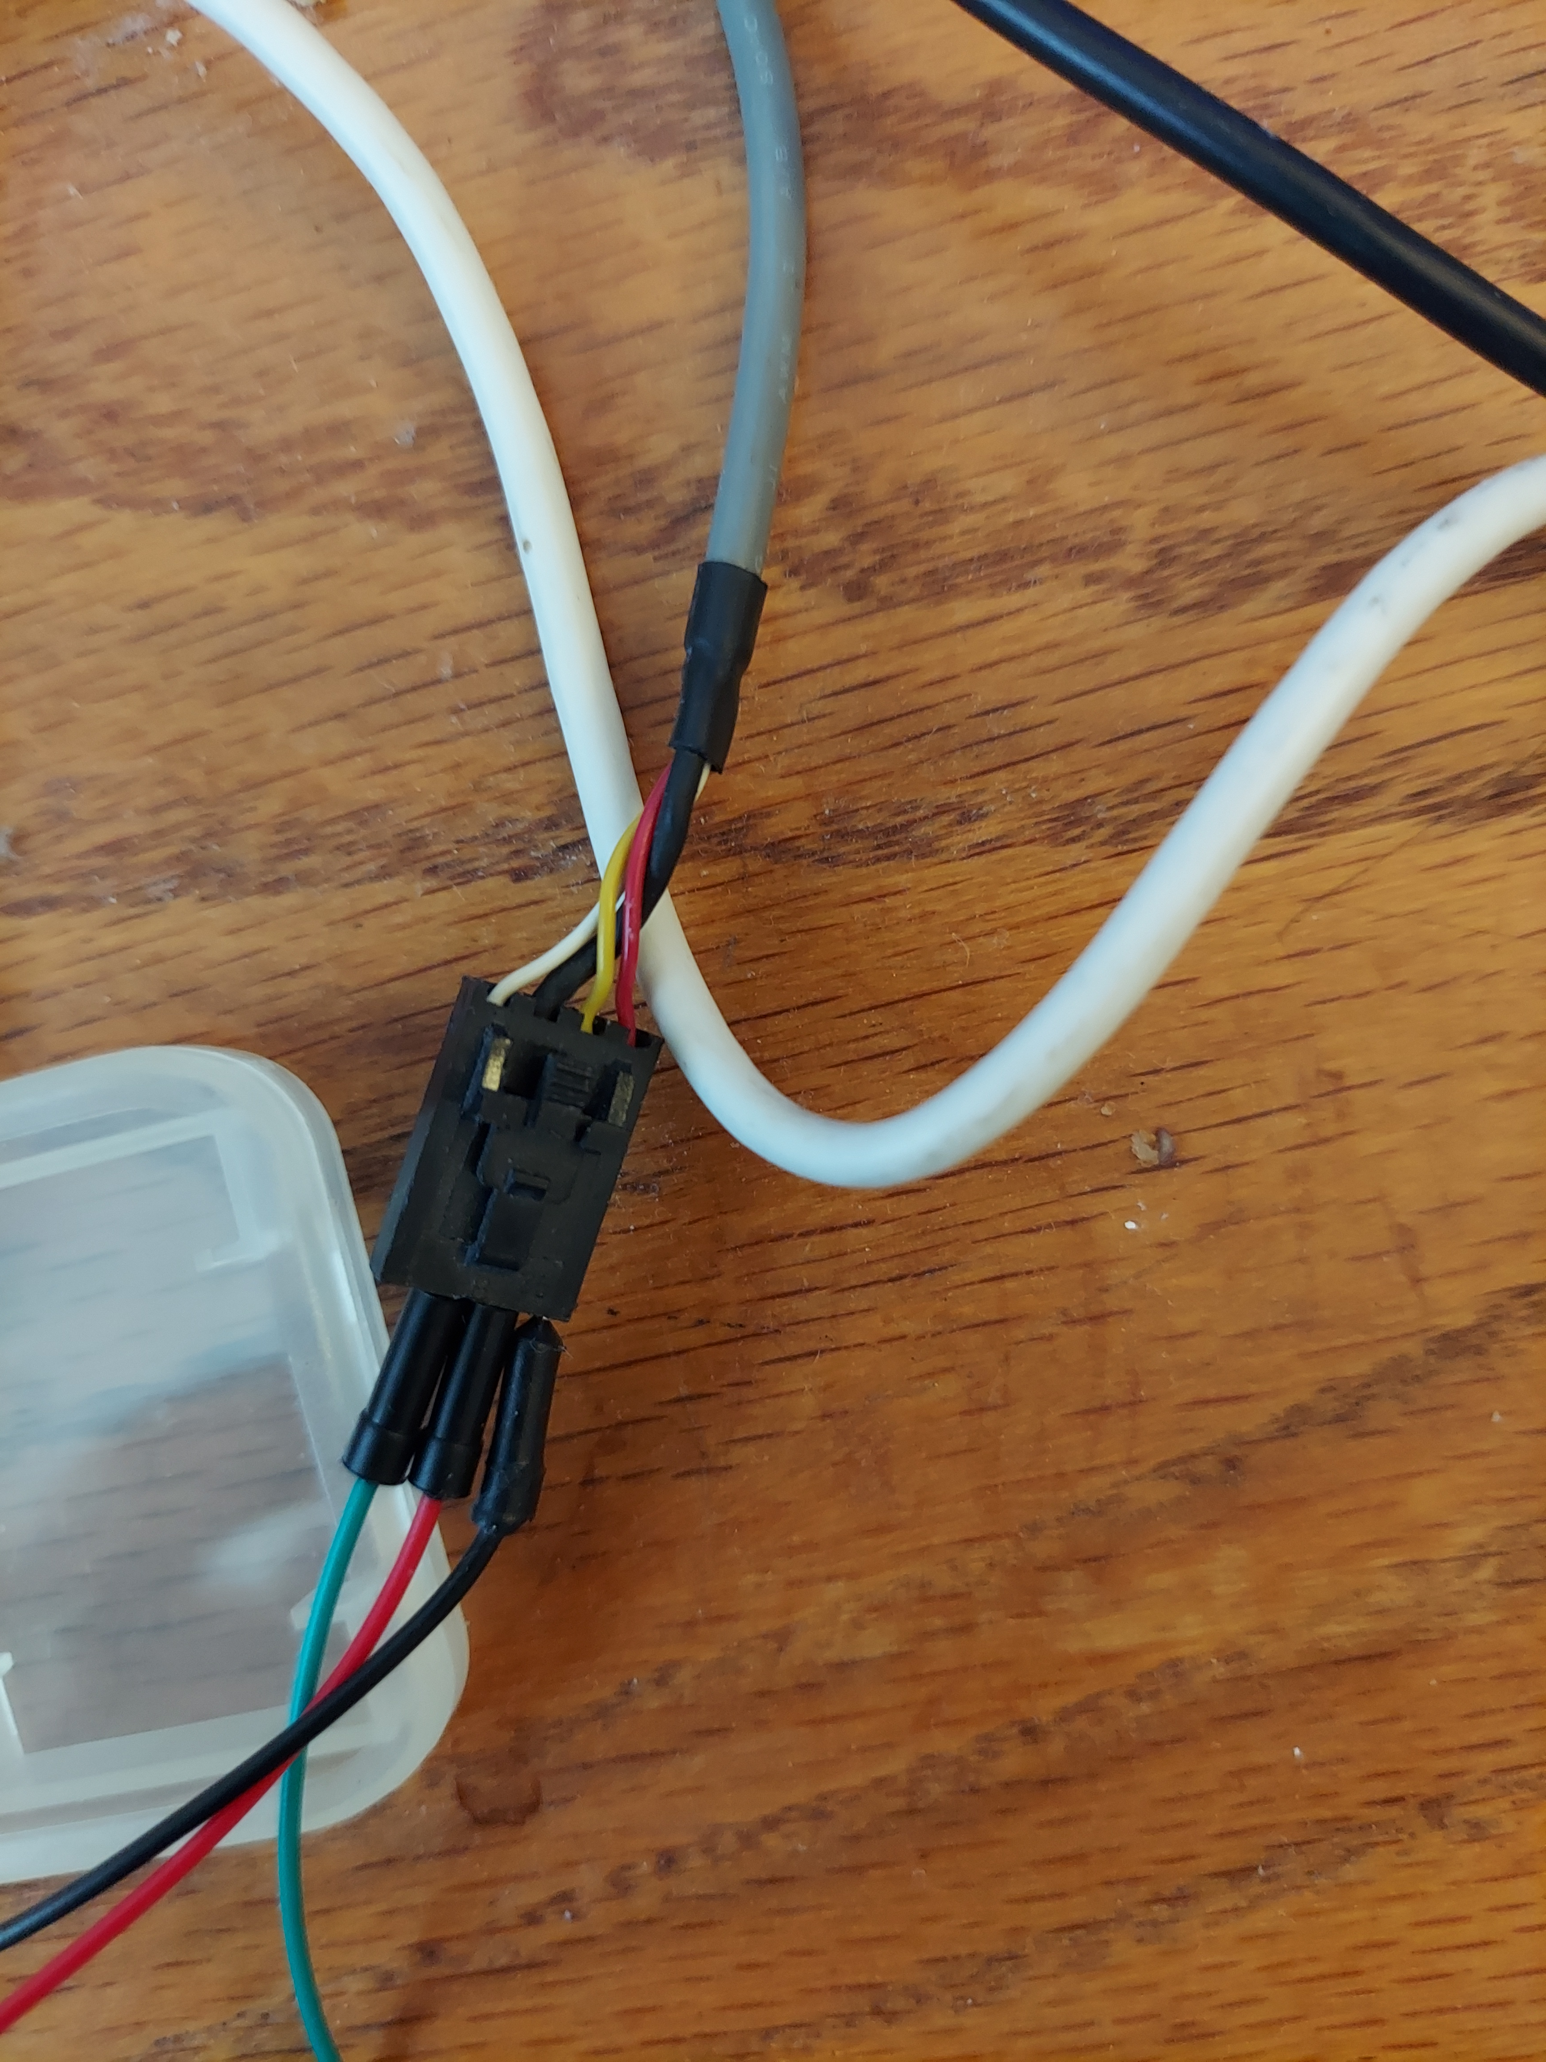
red black
yellow red continues as white pin 5 pmodusb.
blue green continues as green pin 3 pmodusb.

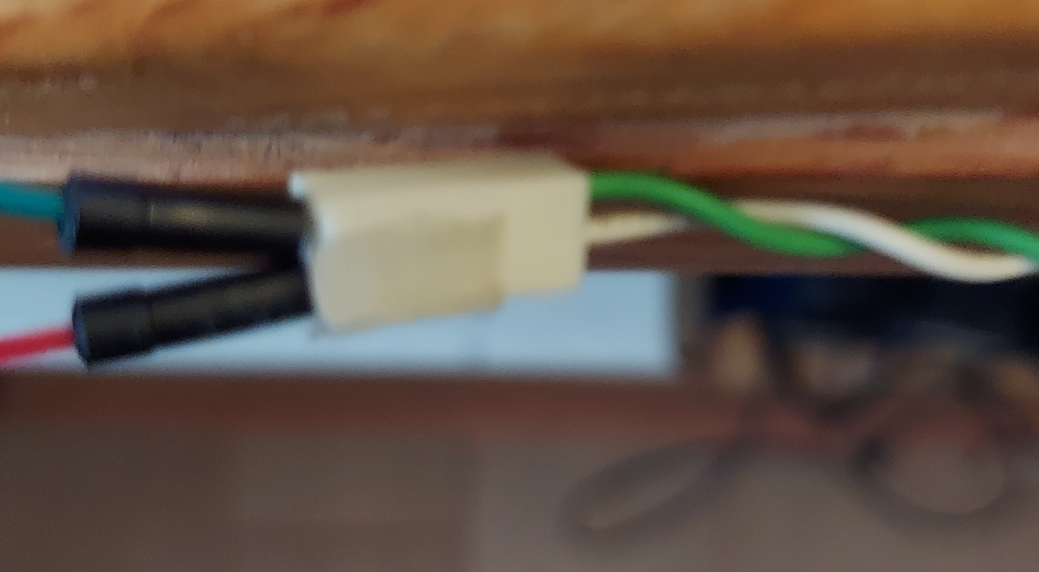
The blue wire is connected to a 2 pin blue. The output of the end which is extended to black wire is connecter to pmodusb pin 2 which is the RX.

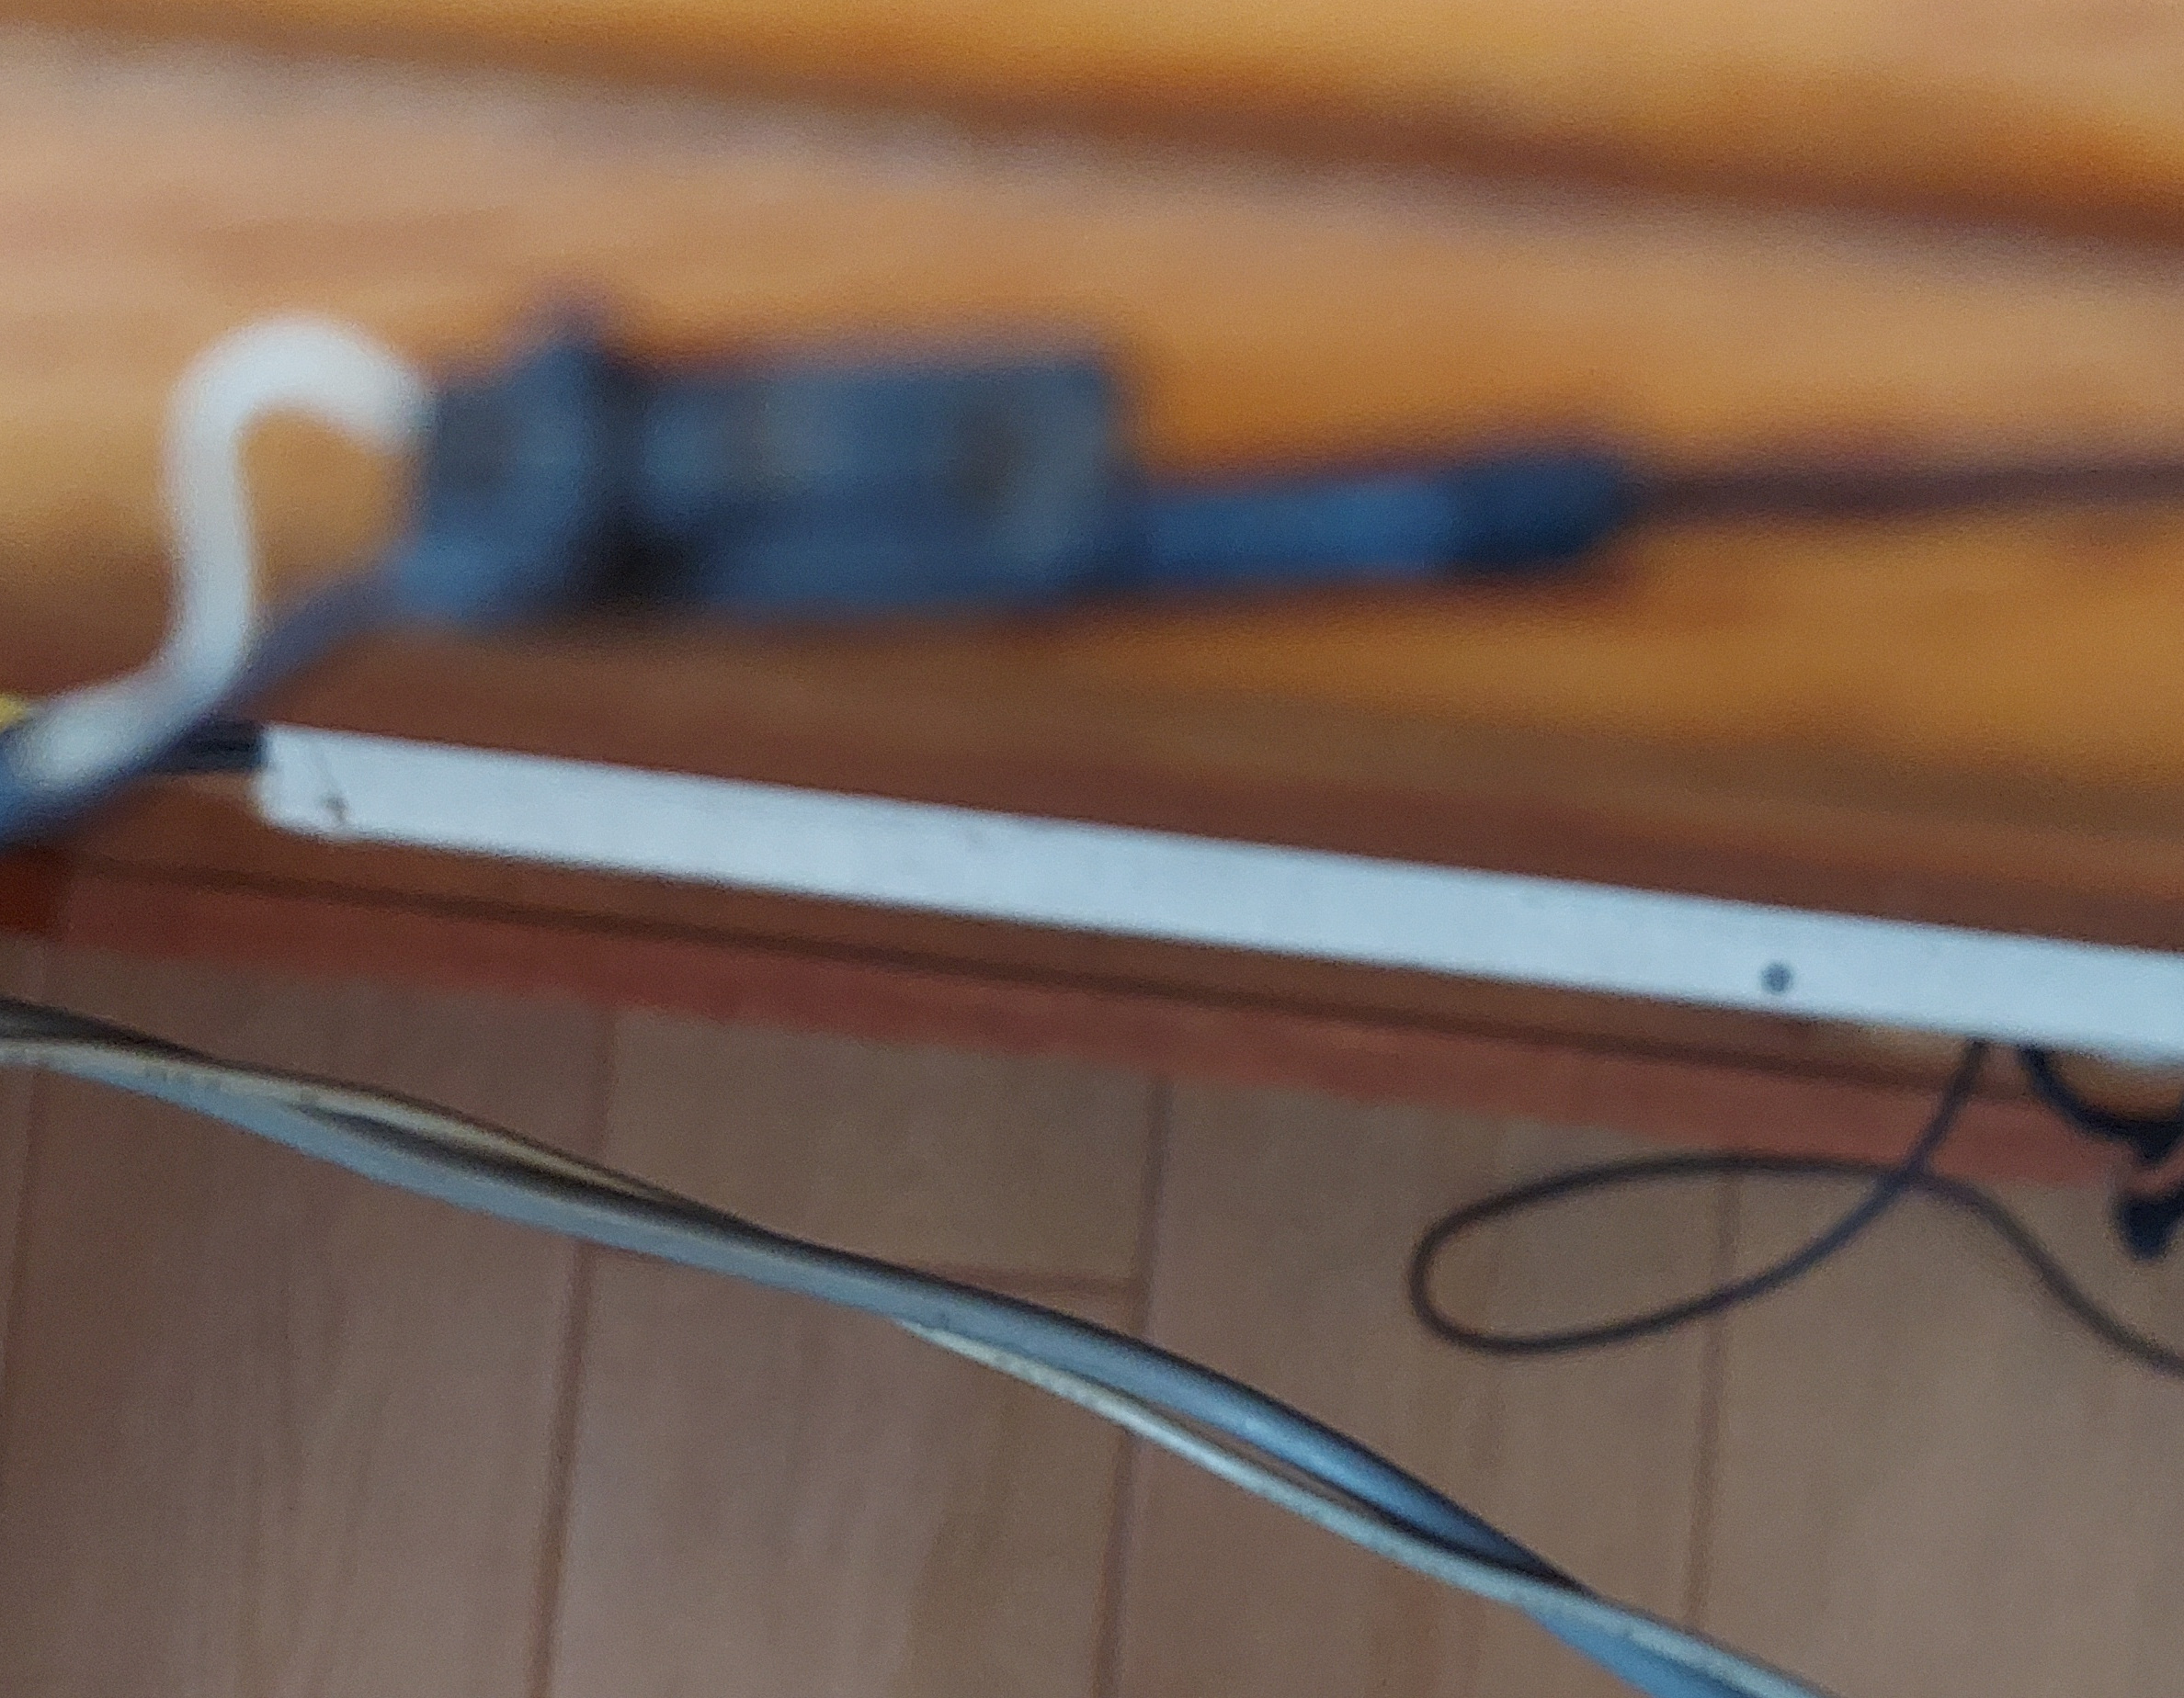
The end blue continues black to bin 2 of pmodusb RX

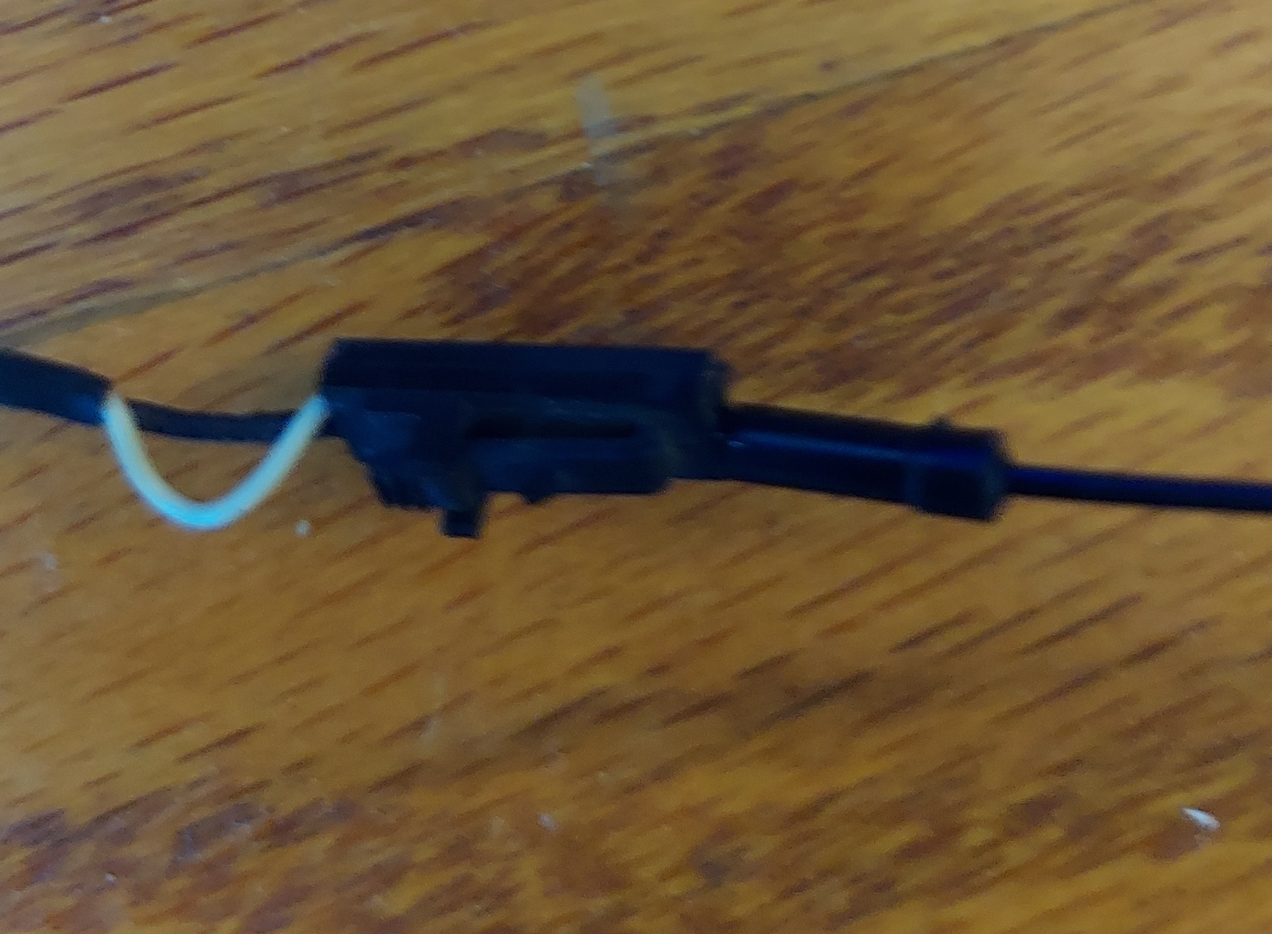
ttyUSB0

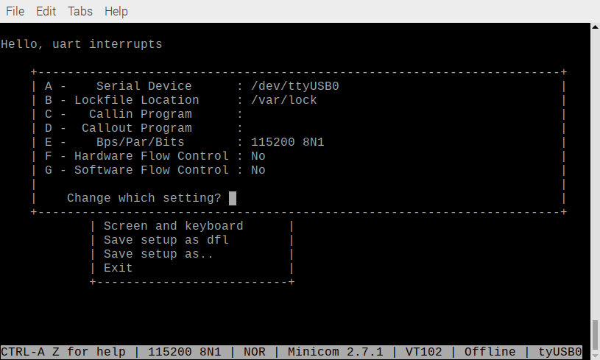
When you connect the pico to USB of the RPi4.
Line 80 uart_puts(UART_ID, "\nHello, uart interrupts\n");


