******************Draft******************
Pico Lifting Step
Led On/Off
Using TinyUSB
12/18/21
******************Draft******************

Testing Two picos connected to RPi4B.
These test were perform with updated pico-sdk

commit 2062372d203b372849d573f252cf7c6dc2800c0a (HEAD -> master, origin/master, origin/HEAD)
Author: Graham Sanderson <graham.sanderson@raspberrypi.com>
Date: Mon Nov 1 14:20:54 2021 -0500

SDK 1.3.0 release

See release notes for details

Co-authored-by: Brian Cooke <bdscooke@gmail.com>
Co-authored-by: Luke Wren <wren6991@gmail.com>
Co-authored-by: Uri Shaked <uri@urishaked.com>
Co-authored-by: Zapta <zapta@users.noreply.github.com>
Co-authored-by: Andrew Scheller <andrew.scheller@raspberrypi.com>
Co-authored-by: Liam Fraser <liam@raspberrypi.com>
Co-authored-by: Gabriel Wang <embedded_zhuoran@Hotmail.com>
Co-authored-by: Matias Silva <matita.martins@gmail.com>
Co-authored-by: dp111 <19616418+dp111@users.noreply.github.com>
Co-authored-by: Leonardo La Rocca <46094699+leoli51@users.noreply.github.com>
Co-authored-by: Mahyar Koshkouei <mk@deltabeard.com>
Co-authored-by: Brian Starkey <stark3y@gmail.com>
Co-authored-by: Philip Howard <github@gadgetoid.com>
The picos were program by copying the uf2 to each of the picos
devel@mypi3-20:/opt/pico-examples/build/blink_led $ ls blink_led.uf2
blink_led.uf2
devel@mypi3-20:/opt/pico-examples/build/hello_world/usb $ ls hello_usb.uf2
hello_usb.uf2
In the image below in lower right hand corner is pico with the led on done with the shell on the left at 115200 Baud.
In the shell on the right a lifting step was done at 1MBaud.

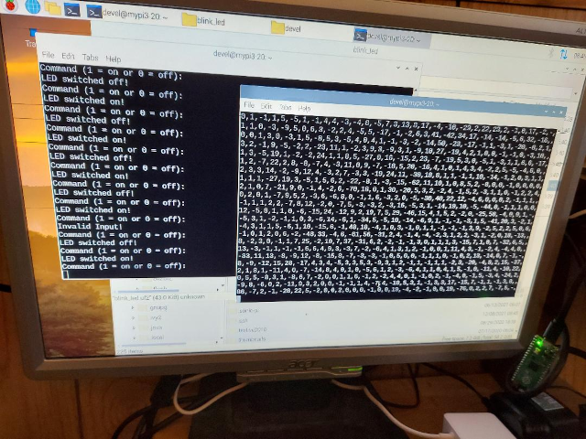

In the image below in lower right hand corner is pico with the led off done with the shell on the left at 115200 Baud.
In the shell on the right a lifting step was done at 1MBaud.

In the shell on the right selecting a64.bin which file to send the pico.
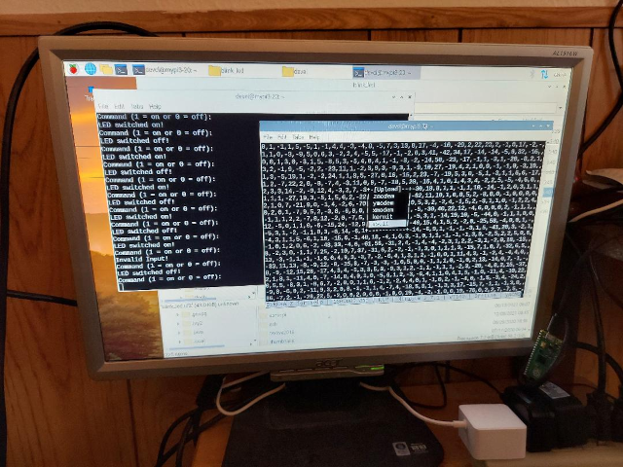
In the image below in lower right hand corner is pico with the led off done with the shell on the left at 115200 Baud.

