******************Draft******************
Raspberry Pico Hello World program
Data Serial Transfers

11/07/21
******************Draft******************

When the Raspberry Pico was connected to the RPi4 usb while hoiding the BOOTSEL switch it mount as a usb drive.
ls /media/devel/RPI-RP2/
INDEX.HTM INFO_UF2.TXT

To compile the program and create the hello_usb.uf2 requires the Raspberry Pico SDK.
https://www.youtube.com/watch?v=UZwq3eb5My0 I used the video to installed the Raspberry Pico SDK.

devel@mypi3-20:/opt/pico-examples/build/hello_world/usb $ cp hello_usb.uf2 /media/devel/RPI-RP2/
When this copy is done the Raspberry Pico unmouts and starts running the hello_world program.

sudo minicom -s
[sudo] password for devel:

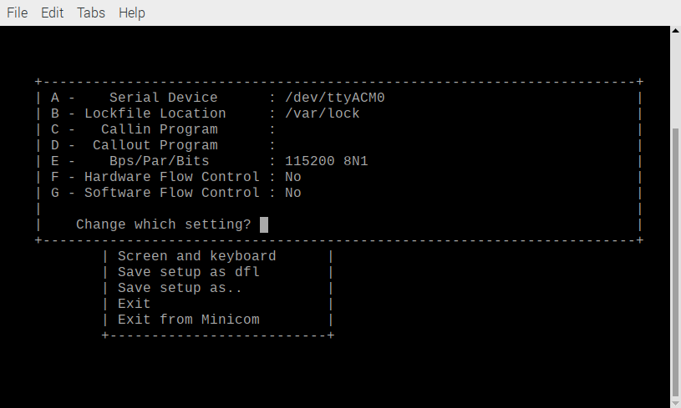
Below is the Raspberry Pico sending Hello, world! at 115000 8N1.
