**************Default**************
Testing Pico MultiCore
01/15/22
**************Default**************

PmodUSBUART
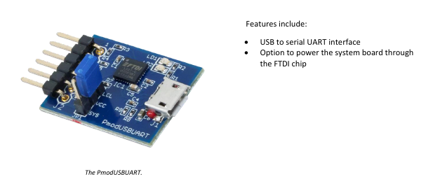

Pico PmodUSBUART
Orange pin 1 TX pin 2 RX
White pin 2 RX pin 3 TX
Black pin 3 GRD pin 5 GRD

export PATH=~/local/openocd/bin:$PATH

devel@mypi3-20:/opt/pico-examples/build $

openocd -f interface/raspberrypi-swd.cfg -f target/rp2040.cfg -c "program multicore/multicore_runner/multicore_runner.elf verify reset exit"

Hello, multicore_runner!
Factorial 10 is 3628800
Fibonacci 10 is 0

openocd -f interface/raspberrypi-swd.cfg -f target/rp2040.cfg -c "program multicore/hello_multicore/hello_multicore.elf verify reset exit"

Hello, multicore!
It's all gone well on core 0!

openocd -f interface/raspberrypi-swd.cfg -f target/rp2040.cfg -c "program multicore/multicore_fifo_irqs/multicore_fifo_irqs.elf verify reset exit"

Hello, multicore_fifo_irqs!
Irq handlers should have rx'd some stuff - core 0 got 0, core 1 got 0!
Minicom Baud Rate

