***********************Draft***********************
Raspberry Pico. 2021
Motorola 68000 1980
07/22/22
***********************Draft***********************

Raspberry Pico-W
This version same pico but now supports WIFI.
The pico-sdk provides several examples.
iperf
ntp_client
tcp_client
tcp_server
/access_point
wifi_scan
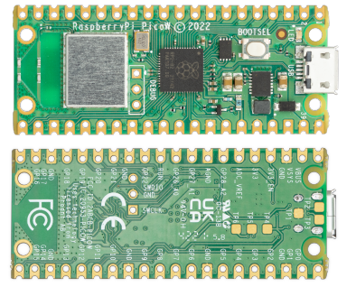

Raspberry Pico.

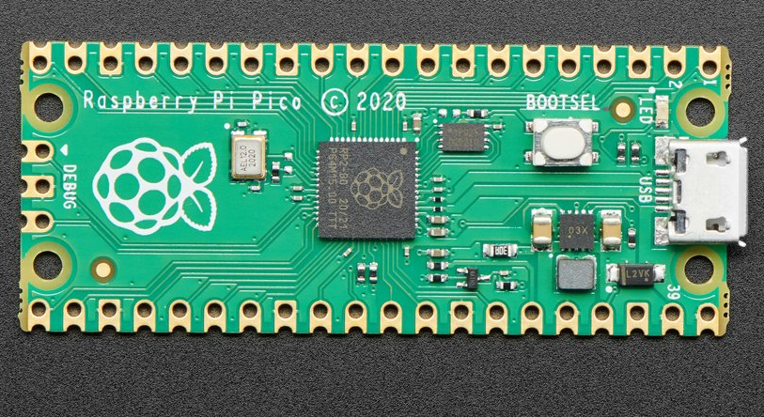

Back
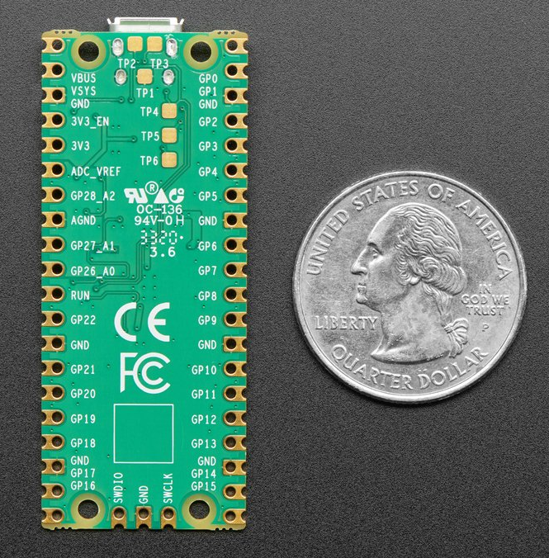

Raspberry Pi Pico RP2040
Product ID: 4864
$4.00

- 21 mm × 51 mm form factor
- RP2040 microcontroller chip designed by Raspberry Pi in the UK
- Dual-core Arm Cortex-M0+ processor, flexible clock running up to 133 MHz
- 264KB on-chip SRAM
- 2MB on-board QSPI Flash
- 26 multifunction GPIO pins, including 3 analogue inputs
- 2 × UART, 2 × SPI controllers, 2 × I2C controllers, 16 × PWM channels
- 1 × USB 1.1 controller and PHY, with host and device support
- 8 × Programmable I/O (PIO) state machines for custom peripheral support
- Supported input power 1.8–5.5V DC
- Operating temperature -20°C to +85°C
- Castellated module allows soldering direct to carrier boards
- Drag-and-drop programming using mass storage over USB
- Low-power sleep and dormant modes
- Accurate on-chip clock
- Temperature sensor
- Accelerated integer and floating-point libraries on-chip

The Motorola 68000 Educational Computer Board (MEX68KECB) was a development board
for the Motorola 68000 microprocessor, introduced by Motorola in 1981.
It featured the 68K CPU, memory, I/O devices and built-in educational and training software.

CPU: 4-MHz Motorola 68000
RAM: 32KB
ROM: 16KB
9600 baud serial port for dumb terminal connection
9600 baud serial port for host computer connection
Parallel port for communication and printer connection
Audio output for tape storage
24-bit programmable interval timer
Wire-wrap area for custom circuitry
Required power voltage: 12V and 5V

The price of the Motorola ECB at launch was $495[1] which was
relatively inexpensive for a computer with an advanced for that time 16-bit CPU.

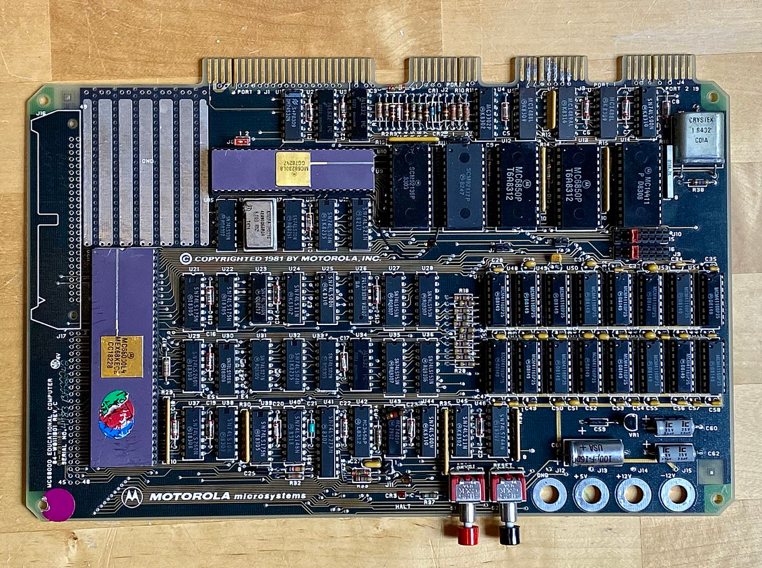
A Motorola MEX68KECB Microcomputer, circa 1981. This microcomputer is based on a
Motorola 68000 16/32-bit microprocessor.

