***************************Draft***************************
Code clean up and getting a more reliable Compile
with TinyUSB
01/07/22
***************************Draft***************************

Some are using are Window OS for there development work. I for one, are using Raspberry Pi O/S with the following tools ( binutils-arm-none-eabi, gcc-arm-none-eabi, libnewlib-arm-none-eabi, Open On-Chip Debugger 0.10.0+dev-g71510a7-dirty (2021-08-15-17:08), pico-sdk 1.3, git and gitk) Bullseye on my RPi4B with 8 Gb.

We were having issues with the pico working with Ultibo Bare Metal.

Paul Wrote

Attached is my Ultibo and Pico test files. The compiled uf2 file is included if you can't compile the pico source.
All the Pico program does is to transmit the word "pulsing" every half second which is received by the Ultibo program.
Regards
Paul

CmakeLists.txt
cmake_minimum_required(VERSION 3.12)
include($ENV{PICO_SDK_PATH}/external/pico_sdk_import.cmake)
project(test C CXX ASM)
set(CMAKE_C_STANDARD 11)
set(CMAKE_CXX_STANDARD 17)

pico_sdk_init ()
add_executable(${PROJECT_NAME}
main.c
)

pico_add_extra_outputs(${PROJECT_NAME})

target_link_libraries(${PROJECT_NAME}
pico_stdlib
)

pico_enable_stdio_usb(${PROJECT_NAME} 1)
pico_enable_stdio_uart(${PROJECT_NAME} 0)

main.c
#include <stdio.h>
#include <stdlib.h>
#include "pico/stdlib.h"
#include <string.h>
#include <ctype.h>

int flag = 0;
const int led_pin = 25;

bool timer_callback(struct repeating_timer *t)
{
printf ("pulsing\r");
flag = !flag;
gpio_put (led_pin, flag);
return true;
}

int main ()
{
struct repeating_timer timer;

gpio_init (led_pin);
gpio_set_dir (led_pin, GPIO_OUT);
stdio_init_all();
add_repeating_timer_ms(500, timer_callback, NULL, &timer);

while (true)
{
sleep_ms (50);
} // main loop
}

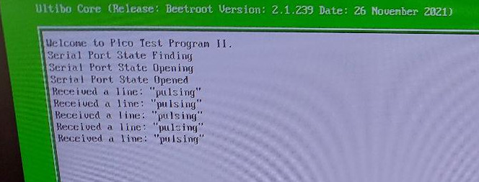

This Ultibo code detects the pico using TinyUSB. This is reliable using Window putty following transfer test.uf2 to the pico. I is also reliable using openocd to program the pico and minicom to test the output.
export PATH=~/local/openocd/bin:$PATH

cd /opt/pico-examples/build

openocd -f interface/raspberrypi-swd.cfg -f target/rp2040.cfg -c "program pulsing/test.elf verify reset exit"

sudo minicom -s

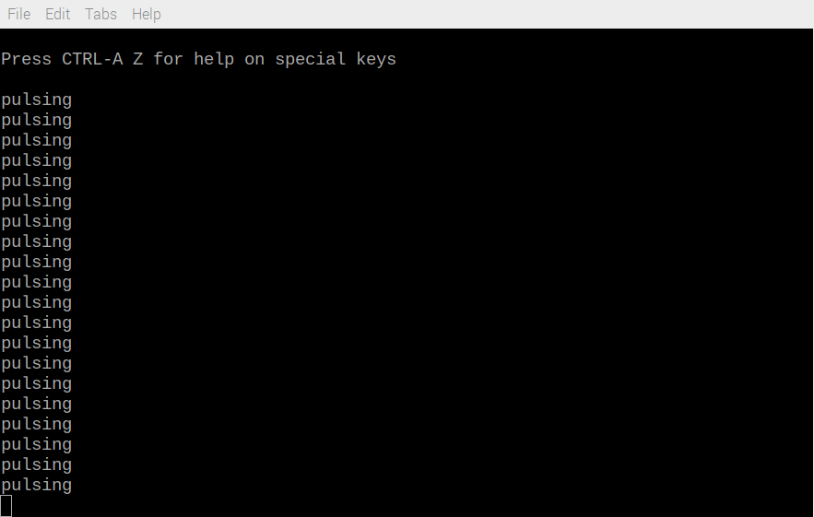

Paul Wrote,

t took me a number of attempts using various online guides to eventually setup the pico environment on a Windows machine.
I finally used the following
https://www.youtube.com/watch?v=B5rQSoOmR5w
https://www.digikey.com/en/maker/proje ... 0f39ae8422
and after numerous trials, managed to get it going.
It uses WinGW instead of NMake which means you don't have to start MS Visual Studio Code from the command prompt.
Also use CMake 3.19 as .20 and .21 have bugs. Another gotcha is that you need to restart VCS each time you make a change to the extensions or settings.
The inside of the CMakeList.txt was shown in these pages and now all I do is copy the file accross, change the program name and add any additinal libries (such as harware).
Regards
Paul

After testing his code I decided ti try his methods on my code.

The initial code was developed using /opt/pico-examples/helloworld/usb/hello_usb.c

To clean the code
cmake --version
cmake version 3.18.4

CMake suite maintained and supported by Kitware (kitware.com/cmake).

Add openocd to your PATH env.

export PATH=~/local/openocd/bin:$PATH

cd /opt/pico-examples/build
Now opendocd can be used with Single Wire Debubber SWD to load programs onto the pico.

/opt/pico-examples/build $ openocd -f interface/raspberrypi-swd.cfg -f target/rp2040.cfg -c "program hello_world/usb/hello_usb.elf verify reset exit"

/opt/pico-examples/build $ openocd -f interface/raspberrypi-swd.cfg -f target/rp2040.cfg -c "program lifting/test1.elf verify reset exit"

sudo minicom -s
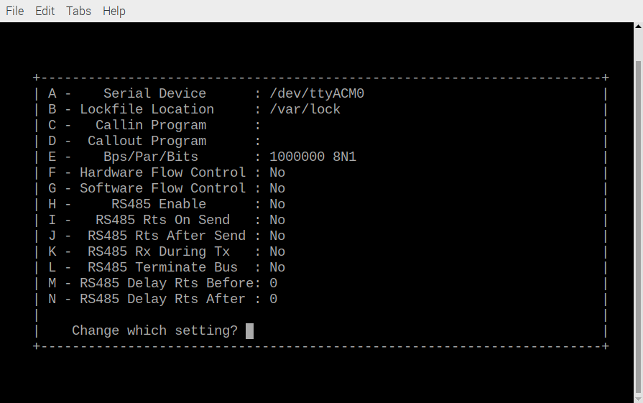
/opt/pico-examples/build $ openocd -f interface/raspberrypi-swd.cfg -f target/rp2040.cfg -c "program hello_world/usb/hello_usb.elf verify reset exit"
or
/opt/pico-examples/build $ openocd -f interface/raspberrypi-swd.cfg -f target/rp2040.cfg -c "program lifting/test1.elf verify reset exit"

Sending the data for computing the lifting dwt

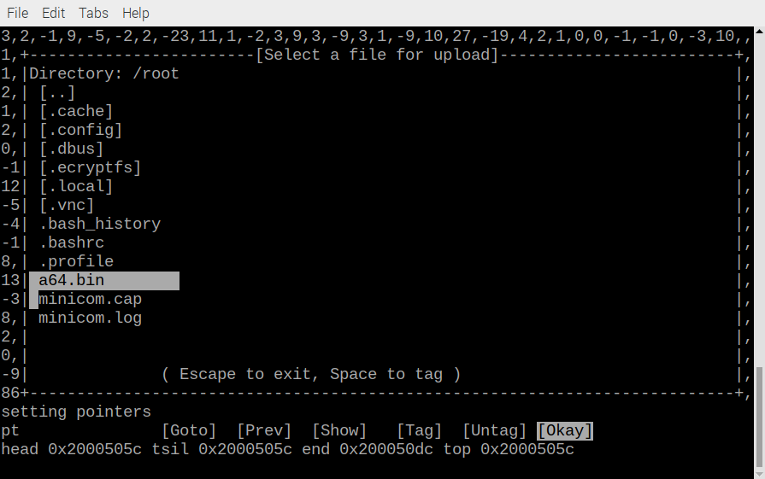
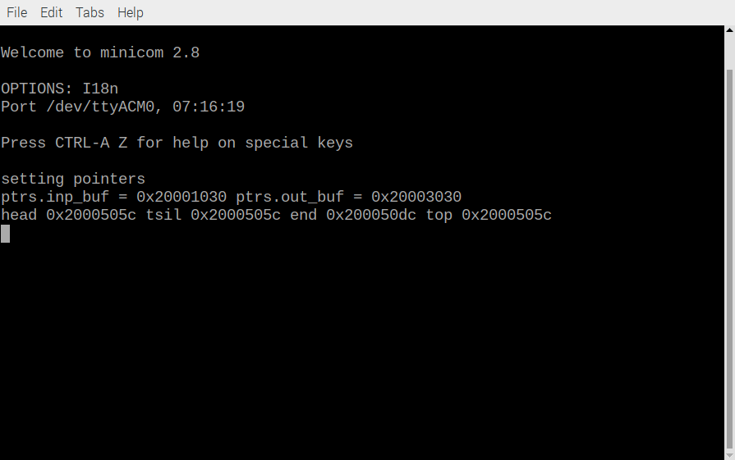
Once the data has been sent.

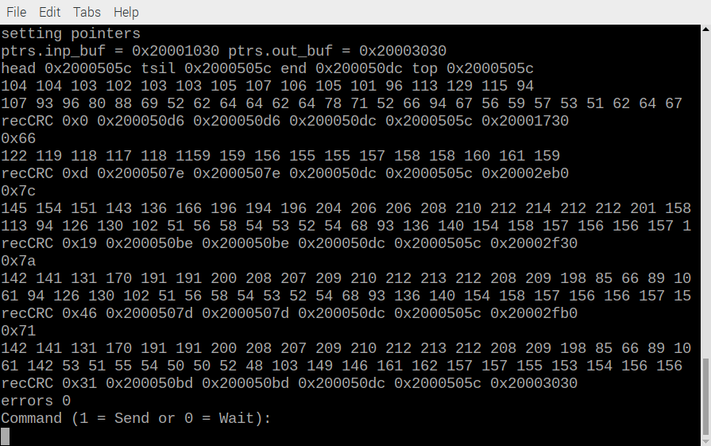
Now the results of the lifting DWT

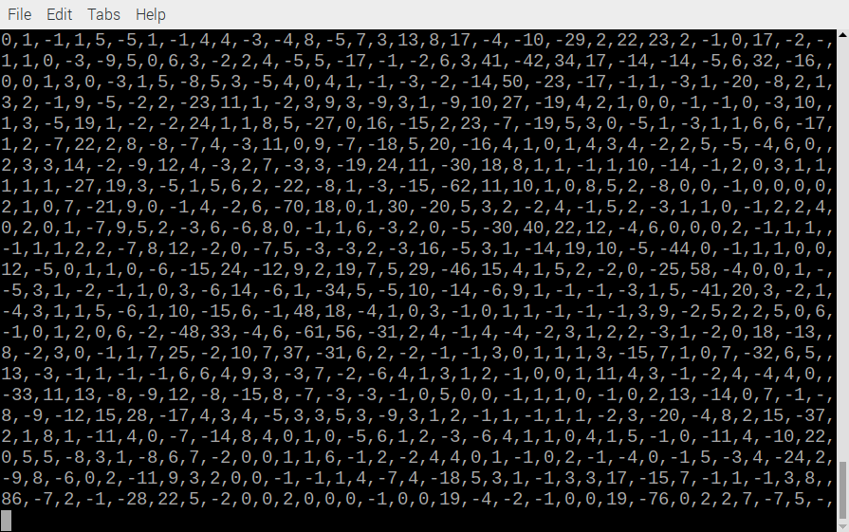

All code is contained in 1 file /opt/pico-examples/lifting/main.c

/opt/pico-examples/build/lifting $ diffuse ../../lifting/main.c ../../hello_world/usb/hello_usb.c

commit d4309451416d2a60c912130a901841274d115fa8 (HEAD)
Author: Ed Vidal Jr <devel@pi4-23.attlocal.net>
Date: Thu Jan 6 16:48:58 2022 -0700

testing using folder pico_examples/lifting with the same process
used by Paul on pulsing.

/opt/pico-examples/build $ git checkout d4309
The image below was gitk &

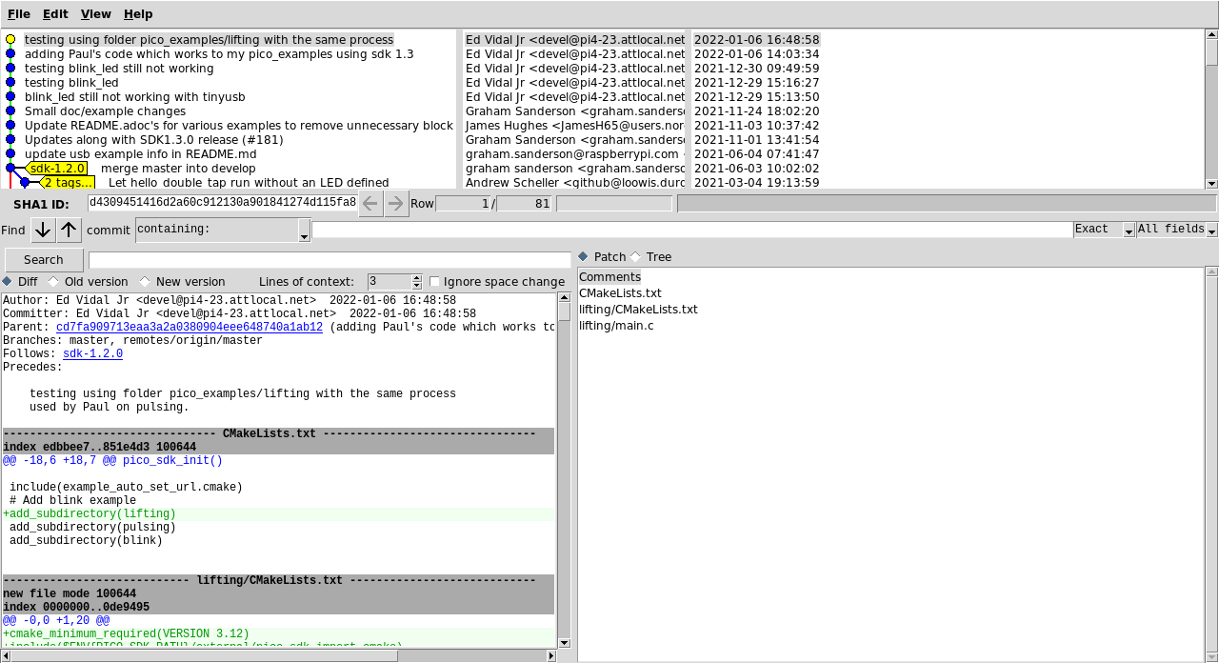

/opt/pico-examples/build $ cmake ..
PICO_SDK_PATH is /opt/pico-sdk
PICO platform is rp2040.
PICO target board is pico.
Using board configuration from /opt/pico-sdk/src/boards/include/boards/pico.h
TinyUSB available at /opt/pico-sdk/lib/tinyusb/src/portable/raspberrypi/rp2040; enabling build support for USB.
-- Configuring done
-- Generating done
-- Build files have been written to: /opt/pico-examples/build

/opt/pico-examples/build/lifting $ make clean; make
[ 0%] Creating directories for 'ELF2UF2Build'
[ 0%] No download step for 'ELF2UF2Build'
[ 0%] No update step for 'ELF2UF2Build'
[ 0%] No patch step for 'ELF2UF2Build'
[ 0%] Performing configure step for 'ELF2UF2Build'
-- Configuring done
-- Generating done
-- Build files have been written to: /opt/pico-examples/build/elf2uf2
[ 0%] Performing build step for 'ELF2UF2Build'
[100%] Built target elf2uf2
[ 0%] No install step for 'ELF2UF2Build'
[ 0%] Completed 'ELF2UF2Build'
[ 0%] Built target ELF2UF2Build
[ 0%] Built target bs2_default
[ 0%] Built target bs2_default_padded_checksummed_asm
[ 0%] Building C object lifting/CMakeFiles/test1.dir/main.c.obj
/opt/pico-examples/lifting/main.c: In function 'lifting':
/opt/pico-examples/lifting/main.c:222:11: warning: iteration 3 invokes undefined behavior [-Waggressive-loop-optimizations]
ov[lvl] = offset + ((lvl)?(ov[lvl-1]):0);
~~~~~~~~^~~~~~~~~~~~~~~~~~~~~~~~~~~~~~~~
/opt/pico-examples/lifting/main.c:194:2: note: within this loop
for(lvl=0; lvl<LVLS; lvl++) {
^~~
[ 0%] Building C object lifting/CMakeFiles/test1.dir/opt/pico-sdk/src/rp2_common/pico_stdlib/stdlib.c.obj
[ 0%] Building C object lifting/CMakeFiles/test1.dir/opt/pico-sdk/src/rp2_common/hardware_gpio/gpio.c.obj
[ 0%] Building C object lifting/CMakeFiles/test1.dir/opt/pico-sdk/src/rp2_common/hardware_claim/claim.c.obj
[ 0%] Building C object lifting/CMakeFiles/test1.dir/opt/pico-sdk/src/rp2_common/pico_platform/platform.c.obj
[ 0%] Building C object lifting/CMakeFiles/test1.dir/opt/pico-sdk/src/rp2_common/hardware_sync/sync.c.obj
[ 0%] Building C object lifting/CMakeFiles/test1.dir/opt/pico-sdk/src/rp2_common/hardware_uart/uart.c.obj
[ 0%] Building ASM object lifting/CMakeFiles/test1.dir/opt/pico-sdk/src/rp2_common/hardware_divider/divider.S.obj
[ 0%] Building C object lifting/CMakeFiles/test1.dir/opt/pico-sdk/src/common/pico_time/time.c.obj
[ 0%] Building C object lifting/CMakeFiles/test1.dir/opt/pico-sdk/src/common/pico_time/timeout_helper.c.obj
[ 0%] Building C object lifting/CMakeFiles/test1.dir/opt/pico-sdk/src/rp2_common/hardware_timer/timer.c.obj
[ 0%] Building C object lifting/CMakeFiles/test1.dir/opt/pico-sdk/src/common/pico_sync/sem.c.obj
[ 0%] Building C object lifting/CMakeFiles/test1.dir/opt/pico-sdk/src/common/pico_sync/lock_core.c.obj
[ 0%] Building C object lifting/CMakeFiles/test1.dir/opt/pico-sdk/src/common/pico_sync/mutex.c.obj
[ 0%] Building C object lifting/CMakeFiles/test1.dir/opt/pico-sdk/src/common/pico_sync/critical_section.c.obj
[ 0%] Building C object lifting/CMakeFiles/test1.dir/opt/pico-sdk/src/common/pico_util/datetime.c.obj
[ 0%] Building C object lifting/CMakeFiles/test1.dir/opt/pico-sdk/src/common/pico_util/pheap.c.obj
[ 0%] Building C object lifting/CMakeFiles/test1.dir/opt/pico-sdk/src/common/pico_util/queue.c.obj
[ 0%] Building C object lifting/CMakeFiles/test1.dir/opt/pico-sdk/src/rp2_common/pico_runtime/runtime.c.obj
[ 0%] Building C object lifting/CMakeFiles/test1.dir/opt/pico-sdk/src/rp2_common/hardware_clocks/clocks.c.obj
[ 0%] Building C object lifting/CMakeFiles/test1.dir/opt/pico-sdk/src/rp2_common/hardware_irq/irq.c.obj
[ 0%] Building ASM object lifting/CMakeFiles/test1.dir/opt/pico-sdk/src/rp2_common/hardware_irq/irq_handler_chain.S.obj
[ 0%] Building C object lifting/CMakeFiles/test1.dir/opt/pico-sdk/src/rp2_common/hardware_pll/pll.c.obj
[ 0%] Building C object lifting/CMakeFiles/test1.dir/opt/pico-sdk/src/rp2_common/hardware_vreg/vreg.c.obj
[ 0%] Building C object lifting/CMakeFiles/test1.dir/opt/pico-sdk/src/rp2_common/hardware_watchdog/watchdog.c.obj
[ 0%] Building C object lifting/CMakeFiles/test1.dir/opt/pico-sdk/src/rp2_common/hardware_xosc/xosc.c.obj
[ 0%] Building C object lifting/CMakeFiles/test1.dir/opt/pico-sdk/src/rp2_common/pico_printf/printf.c.obj
[ 0%] Building ASM object lifting/CMakeFiles/test1.dir/opt/pico-sdk/src/rp2_common/pico_bit_ops/bit_ops_aeabi.S.obj
[ 0%] Building C object lifting/CMakeFiles/test1.dir/opt/pico-sdk/src/rp2_common/pico_bootrom/bootrom.c.obj
[ 0%] Building ASM object lifting/CMakeFiles/test1.dir/opt/pico-sdk/src/rp2_common/pico_divider/divider.S.obj
[ 0%] Building ASM object lifting/CMakeFiles/test1.dir/opt/pico-sdk/src/rp2_common/pico_double/double_aeabi.S.obj
[ 0%] Building C object lifting/CMakeFiles/test1.dir/opt/pico-sdk/src/rp2_common/pico_double/double_init_rom.c.obj
[ 0%] Building C object lifting/CMakeFiles/test1.dir/opt/pico-sdk/src/rp2_common/pico_double/double_math.c.obj
[ 0%] Building ASM object lifting/CMakeFiles/test1.dir/opt/pico-sdk/src/rp2_common/pico_double/double_v1_rom_shim.S.obj
[ 0%] Building ASM object lifting/CMakeFiles/test1.dir/opt/pico-sdk/src/rp2_common/pico_int64_ops/pico_int64_ops_aeabi.S.obj
[ 0%] Building ASM object lifting/CMakeFiles/test1.dir/opt/pico-sdk/src/rp2_common/pico_float/float_aeabi.S.obj
[ 0%] Building C object lifting/CMakeFiles/test1.dir/opt/pico-sdk/src/rp2_common/pico_float/float_init_rom.c.obj
[ 0%] Building C object lifting/CMakeFiles/test1.dir/opt/pico-sdk/src/rp2_common/pico_float/float_math.c.obj
[ 0%] Building ASM object lifting/CMakeFiles/test1.dir/opt/pico-sdk/src/rp2_common/pico_float/float_v1_rom_shim.S.obj
[ 0%] Building C object lifting/CMakeFiles/test1.dir/opt/pico-sdk/src/rp2_common/pico_malloc/pico_malloc.c.obj
[ 0%] Building ASM object lifting/CMakeFiles/test1.dir/opt/pico-sdk/src/rp2_common/pico_mem_ops/mem_ops_aeabi.S.obj
[ 0%] Building ASM object lifting/CMakeFiles/test1.dir/opt/pico-sdk/src/rp2_common/pico_standard_link/crt0.S.obj
[ 0%] Building CXX object lifting/CMakeFiles/test1.dir/opt/pico-sdk/src/rp2_common/pico_standard_link/new_delete.cpp.obj
[ 0%] Building C object lifting/CMakeFiles/test1.dir/opt/pico-sdk/src/rp2_common/pico_standard_link/binary_info.c.obj
[ 0%] Building C object lifting/CMakeFiles/test1.dir/opt/pico-sdk/src/rp2_common/pico_stdio/stdio.c.obj
[ 0%] Building C object lifting/CMakeFiles/test1.dir/opt/pico-sdk/src/rp2_common/pico_stdio_usb/reset_interface.c.obj
[ 0%] Building C object lifting/CMakeFiles/test1.dir/opt/pico-sdk/src/rp2_common/pico_stdio_usb/stdio_usb.c.obj
[ 0%] Building C object lifting/CMakeFiles/test1.dir/opt/pico-sdk/src/rp2_common/pico_stdio_usb/stdio_usb_descriptors.c.obj
[ 0%] Building C object lifting/CMakeFiles/test1.dir/opt/pico-sdk/lib/tinyusb/src/portable/raspberrypi/rp2040/dcd_rp2040.c.obj
[ 0%] Building C object lifting/CMakeFiles/test1.dir/opt/pico-sdk/lib/tinyusb/src/portable/raspberrypi/rp2040/rp2040_usb.c.obj
[ 0%] Building C object lifting/CMakeFiles/test1.dir/opt/pico-sdk/lib/tinyusb/src/device/usbd.c.obj
[ 0%] Building C object lifting/CMakeFiles/test1.dir/opt/pico-sdk/lib/tinyusb/src/device/usbd_control.c.obj
[ 0%] Building C object lifting/CMakeFiles/test1.dir/opt/pico-sdk/lib/tinyusb/src/class/audio/audio_device.c.obj
[ 0%] Building C object lifting/CMakeFiles/test1.dir/opt/pico-sdk/lib/tinyusb/src/class/cdc/cdc_device.c.obj
[ 0%] Building C object lifting/CMakeFiles/test1.dir/opt/pico-sdk/lib/tinyusb/src/class/dfu/dfu_device.c.obj
[ 0%] Building C object lifting/CMakeFiles/test1.dir/opt/pico-sdk/lib/tinyusb/src/class/dfu/dfu_rt_device.c.obj
[ 0%] Building C object lifting/CMakeFiles/test1.dir/opt/pico-sdk/lib/tinyusb/src/class/hid/hid_device.c.obj
[ 0%] Building C object lifting/CMakeFiles/test1.dir/opt/pico-sdk/lib/tinyusb/src/class/midi/midi_device.c.obj
[ 0%] Building C object lifting/CMakeFiles/test1.dir/opt/pico-sdk/lib/tinyusb/src/class/msc/msc_device.c.obj
[100%] Building C object lifting/CMakeFiles/test1.dir/opt/pico-sdk/lib/tinyusb/src/class/net/ecm_rndis_device.c.obj
[100%] Building C object lifting/CMakeFiles/test1.dir/opt/pico-sdk/lib/tinyusb/src/class/net/ncm_device.c.obj
[100%] Building C object lifting/CMakeFiles/test1.dir/opt/pico-sdk/lib/tinyusb/src/class/usbtmc/usbtmc_device.c.obj
[100%] Building C object lifting/CMakeFiles/test1.dir/opt/pico-sdk/lib/tinyusb/src/class/vendor/vendor_device.c.obj
[100%] Building C object lifting/CMakeFiles/test1.dir/opt/pico-sdk/lib/tinyusb/src/class/video/video_device.c.obj
[100%] Building C object lifting/CMakeFiles/test1.dir/opt/pico-sdk/lib/tinyusb/src/tusb.c.obj
[100%] Building C object lifting/CMakeFiles/test1.dir/opt/pico-sdk/lib/tinyusb/src/common/tusb_fifo.c.obj
[100%] Building C object lifting/CMakeFiles/test1.dir/opt/pico-sdk/src/rp2_common/pico_fix/rp2040_usb_device_enumeration/rp2040_usb_device_enumeration.c.obj
[100%] Building C object lifting/CMakeFiles/test1.dir/opt/pico-sdk/src/rp2_common/pico_unique_id/unique_id.c.obj
[100%] Building C object lifting/CMakeFiles/test1.dir/opt/pico-sdk/src/rp2_common/hardware_flash/flash.c.obj
[100%] Linking CXX executable test1.elf
[100%] Built target test1

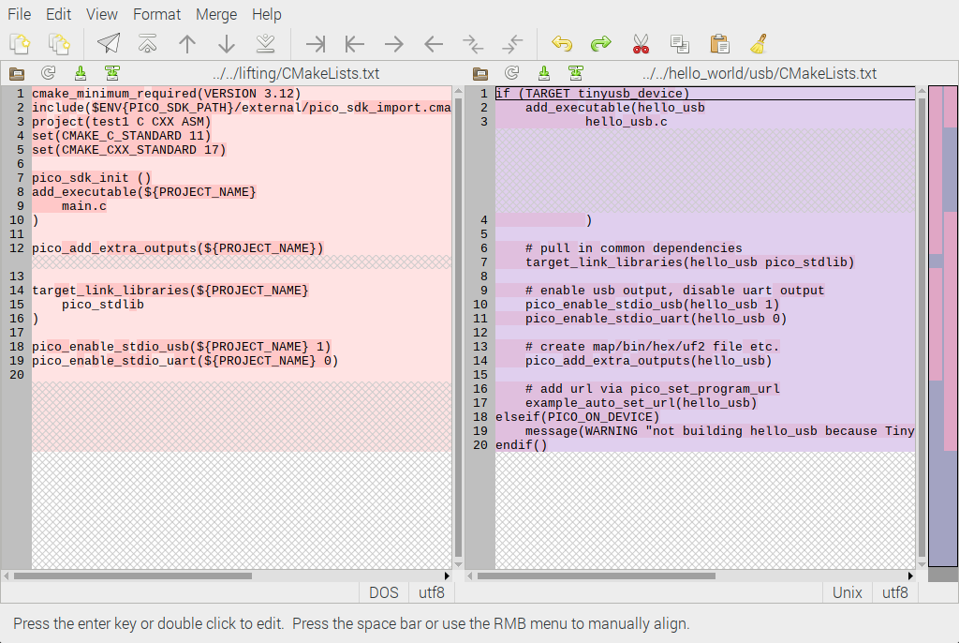
This is now taking out several of methods from main.c

extern void singlelift(int rb, int w, int * const ibuf, int * const obuf);
extern void ilift(int rb, int w, int * const ibuf, int * const obuf);
extern void lifting(int w, int *ibuf, int *tmpbuf, int *fwd);
to the files lifting.c & lifting.h

/opt/pico-examples $ git checkout 0712070

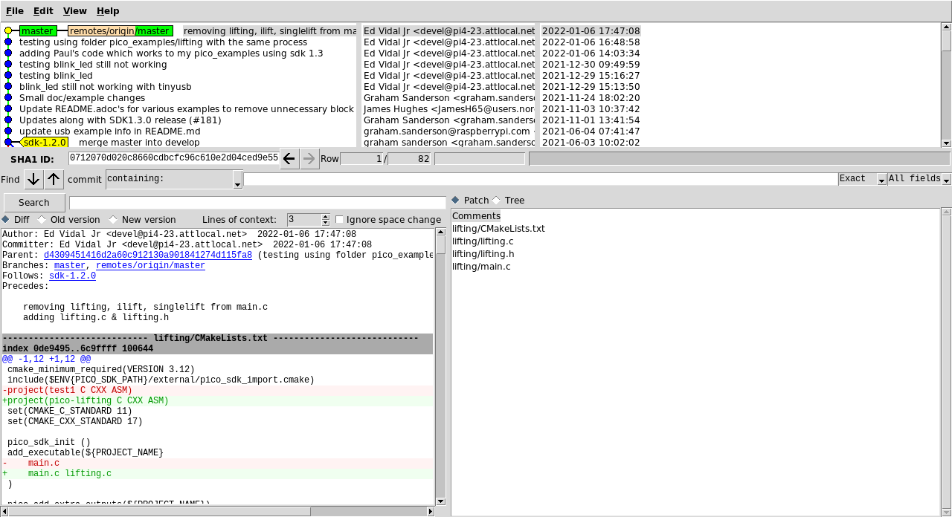
This is the new CmakeLists.txt

cmake_minimum_required(VERSION 3.12)
include($ENV{PICO_SDK_PATH}/external/pico_sdk_import.cmake)
project(pico-lifting C CXX ASM)
set(CMAKE_C_STANDARD 11)
set(CMAKE_CXX_STANDARD 17)

pico_sdk_init ()
add_executable(${PROJECT_NAME}
main.c lifting.c
)

pico_add_extra_outputs(${PROJECT_NAME})

target_link_libraries(${PROJECT_NAME}
pico_stdlib
)

pico_enable_stdio_usb(${PROJECT_NAME} 1)
pico_enable_stdio_uart(${PROJECT_NAME} 0)

/opt/pico-examples/build $ cmake ..
PICO_SDK_PATH is /opt/pico-sdk
PICO platform is rp2040.
PICO target board is pico.
Using board configuration from /opt/pico-sdk/src/boards/include/boards/pico.h
TinyUSB available at /opt/pico-sdk/lib/tinyusb/src/portable/raspberrypi/rp2040; enabling build support for USB.
-- Configuring done
-- Generating done
-- Build files have been written to: /opt/pico-examples/build
Now instead of compiling a single file main.c. Now main.c. & lifting.c need to be compiled resulting I pico-lifting.

/opt/pico-examples/build/lifting $ make clean; make
[ 0%] Creating directories for 'ELF2UF2Build'
[ 0%] No download step for 'ELF2UF2Build'
[ 0%] No update step for 'ELF2UF2Build'
[ 0%] No patch step for 'ELF2UF2Build'
[ 0%] Performing configure step for 'ELF2UF2Build'
-- Configuring done
-- Generating done
-- Build files have been written to: /opt/pico-examples/build/elf2uf2
[ 0%] Performing build step for 'ELF2UF2Build'
[100%] Built target elf2uf2
[ 0%] No install step for 'ELF2UF2Build'
[ 0%] Completed 'ELF2UF2Build'
[ 0%] Built target ELF2UF2Build
[ 0%] Built target bs2_default
[ 0%] Built target bs2_default_padded_checksummed_asm
Scanning dependencies of target pico-lifting
[ 0%] Building C object lifting/CMakeFiles/pico-lifting.dir/main.c.obj
/opt/pico-examples/lifting/main.c: In function 'main':
/opt/pico-examples/lifting/main.c:488:23: warning: passing argument 2 of 'lifting' from incompatible pointer type [-Wincompatible-pointer-types]
lifting(ptrs.w,ptrs.inp_buf,ptrs.out_buf,ptrs.fwd_inv);
~~~~^~~~~~~~
In file included from /opt/pico-examples/lifting/main.c:9:
/opt/pico-examples/lifting/lifting.h:46:33: note: expected 'int *' but argument is of type 'short int *'
extern void lifting(int w, int *ibuf, int *tmpbuf, int *fwd);
~~~~~^~~~
/opt/pico-examples/lifting/main.c:488:36: warning: passing argument 3 of 'lifting' from incompatible pointer type [-Wincompatible-pointer-types]
lifting(ptrs.w,ptrs.inp_buf,ptrs.out_buf,ptrs.fwd_inv);
~~~~^~~~~~~~
In file included from /opt/pico-examples/lifting/main.c:9:
/opt/pico-examples/lifting/lifting.h:46:44: note: expected 'int *' but argument is of type 'short int *'
extern void lifting(int w, int *ibuf, int *tmpbuf, int *fwd);
~~~~~^~~~~~
/opt/pico-examples/lifting/main.c:488:49: warning: passing argument 4 of 'lifting' from incompatible pointer type [-Wincompatible-pointer-types]
lifting(ptrs.w,ptrs.inp_buf,ptrs.out_buf,ptrs.fwd_inv);
~~~~^~~~~~~~
In file included from /opt/pico-examples/lifting/main.c:9:
/opt/pico-examples/lifting/lifting.h:46:57: note: expected 'int *' but argument is of type 'short int *'
extern void lifting(int w, int *ibuf, int *tmpbuf, int *fwd);
~~~~~^~~
/opt/pico-examples/lifting/main.c:588:23: warning: passing argument 2 of 'lifting' from incompatible pointer type [-Wincompatible-pointer-types]
lifting(ptrs.w,ptrs.inp_buf,ptrs.out_buf,ptrs.fwd_inv);
~~~~^~~~~~~~
In file included from /opt/pico-examples/lifting/main.c:9:
/opt/pico-examples/lifting/lifting.h:46:33: note: expected 'int *' but argument is of type 'short int *'
extern void lifting(int w, int *ibuf, int *tmpbuf, int *fwd);
~~~~~^~~~
/opt/pico-examples/lifting/main.c:588:36: warning: passing argument 3 of 'lifting' from incompatible pointer type [-Wincompatible-pointer-types]
lifting(ptrs.w,ptrs.inp_buf,ptrs.out_buf,ptrs.fwd_inv);
~~~~^~~~~~~~
In file included from /opt/pico-examples/lifting/main.c:9:
/opt/pico-examples/lifting/lifting.h:46:44: note: expected 'int *' but argument is of type 'short int *'
extern void lifting(int w, int *ibuf, int *tmpbuf, int *fwd);
~~~~~^~~~~~
/opt/pico-examples/lifting/main.c:588:49: warning: passing argument 4 of 'lifting' from incompatible pointer type [-Wincompatible-pointer-types]
lifting(ptrs.w,ptrs.inp_buf,ptrs.out_buf,ptrs.fwd_inv);
~~~~^~~~~~~~
In file included from /opt/pico-examples/lifting/main.c:9:
/opt/pico-examples/lifting/lifting.h:46:57: note: expected 'int *' but argument is of type 'short int *'
extern void lifting(int w, int *ibuf, int *tmpbuf, int *fwd);
~~~~~^~~
[ 0%] Building C object lifting/CMakeFiles/pico-lifting.dir/lifting.c.obj
/opt/pico-examples/lifting/lifting.c: In function 'lifting':
/opt/pico-examples/lifting/lifting.c:229:11: warning: iteration 3 invokes undefined behavior [-Waggressive-loop-optimizations]
ov[lvl] = offset + ((lvl)?(ov[lvl-1]):0);
~~~~~~~~^~~~~~~~~~~~~~~~~~~~~~~~~~~~~~~~
/opt/pico-examples/lifting/lifting.c:201:2: note: within this loop
for(lvl=0; lvl<LVLS; lvl++) {
^~~
[ 0%] Building C object lifting/CMakeFiles/pico-lifting.dir/opt/pico-sdk/src/rp2_common/pico_stdlib/stdlib.c.obj
[ 0%] Building C object lifting/CMakeFiles/pico-lifting.dir/opt/pico-sdk/src/rp2_common/hardware_gpio/gpio.c.obj
[ 0%] Building C object lifting/CMakeFiles/pico-lifting.dir/opt/pico-sdk/src/rp2_common/hardware_claim/claim.c.obj
[ 50%] Building C object lifting/CMakeFiles/pico-lifting.dir/opt/pico-sdk/src/rp2_common/pico_platform/platform.c.obj
[ 50%] Building C object lifting/CMakeFiles/pico-lifting.dir/opt/pico-sdk/src/rp2_common/hardware_sync/sync.c.obj
[ 50%] Building C object lifting/CMakeFiles/pico-lifting.dir/opt/pico-sdk/src/rp2_common/hardware_uart/uart.c.obj
[ 50%] Building ASM object lifting/CMakeFiles/pico-lifting.dir/opt/pico-sdk/src/rp2_common/hardware_divider/divider.S.obj
[ 50%] Building C object lifting/CMakeFiles/pico-lifting.dir/opt/pico-sdk/src/common/pico_time/time.c.obj
[ 50%] Building C object lifting/CMakeFiles/pico-lifting.dir/opt/pico-sdk/src/common/pico_time/timeout_helper.c.obj
[ 50%] Building C object lifting/CMakeFiles/pico-lifting.dir/opt/pico-sdk/src/rp2_common/hardware_timer/timer.c.obj
[ 50%] Building C object lifting/CMakeFiles/pico-lifting.dir/opt/pico-sdk/src/common/pico_sync/sem.c.obj
[ 50%] Building C object lifting/CmakeFiles/pico-lifting.dir/opt/pico-sdk/src/common/pico_sync/lock_core.c.obj

[ 50%] Building C object lifting/CMakeFiles/pico-lifting.dir/opt/pico-sdk/src/common/pico_sync/mutex.c.obj
[ 50%] Building C object lifting/CMakeFiles/pico-lifting.dir/opt/pico-sdk/src/common/pico_sync/critical_section.c.obj
[ 50%] Building C object lifting/CMakeFiles/pico-lifting.dir/opt/pico-sdk/src/common/pico_util/datetime.c.obj
[ 50%] Building C object lifting/CMakeFiles/pico-lifting.dir/opt/pico-sdk/src/common/pico_util/pheap.c.obj
[ 50%] Building C object lifting/CMakeFiles/pico-lifting.dir/opt/pico-sdk/src/common/pico_util/queue.c.obj
[ 50%] Building C object lifting/CMakeFiles/pico-lifting.dir/opt/pico-sdk/src/rp2_common/pico_runtime/runtime.c.obj
[ 50%] Building C object lifting/CMakeFiles/pico-lifting.dir/opt/pico-sdk/src/rp2_common/hardware_clocks/clocks.c.obj
[ 50%] Building C object lifting/CMakeFiles/pico-lifting.dir/opt/pico-sdk/src/rp2_common/hardware_irq/irq.c.obj
[ 50%] Building ASM object lifting/CMakeFiles/pico-lifting.dir/opt/pico-sdk/src/rp2_common/hardware_irq/irq_handler_chain.S.obj
[ 50%] Building C object lifting/CMakeFiles/pico-lifting.dir/opt/pico-sdk/src/rp2_common/hardware_pll/pll.c.obj
[ 50%] Building C object lifting/CMakeFiles/pico-lifting.dir/opt/pico-sdk/src/rp2_common/hardware_vreg/vreg.c.obj
[ 50%] Building C object lifting/CMakeFiles/pico-lifting.dir/opt/pico-sdk/src/rp2_common/hardware_watchdog/watchdog.c.obj
[ 50%] Building C object lifting/CMakeFiles/pico-lifting.dir/opt/pico-sdk/src/rp2_common/hardware_xosc/xosc.c.obj
[ 50%] Building C object lifting/CMakeFiles/pico-lifting.dir/opt/pico-sdk/src/rp2_common/pico_printf/printf.c.obj
[ 50%] Building ASM object lifting/CMakeFiles/pico-lifting.dir/opt/pico-sdk/src/rp2_common/pico_bit_ops/bit_ops_aeabi.S.obj
[ 50%] Building C object lifting/CMakeFiles/pico-lifting.dir/opt/pico-sdk/src/rp2_common/pico_bootrom/bootrom.c.obj
[ 50%] Building ASM object lifting/CMakeFiles/pico-lifting.dir/opt/pico-sdk/src/rp2_common/pico_divider/divider.S.obj
[ 50%] Building ASM object lifting/CMakeFiles/pico-lifting.dir/opt/pico-sdk/src/rp2_common/pico_double/double_aeabi.S.obj
[ 50%] Building C object lifting/CMakeFiles/pico-lifting.dir/opt/pico-sdk/src/rp2_common/pico_double/double_init_rom.c.obj
[ 50%] Building C object lifting/CMakeFiles/pico-lifting.dir/opt/pico-sdk/src/rp2_common/pico_double/double_math.c.obj
[ 50%] Building ASM object lifting/CMakeFiles/pico-lifting.dir/opt/pico-sdk/src/rp2_common/pico_double/double_v1_rom_shim.S.obj
[ 50%] Building ASM object lifting/CMakeFiles/pico-lifting.dir/opt/pico-sdk/src/rp2_common/pico_int64_ops/pico_int64_ops_aeabi.S.obj
[ 50%] Building ASM object lifting/CMakeFiles/pico-lifting.dir/opt/pico-sdk/src/rp2_common/pico_float/float_aeabi.S.obj
[ 50%] Building C object lifting/CMakeFiles/pico-lifting.dir/opt/pico-sdk/src/rp2_common/pico_float/float_init_rom.c.obj
[ 50%] Building C object lifting/CMakeFiles/pico-lifting.dir/opt/pico-sdk/src/rp2_common/pico_float/float_math.c.obj
[ 50%] Building ASM object lifting/CMakeFiles/pico-lifting.dir/opt/pico-sdk/src/rp2_common/pico_float/float_v1_rom_shim.S.obj
[ 50%] Building C object lifting/CMakeFiles/pico-lifting.dir/opt/pico-sdk/src/rp2_common/pico_malloc/pico_malloc.c.obj
[ 50%] Building ASM object lifting/CMakeFiles/pico-lifting.dir/opt/pico-sdk/src/rp2_common/pico_mem_ops/mem_ops_aeabi.S.obj
[ 50%] Building ASM object lifting/CMakeFiles/pico-lifting.dir/opt/pico-sdk/src/rp2_common/pico_standard_link/crt0.S.obj
[ 50%] Building CXX object lifting/CMakeFiles/pico-lifting.dir/opt/pico-sdk/src/rp2_common/pico_standard_link/new_delete.cpp.obj
[ 50%] Building C object lifting/CMakeFiles/pico-lifting.dir/opt/pico-sdk/src/rp2_common/pico_standard_link/binary_info.c.obj
[ 50%] Building C object lifting/CMakeFiles/pico-lifting.dir/opt/pico-sdk/src/rp2_common/pico_stdio/stdio.c.obj
[ 50%] Building C object lifting/CMakeFiles/pico-lifting.dir/opt/pico-sdk/src/rp2_common/pico_stdio_usb/reset_interface.c.obj
[ 50%] Building C object lifting/CMakeFiles/pico-lifting.dir/opt/pico-sdk/src/rp2_common/pico_stdio_usb/stdio_usb.c.obj
[ 50%] Building C object lifting/CMakeFiles/pico-lifting.dir/opt/pico-sdk/src/rp2_common/pico_stdio_usb/stdio_usb_descriptors.c.obj
[ 50%] Building C object lifting/CMakeFiles/pico-lifting.dir/opt/pico-sdk/lib/tinyusb/src/portable/raspberrypi/rp2040/dcd_rp2040.c.obj
[ 50%] Building C object lifting/CMakeFiles/pico-lifting.dir/opt/pico-sdk/lib/tinyusb/src/portable/raspberrypi/rp2040/rp2040_usb.c.obj
[ 50%] Building C object lifting/CMakeFiles/pico-lifting.dir/opt/pico-sdk/lib/tinyusb/src/device/usbd.c.obj
[ 50%] Building C object lifting/CMakeFiles/pico-lifting.dir/opt/pico-sdk/lib/tinyusb/src/device/usbd_control.c.obj
[ 50%] Building C object lifting/CMakeFiles/pico-lifting.dir/opt/pico-sdk/lib/tinyusb/src/class/audio/audio_device.c.obj
[ 50%] Building C object lifting/CMakeFiles/pico-lifting.dir/opt/pico-sdk/lib/tinyusb/src/class/cdc/cdc_device.c.obj
[ 50%] Building C object lifting/CMakeFiles/pico-lifting.dir/opt/pico-sdk/lib/tinyusb/src/class/dfu/dfu_device.c.obj
[ 50%] Building C object lifting/CMakeFiles/pico-lifting.dir/opt/pico-sdk/lib/tinyusb/src/class/dfu/dfu_rt_device.c.obj
[ 50%] Building C object lifting/CMakeFiles/pico-lifting.dir/opt/pico-sdk/lib/tinyusb/src/class/hid/hid_device.c.obj
[ 50%] Building C object lifting/CMakeFiles/pico-lifting.dir/opt/pico-sdk/lib/tinyusb/src/class/midi/midi_device.c.obj
[ 50%] Building C object lifting/CMakeFiles/pico-lifting.dir/opt/pico-sdk/lib/tinyusb/src/class/msc/msc_device.c.obj
[ 50%] Building C object lifting/CMakeFiles/pico-lifting.dir/opt/pico-sdk/lib/tinyusb/src/class/net/ecm_rndis_device.c.obj
[ 50%] Building C object lifting/CMakeFiles/pico-lifting.dir/opt/pico-sdk/lib/tinyusb/src/class/net/ncm_device.c.obj
[ 50%] Building C object lifting/CMakeFiles/pico-lifting.dir/opt/pico-sdk/lib/tinyusb/src/class/usbtmc/usbtmc_device.c.obj
[ 50%] Building C object lifting/CMakeFiles/pico-lifting.dir/opt/pico-sdk/lib/tinyusb/src/class/vendor/vendor_device.c.obj
[ 50%] Building C object lifting/CMakeFiles/pico-lifting.dir/opt/pico-sdk/lib/tinyusb/src/class/video/video_device.c.obj
[ 50%] Building C object lifting/CMakeFiles/pico-lifting.dir/opt/pico-sdk/lib/tinyusb/src/tusb.c.obj
[100%] Building C object lifting/CMakeFiles/pico-lifting.dir/opt/pico-sdk/lib/tinyusb/src/common/tusb_fifo.c.obj
[100%] Building C object lifting/CMakeFiles/pico-lifting.dir/opt/pico-sdk/src/rp2_common/pico_fix/rp2040_usb_device_enumeration/rp2040_usb_device_enumeration.c.obj
[100%] Building C object lifting/CMakeFiles/pico-lifting.dir/opt/pico-sdk/src/rp2_common/pico_unique_id/unique_id.c.obj
[100%] Building C object lifting/CMakeFiles/pico-lifting.dir/opt/pico-sdk/src/rp2_common/hardware_flash/flash.c.obj
[100%] Linking CXX executable pico-lifting.elf
[100%] Built target pico-lifting

Using openocd to program the pico.

/opt/pico-examples/build $ openocd -f interface/raspberrypi-swd.cfg -f target/rp2040.cfg -c "program lifting/pico-lifting.elf verify reset exit"
Open On-Chip Debugger 0.10.0+dev-g71510a7-dirty (2021-08-15-17:08)
Licensed under GNU GPL v2
For bug reports, read
http://openocd.org/doc/doxygen/bugs.html
adapter speed: 1000 kHz

Info : Hardware thread awareness created
Info : Hardware thread awareness created
Info : RP2040 Flash Bank Command
Info : BCM2835 GPIO JTAG/SWD bitbang driver
Info : clock speed 1001 kHz
Info : SWD DPIDR 0x0bc12477
Info : SWD DLPIDR 0x00000001
Info : SWD DPIDR 0x0bc12477
Info : SWD DLPIDR 0x10000001
Info : rp2040.core0: hardware has 4 breakpoints, 2 watchpoints
Info : rp2040.core1: hardware has 4 breakpoints, 2 watchpoints
Info : starting gdb server for rp2040.core0 on 3333
Info : Listening on port 3333 for gdb connections
target halted due to debug-request, current mode: Thread
xPSR: 0xf1000000 pc: 0x000000ee msp: 0x20041f00
target halted due to debug-request, current mode: Thread
xPSR: 0xf1000000 pc: 0x000000ee msp: 0x20041f00
** Programming Started **
Info : RP2040 B0 Flash Probe: 2097152 bytes @10000000, in 512 sectors

target halted due to debug-request, current mode: Thread
xPSR: 0x01000000 pc: 0x0000012a msp: 0x20041f00
target halted due to debug-request, current mode: Thread
xPSR: 0x01000000 pc: 0x0000012a msp: 0x20041f00
target halted due to debug-request, current mode: Thread
xPSR: 0x01000000 pc: 0x0000012a msp: 0x20041f00
target halted due to debug-request, current mode: Thread
xPSR: 0x01000000 pc: 0x0000012a msp: 0x20041f00
Info : Writing 36864 bytes starting at 0x0
target halted due to debug-request, current mode: Thread
xPSR: 0x01000000 pc: 0x0000012a msp: 0x20041f00
target halted due to debug-request, current mode: Thread
xPSR: 0x01000000 pc: 0x0000012a msp: 0x20041f00
target halted due to debug-request, current mode: Thread
xPSR: 0x01000000 pc: 0x0000012a msp: 0x20041f00
target halted due to debug-request, current mode: Thread
xPSR: 0x01000000 pc: 0x0000012a msp: 0x20041f00
target halted due to debug-request, current mode: Thread
xPSR: 0x01000000 pc: 0x0000012a msp: 0x20041f00
target halted due to debug-request, current mode: Thread
xPSR: 0x01000000 pc: 0x0000012a msp: 0x20041f00
target halted due to debug-request, current mode: Thread
xPSR: 0x01000000 pc: 0x0000012a msp: 0x20041f00
** Programming Finished **
** Verify Started **
target halted due to debug-request, current mode: Thread
xPSR: 0x01000000 pc: 0x0000012a msp: 0x20041f00
target halted due to debug-request, current mode: Thread
xPSR: 0x01000000 pc: 0x0000012a msp: 0x20041f00
** Verified OK **
** Resetting Target **
shutdown command invoked

sudo minicom -s

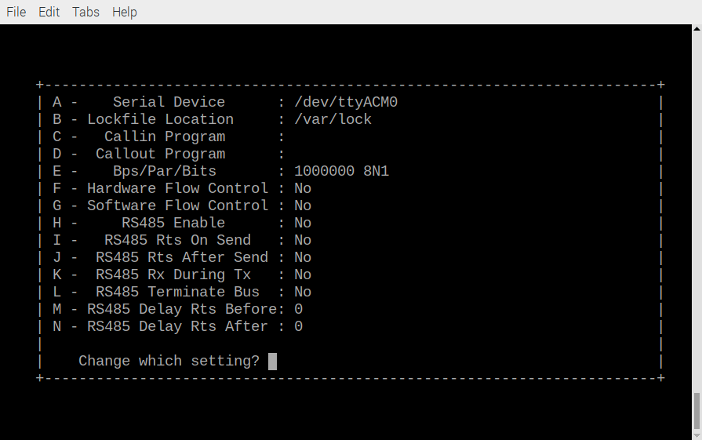
xxx

Once the data has been sent.

This is where the program is failing. You can not depress I to proceed with the lifting step DWT.

