******************Draft******************
Pico Tools
SDK OPENOCD
11/08/21
******************Draft******************

/opt/
pico-extras pico-sdk
pico-examples pico-playground

Backups:

devel@mypi3-16:/media/devel/1b763776-4e1d-499c-9f24-a116a58c161f $ ls pico/
installed-openocd081421-71510a.img pico-examples.img pico-playground.img
openocd081421-71510a.img pico-extras.img pico-sdk.img

cd opt
sudo unsquashfs -d pico-sdk pico-sdk.img
sudo unsquashfs -d pico-examples pico-examples.img

Openocd was download from “https://github.com/raspberrypi/openocd.git”
An img file “openocd081421-71510a.img” was created of the

commit 71510a77a61c6eb2b1266e00010f8f258785a54b (grafted, HEAD -> rp2040, origin/rp2040, origin/HEAD)
Author: Peter Lawrence <12226419+majbthrd@users.noreply.github.com>
Date: Thu Jun 3 14:06:09 2021 -0500

tcl/boards: add pico-debug.cfg

The folder “/home/devel/local/openocd” was created from the file “installed-openocd081421-71510a.img” in “/home/devel” and executing the command “sudo unsquashfs -d openocd ../installed-openocd081421-71510a.img” in “/home/devel/local” folder.

ls -la local/openocd/bin/openocd

Rpi Pico
SWDIO----18 red--------black-------black------ blue----swclk
grd----------20 yellow-----red---------blue------- green---grd
SWCLK---22 orange-----orange------green------ black---swdio

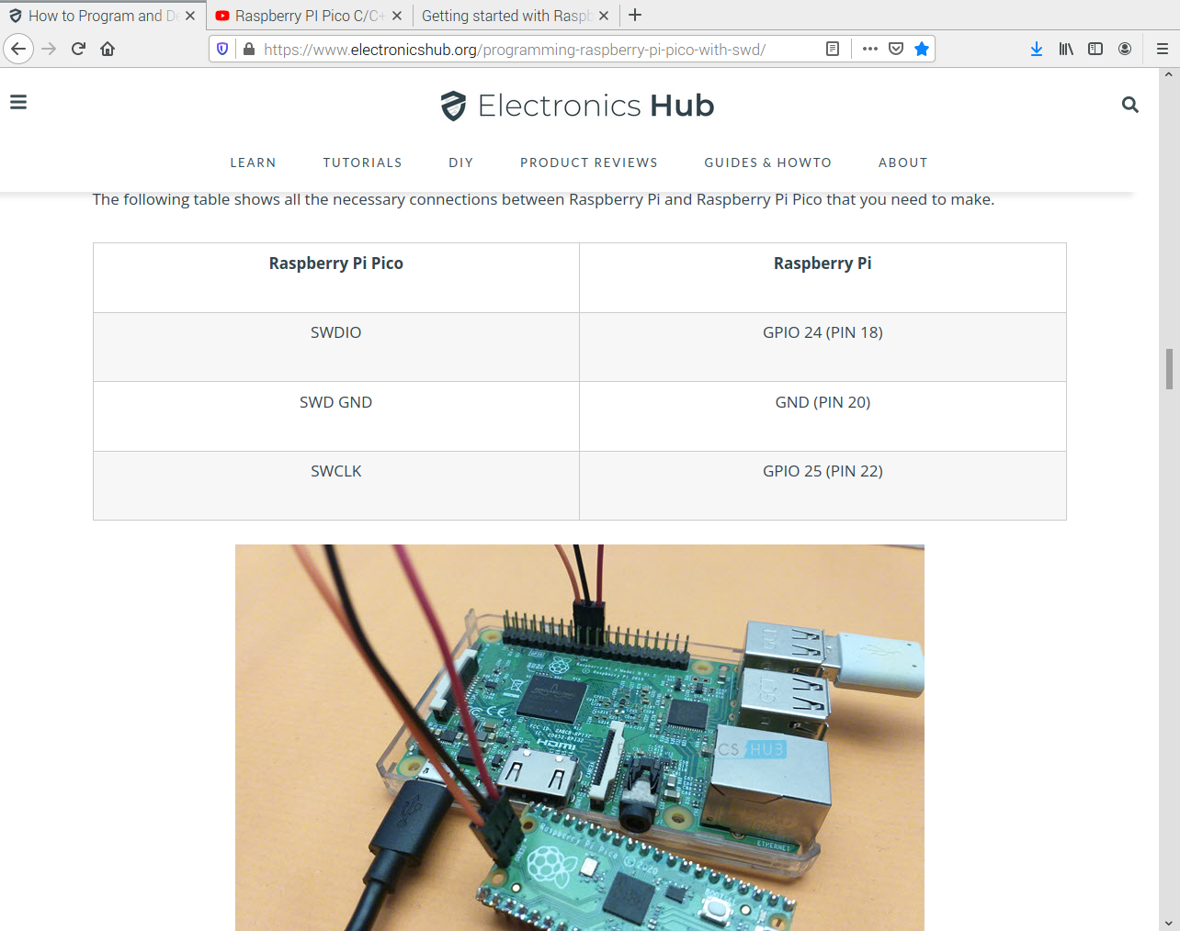
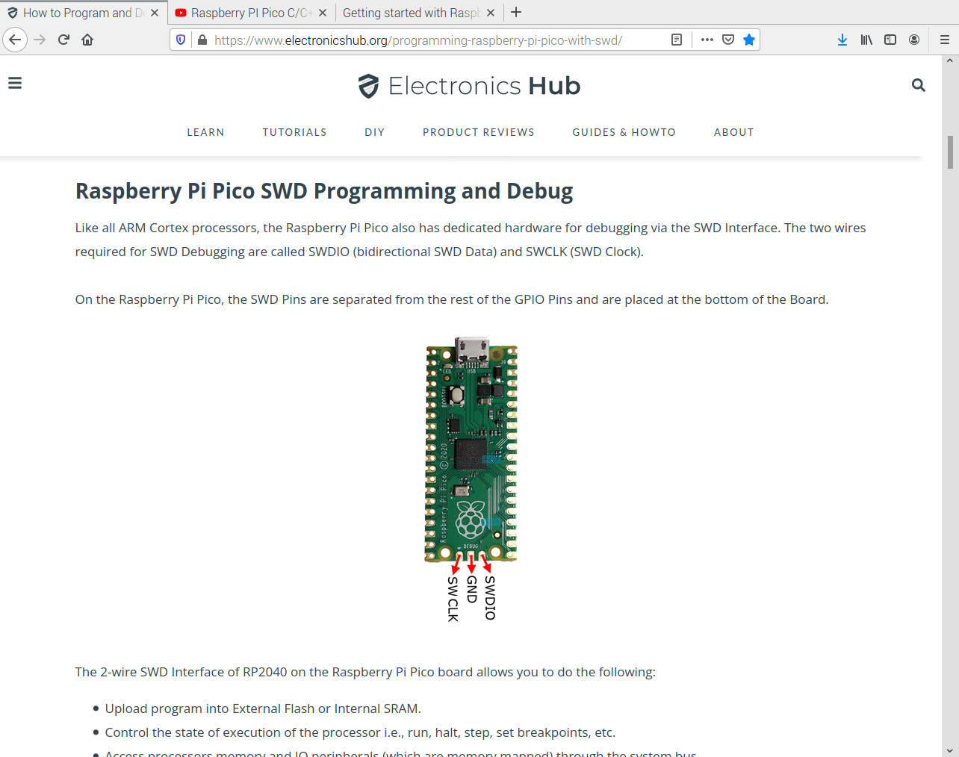
Pico The labels swclk grd swdio are only on the bottom side.

pico-pi-sdk-build.txt has the instruction from the video below.

Revist the video below
https://www.youtube.com/watch?v=UZwq3eb5My0

Downloaded the getting-started

https://datasheets.raspberrypi.com/pico/getting-started-with-pico.pdf

