https://www.youtube.com/watch?app=desktop&v=Ba89cI9eIg8

Color Space Conversion
3000 x 4000 x 3
Chroma Subsampling
cb & cr are scaled to reduce the size of the image.

clear
close all
pkg load image
A = imread('lena_rgb_256.png');
[im,map,alpha] = imread('lena_rgb_256.png');
YCBCR = rgb2ycbcr(A);
y=YCBCR(1:256,1:256,1);
cb=YCBCR(1:256,1:256,2);
cr=YCBCR(1:256,1:256,3);
figure
imagesc(A)
figure
imagesc(y)
colormap 'gray'
colorbar
title '01/26/22 Y image'
figure
imagesc(cb)
colormap 'gray'
colorbar
title '01/26/22 cb image'
figure
imagesc(cr)
colormap 'gray'
colorbar
title '01/26/22 cr image'

Orig image 256 x 256

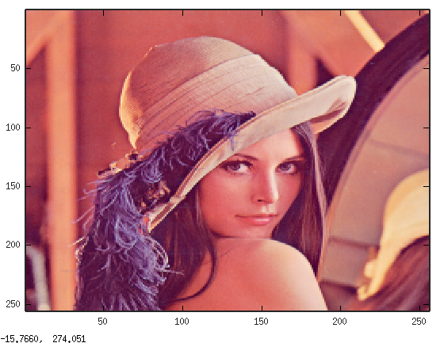

Y image



cB image

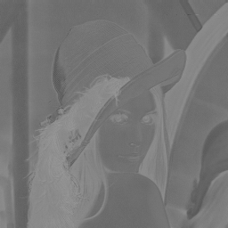

cR image

