Forked https://github.com/raspberrypi/pico-project-generator.git

git clone git@github.com:develone/pico-project-generator.git

cd pico-project-generator/

./pico_project.py –gui

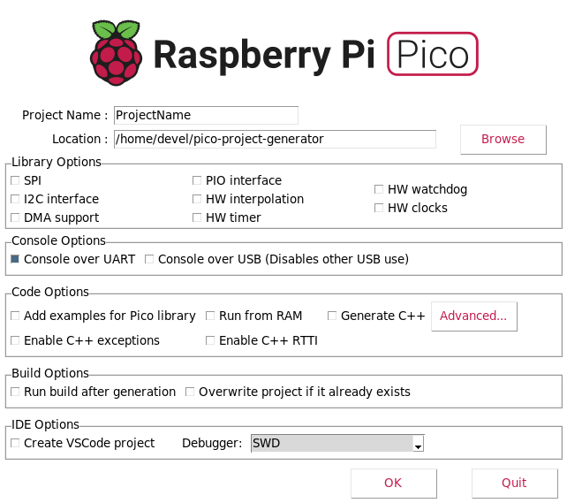

After Setting the options

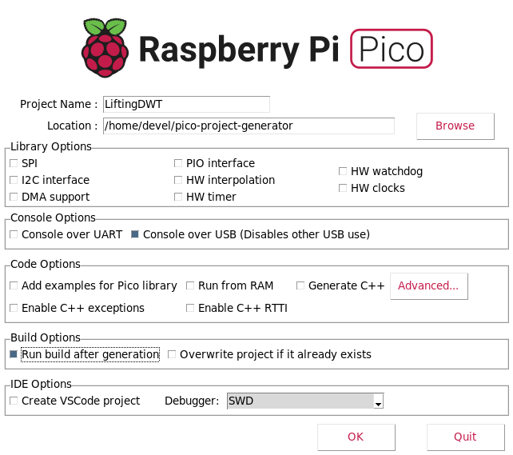
Depress OK

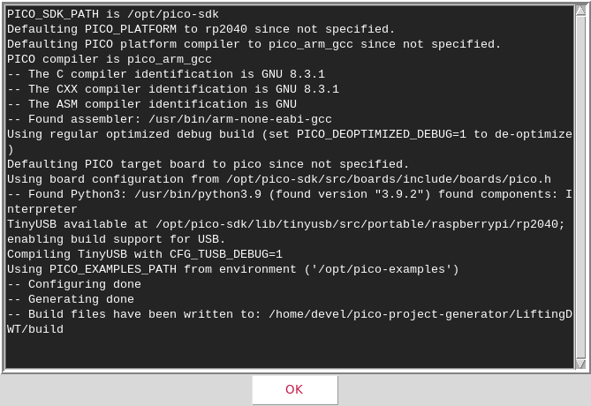

Depress OK
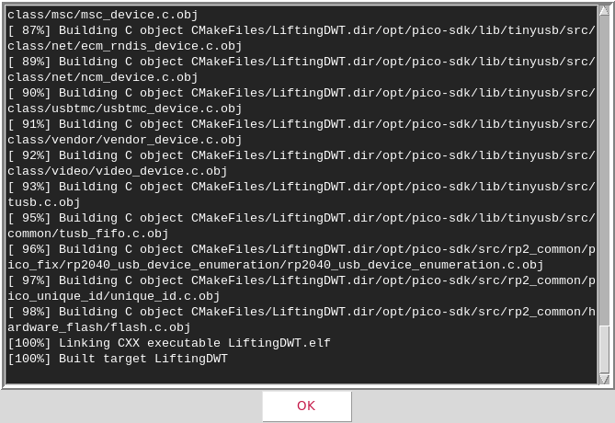
CmakeLists.txt

# Generated Cmake Pico project file

cmake_minimum_required(VERSION 3.13)

set(CMAKE_C_STANDARD 11)
set(CMAKE_CXX_STANDARD 17)

# Initialise pico_sdk from installed location
# (note this can come from environment, CMake cache etc)
set(PICO_SDK_PATH "/opt/pico-sdk")

# Pull in Raspberry Pi Pico SDK (must be before project)
include(pico_sdk_import.cmake)

project(LiftingDWT C CXX ASM)

# Initialise the Raspberry Pi Pico SDK
pico_sdk_init()

# Add executable. Default name is the project name, version 0.1

add_executable(LiftingDWT LiftingDWT.c )

pico_set_program_name(LiftingDWT "LiftingDWT")
pico_set_program_version(LiftingDWT "0.1")

pico_enable_stdio_uart(LiftingDWT 0)
pico_enable_stdio_usb(LiftingDWT 1)

# Add the standard library to the build
target_link_libraries(LiftingDWT pico_stdlib)

pico_add_extra_outputs(LiftingDWT)

LiftingDWT.c

#include <stdio.h>
#include "pico/stdlib.h"

int main()
{
stdio_init_all();

puts("Hello, world!");

return 0;
}

devel@pi4-23:~/pico-project-generator/LiftingDWT/build $ ls
CMakeCache.txt generated LiftingDWT.elf.map pico-sdk
CMakeFiles LiftingDWT.bin LiftingDWT.hex
cmake_install.cmake LiftingDWT.dis LiftingDWT.uf2
elf2uf2 LiftingDWT.elf Makefile

export PATH=~/local/openocd/bin:$PATH

devel@pi4-23:~/pico-project-generator/LiftingDWT/build $ echo $PATH
/home/devel/local/openocd/bin:/usr/local/sbin:/usr/local/bin:/usr/sbin:/usr/bin:/sbin:/bin:/usr/local/games:/usr/games

devel@pi4-23:~/pico-project-generator/LiftingDWT/build $ openocd -f interface/raspberrypi-swd.cfg -f target/rp2040.cfg -c "program LiftingDWT.elf verify reset exit"
Open On-Chip Debugger 0.10.0+dev-g71510a7-dirty (2021-08-15-17:08)
Licensed under GNU GPL v2
For bug reports, read
http://openocd.org/doc/doxygen/bugs.html
adapter speed: 1000 kHz

Info : Hardware thread awareness created
Info : Hardware thread awareness created
Info : RP2040 Flash Bank Command
Info : BCM2835 GPIO JTAG/SWD bitbang driver
Info : clock speed 1001 kHz
Info : SWD DPIDR 0x0bc12477
Info : SWD DLPIDR 0x00000001
Info : SWD DPIDR 0x0bc12477
Info : SWD DLPIDR 0x10000001
Info : rp2040.core0: hardware has 4 breakpoints, 2 watchpoints
Info : rp2040.core1: hardware has 4 breakpoints, 2 watchpoints
Info : starting gdb server for rp2040.core0 on 3333
Info : Listening on port 3333 for gdb connections
target halted due to debug-request, current mode: Thread
xPSR: 0xf1000000 pc: 0x000000ee msp: 0x20041f00
target halted due to debug-request, current mode: Thread
xPSR: 0xf1000000 pc: 0x000000ee msp: 0x20041f00
** Programming Started **
Info : RP2040 B0 Flash Probe: 2097152 bytes @10000000, in 512 sectors

target halted due to debug-request, current mode: Thread
xPSR: 0x01000000 pc: 0x0000012a msp: 0x20041f00
target halted due to debug-request, current mode: Thread
xPSR: 0x01000000 pc: 0x0000012a msp: 0x20041f00
target halted due to debug-request, current mode: Thread
xPSR: 0x01000000 pc: 0x0000012a msp: 0x20041f00
target halted due to debug-request, current mode: Thread
xPSR: 0x01000000 pc: 0x0000012a msp: 0x20041f00
Info : Writing 36864 bytes starting at 0x0
target halted due to debug-request, current mode: Thread
xPSR: 0x01000000 pc: 0x0000012a msp: 0x20041f00
target halted due to debug-request, current mode: Thread
xPSR: 0x01000000 pc: 0x0000012a msp: 0x20041f00
target halted due to debug-request, current mode: Thread
xPSR: 0x01000000 pc: 0x0000012a msp: 0x20041f00
target halted due to debug-request, current mode: Thread
xPSR: 0x01000000 pc: 0x0000012a msp: 0x20041f00
target halted due to debug-request, current mode: Thread
xPSR: 0x01000000 pc: 0x0000012a msp: 0x20041f00
target halted due to debug-request, current mode: Thread
xPSR: 0x01000000 pc: 0x0000012a msp: 0x20041f00
target halted due to debug-request, current mode: Thread
xPSR: 0x01000000 pc: 0x0000012a msp: 0x20041f00
** Programming Finished **
** Verify Started **
target halted due to debug-request, current mode: Thread
xPSR: 0x01000000 pc: 0x0000012a msp: 0x20041f00
target halted due to debug-request, current mode: Thread
xPSR: 0x01000000 pc: 0x0000012a msp: 0x20041f00
** Verified OK **
** Resetting Target **
shutdown command invoked

mkdir /opt/pico-examples/LiftingDWT

devel@pi4-23:~ $ cp pico-project-generator/LiftingDWT/LiftingDWT.c /opt/pico-examples/LiftingDWT/
devel@pi4-23:~ $ cp pico-project-generator/LiftingDWT/CMakeLists.txt /opt/pico-examples/LiftingDWT/

diff ../LiftingDWT/CMakeLists.txt ~/pico-project-generator/LiftingDWT/CMakeLists.txt
13c13
< #include(pico_sdk_import.cmake)
---
> include(pico_sdk_import.cmake)

openocd -f interface/raspberrypi-swd.cfg -f target/rp2040.cfg -c "program LiftingDWT/LiftingDWT.elf verify reset exit"

