*********************Defualt*********************
pico2-ice rev1
04/05/25
*********************Defualt*********************

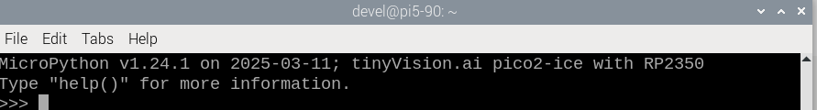
xx

```python
from machine import Pin
import ice
fpga = ice.fpga(cdone=Pin(40), clock=Pin(21), creset=Pin(31), cram_cs=Pin(5), cram_mosi=Pin(4), cram_sck=Pin(6), frequency=48)
file = open("bitstream.bin", "br")
fpga.start()
fpga.cram(file)```
pico2-ice rev1

xx
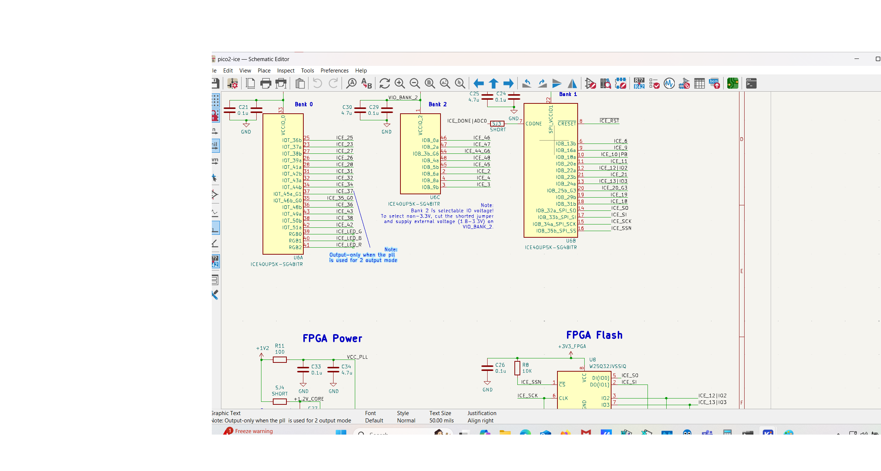
xx
RP2350
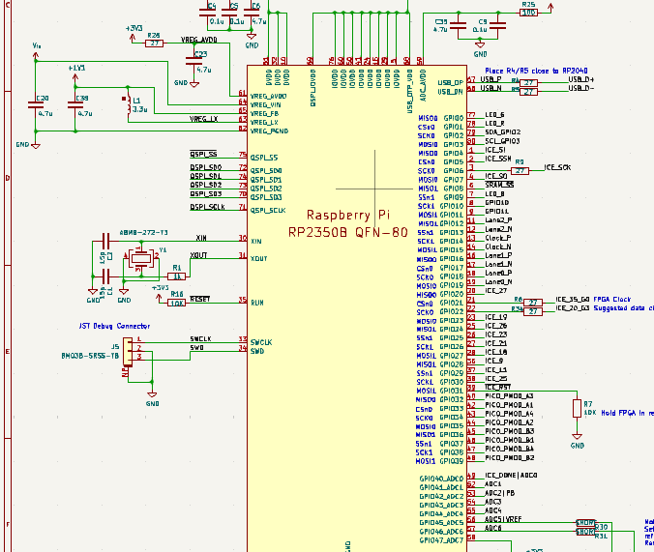
xx

