*********************Defualt*********************
pico2-ice rev1
04/05/25
*********************Defualt*********************

This version was received 04/05/25 from tinyvison.ai

This image was posted before shipped.

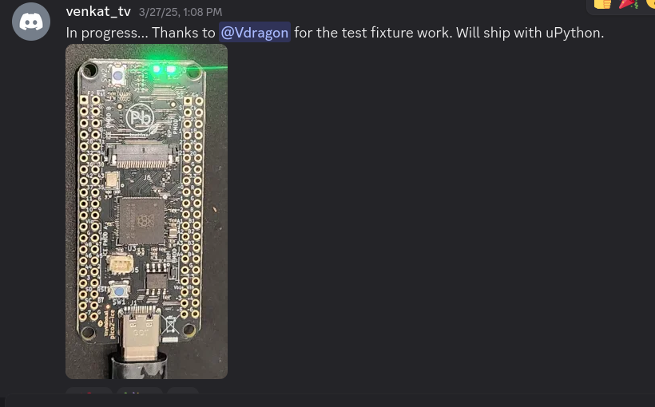
pico2-with pmods

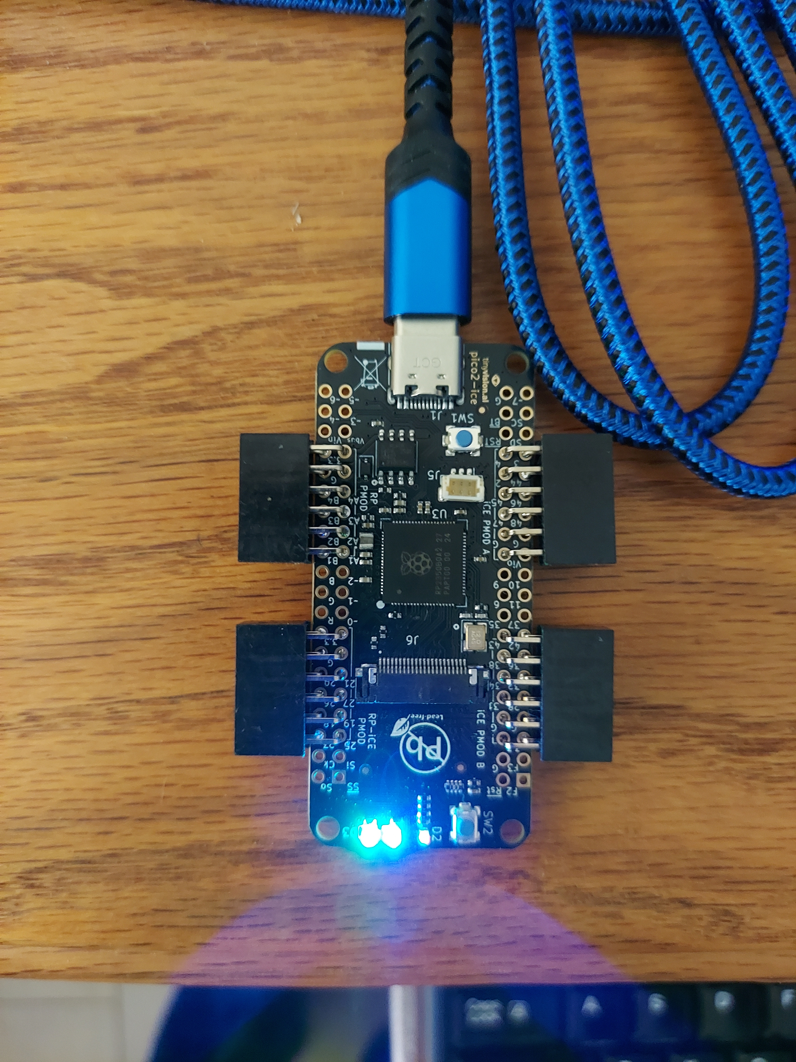

devel@pi5-90:~ $ git clone https://github.com/develone/pico2-ice.git -b test-dev
Cloning into 'pico2-ice'...
remote: Enumerating objects: 304, done.
remote: Counting objects: 100% (304/304), done.
remote: Compressing objects: 100% (203/203), done.
remote: Total 304 (delta 134), reused 239 (delta 73), pack-reused 0 (from 0)
Receiving objects: 100% (304/304), 10.71 MiB | 19.62 MiB/s, done.
Resolving deltas: 100% (134/134), done.
devel@pi5-90:~ $ cd pico2-ice/

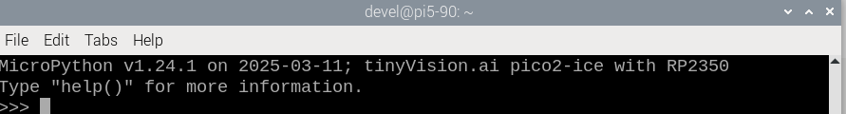
xx

```python
from machine import Pin
import ice
fpga = ice.fpga(cdone=Pin(40), clock=Pin(21), creset=Pin(31), cram_cs=Pin(5), cram_mosi=Pin(4), cram_sck=Pin(6), frequency=48)
file = open("bitstream.bin", "br")
fpga.start()
fpga.cram(file)```
pico2-ice rev1

xx
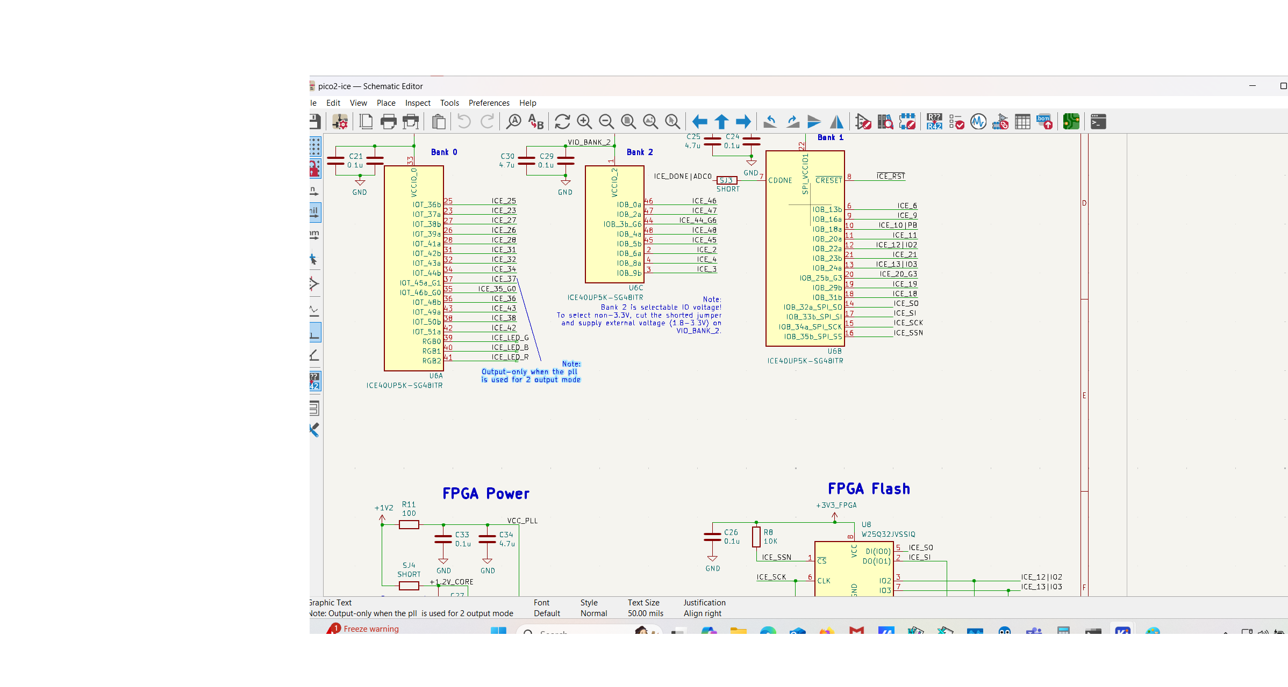
xx
RP2350
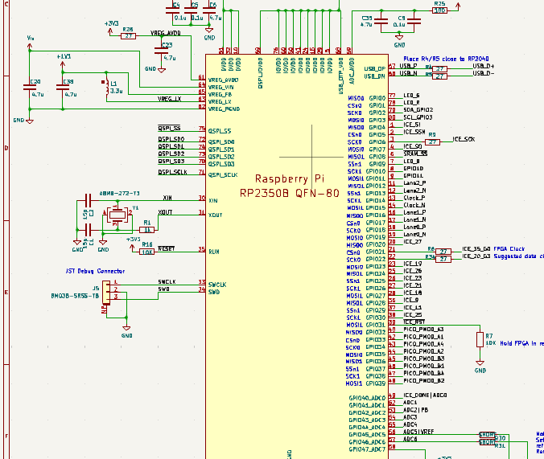
xx

