**************Default**************
Default Firmware with pmod leddigits
&
MicroPython pico2-ice with pmod leddigits
04/25/25
**************Default**************

cp ~/master-repos/pico2-ice/Firmware/pico2-ice-default/pico2_ice_default.uf2 /media/devel/RP2350/

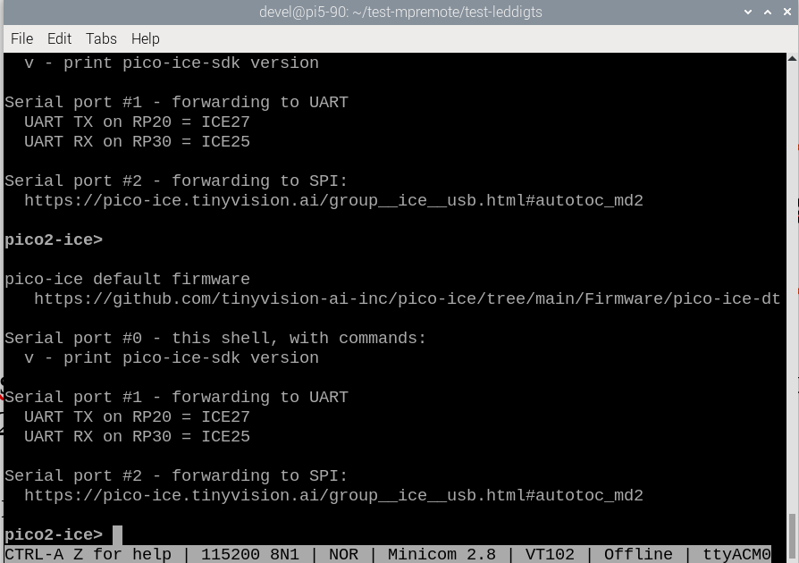
xx
devel@pi5-90:~/pico-ice/leddigits $ cd pico-ice/leddigits/
devel@pi5-90:~/pico-ice/leddigits $ make clean
devel@pi5-90:~/pico-ice/leddigits $ make
devel@pi5-90:~/pico-ice/leddigits $ bin2uf2 -o top.uf2 top.bin
devel@pi5-90:~/pico-ice/leddigits $ cp top.uf2 /media/devel/pico2-ice/

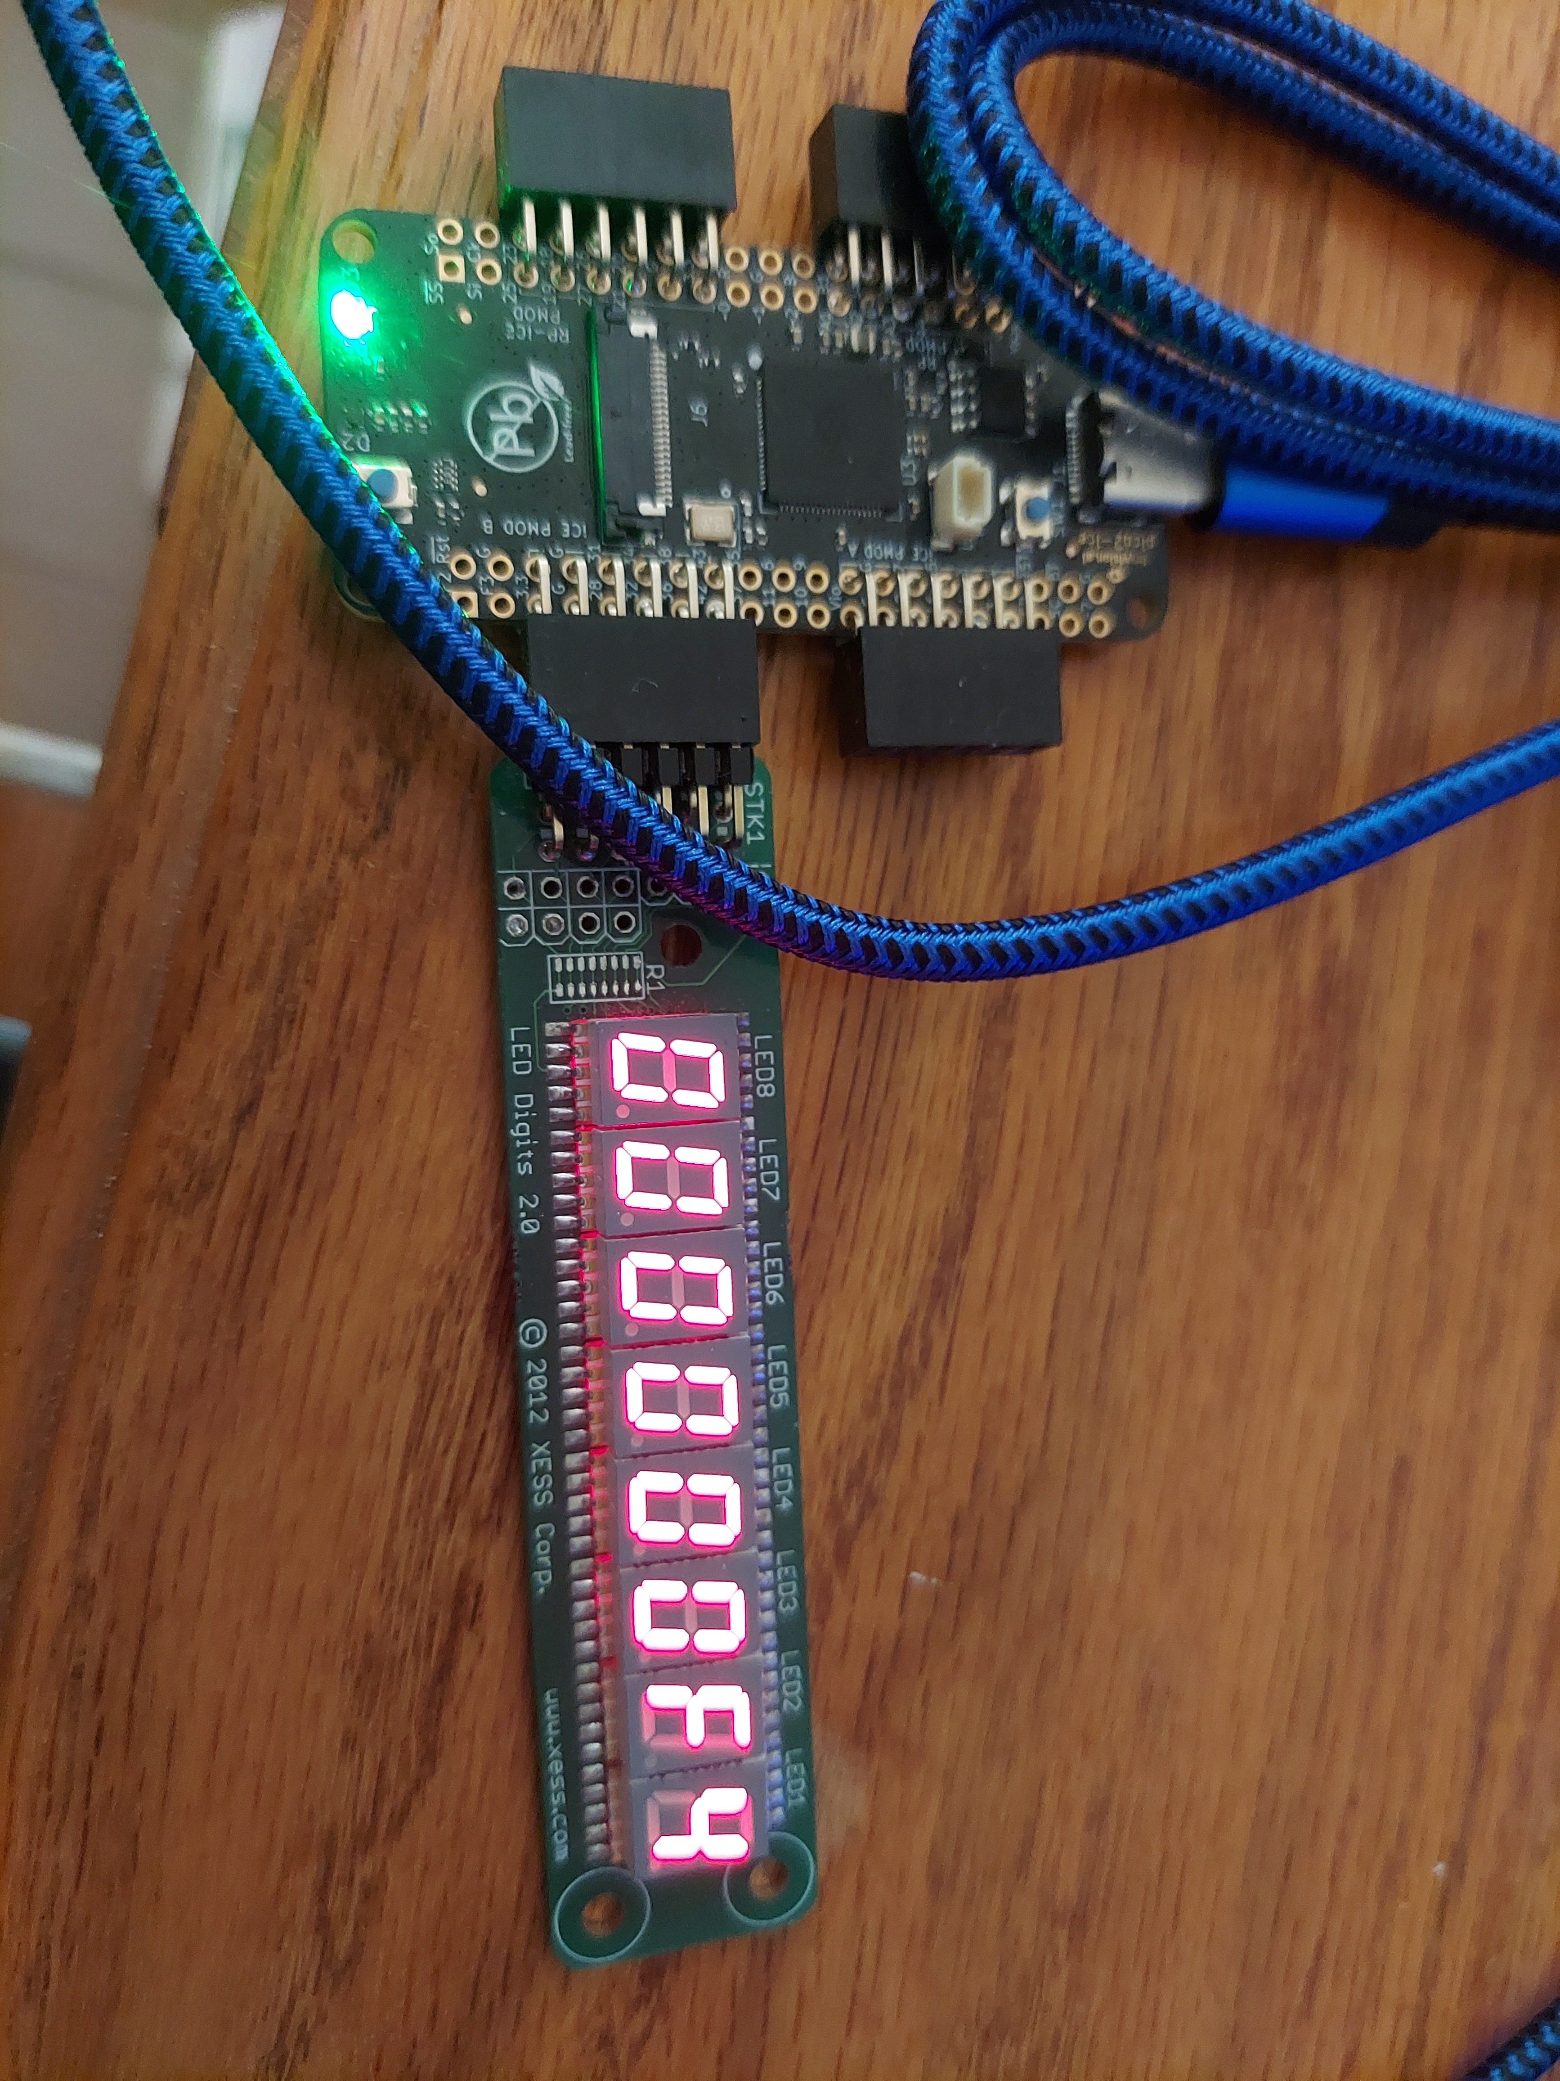

The pico2-ice starting counting.

Depress the sw on right side of USB connector on power-up.

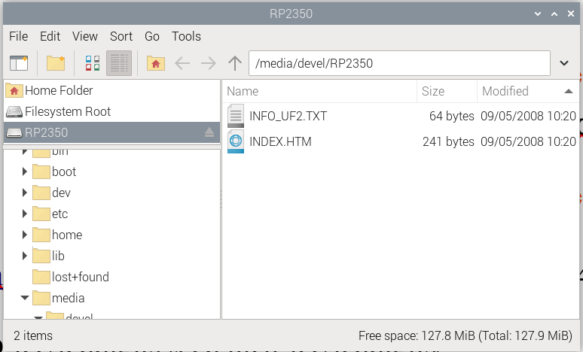
devel@pi5-90:~/pico-ice/leddigits $ cp ~/master-repos/pico-ice-micropython/pico2-ice-uf2/firmware.uf2 /media/devel/RP2350/

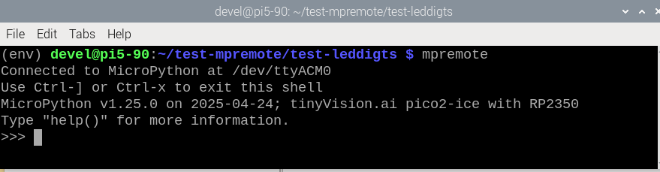
xx
pico2-ice starts blinking.

“git clone https://github.com/develone/pico-ice.git -b test-dev-100424”

devel@pi5-90:~/pico-ice/leddigits $ cd pico-ice/leddigits/
devel@pi5-90:~/pico-ice/leddigits $ make clean
devel@pi5-90:~/pico-ice/leddigits $ make
The top.bin was created
In MicroPython the iCE40UP5K does not show up as pico-ice
df
/dev/sda 3048 200 2848 7% /media/devel/5221-0000

pico2-iCE40UP5K

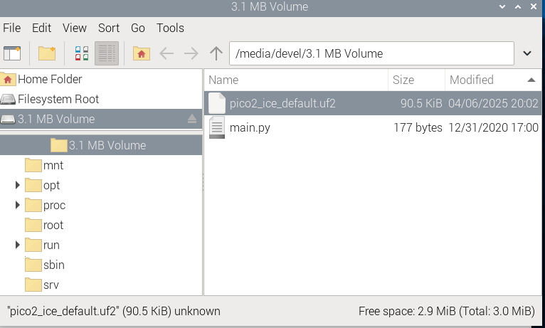

devel@pi5-90:~/pico-ice/leddigits $ cp top.bin /media/devel/5221-0000/

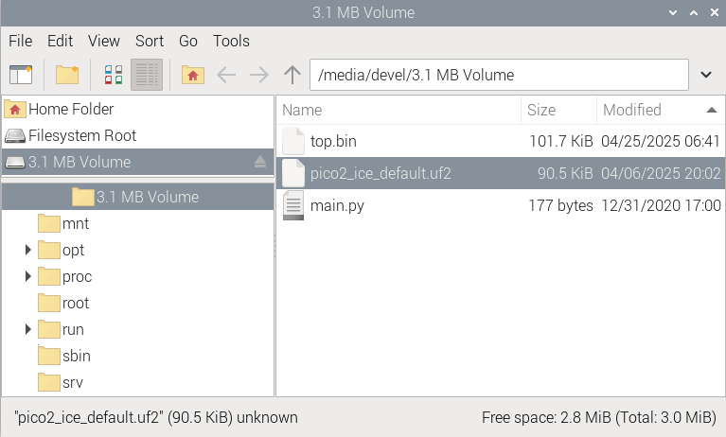

Testing mpremote in new folder.
Note: Very important needs to disconnected an reconnected in between starting a new process.
Note: Question where does top.bin or gateware.bin need to be located? In the folder where mpremote is being run or on the pico2-ice drive. It appears to be needed in both locations.
(env) devel@pi5-90:~/test-mpremote-042525 $ mpremote
Connected to MicroPython at /dev/ttyACM0
Use Ctrl-] or Ctrl-x to exit this shell
MicroPython v1.25.0 on 2025-04-24; tinyVision.ai pico2-ice with RP2350
Type "help()" for more information.
>>> from machine import Pin
>>> import ice
>>>
>>> file = open("gateware.bin", "br")
>>> flash = ice.flash(miso=Pin(4), mosi=Pin(7), sck=Pin(6), cs=Pin(5))
>>> flash.write(file)
>>> fpga = ice.fpga(cdone=Pin(40), clock=Pin(21), creset=Pin(31), cram_cs=Pin(5), cram_mosi=Pin(4), cram_sck=Pin(6), frequency=48)
>>> fpga.start()
True
>>> device disconnected did not start to blinking green until is was connected. devel@pi5-90:~/pico-ice/examples-tested-1_6_1/pico-ice/ice_makefile_blinky $ rm -rf /media/devel/5221-0000/gateware.bin devel@pi5-90:~/pico-ice/examples-tested-1_6_1/pico-ice/ice_makefile_blinky $ cp ../../../leddigits/top.bin /media/devel/5221-0000/

devel@pi5-90:~/pico-ice/leddigits $ mkdir ~/test-mpremote-042525
devel@pi5-90:~/pico-ice/leddigits $ cp ~/test-mpremote/virtp.sh ~/test-mpremote-042525
devel@pi5-90:~/pico-ice/leddigits $ cd ~/test-mpremote-042525/
devel@pi5-90:~/test-mpremote-042525 $ . ./virtp.sh
(env) devel@pi5-90:~/test-mpremote-042525 $
(env) devel@pi5-90:~/test-mpremote-042525 $ pip3 install mpremote
Looking in indexes: https://pypi.org/simple, https://www.piwheels.org/simple
Collecting mpremote
Downloading mpremote-1.25.0-py3-none-any.whl (33 kB)
Collecting pyserial>=3.3
Using cached https://www.piwheels.org/simple/pyserial/pyserial-3.5-py2.py3-none-any.whl (90 kB)
Installing collected packages: pyserial, mpremote
Successfully installed mpremote-1.25.0 pyserial-3.5
(env) devel@pi5-90:~/test-mpremote-042525 $
(env) devel@pi5-90:~/test-mpremote-042525 $ mpremote
Connected to MicroPython at /dev/ttyACM0
Use Ctrl-] or Ctrl-x to exit this shell
MicroPython v1.25.0 on 2025-04-24; tinyVision.ai pico2-ice with RP2350
Type "help()" for more information.
>>> from machine import Pin
>>> import ice
>>> file = open("top.bin", "br")
>>> flash = ice.flash(miso=Pin(4), mosi=Pin(7), sck=Pin(6), cs=Pin(5))
>>> flash.write(file)
>>> fpga = ice.fpga(cdone=Pin(40), clock=Pin(21), creset=Pin(31), cram_cs=Pin(5), cram_mosi=Pin(4), cram_sck=Pin(6), frequency=48)
>>> fpga.start()
>>> flash.erase(4096)
devel@pi5-90:~ $ cd ~/test-mpremote/
>>> flash.write(file)
>>> fpga = ice.fpga(cdone=Pin(40), clock=Pin(21), creset=Pin(31), cram_cs=Pin(5), cram_mosi=Pin(4), cram_sck=Pin(6), frequency=48)
>>> fpga.start()
True

devel@pi5-90:~/test-mpremote $ . ./virtp.sh
(env) devel@pi5-90:~/test-mpremote $

(env) devel@pi5-90:~/test-mpremote $ cd test-leddigts/

(env) devel@pi5-90:~/test-mpremote/test-leddigts $ ls ../env/bin/
activate Activate.ps1 pip3 pyserial-ports python3.11
activate.csh mpremote pip3.11 python
activate.fish pip pyserial-miniterm python3

(env) devel@pi5-90:~/test-mpremote/test-leddigts $ mpremote
Connected to MicroPython at /dev/ttyACM0
Use Ctrl-] or Ctrl-x to exit this shell
MicroPython v1.25.0 on 2025-04-24; tinyVision.ai pico2-ice with RP2350
Type "help()" for more information.

>>> from machine import Pin
>>> import ice
>>> file = open("top.bin","br")
Additional testing with gateware-blue.bin

(env) devel@pi5-90:~/test-mpremote-042525 $ cp gateware-blue.bin /media/devel/5221-0000/
(env) devel@pi5-90:~/test-mpremote-042525 $ mpremote
Connected to MicroPython at /dev/ttyACM0
Use Ctrl-] or Ctrl-x to exit this shell
MicroPython v1.25.0 on 2025-04-24; tinyVision.ai pico2-ice with RP2350
Type "help()" for more information.
>>> from machine import Pin
>>> import ice
>>> file = open("gateware-blue.bin", "br")
>>> flash = ice.flash(miso=Pin(4), mosi=Pin(7), sck=Pin(6), cs=Pin(5))
>>> flash.write(file)
>>> fpga = ice.fpga(cdone=Pin(40), clock=Pin(21), creset=Pin(31), cram_cs=Pin(5), cram_mosi=Pin(4), cram_sck=Pin(6), frequency=48)
>>> fpga.start()
True
>>> device disconnected
(env) devel@pi5-90:~/test-mpremote-042525 $ ls
env gateware.bin gateware-blue.bin top.bin top.bin.tmp virtp.sh

now the pico2-ice blinks blue.
(env) devel@pi5-90:~/test-mpremote-042525 $ cp gateware-red.bin /media/devel/5221-0000/
(env) devel@pi5-90:~/test-mpremote-042525 $ mpremote
Connected to MicroPython at /dev/ttyACM0
Use Ctrl-] or Ctrl-x to exit this shell
MicroPython v1.25.0 on 2025-04-24; tinyVision.ai pico2-ice with RP2350
Type "help()" for more information.
>>> from machine import Pin
>>> import ice
>>> file = open("gateware-red.bin", "br")
>>> flash = ice.flash(miso=Pin(4), mosi=Pin(7), sck=Pin(6), cs=Pin(5))
>>> flash.write(file)
>>> fpga = ice.fpga(cdone=Pin(40), clock=Pin(21), creset=Pin(31), cram_cs=Pin(5), cram_mosi=Pin(4), cram_sck=Pin(6), frequency=48)
>>> fpga.start()
True
>>> device disconnected
(env) devel@pi5-90:~/test-mpremote-042525 $
now the pico2-ice blinks red

