*********************Defualt*********************
pico2-ice rev1
04/09/25
*********************Defualt*********************

This version was received 04/05/25 from tinyvison.ai

This image was posted before shipped.

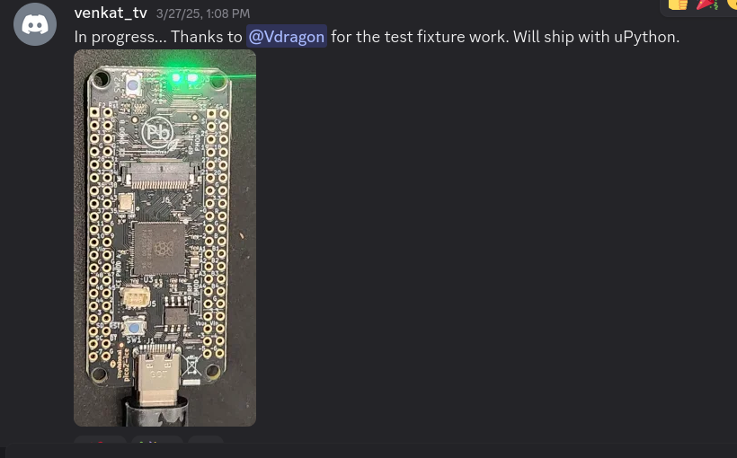
pico2-with pmods

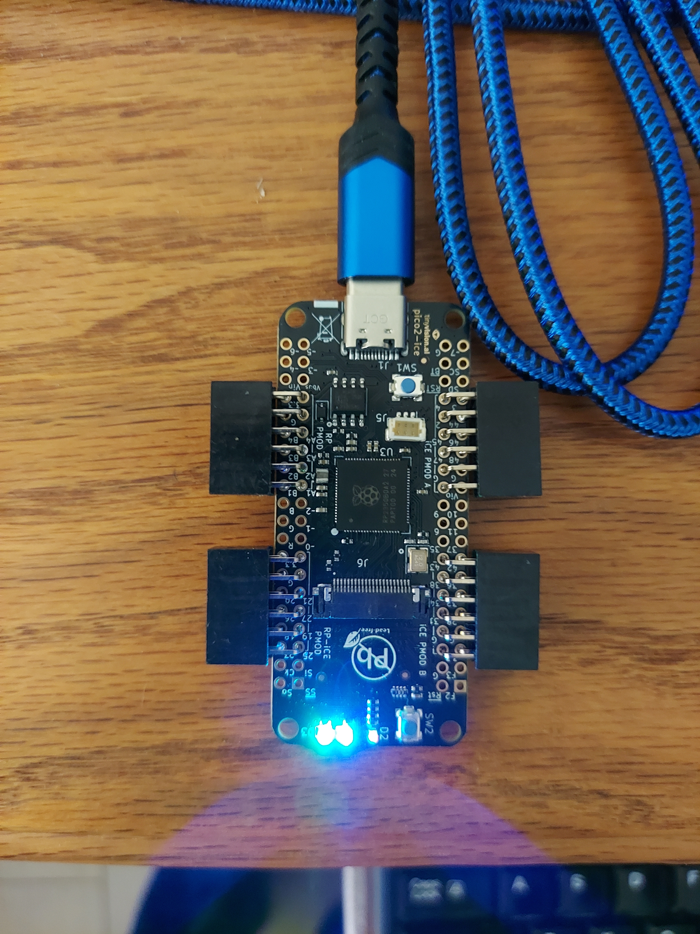

/dev/ttyACM0
https://pico-ice.tinyvision.ai/group__ice__usb.html#autotoc_md2

pico2-ice>

pico-ice default firmware
https://github.com/tinyvision-ai-inc/pico-ice/tree/main/Firmware/pico-ice-default

Serial port #0 - this shell, with commands:
v - print pico-ice-sdk version

Serial port #1 - forwarding to UART
UART TX on RP20 = ICE27
UART RX on RP30 = ICE25

Serial port #2 - forwarding to SPI:
https://pico-ice.tinyvision.ai/group__ice__usb.html#autotoc_md2

pico2-ice>

pico-ice default firmware
https://github.com/tinyvision-ai-inc/pico-ice/tree/main/Firmware/pico-ice-default

Serial port #0 - this shell, with commands:
v - print pico-ice-sdk version

Serial port #1 - forwarding to UART
UART TX on RP20 = ICE27
UART RX on RP30 = ICE25

Serial port #2 - forwarding to SPI:
https://pico-ice.tinyvision.ai/group__ice__usb.html#autotoc_md2

pico2-ice>
xx

devel@pi5-90:~ $ git clone https://github.com/develone/pico2-ice.git -b test-dev
Cloning into 'pico2-ice'...
remote: Enumerating objects: 304, done.
remote: Counting objects: 100% (304/304), done.
remote: Compressing objects: 100% (203/203), done.
remote: Total 304 (delta 134), reused 239 (delta 73), pack-reused 0 (from 0)
Receiving objects: 100% (304/304), 10.71 MiB | 19.62 MiB/s, done.
Resolving deltas: 100% (134/134), done.
devel@pi5-90:~ $ cd pico2-ice/

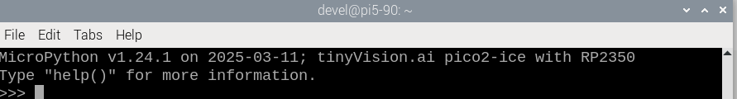
xx

```python
from machine import Pin
import ice
fpga = ice.fpga(cdone=Pin(40), clock=Pin(21), creset=Pin(31), cram_cs=Pin(5), cram_mosi=Pin(4), cram_sck=Pin(6), frequency=48)
file = open("bitstream.bin", "br")
fpga.start()
fpga.cram(file)```
pico2-ice rev1

https://pico-ice.tinyvision.ai/group__ice__usb.html#autotoc_md2

pico2-ice>

pico-ice default firmware
https://github.com/develone/pico2-ice/blob/test-dev/Firmware/pico2-ice-default/pico2_ice_default.uf2
https://github.com/tinyvision-ai-inc/pico-ice/tree/main/Firmware/pico-ice-default

Serial port #0 - this shell, with commands:
v - print pico-ice-sdk version

Serial port #1 - forwarding to UART
UART TX on RP20 = ICE27
UART RX on RP30 = ICE25

Serial port #2 - forwarding to SPI:
https://pico-ice.tinyvision.ai/group__ice__usb.html#autotoc_md2

pico2-ice>

pico-ice default firmware
https://github.com/tinyvision-ai-inc/pico-ice/tree/main/Firmware/pico-ice-default

Serial port #0 - this shell, with commands:
v - print pico-ice-sdk version

xxx
pico2-ice with Digilent pmod-vga This works on the pico-ice or pico2-ice
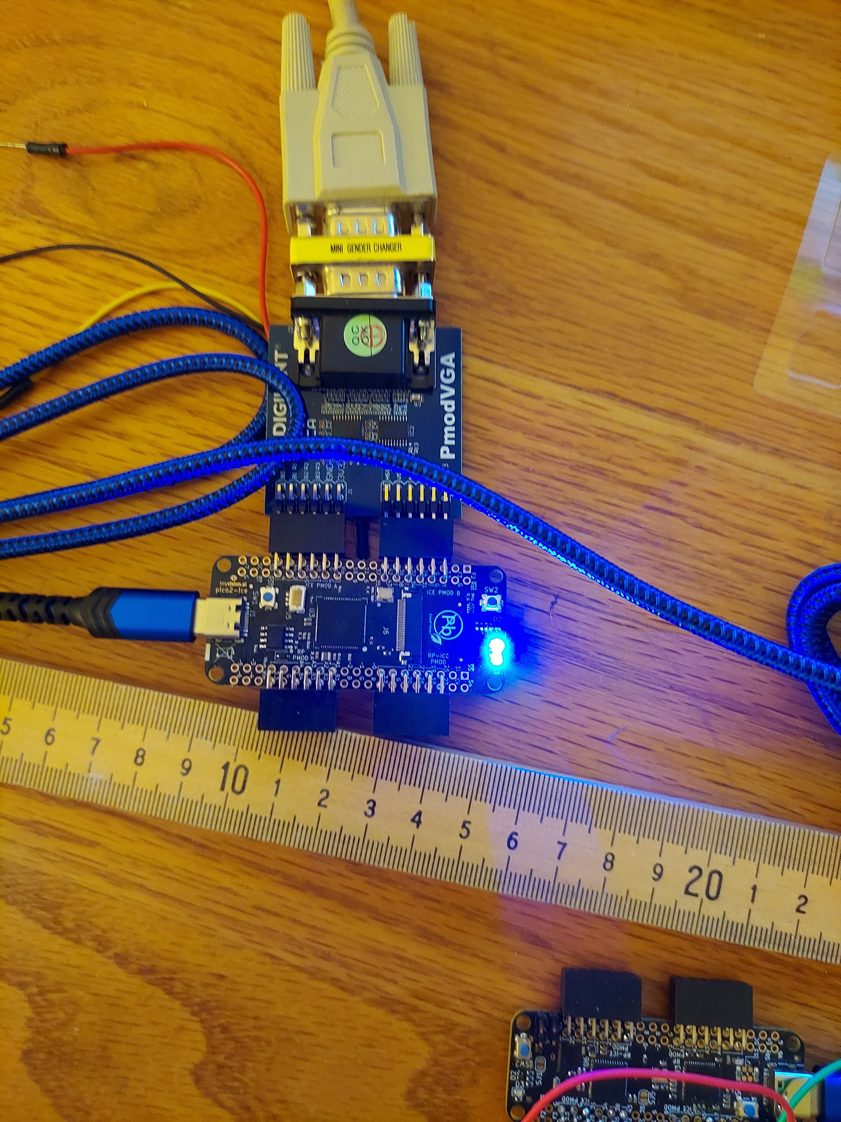
xxx
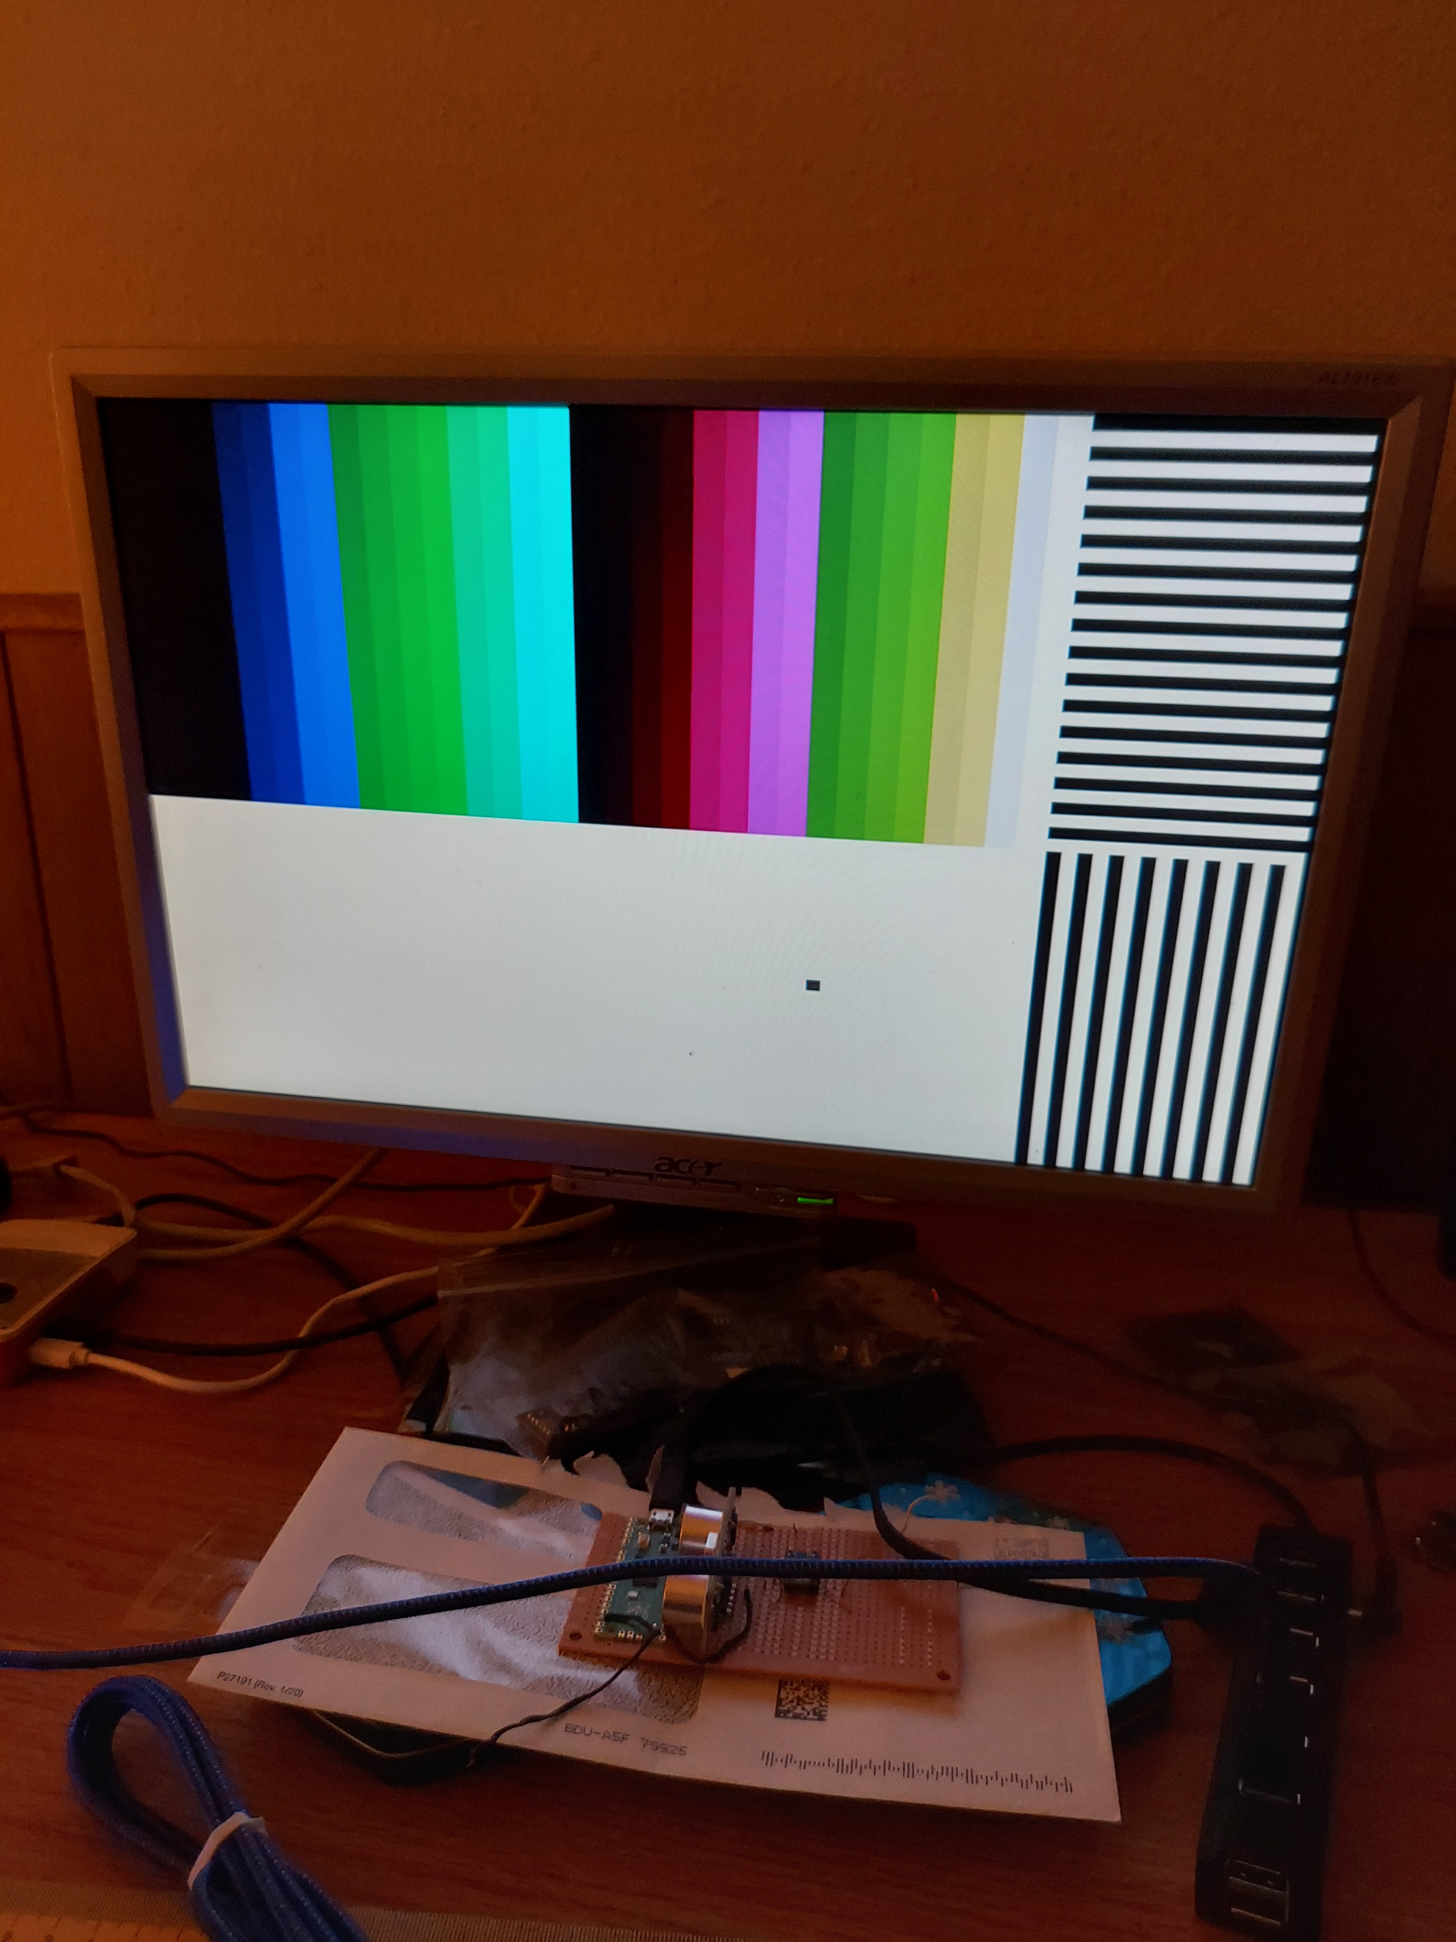
xxx
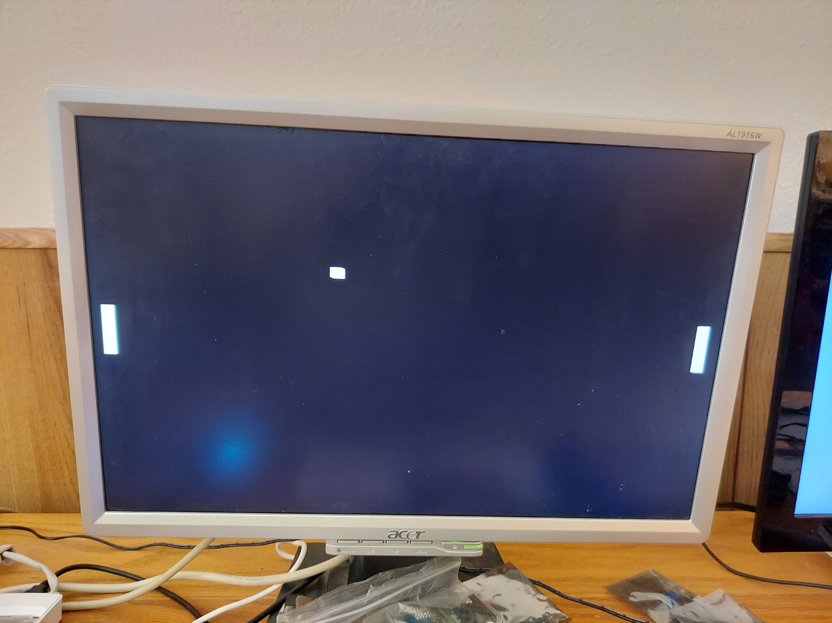
xx
Serial port #1 - forwarding to UART
UART TX on RP20 = ICE27
UART RX on RP30 = ICE25

Serial port #2 - forwarding to SPI:
https://pico-ice.tinyvision.ai/group__ice__usb.html#autotoc_md2
xx

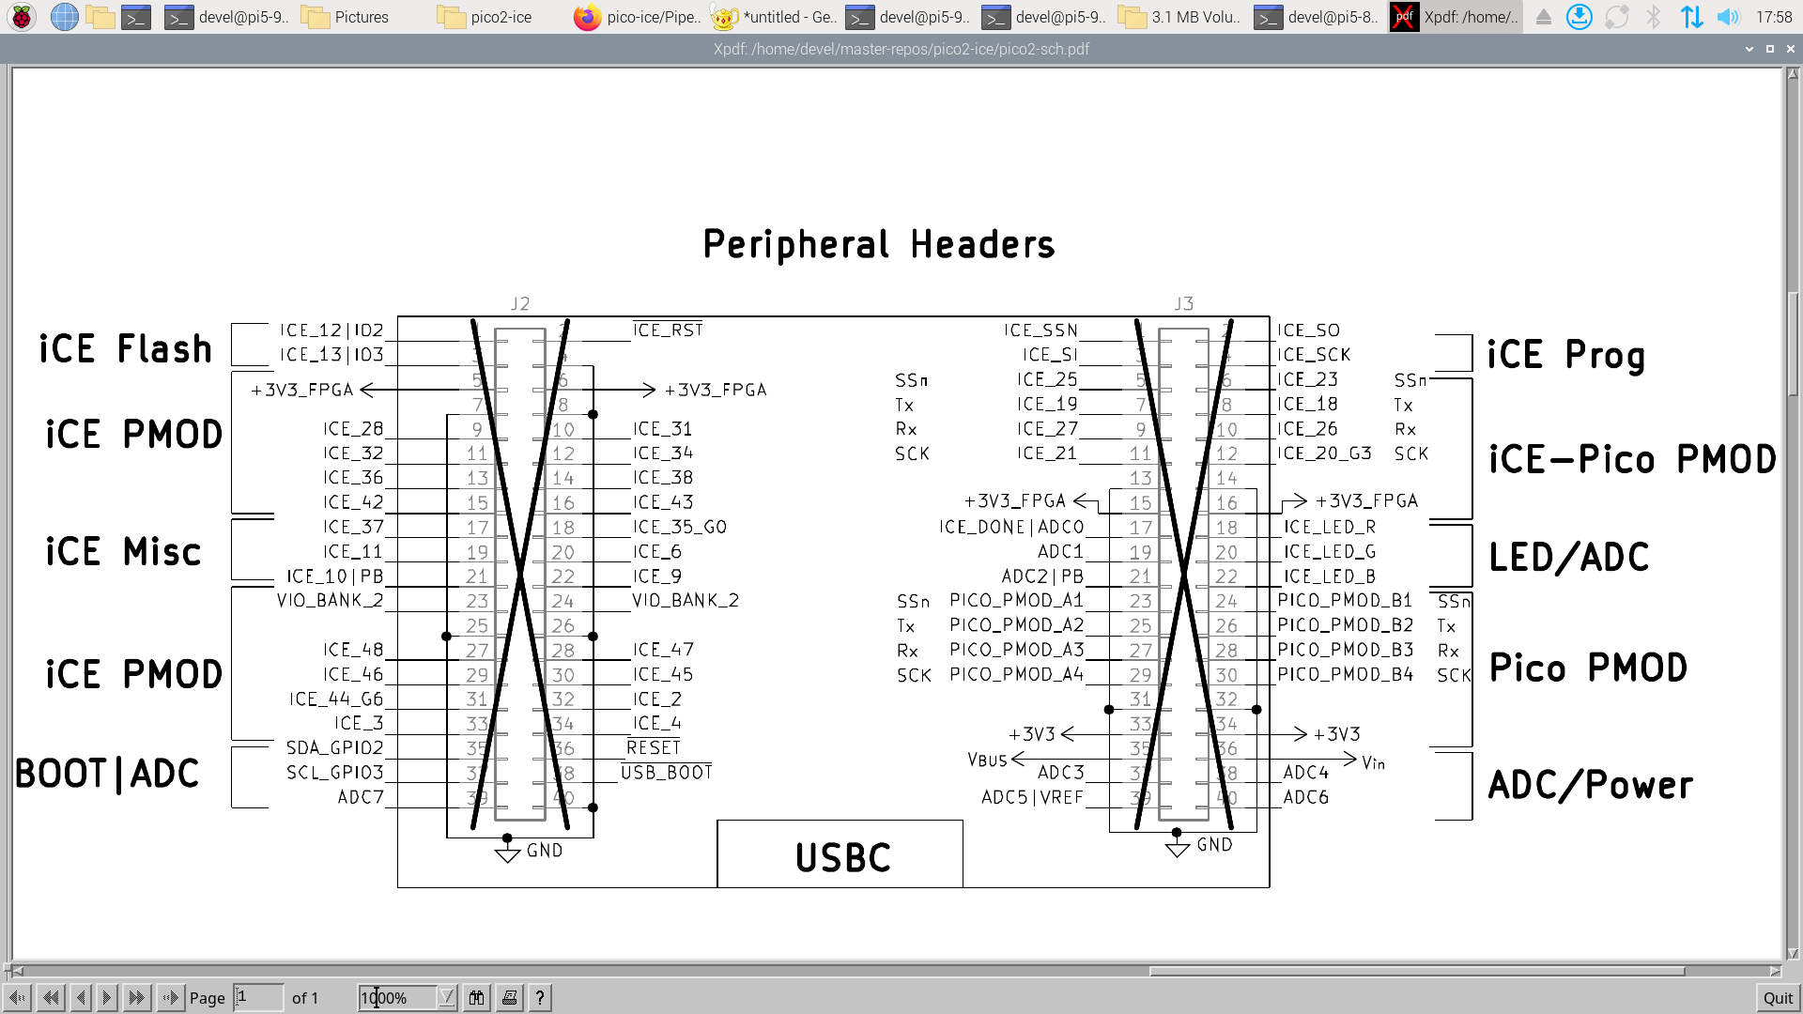
xx

pico2-ice>
xx
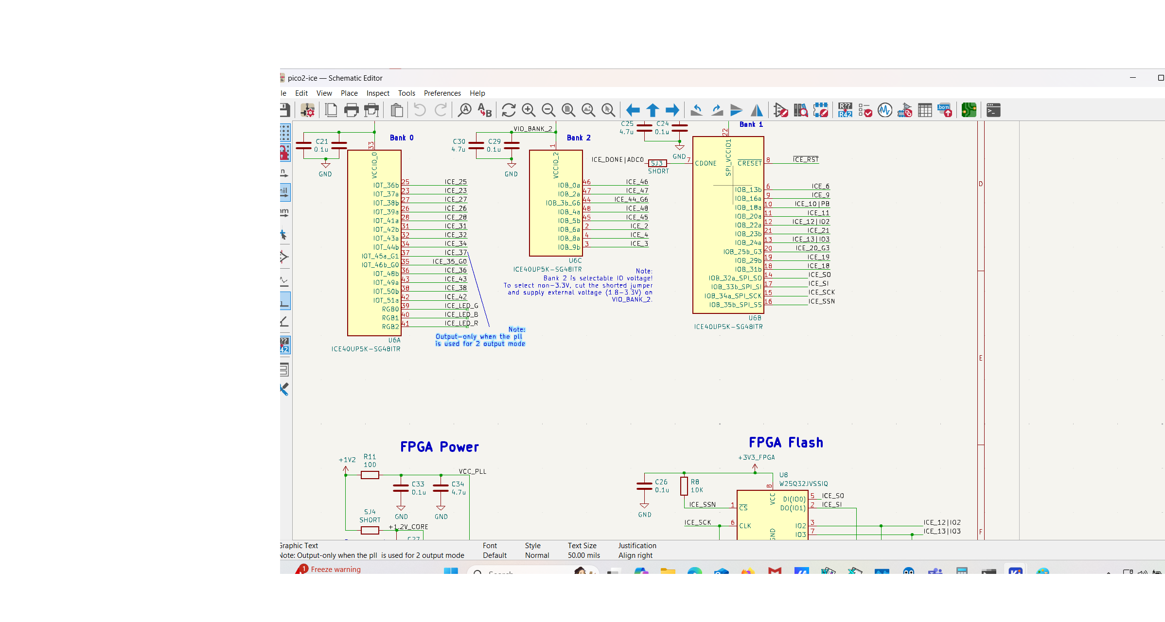
xx
RP2350
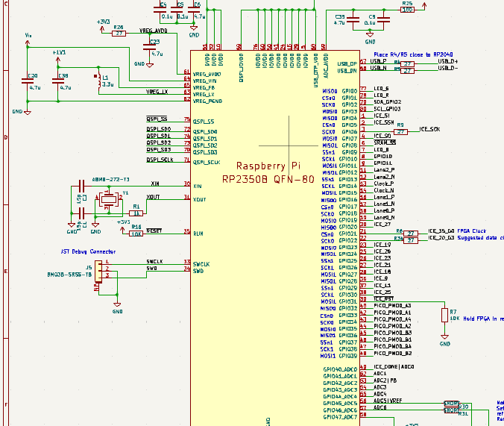
xx

