********************Default********************
Initial pico2_w-mqtt based on pico-examples
and hostapd testing
pico2_w-mqtt key starting point
04/11/25
********************Default********************

The repository “https://github.com/develone/pico-examples/tree/test-dev” branch test-dev
with “https://github.com/develone/pico-examples/blob/test-dev/pico_w/wifi/freertos/iperf/picow_freertos_iperf.c” opens the way to for repository “https://github.com/develone/pico2_w-mqtt”. The pico2_w-mqtt needs a few extra projects called in “https://github.com/develone/pico_w-mqtt/blob/master/pico_w/wifi/freertos/iperf/CmakeLists.txt”.

04/11/25 This is going to use another of the wifi networks "Pico_w-Net3" that I have working using hostapd on a Raspberry Pi4 4Gb.
This build required setting two environment variables.
export WIFI_SSID="Pico_w-Net3"
export WIFI_PASSWORD="WIFI_PASSWORD"

devel@pi5-70:~/pico2_w-mqtt/pico2_w/wifi/freertos/iperf $ less ~/pico-examples/compile-rp2350.sh
#!/bin/bash
rm -rf build-rp2350
mkdir build-rp2350
cd build-rp2350
cmake .. -DPICO_BOARD=pico2_w -DPICO_PLATFORM=rp2350 -DWIFI_SSID="Pico_w-Net3" -DWIFI_PASSWORD="WIFI_PASSWORD"
make
#!/bin/bash
rm -rf build-rp2350
mkdir build-rp2350
cd build-rp2350
Raspberry Pi4 provided the WIFI_SSID="Pico_w-Net3" running hostapd

Note:Need the step required to get hostapd working

devel@pi4-60:~ $ less /etc/hostapd/hostapd.conf
interface=wlan0
driver=nl80211
ssid=Pico_w-Net3
hw_mode=g
channel=7
wmm_enabled=0
macaddr_acl=0
auth_algs=1
ignore_broadcast_ssid=0
wpa=2
wpa_passphrase="WIFI_PASSWORD"
wpa_key_mgmt=WPA-PSK
wpa_pairwise=TKIP
rsn_pairwise=CCMP

devel@pi4-60:~ $ ifconfig wlan0
wlan0: flags=4163<UP,BROADCAST,RUNNING,MULTICAST> mtu 1500
inet 192.168.20.1 netmask 255.255.255.0 broadcast 192.168.20.255
inet6 fe80::70e3:cabc:fb9b:de49 prefixlen 64 scopeid 0x20<link>
ether dc:a6:32:09:35:24 txqueuelen 1000 (Ethernet)
RX packets 108 bytes 6694 (6.5 KiB)
RX errors 0 dropped 0 overruns 0 frame 0
TX packets 272 bytes 47167 (46.0 KiB)
TX errors 0 dropped 0 overruns 0 carrier 0 collisions 0

cmake .. -DPICO_BOARD=pico2_w -DPICO_PLATFORM=rp2350 -DWIFI_SSID="Pico_w-Net3" -DWIFI_PASSWORD="WIFI_PASSWORD"
make

commit 3959c1a2b7ff33f025c5bcd9f07f32898894066d (HEAD -> test-dev, origin/test-dev)
Merge: b3403e5 84e8d48
Author: develone <develone@sbcglobal.net>
Date: Wed Apr 9 11:14:17 2025 -0600

Merge branch 'raspberrypi:master' into test-dev

diff --git a/pico_w/CMakeLists.txt b/pico_w/CMakeLists.txt
index f66c02e..35fd59a 100644
--- a/pico_w/CMakeLists.txt
+++ b/pico_w/CMakeLists.txt
@@ -1,28 +1,9 @@
cmake_minimum_required(VERSION 3.12)
-
-if (PICO_CYW43_SUPPORTED) # set by PICO_BOARD=pico_w
- if (NOT TARGET pico_cyw43_arch)
- message("Skipping Pico W examples as support is not available")
- else()
-
- if (DEFINED ENV{WIFI_SSID} AND (NOT WIFI_SSID))
- set(WIFI_SSID $ENV{WIFI_SSID})
- message("Using WIFI_SSID from environment ('${WIFI_SSID}')")
- endif()
-
- if (DEFINED ENV{WIFI_PASSWORD} AND (NOT WIFI_PASSWORD))
- set(WIFI_PASSWORD $ENV{WIFI_PASSWORD})
- message("Using WIFI_PASSWORD from environment")
- endif()
-
- set(WIFI_SSID "${WIFI_SSID}" CACHE INTERNAL "WiFi SSID for examples")
- if (DEFINED ENV{WIFI_PASSWORD} AND (NOT WIFI_PASSWORD))
- set(WIFI_PASSWORD $ENV{WIFI_PASSWORD})
- message("Using WIFI_PASSWORD from environment")
- endif()
-
- set(WIFI_SSID "${WIFI_SSID}" CACHE INTERNAL "WiFi SSID for examples")
- set(WIFI_PASSWORD "${WIFI_PASSWORD}" CACHE INTERNAL "WiFi password for examples")
+set(WIFI_SSID $ENV{WIFI_SSID})
+set(WIFI_PASSWORD $ENV{WIFI_PASSWORD})
+message("Using WIFI_SSID from environment ('${WIFI_SSID}')")
+message("Using WIFI_PASSWORD from environment")
+message("Using WIFI_PASSWORD from environment ('${WIFI_PASSWORD}')")

add_subdirectory(wifi)
- if (NOT TARGET pico_btstack_base)
- message("Skipping Pico W Bluetooth examples as support is not available")
- else()
add_subdirectory(bt)
- endif()
- endif()
-endif()
devel@pi5-70:~/pico-examples $ ls build-rp2350/pico_w/wifi/
access_point cmake_install.cmake httpd mqtt tcp_server wifi_scan
blink freertos iperf ntp_client tls_client
CMakeFiles http_client Makefile tcp_client udp_beacon

devel@pi5-70:~/pico-examples/build-rp2350/pico_w/wifi/freertos/iperf $ scp picow_freertos_iperf_server_sys.uf2 pi5-90:/media/devel/RP2350/
picow_freertos_iperf_server_sys.uf2 100% 655KB 10.6MB/s 00:00
The is working pico2_w

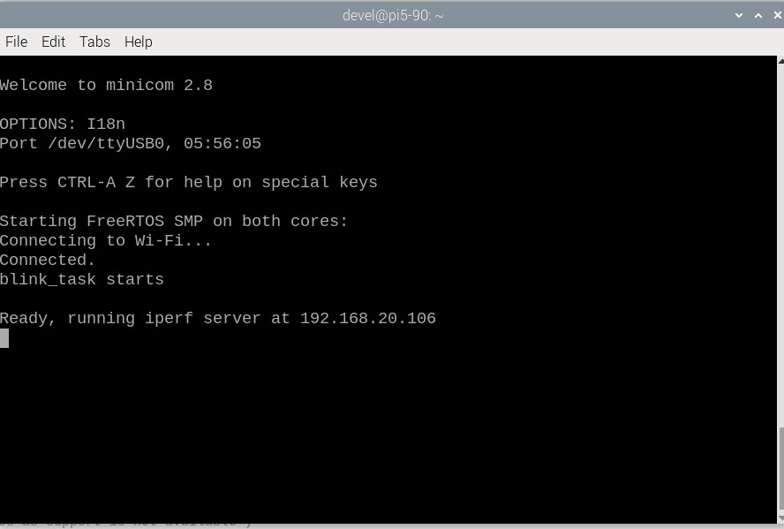
xx

