*******************Default*******************
Pico2_w pico-examples
04/10/25
*******************Default*******************
“git clone https://github.com/develone/pico-examples.git -b test-dev”
#!/bin/bash
#rm -rf build-2350
#mkdir build-2350
cd build-2350
cmake .. -DPICO_BOARD=pico2_w -DPICO_PLATFORM=rp2350 -DWIFI_SSID="WIFI_SSID" -DWIFI_PASSWORD="WIFI_PASSWORD"
make
The first issue in the build
CMake is dropping a preprocessor definition: WIFI_PASSWORD="xxxxxxxxx#xx"
The next tried adding
export WIFI_SSID="WIFI_SSID"
export WIFI_PASSWORD="WIFI_PASSWORD"
Modified the file
devel@pi5-90:~/pico-examples $ git diff pico_w/CMakeLists.txt
diff --git a/pico_w/CMakeLists.txt b/pico_w/CMakeLists.txt
index f66c02e..35fd59a 100644
--- a/pico_w/CMakeLists.txt
+++ b/pico_w/CMakeLists.txt
@@ -1,28 +1,9 @@
cmake_minimum_required(VERSION 3.12)
-
-if (PICO_CYW43_SUPPORTED) # set by PICO_BOARD=pico_w
- if (NOT TARGET pico_cyw43_arch)
- message("Skipping Pico W examples as support is not available")
- else()
-
- if (DEFINED ENV{WIFI_SSID} AND (NOT WIFI_SSID))
- set(WIFI_SSID $ENV{WIFI_SSID})
- message("Using WIFI_SSID from environment ('${WIFI_SSID}')")
- endif()
-
- if (DEFINED ENV{WIFI_PASSWORD} AND (NOT WIFI_PASSWORD))
- set(WIFI_PASSWORD $ENV{WIFI_PASSWORD})
- message("Using WIFI_PASSWORD from environment")
- endif()
-
- set(WIFI_SSID "${WIFI_SSID}" CACHE INTERNAL "WiFi SSID for examples")
- set(WIFI_PASSWORD "${WIFI_PASSWORD}" CACHE INTERNAL "WiFi password for examples")
+set(WIFI_SSID $ENV{WIFI_SSID})
+set(WIFI_PASSWORD $ENV{WIFI_PASSWORD})
+message("Using WIFI_SSID from environment ('${WIFI_SSID}')")
+message("Using WIFI_PASSWORD from environment")
+message("Using WIFI_PASSWORD from environment ('${WIFI_PASSWORD}')")

add_subdirectory(wifi)
- if (NOT TARGET pico_btstack_base)
- message("Skipping Pico W Bluetooth examples as support is not available")
- else()
add_subdirectory(bt)
- endif()
- endif()
-endif()

xx
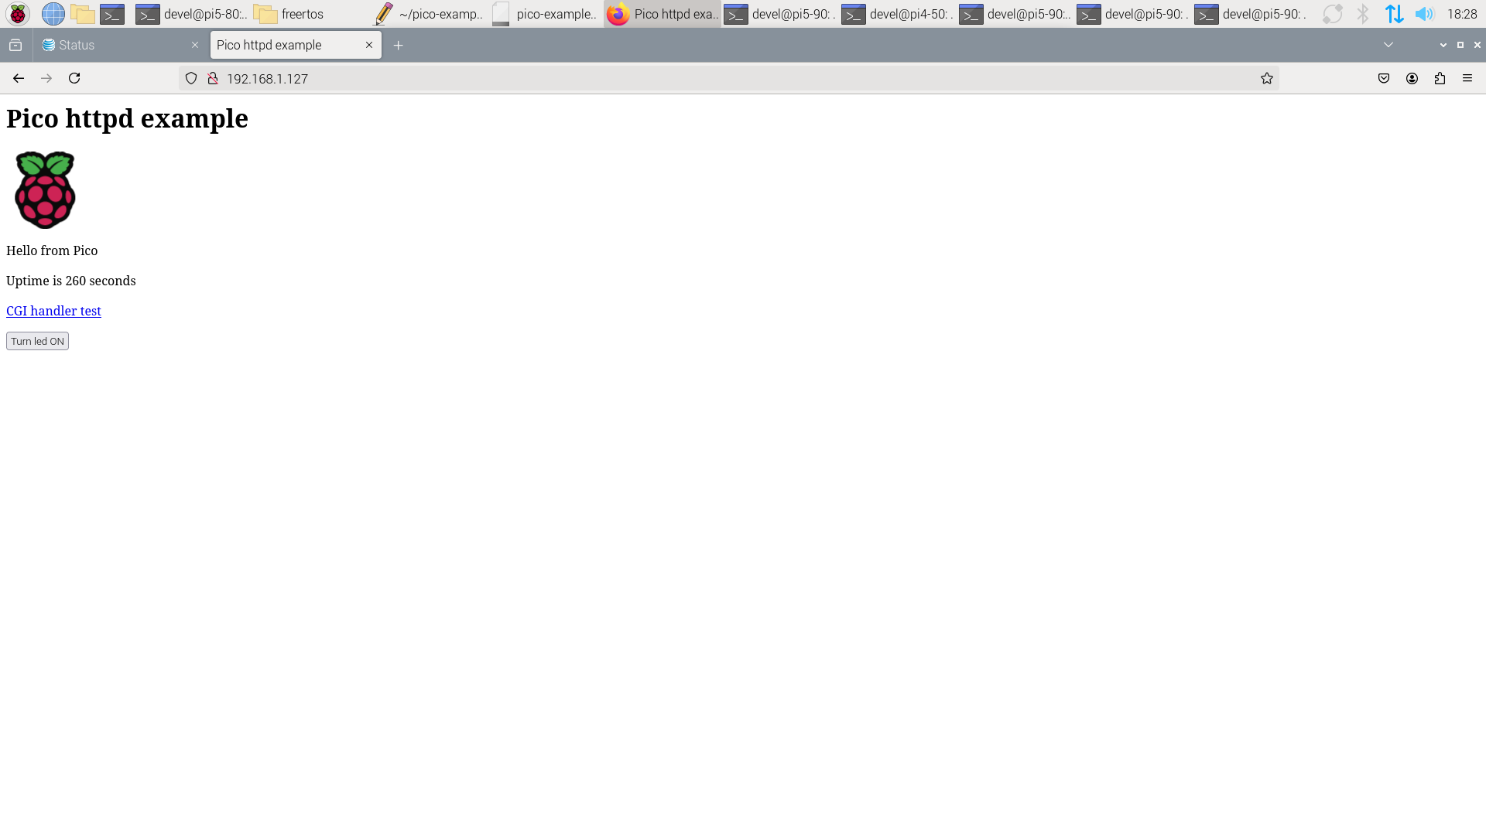
xx

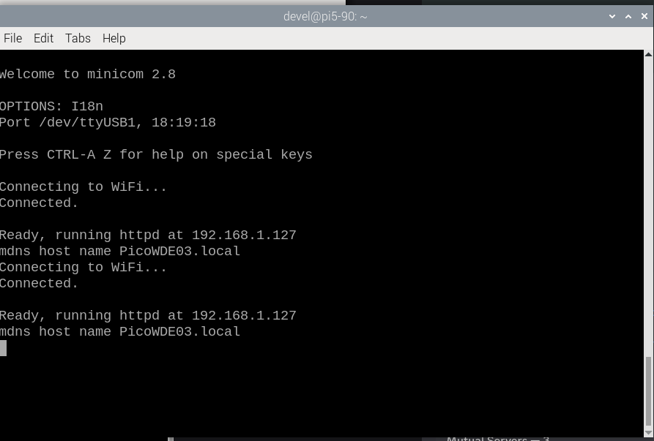
xx

xx

xx
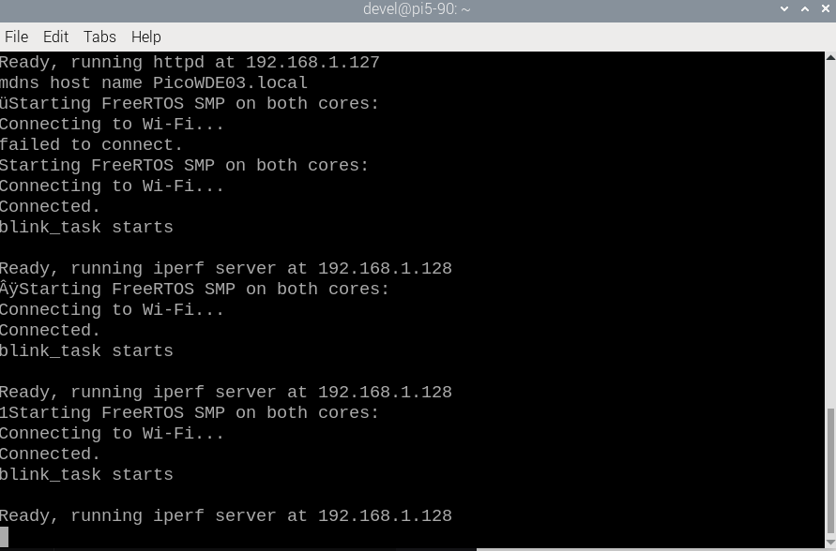
xx

