******************Draft******************
pshell /dev/ttyACM0
or
pshell /dev/ttyUSB0
07/30/26
******************Draft******************

The following text in pshell/CmakeList.txt file controls which port is used.

if (USB_CONSOLE)
pico_enable_stdio_uart(${PSHELL} 0)
pico_enable_stdio_usb(${PSHELL} 1)
else()
pico_enable_stdio_uart(${PSHELL} 1)
pico_enable_stdio_usb(${PSHELL} 0)
endif()

This statement in pshell/cmpico2
cmake .. -DUSB_CONSOLE=0 -DPICO_BOARD=pico2 -DPICO_PLATFORM=rp2350

xx

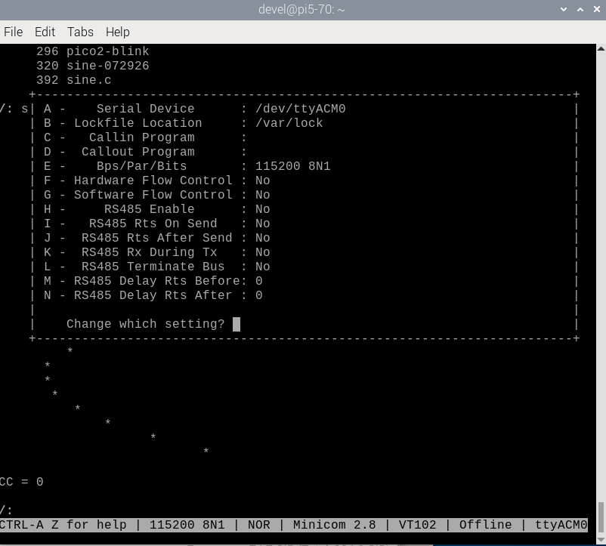

/: version

Pico Shell , LittleFS v2.9, Vi 0.9.1, SDK v2.2.0xx

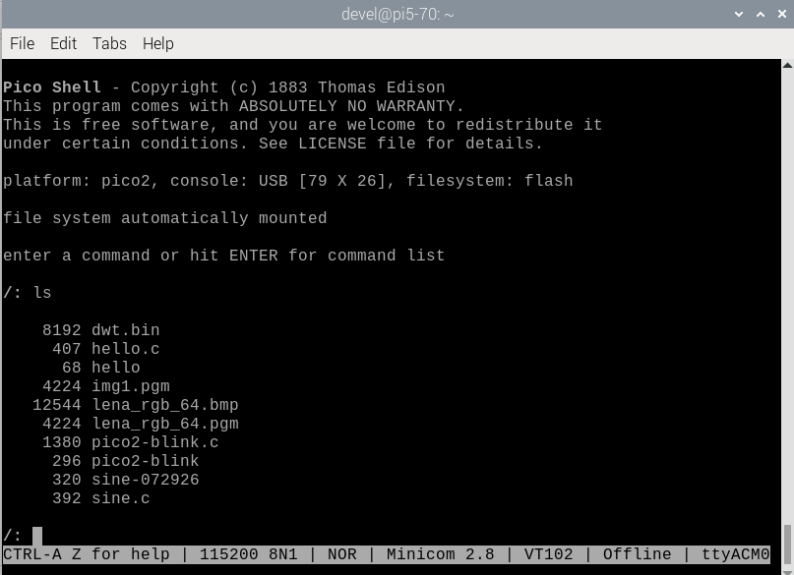

xx

If the pshell/cmpico2 or pshell/cmpico are used to create the Makefile.

The FTDI 2 USB is located in lower part of the image below.

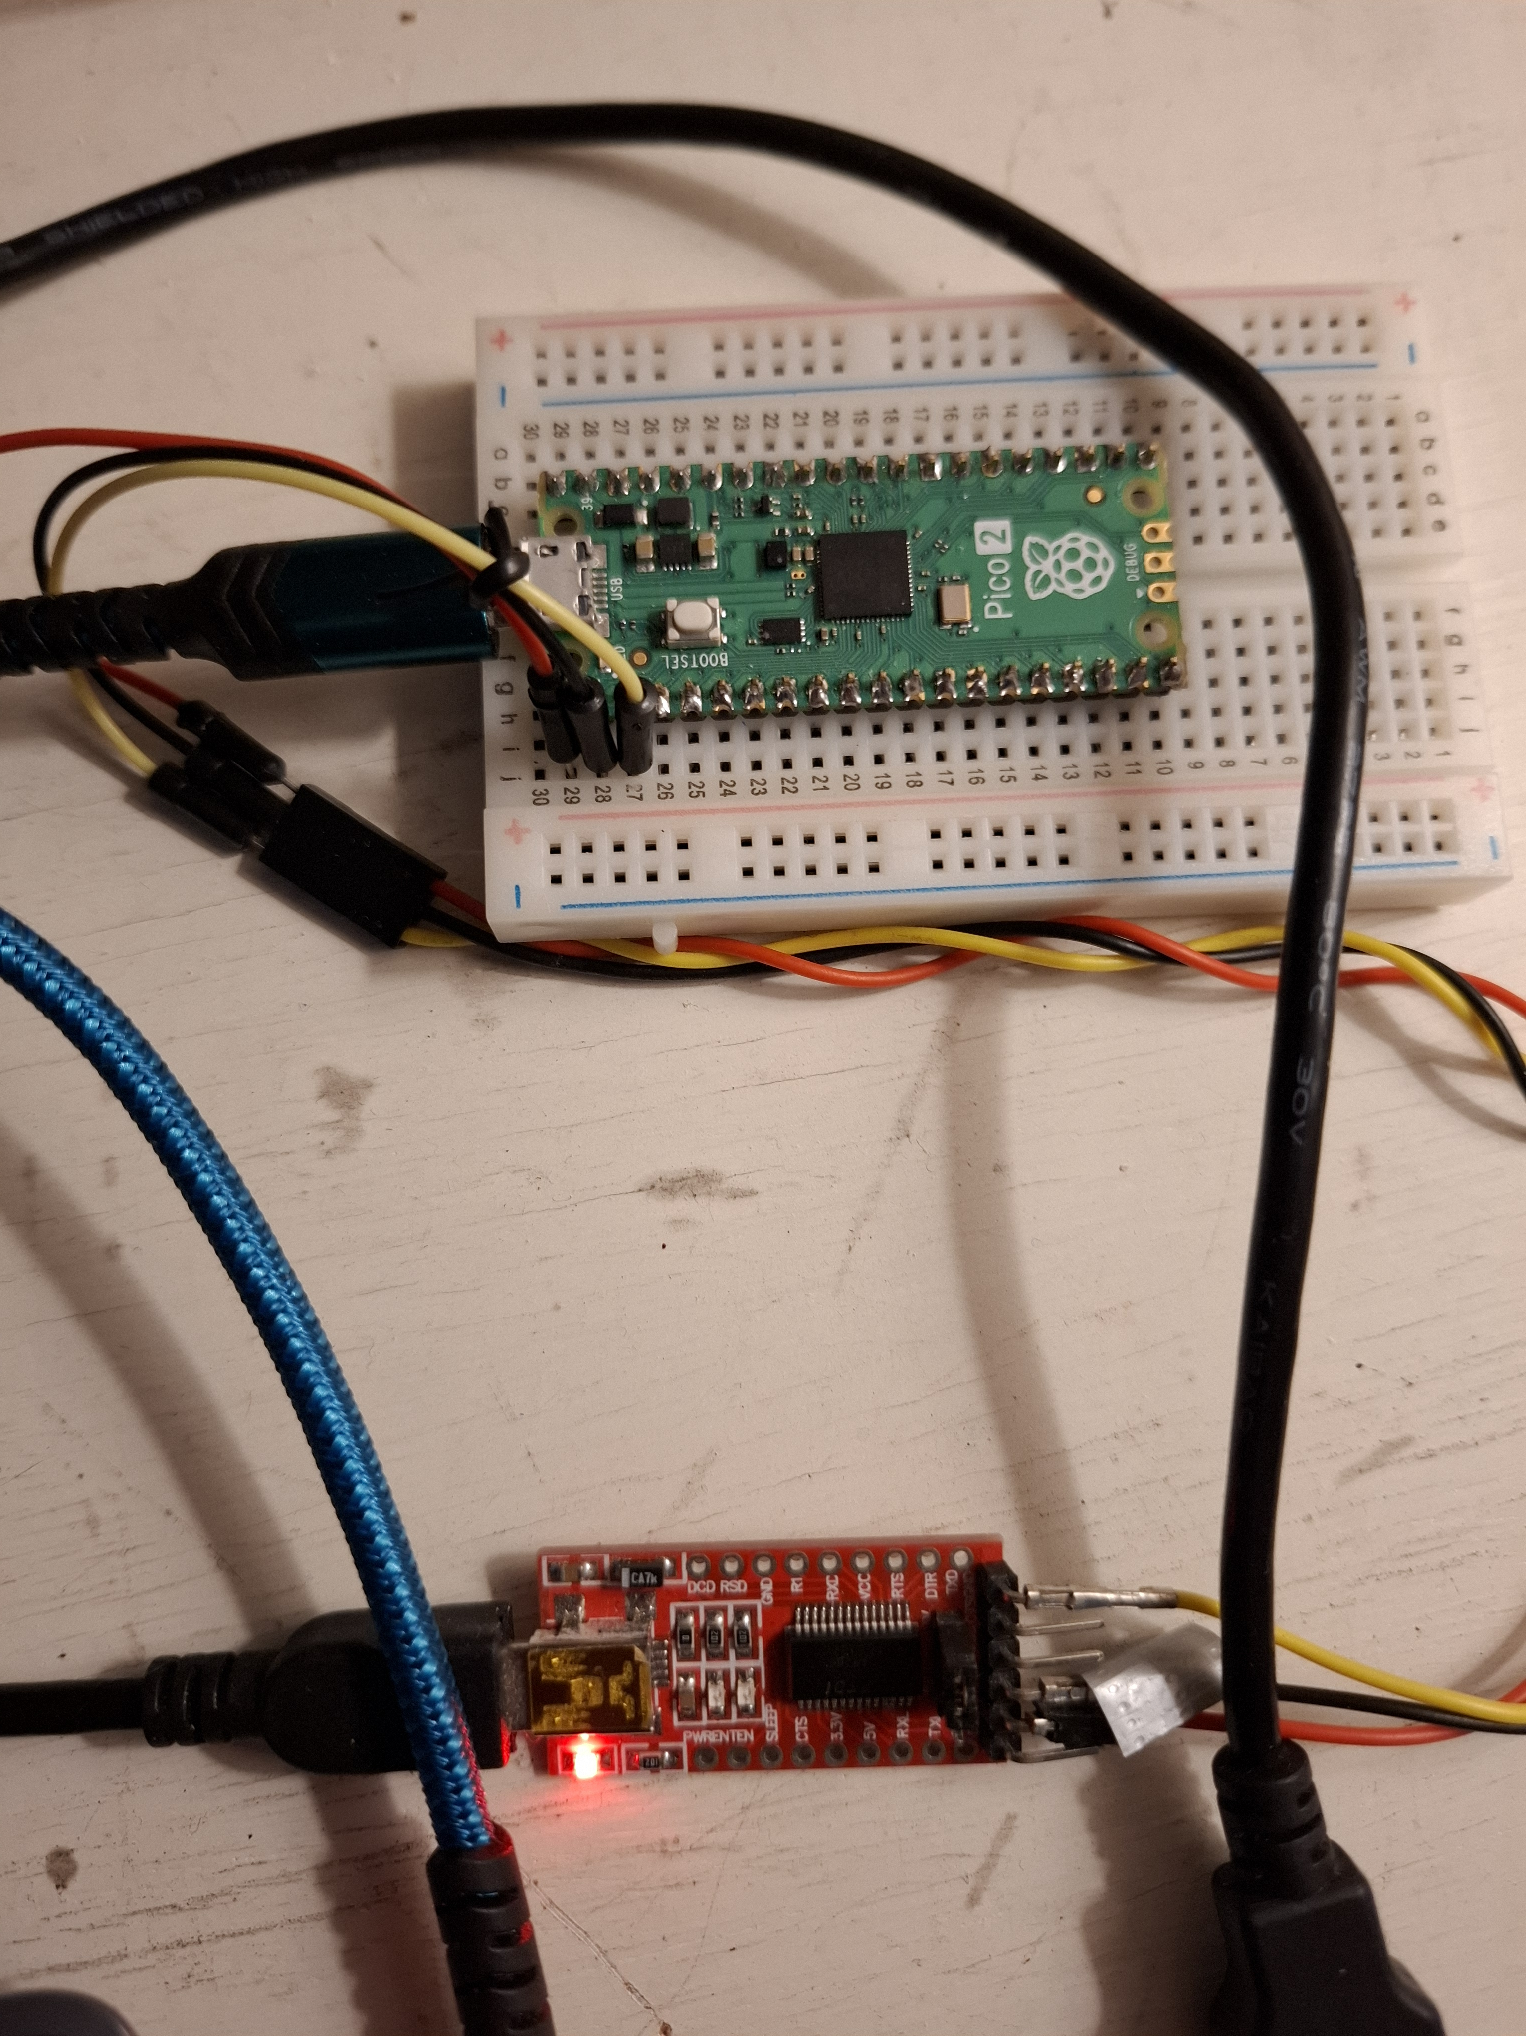

These are the settings of the USB port.
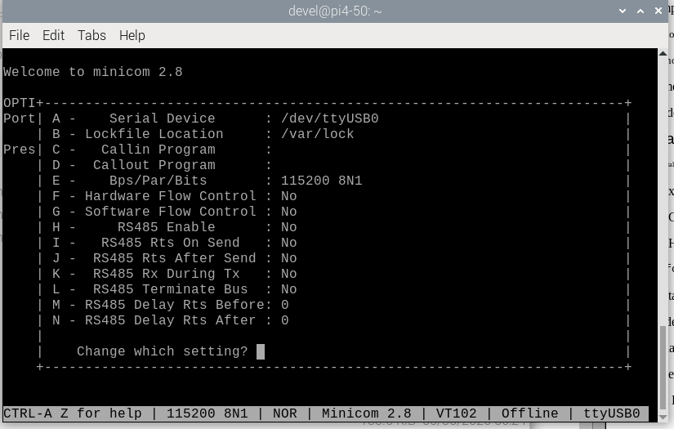

This is USB after reboot
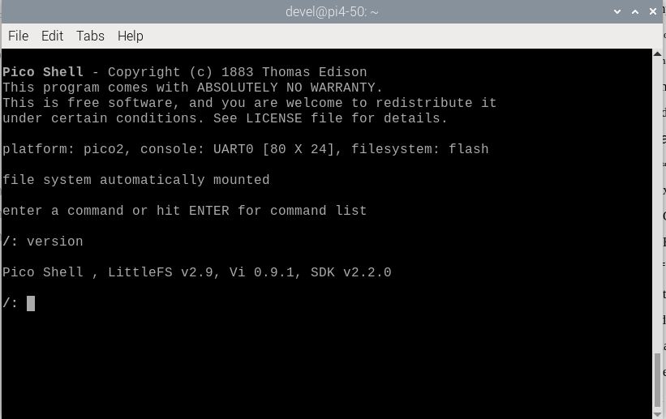

xx

