Testing Cat Board tools
Yosys_Arachne-pnr_Icebox
Iverilog installed from
gtkwave_iverilog_python3_yosys_bcm2735_arachne-pnr_icebox_usrlocal091715
10/28/15

GTKWave can be installed with the command “sudo apt-get install gtkwave”.

The script “yosys_arachne-pnr_icebox_extract.sh”

#!/bin/bash

#10/27/15

#Requires 2015-09-24-raspbian-jessie

#sudo apt-get install libffi-dev tcl-dev mercurial libreadline-dev squashfs-tools

#git clone https://github.com/jandecaluwe/myhdl.git

#cd myhdl/

#sudo python setup.py install

#Provides the tools to support the cat board.

#yosys arachne-pnr icebox

sudo unsquashfs gtkwave_iverilog_python3_yosys_bcm2735_arachne-pnr_icebox_usrlocal091715

sudo cp squashfs-root/bin/yosys* /usr/local/bin

sudo cp squashfs-root/bin/arachne-pnr /usr/local/bin

sudo cp squashfs-root/bin/icebox* /usr/local/bin

sudo cp -R squashfs-root/share/arachne-pnr/ /usr/local/share/

sudo cp -R squashfs-root/share/icebox/ /usr/local/share/

sudo cp -R squashfs-root/share/yosys /usr/local/share/

sudo cp squashfs-root/bin/icepack /usr/local/bin

sudo cp squashfs-root/bin/iceprog /usr/local/bin

sudo cp squashfs-root/bin/icemulti /usr/local/bin

git clone https://github.com/cfelton/rhea.git

cd rhea/

sudo python setup.py develop

cd examples/build

python ex_icestick.py

python ex_catboard.py

ls -la iceriver/

The script “iverilog_extract.sh” copies the file from squashfs-root to /usr/local.

#!/bin/bash
#10/27/15
#Requires 2015-09-24-raspbian-jessie
#sudo apt-get install libffi-dev tcl-dev mercurial libreadline-dev squashfs-tools
#git clone https://github.com/jandecaluwe/myhdl.git
#cd myhdl/
#sudo python setup.py install
#Provides the tools to support the cat board.
#yosys arachne-pnr icebox

sudo cp squashfs-root/bin/iverilog* /usr/local/bin
sudo cp squashfs-root/bin/vvp /usr/local/bin
sudo cp -R squashfs-root/include/iverilog /usr/local/include

sudo cp squashfs-root/lib/libvpi.a /usr/local/lib
sudo cp squashfs-root/lib/libveriuser.a /usr/local/lib
sudo cp -R squashfs-root/lib/ivl /usr/local/lib

The initial links of libbz2 of a jessie raspbian look like the image below.
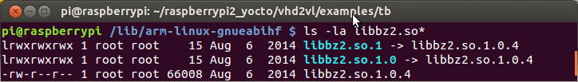

With the command sudo ln -sf libbz2.so.1.0.4 libbz2.so.0 in the /lib/arm-linux-gnueabihf of a jessie raspbian look like the image below.
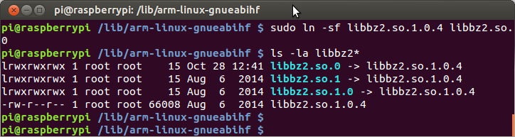
cd myhdl/

pi@raspberrypi ~/myhdl $ cd cosimulation/icarus/

pi@raspberrypi ~/myhdl/cosimulation/icarus $ make

iverilog-vpi myhdl.c myhdl_table.c

Compiling myhdl.c...

myhdl.c: In function ‘to_myhdl_calltf’:

myhdl.c:159:15: warning: variable ‘value_s’ set but not used [-Wunused-but-set-variable]

s_vpi_value value_s;

^

Compiling myhdl_table.c...

Making myhdl.vpi from myhdl.o myhdl_table.o...

cp ~/myhdl/cosimulation/icarus/myhdl.vpi .

pi@raspberrypi ~/raspberrypi2_yocto/vhd2vl/examples/tb $ mkdir vcd

pi@raspberrypi ~/raspberrypi2_yocto/vhd2vl/examples/tb $ python test_ifchain.py Running test...

0

*{'a': Signal(intbv(0L)), 'status': Signal(False), 'rstn': Signal(False), 'b': Signal(intbv(0L)), 'clk': Signal(False)}

compiling ...

iverilog -o ifchain ../ifchain.v ./tb_ifchain.v

cosimulation setup ...

vvp -m ./myhdl.vpi ifchain

VCD info: dumpfile vcd/ifchain1.vcd opened for output.

gtkwave vcd/ifchain1.vcd

