QEMU for Raspberry Pi Ubuntu 16.04
with qemu-system-arm as a
deb package
12/7/19

https://azeria-labs.com/emulate-raspberry-pi-with-qemu/
Testing qemu on ws009 for raspberry pi
vidal@ws009:~$ cd qemu_vms

Steps below to prepare the image to boot using qemu. This only needs to be done once to prepare the 2017-04-10-raspbian-jessie.img for qemu.

vidal@ws009:~/qemu_vms$ unzip 2017-04-10-raspbian-jessie.zip
vidal@ws009:~/qemu_vms$ fdisk -l 2017-04-10-raspbian-jessie.img
Disk 2017-04-10-raspbian-jessie.img: 4 GiB, 4285005824 bytes, 8369152 sectors
Units: sectors of 1 * 512 = 512 bytes
Sector size (logical/physical): 512 bytes / 512 bytes
I/O size (minimum/optimal): 512 bytes / 512 bytes
Disklabel type: dos
Disk identifier: 0x402e4a57

Device Boot Start End Sectors Size Id Type
2017-04-10-raspbian-jessie.img1 8192 92159 83968 41M c W95 FAT32 (LBA)
2017-04-10-raspbian-jessie.img2 92160 8369151 8276992 4G 83 Linux
92160 47185920

vidal@ws009:~/qemu_vms$ sudo mount -v -o offset=47185920 -t ext4 ~/qemu_vms/2017-04-10-raspbian-jessie.img /mnt/raspbian
[sudo] password for vidal:
mount: /dev/loop0 mounted on /mnt/raspbian.
vidal@ws009:~/qemu_vms$ sudo cp /mnt/raspbian/etc/ld.so.preload .
vidal@ws009:~/qemu_vms$ sudo cp /mnt/raspbian/etc/fstab .
vidal@ws009:~/qemu_vms$ sudo nano /mnt/raspbian/etc/ld.so.preload

vidal@ws009:~/qemu_vms$ sudo nano /mnt/raspbian/etc/fstab
vidal@ws009:~/qemu_vms$ diff fstab /mnt/raspbian/etc/fstab
2,3c2,3
< PARTUUID=402e4a57-01 /boot vfat defaults 0 2
< PARTUUID=402e4a57-02 / ext4 defaults,noatime 0 1
---
> /dev/sda1 /boot vfat defaults 0 2
> /dev/sda2 / ext4 defaults,noatime 0 1
vidal@ws009:~/qemu_vms$ sudo umount /mnt/raspbian

Command to start the virtual raspberry pi

Note: The yocto sdk qemu fails at startup.
vidal@ws009:~/qemu_vms$ . /opt/poky/3.0.1/rpi4/environment-setup-cortexa7t2hf-neon-vfpv4-poky-linux-gnueabi
vidal@ws009:~/qemu_vms$ qemu-system-arm -kernel ~/qemu_vms/qemu-rpi-kernel/kernel-qemu-4.4.34-jessie -cpu arm1176 -m 256 -M versatilepb -serial stdio -append "root=/dev/sda2 rootfstype=ext4 rw" -hda ~/qemu_vms/2017-04-10-raspbian-jessie.img -redir tcp:5022::22 -no-reboot
qemu-system-arm: -redir: invalid option

Removing the -redir tcp:5022::22 boots okay to

Command to start the virtual raspberry pi

vidal@ws009:~/qemu_vms$ qemu-system-arm -kernel ~/qemu_vms/qemu-rpi-kernel/kernel-qemu-4.4.34-jessie \
-cpu arm1176 -m 256 -M versatilepb -serial stdio \
-append "root=/dev/sda2 rootfstype=ext4 rw" -hda ~/qemu_vms/2017-04-10-raspbian-jessie.img \
-redir tcp:5022::22 -no-reboot
WARNING: Image format was not specified for '/home/vidal/qemu_vms/2017-04-10-raspbian-jessie.img' and probing guessed raw.
Automatically detecting the format is dangerous for raw images, write operations on block 0 will be restricted.
Specify the 'raw' format explicitly to remove the restrictions.
pulseaudio: set_sink_input_volume() failed
pulseaudio: Reason: Invalid argument
pulseaudio: set_sink_input_mute() failed
pulseaudio: Reason: Invalid argument
Uncompressing Linux... done, booting the kernel.

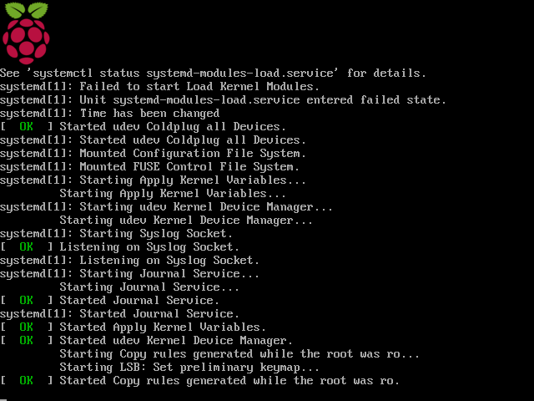

Raspberry Pi at console.

