Step1 Cross Compiling Yosys Tools for Raspberry Pi
Testing cross compiling on yocto sdk Ubuntu 16.04 icestorm
& arachne-pnr create catzip.bin from catzip.blif
12/7/19

vidal@ws009:~/wkg/test-yocto-sdk$ git clone https://github.com/develone/arachne-pnr.git
Cloning into 'arachne-pnr'...
remote: Enumerating objects: 1957, done.
remote: Total 1957 (delta 0), reused 0 (delta 0), pack-reused 1957
Receiving objects: 100% (1957/1957), 630.98 KiB | 0 bytes/s, done.
Resolving deltas: 100% (1369/1369), done.
Checking connectivity... done.
vidal@ws009:~/wkg/test-yocto-sdk$ cd arachne-pnr/
vidal@ws009:~/wkg/test-yocto-sdk/arachne-pnr$ time make -e
arm-poky-linux-gnueabi-g++ -mthumb -mfpu=neon-vfpv4 -mfloat-abi=hard -mcpu=cortex-a7 --sysroot=/opt/poky/3.0.1/rpi4/sysroots/cortexa7t2hf-neon-vfpv4-poky-linux-gnueabi -O2 -pipe -g -feliminate-unused-debug-types -c -o src/arachne-pnr.o src/arachne-pnr.cc
arm-poky-linux-gnueabi-g++ -mthumb -mfpu=neon-vfpv4 -mfloat-abi=hard -mcpu=cortex-a7 --sysroot=/opt/poky/3.0.1/rpi4/sysroots/cortexa7t2hf-neon-vfpv4-poky-linux-gnueabi -O2 -pipe -g -feliminate-unused-debug-types -c -o src/netlist.o src/netlist.cc
arm-poky-linux-gnueabi-g++ -mthumb -mfpu=neon-vfpv4 -mfloat-abi=hard -mcpu=cortex-a7 --sysroot=/opt/poky/3.0.1/rpi4/sysroots/cortexa7t2hf-neon-vfpv4-poky-linux-gnueabi -O2 -pipe -g -feliminate-unused-debug-types -c -o src/blif.o src/blif.cc
arm-poky-linux-gnueabi-g++ -mthumb -mfpu=neon-vfpv4 -mfloat-abi=hard -mcpu=cortex-a7 --sysroot=/opt/poky/3.0.1/rpi4/sysroots/cortexa7t2hf-neon-vfpv4-poky-linux-gnueabi -O2 -pipe -g -feliminate-unused-debug-types -c -o src/pack.o src/pack.cc
arm-poky-linux-gnueabi-g++ -mthumb -mfpu=neon-vfpv4 -mfloat-abi=hard -mcpu=cortex-a7 --sysroot=/opt/poky/3.0.1/rpi4/sysroots/cortexa7t2hf-neon-vfpv4-poky-linux-gnueabi -O2 -pipe -g -feliminate-unused-debug-types -c -o src/place.o src/place.cc
In file included from /opt/poky/3.0.1/rpi4/sysroots/cortexa7t2hf-neon-vfpv4-poky-linux-gnueabi/usr/include/c++/9.2.0/vector:72,
from src/util.hh:29,
from src/place.cc:16:
/opt/poky/3.0.1/rpi4/sysroots/cortexa7t2hf-neon-vfpv4-poky-linux-gnueabi/usr/include/c++/9.2.0/bits/vector.tcc: In member function ‘void std::vector<_Tp, _Alloc>::_M_fill_insert(std::vector<_Tp, _Alloc>::iterator, std::vector<_Tp, _Alloc>::size_type, const value_type&) [with _Tp = long long unsigned int; _Alloc = std::allocator<long long unsigned int>]’:
/opt/poky/3.0.1/rpi4/sysroots/cortexa7t2hf-neon-vfpv4-poky-linux-gnueabi/usr/include/c++/9.2.0/bits/vector.tcc:509:5: note: parameter passing for argument of type ‘std::vector<long long unsigned int>::iterator’ {aka ‘__gnu_cxx::__normal_iterator<long long unsigned int*, std::vector<long long unsigned int> >’} changed in GCC 7.1
509 | vector<_Tp, _Alloc>::
| ^~~~~~~~~~~~~~~~~~~
In file included from /opt/poky/3.0.1/rpi4/sysroots/cortexa7t2hf-neon-vfpv4-poky-linux-gnueabi/usr/include/c++/9.2.0/vector:67,
from src/util.hh:29,
from src/place.cc:16:
/opt/poky/3.0.1/rpi4/sysroots/cortexa7t2hf-neon-vfpv4-poky-linux-gnueabi/usr/include/c++/9.2.0/bits/stl_vector.h: In member function ‘void std::vector<_Tp, _Alloc>::resize(std::vector<_Tp, _Alloc>::size_type, const value_type&) [with _Tp = long long unsigned int; _Alloc = std::allocator<long long unsigned int>]’:
/opt/poky/3.0.1/rpi4/sysroots/cortexa7t2hf-neon-vfpv4-poky-linux-gnueabi/usr/include/c++/9.2.0/bits/stl_vector.h:957:4: note: parameter passing for argument of type ‘__gnu_cxx::__normal_iterator<long long unsigned int*, std::vector<long long unsigned int> >’ changed in GCC 7.1
957 | _M_fill_insert(end(), __new_size - size(), __x);
| ^~~~~~~~~~~~~~
/opt/poky/3.0.1/rpi4/sysroots/cortexa7t2hf-neon-vfpv4-poky-linux-gnueabi/usr/include/c++/9.2.0/bits/stl_vector.h: In member function ‘void Placer::place_initial()’:
/opt/poky/3.0.1/rpi4/sysroots/cortexa7t2hf-neon-vfpv4-poky-linux-gnueabi/usr/include/c++/9.2.0/bits/stl_vector.h:957:4: note: parameter passing for argument of type ‘__gnu_cxx::__normal_iterator<long long unsigned int*, std::vector<long long unsigned int> >’ changed in GCC 7.1
957 | _M_fill_insert(end(), __new_size - size(), __x);
| ^~~~~~~~~~~~~~
/opt/poky/3.0.1/rpi4/sysroots/cortexa7t2hf-neon-vfpv4-poky-linux-gnueabi/usr/include/c++/9.2.0/bits/stl_vector.h:957:4: note: parameter passing for argument of type ‘__gnu_cxx::__normal_iterator<long long unsigned int*, std::vector<long long unsigned int> >’ changed in GCC 7.1
957 | _M_fill_insert(end(), __new_size - size(), __x);
| ^~~~~~~~~~~~~~
/opt/poky/3.0.1/rpi4/sysroots/cortexa7t2hf-neon-vfpv4-poky-linux-gnueabi/usr/include/c++/9.2.0/bits/stl_vector.h: In member function ‘void Placer::configure_extra_cell(int, Instance*, const std::vector<std::pair<std::__cxx11::basic_string<char>, int> >&, bool)’:
/opt/poky/3.0.1/rpi4/sysroots/cortexa7t2hf-neon-vfpv4-poky-linux-gnueabi/usr/include/c++/9.2.0/bits/stl_vector.h:957:4: note: parameter passing for argument of type ‘__gnu_cxx::__normal_iterator<long long unsigned int*, std::vector<long long unsigned int> >’ changed in GCC 7.1
957 | _M_fill_insert(end(), __new_size - size(), __x);
| ^~~~~~~~~~~~~~
/opt/poky/3.0.1/rpi4/sysroots/cortexa7t2hf-neon-vfpv4-poky-linux-gnueabi/usr/include/c++/9.2.0/bits/stl_vector.h:957:4: note: parameter passing for argument of type ‘__gnu_cxx::__normal_iterator<long long unsigned int*, std::vector<long long unsigned int> >’ changed in GCC 7.1
957 | _M_fill_insert(end(), __new_size - size(), __x);
| ^~~~~~~~~~~~~~
/opt/poky/3.0.1/rpi4/sysroots/cortexa7t2hf-neon-vfpv4-poky-linux-gnueabi/usr/include/c++/9.2.0/bits/stl_vector.h: In constructor ‘Placer::Placer(random_generator&, DesignState&)’:
/opt/poky/3.0.1/rpi4/sysroots/cortexa7t2hf-neon-vfpv4-poky-linux-gnueabi/usr/include/c++/9.2.0/bits/stl_vector.h:957:4: note: parameter passing for argument of type ‘__gnu_cxx::__normal_iterator<long long unsigned int*, std::vector<long long unsigned int> >’ changed in GCC 7.1
957 | _M_fill_insert(end(), __new_size - size(), __x);
| ^~~~~~~~~~~~~~
/opt/poky/3.0.1/rpi4/sysroots/cortexa7t2hf-neon-vfpv4-poky-linux-gnueabi/usr/include/c++/9.2.0/bits/stl_vector.h: In member function ‘void Placer::configure()’:
/opt/poky/3.0.1/rpi4/sysroots/cortexa7t2hf-neon-vfpv4-poky-linux-gnueabi/usr/include/c++/9.2.0/bits/stl_vector.h:957:4: note: parameter passing for argument of type ‘__gnu_cxx::__normal_iterator<long long unsigned int*, std::vector<long long unsigned int> >’ changed in GCC 7.1
957 | _M_fill_insert(end(), __new_size - size(), __x);
| ^~~~~~~~~~~~~~
arm-poky-linux-gnueabi-g++ -mthumb -mfpu=neon-vfpv4 -mfloat-abi=hard -mcpu=cortex-a7 --sysroot=/opt/poky/3.0.1/rpi4/sysroots/cortexa7t2hf-neon-vfpv4-poky-linux-gnueabi -O2 -pipe -g -feliminate-unused-debug-types -c -o src/util.o src/util.cc
arm-poky-linux-gnueabi-g++ -mthumb -mfpu=neon-vfpv4 -mfloat-abi=hard -mcpu=cortex-a7 --sysroot=/opt/poky/3.0.1/rpi4/sysroots/cortexa7t2hf-neon-vfpv4-poky-linux-gnueabi -O2 -pipe -g -feliminate-unused-debug-types -c -o src/io.o src/io.cc
arm-poky-linux-gnueabi-g++ -mthumb -mfpu=neon-vfpv4 -mfloat-abi=hard -mcpu=cortex-a7 --sysroot=/opt/poky/3.0.1/rpi4/sysroots/cortexa7t2hf-neon-vfpv4-poky-linux-gnueabi -O2 -pipe -g -feliminate-unused-debug-types -c -o src/route.o src/route.cc
arm-poky-linux-gnueabi-g++ -mthumb -mfpu=neon-vfpv4 -mfloat-abi=hard -mcpu=cortex-a7 --sysroot=/opt/poky/3.0.1/rpi4/sysroots/cortexa7t2hf-neon-vfpv4-poky-linux-gnueabi -O2 -pipe -g -feliminate-unused-debug-types -c -o src/chipdb.o src/chipdb.cc
arm-poky-linux-gnueabi-g++ -mthumb -mfpu=neon-vfpv4 -mfloat-abi=hard -mcpu=cortex-a7 --sysroot=/opt/poky/3.0.1/rpi4/sysroots/cortexa7t2hf-neon-vfpv4-poky-linux-gnueabi -O2 -pipe -g -feliminate-unused-debug-types -c -o src/location.o src/location.cc
arm-poky-linux-gnueabi-g++ -mthumb -mfpu=neon-vfpv4 -mfloat-abi=hard -mcpu=cortex-a7 --sysroot=/opt/poky/3.0.1/rpi4/sysroots/cortexa7t2hf-neon-vfpv4-poky-linux-gnueabi -O2 -pipe -g -feliminate-unused-debug-types -c -o src/configuration.o src/configuration.cc
In file included from /opt/poky/3.0.1/rpi4/sysroots/cortexa7t2hf-neon-vfpv4-poky-linux-gnueabi/usr/include/c++/9.2.0/vector:72,
from src/util.hh:29,
from src/bstream.hh:19,
from src/location.hh:19,
from src/chipdb.hh:19,
from src/configuration.hh:19,
from src/configuration.cc:16:
/opt/poky/3.0.1/rpi4/sysroots/cortexa7t2hf-neon-vfpv4-poky-linux-gnueabi/usr/include/c++/9.2.0/bits/vector.tcc: In member function ‘void std::vector<_Tp, _Alloc>::_M_fill_insert(std::vector<_Tp, _Alloc>::iterator, std::vector<_Tp, _Alloc>::size_type, const value_type&) [with _Tp = long long unsigned int; _Alloc = std::allocator<long long unsigned int>]’:
/opt/poky/3.0.1/rpi4/sysroots/cortexa7t2hf-neon-vfpv4-poky-linux-gnueabi/usr/include/c++/9.2.0/bits/vector.tcc:509:5: note: parameter passing for argument of type ‘std::vector<long long unsigned int>::iterator’ {aka ‘__gnu_cxx::__normal_iterator<long long unsigned int*, std::vector<long long unsigned int> >’} changed in GCC 7.1
509 | vector<_Tp, _Alloc>::
| ^~~~~~~~~~~~~~~~~~~
In file included from /opt/poky/3.0.1/rpi4/sysroots/cortexa7t2hf-neon-vfpv4-poky-linux-gnueabi/usr/include/c++/9.2.0/vector:67,
from src/util.hh:29,
from src/bstream.hh:19,
from src/location.hh:19,
from src/chipdb.hh:19,
from src/configuration.hh:19,
from src/configuration.cc:16:
/opt/poky/3.0.1/rpi4/sysroots/cortexa7t2hf-neon-vfpv4-poky-linux-gnueabi/usr/include/c++/9.2.0/bits/stl_vector.h: In member function ‘void Configuration::write_txt(std::ostream&, const ChipDB*, Design*, const std::map<Instance*, int, IdLess>&, const std::vector<Net*>&)’:
/opt/poky/3.0.1/rpi4/sysroots/cortexa7t2hf-neon-vfpv4-poky-linux-gnueabi/usr/include/c++/9.2.0/bits/stl_vector.h:957:4: note: parameter passing for argument of type ‘__gnu_cxx::__normal_iterator<long long unsigned int*, std::vector<long long unsigned int> >’ changed in GCC 7.1
957 | _M_fill_insert(end(), __new_size - size(), __x);
| ^~~~~~~~~~~~~~
src/configuration.cc:138:1: note: parameter passing for argument of type ‘std::vector<long long unsigned int>::iterator’ {aka ‘__gnu_cxx::__normal_iterator<long long unsigned int*, std::vector<long long unsigned int> >’} changed in GCC 7.1
138 | }
| ^
arm-poky-linux-gnueabi-g++ -mthumb -mfpu=neon-vfpv4 -mfloat-abi=hard -mcpu=cortex-a7 --sysroot=/opt/poky/3.0.1/rpi4/sysroots/cortexa7t2hf-neon-vfpv4-poky-linux-gnueabi -O2 -pipe -g -feliminate-unused-debug-types -c -o src/line_parser.o src/line_parser.cc
arm-poky-linux-gnueabi-g++ -mthumb -mfpu=neon-vfpv4 -mfloat-abi=hard -mcpu=cortex-a7 --sysroot=/opt/poky/3.0.1/rpi4/sysroots/cortexa7t2hf-neon-vfpv4-poky-linux-gnueabi -O2 -pipe -g -feliminate-unused-debug-types -c -o src/pcf.o src/pcf.cc
arm-poky-linux-gnueabi-g++ -mthumb -mfpu=neon-vfpv4 -mfloat-abi=hard -mcpu=cortex-a7 --sysroot=/opt/poky/3.0.1/rpi4/sysroots/cortexa7t2hf-neon-vfpv4-poky-linux-gnueabi -O2 -pipe -g -feliminate-unused-debug-types -c -o src/global.o src/global.cc
arm-poky-linux-gnueabi-g++ -mthumb -mfpu=neon-vfpv4 -mfloat-abi=hard -mcpu=cortex-a7 --sysroot=/opt/poky/3.0.1/rpi4/sysroots/cortexa7t2hf-neon-vfpv4-poky-linux-gnueabi -O2 -pipe -g -feliminate-unused-debug-types -c -o src/constant.o src/constant.cc
arm-poky-linux-gnueabi-g++ -mthumb -mfpu=neon-vfpv4 -mfloat-abi=hard -mcpu=cortex-a7 --sysroot=/opt/poky/3.0.1/rpi4/sysroots/cortexa7t2hf-neon-vfpv4-poky-linux-gnueabi -O2 -pipe -g -feliminate-unused-debug-types -c -o src/designstate.o src/designstate.cc
echo "const char *version_str = \"arachne-pnr 0.1+325+0 (git sha1 840bdfd, arm-poky-linux-gnueabi-g++ -mthumb -mfpu=neon-vfpv4 -mfloat-abi=hard -mcpu=cortex-a7 cortexa7t2hf-neon-vfpv4-poky-linux-gnueabi `arm-poky-linux-gnueabi-g++ -mthumb -mfpu=neon-vfpv4 -mfloat-abi=hard -mcpu=cortex-a7 --sysroot=/opt/poky/3.0.1/rpi4/sysroots/cortexa7t2hf-neon-vfpv4-poky-linux-gnueabi --version | tr ' ()' '\n' | grep '^[0-9]' | head -n1` -O2 -feliminate-unused-debug-types)\";" > src/version_12247.cc
arm-poky-linux-gnueabi-g++ -mthumb -mfpu=neon-vfpv4 -mfloat-abi=hard -mcpu=cortex-a7 --sysroot=/opt/poky/3.0.1/rpi4/sysroots/cortexa7t2hf-neon-vfpv4-poky-linux-gnueabi -O2 -pipe -g -feliminate-unused-debug-types -c -o src/version_12247.o src/version_12247.cc
arm-poky-linux-gnueabi-g++ -mthumb -mfpu=neon-vfpv4 -mfloat-abi=hard -mcpu=cortex-a7 --sysroot=/opt/poky/3.0.1/rpi4/sysroots/cortexa7t2hf-neon-vfpv4-poky-linux-gnueabi -O2 -pipe -g -feliminate-unused-debug-types -Wl,-O1 -Wl,--hash-style=gnu -Wl,--as-needed -o bin/arachne-pnr src/arachne-pnr.o src/netlist.o src/blif.o src/pack.o src/place.o src/util.o src/io.o src/route.o src/chipdb.o src/location.o src/configuration.o src/line_parser.o src/pcf.o src/global.o src/constant.o src/designstate.o src/version_12247.o -lm
cp bin/arachne-pnr bin/arachne-pnr-host
mkdir -p share/arachne-pnr
./bin/arachne-pnr-host -d 384 -c /usr/local/share/icebox/chipdb-384.txt --write-binary-chipdb share/arachne-pnr/chipdb-384.bin
./bin/arachne-pnr-host: 1: ./bin/arachne-pnr-host: Syntax error: word unexpected (expecting ")")
Makefile:76: recipe for target 'share/arachne-pnr/chipdb-384.bin' failed
make: *** [share/arachne-pnr/chipdb-384.bin] Error 2

real 2m3.450s
user 2m3.948s
sys 0m3.136s
Transfer to cross compiled icestorm & arachne-pnr to target core-image-sato rpi4.

“cd test-yocto-sdk/icestorm”
“su”
“make install”
“cd ../arachne-pr”
“make install”
“/usr/local/bin”

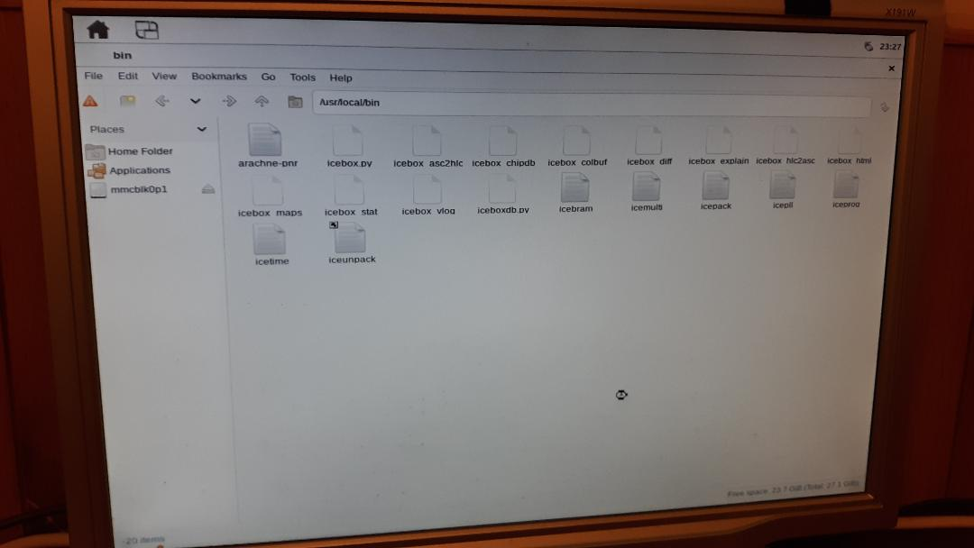

“/usr/local/share/arachne-pnr”

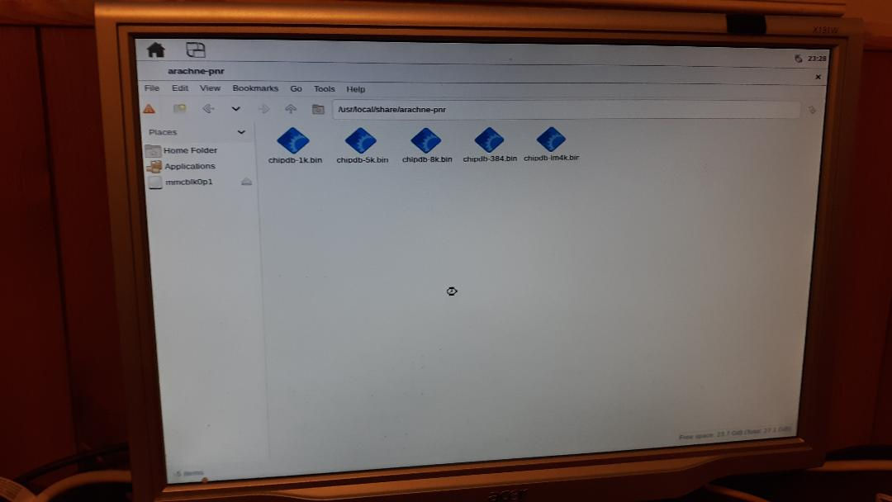

“/usr/local/share/icebox”

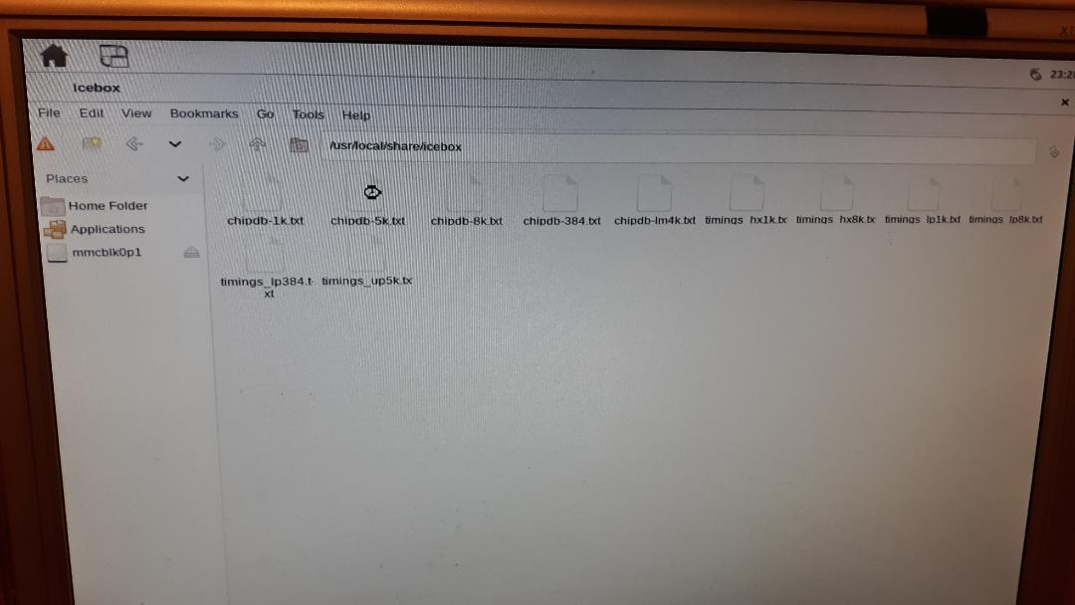
“cp catzip/rtl/catzip.blif ~/”
“cp catzip/rtl/catzip.pcf ~/arachne-pnr -d 8k -r -p catzip.pcf catzip.blif -o catzip.asc”

“ pass 90, 0 shared.

After routing:
span_4 16523 / 29696
span_12 2930 / 5632

route time 1862.66s
write_txt catzip.asc...”

raspberrypi4:~$ icepack catzip.asc catzip.bin
raspberrypi4:~$ icetime -d hx8k -c 40 catzip.asc
// Reading input .asc file..
// Reading 8k chipdb file..
// Creating timing netlist..
// Timing estimate: 21.75 ns (45.98 MHz)
// Checking 25.00 ns (40.00 MHz) clock constraint: PASSED.
raspberrypi4:~$

“Testing cross compiled icestorn & arachne-pr to create catzip.bin”

“raspberrypi4:~$ scp catzip.bin pi@mypi3-1:~/testbuilds/tbcc”

pi@mypi3-1:~/testbuilds/tbcc $ sudo config_cat catzip.bin

OK: GPIO 25 exported
OK: GPIO 17 exported
OK: GPIO 22 exported

OK: SPI driver loaded

Setting GPIO directions
out
out
in
Setting output to low
0
Reseting FPGA
0
1
Checking DONE pin
0
Continuing with configuration procedure
263+1 records in
263+1 records out
135100 bytes (135 kB, 132 KiB) copied, 0.027165 s, 5.0 MB/s
Setting output to high
1
Checking DONE pin
1
pi@mypi3-1:~/testbuilds/tbcc $ cd ../tb315/catzip/sw/host/
pi@mypi3-1:~/testbuilds/tb315/catzip/sw/host $ ./arm-netpport
Listening on port 8363
Listening on port 8364
#
Command port is now connected
< A00800011R
> A00800011R20191129
Command port disconnect

pi@mypi3-1:~/testbuilds/tb315/catzip/sw/host $ ./arm-wbregs version
00800010 ( VERSION) : [...)] 20191129

pi@mypi3-1:~/testbuilds/tb315/catzip/sw/host $ ./runjpeg.sh

pi@mypi3-1:~/testbuilds/tb315/catzip/sw/host $ octave

octave:2> rgb

red
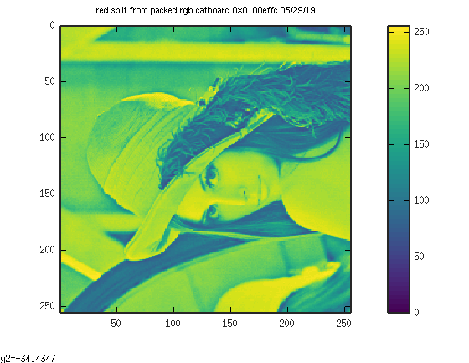
grn
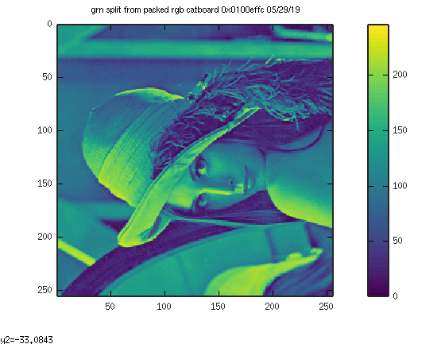

blu
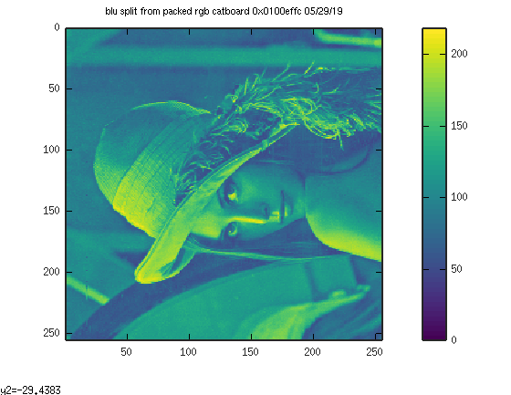
dwt
