Hi Dave,On the Raspberry Pi I copied the XSBRDINF.xml tat you sent
To /usr/local/lib/python2.7/dist=packages/XsTools-0.1.26-py2.7.egg/
I ran sudo python /usr/local/bin/xstest.py -u 0 -b XULA2-LX9

When trying to get the XSTOOLs working on the Raspberry Pi 2 B.
Dave sent a new version of the hex file needed to program the XulA2.

On 06/17/15 reprogrammed the flash on XulA2-LX9

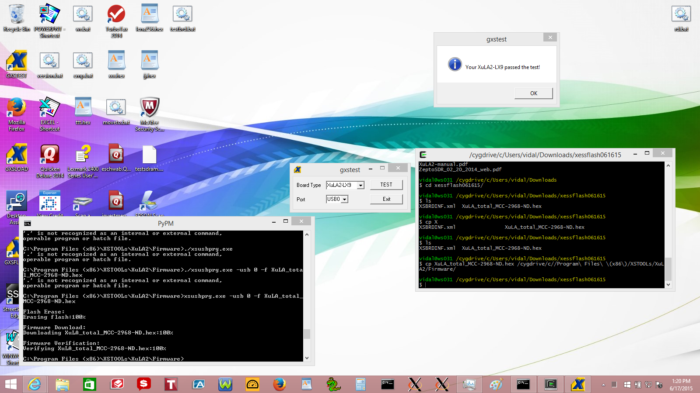

Tested by downloading the blinker.bit

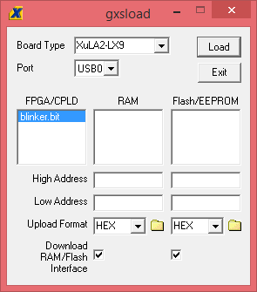
Tested on Raspberry Pi 2 B

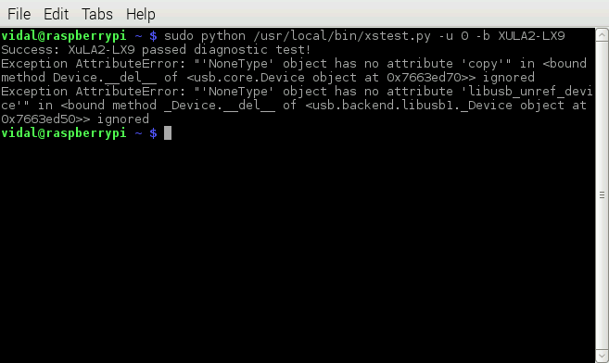
xsload options

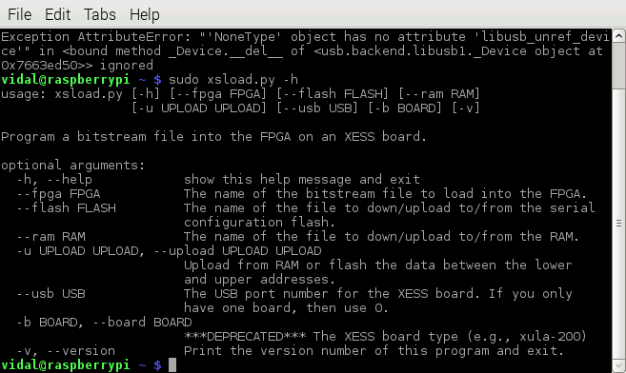
Programing XulA2 with blinker.bit

