Testing GTKWave, MyHDL Iverilog On a Raspberry Pi 2 B
Created with Yocto

GTKWave, Iverilog were compiled on the Raspberry Pi 2 B. Then a squashfs
-rw-r--r-- 1 vidal vidal 74563584 Aug 13 10:03 add_gtkwave_iverilog_xstools

-rw-r--r-- 1 vidal vidal 234613317 Aug 13 09:34 core-image-sato-raspberrypi2-20150812223843.rootfs.rpi-sdimg.gz. After the image is unzipped it can be put on a 4GB SD card.

root@raspberrypi2:~/jpeg-2000-test/ipython_fixbv# df

Filesystem 1K-blocks Used Available Use% Mounted on

/dev/root 3581760 1135320 2254348 34% /

devtmpfs 494728 4 494724 1% /dev

tmpfs 40 0 40 0% /mnt/.psplash

tmpfs 499016 280 498736 1% /run

tmpfs 499016 100 498916 1% /var/volatile

/dev/mmcblk0p1 20422 20118 304 99% /run/media/mmcblk0p1

root@raspberrypi2:~/jpeg-2000-test/ipython_fixbv# cd ~/

root@raspberrypi2:~# ls

add_gtkwave_iverilog_xstools jpeg-2000-test xstools_test_files

cosimulation pi_pkgs.txt

gtkwave_iverilog_compiled_xtools test_jpeg

The add_gtkwave_xstools can be unsquashfsed and a script will perform the final steps of the installation is done.

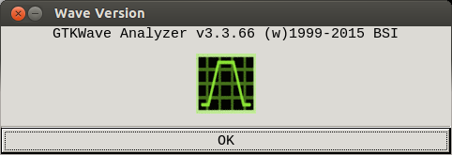

The simulation was run using https://github.com/develone/jpeg-2000-test.git
After cloning cd jpeg-2000-test/ipython_fixbv/test_lifting_jpeg_step.
“python odd root@raspberrypi2:~/jpeg-2000-test/ipython_fixbv/test_lifting_jpeg_step# python odd_even_fsm.py

190 muxsel_i 0 rst_fsm 1

200190

root@raspberrypi2:~/jpeg-2000-test/ipython_fixbv/test_lifting_jpeg_step# gtkwave tb.vcd

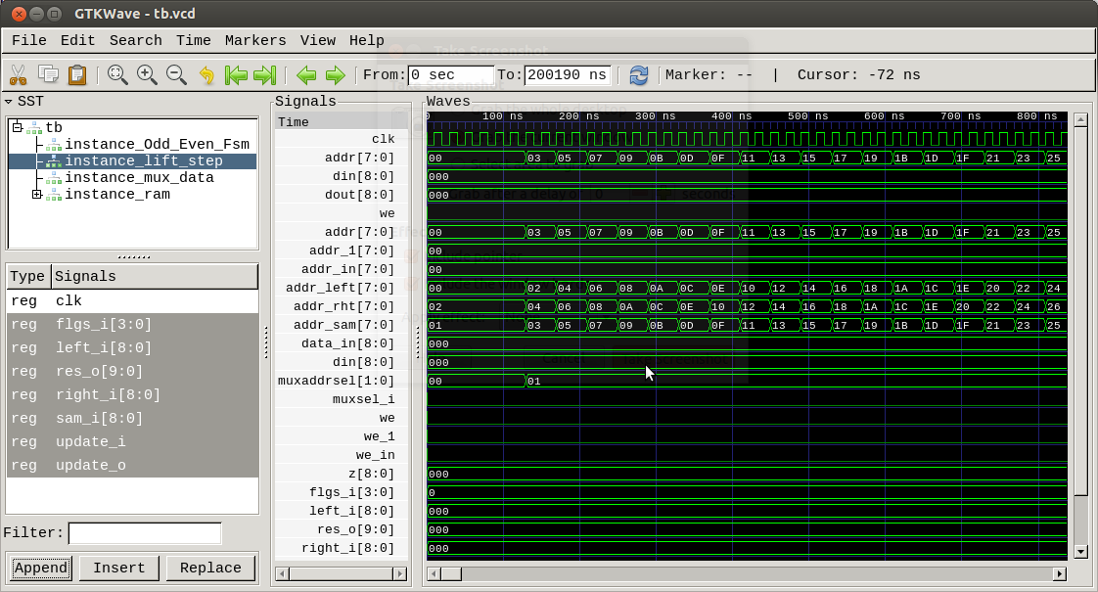
Steps to test MyHDL and Iverilog Co-simulation.
The cosimulation tree was transferred to the Raspberry Pi 2 B.

root@raspberrypi2:~/cosimulation/icarus# make

iverilog-vpi myhdl.c myhdl_table.c

Compiling myhdl.c...

myhdl.c: In function 'to_myhdl_calltf':

myhdl.c:159:15: warning: variable 'value_s' set but not used [-Wunused-but-set-variable]

s_vpi_value value_s;

^

Compiling myhdl_table.c...

Making myhdl.vpi from myhdl.o myhdl_table.o...

root@raspberrypi2:~/cosimulation/icarus# ls -la

total 124

drwxr-xr-x 3 root root 4096 Aug 12 23:28 .

drwxr-xr-x 7 root root 4096 Aug 12 23:28 ..

-rw-r--r-- 1 root root 170 Aug 12 23:28 Makefile

-rw-r--r-- 1 root root 1186 Aug 12 23:28 README.txt

-rw-r--r-- 1 root root 12018 Aug 12 23:28 myhdl.c

-rw-r--r-- 1 root root 11765 Aug 12 23:28 myhdl.c.20030518

-rw-r--r-- 1 root root 26136 Aug 12 23:28 myhdl.o

-rwxr-xr-x 1 root root 28952 Aug 12 23:28 myhdl.vpi

-rw-r--r-- 1 root root 11765 Aug 12 23:28 myhdl_20030518.c

-rw-r--r-- 1 root root 126 Aug 12 23:28 myhdl_table.c

-rw-r--r-- 1 root root 3696 Aug 12 23:28 myhdl_table.o

drwxr-xr-x 2 root root 4096 Aug 12 23:28 test

root@raspberrypi2:~/cosimulation/icarus# cd ~/

root@raspberrypi2:~# ls

add_gtkwave_iverilog_xstools pi_pkgs.txt

cosimulation xstools_test_files

gtkwave_iverilog_compiled_xtools

root@raspberrypi2:~# git clone https://github.com/cfelton/test_jpeg.git

Cloning into 'test_jpeg'...

remote: Counting objects: 1081, done.

remote: Total 1081 (delta 0), reused 0 (delta 0), pack-reused 1081

Receiving objects: 100% (1081/1081), 816.73 KiB | 983.00 KiB/s, done.

Resolving deltas: 100% (577/577), done.

Checking connectivity... done.

root@raspberrypi2:~# cd test_jpeg/test/

root@raspberrypi2:~/test_jpeg/test# ls

Makefile setup.cfg tb_jpegenc.v test_jpegenc.py

header.hex support test_images

root@raspberrypi2:~/test_jpeg/test# cp ~/cosimulation/icarus/myhdl.vpi .

root@raspberrypi2:~/test_jpeg/test# python test_jpegenc.py

Using image ./test_images/color/small4.png

compiling v1 ...

ivl: stmt.cc:1487: int draw_stmt(vhdl_procedural*, stmt_container*, ivl_statement_t, bool): Assertion `stmt' failed.

sh: line 1: 725 Done /usr/local/lib/ivl/ivlpp -L -F"/tmp/ivrlg2b7ad6fe" -f"/tmp/ivrlgb7ad6fe" -p"/tmp/ivrlib7ad6fe"

726 Aborted | /usr/local/lib/ivl/ivl -C"/tmp/ivrlhb7ad6fe" -C"/usr/local/lib/ivl/vhdl.conf" -- -

compiling v2 ...

compiling testbench ...

cosimulation setup ...

WARNING: ../hdl/jpegenc_v1/verilog/HeaderRAM.v:41: $readmemh: Standard inconsistency, following 1364-2005.

WARNING: ../hdl/jpegenc_v1/verilog/HeaderRAM.v:41: $readmemh(./header.hex): Not enough words in the file for the requested range [0:1023].

LXT2 info: dumpfile vcd/_tb_jpegenc.vcd opened for output.

start simulation ...

V2: encode image <PIL.Image.Image image mode=RGB size=208x112 at 0x763D94E0> 208 x 112

V1: encode image <PIL.Image.Image image mode=RGB size=208x112 at 0x763D93A0> 208 x 112

V2: 200 output, latest EBCFD4A6

V1: 200 output, latest 9F9F9E7C

V2: 400 output, latest D7FCB1CD

V1: 400 output, latest F3F3F3CF

V2: 600 output, latest FF00878F

V2: 800 output, latest A23FF073

V2: 1000 output, latest BFF226F8

V1: 600 output, latest 7E79F3F3

V2: 1200 output, latest 4FB67FA1

V1: 800 output, latest E7F7F9F9

V2: 1400 output, latest 3FB08355

V2: 1600 output, latest BA34DFDA

V2: 1800 output, latest E0DF069F

V1: 1000 output, latest F9F9F9F9

V2: 2000 output, latest EC5F6CC7

V1: 1200 output, latest F9F9F9E7

V2: 2200 output, latest B18B4FFF

V2: 2400 output, latest 3DFC1FAC

V1: 1400 output, latest 3F3F3F3C

V2: 2600 output, latest C3E32FEC

V2: 2800 output, latest F7456F67

V1: 1600 output, latest E7E79F3F

V2: 3000 output, latest ED5FF1F9

V2: 3200 output, latest 527C7FDF

V1: 1800 output, latest 7E7F7F9F

V2: 3400 output, latest BFF84ABF

V2: 3600 output, latest 7FE7AFFD

V1: 2000 output, latest 7F9F9F9F

V2: max frame rate 1401.662 frames/sec

V2: end pixel stream 0:21:00.569478

V2: end of bitstream 0:21:04.827813

V1: 2200 output, latest 7F9F9F9E

V1: 2400 output, latest F3F3F3F3

V1: 2600 output, latest 7E7E79F3

V1: 2800 output, latest E7E7F7F9

V1: 3000 output, latest F7F9F9F9

V1: 3200 output, latest F7F9F9F9

V1: 3400 output, latest 3F3F3F3F

V1: 3600 output, latest E7E7E79F

V1: 3800 output, latest BE7E7F7F

V1: 4000 output, latest 7F7F9F9F

II: 16512, 80x80

OO: 32608, 40x160

V1: 4200 output, latest 7F7F9F9F

V1: 4400 output, latest F3F3F3F3II: 16512, 80x80

OO: 32608, 40x160

V1: 4200 output, latest 7F7F9F9F

V1: 4400 output, latest F3F3F3F3

V1: 4600 output, latest 7E7E7E79

V1: end pixel stream 0:44:04.744808

V1: 4800 output, latest 3BE7E7F7

V1: 5000 output, latest E7F7F9F9

V1: 5200 output, latest E7F7F9F9

V1: 5400 output, latest 3F3F3F3F

V1: 5600 output, latest E7E7E7E7

V1: 5800 output, latest F3BE7E7F

II: 23296, 112x208

V1: max frame rate 483.606 frames/sec

V1: end of bitstream 0:55:03.123177

V1 bitstream, len 5934 (more than zeros True)

[ 0] FFD8FFE0

[ 1] 00104A46

[ 2] 49460001

[ 3] 01000001

[ 4] 00010000

[ 5] FFC00011

V1 max frame rate 483.606 @ (208, 112)

V2 bitstream, len 3730

[ 0] FF000FE1

[ 1] B39EF25F

[ 2] F8FE16D6

[ 3] FF008F6F

[ 4] E5DFF306

[ 5] BFCD6AFF

V2 max frame rate 1401.662 @ (208, 112)

end simulation 0:55:05.650218

During the running of python test_jpegEnc.py

top - 00:11:57 up 59 min, 2 users, load average: 1.09, 1.11, 1.04

Tasks: 96 total, 2 running, 93 sleeping, 0 stopped, 1 zombie

%Cpu(s): 24.6 us, 0.6 sy, 0.0 ni, 74.8 id, 0.0 wa, 0.0 hi, 0.0 si, 0.0 st

KiB Mem : 998036 total, 657744 free, 52820 used, 287472 buff/cache

KiB Swap: 0 total, 0 free, 0 used. 908232 avail Mem

PID USER PR NI VIRT RES SHR S %CPU %MEM TIME+ COMMAND

735 root 20 0 19544 17408 2952 R 85.8 1.7 34:10.72 vvp

718 root 20 0 13776 10648 5112 S 14.2 1.1 5:38.29 python

